42nd Annual Cole Camp Fair 5K Run/ 2Mi Walk/Kids’ Run
September 12, 2026 7:30am
Downtown Cole Camp – Maple Street and 52 Hwy, Missouri

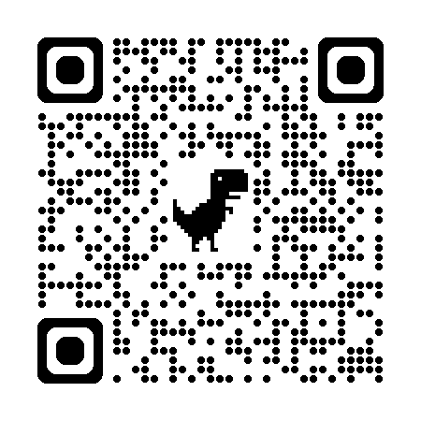
Online registration (scan QR code above or use link below):
https://runsignup.com/Race/MO/ColeCamp/ColeCampFair5kRunWalk

Sponsors:
Schroeder Drilling and Pump Co, Bothwell Regional Health Center, W-K Chevrolet, Septagon Construction, Citizens Farmers Bank of Cole Camp, Peak Physical Therapy, Functional Fitness Training, Tonya’s Rustic Kitchen, Cole Camp Pharmacy, Heide Mae Boutique, and Main Street Mutual Insurance.

Questions: Katie Swanson (660) 553-0874 or colecamp5k@yahoo.com

Race Packet Pickup & Late Registration: Wednesday, September 9, 5pm-7pm @ the Fair Building behind the Bandstand
or Saturday, September 12, 6:30-7:00 am at the bandstand. Race begins promptly at 7:30 am.

RESULTS: All race results will be posted online.

Walk. A 2-mile walk may be enjoyed by those that are interested; however, registration is required, and you must wear the race bib.

Kids’ race. Race begins right after the Run/Walk. Approximate start time is 8:15AM. Must be age 13 or under to participate. ½ Mile. All participants will receive a medal and a T-shirt.

SCOOTERS, BICYCLES, OR PETS WILL NOT BE ALLOWED ON EITHER COURSE

Pre-Registered participants will receive a T-shirt Circle size: Youth S Youth M Youth L Youth XL
Circle size: Adult S Adult M Adult L Adult XL Adult 2X* Adult 3X* *2X and up add $3 extra
Age Division: as of 9-12-26 Circle one: Kids’ Run 14&U 15-19 20-29 30-39 40-49 50-59 60-69 70+

ENTRY FEES: Pre-Registration $28 through August 16 Late registration $33 August 17 – race day Kid’s registration $20

Registering for: 5K Run_____ 2 Mile Walk_____ Kid’s ½ Mile_____ Purchasing a shirt only_____

Name: ____________________________________________________ Phone: _________________________

Address: _____________________________________ City: _________________________ State: _______ Zip: ___________

Male: _____ Female: _____ Email: ________________________________________ Birthdate: ___________________
Age:_____________

WAIVER: MUST BE SIGNED BY ALL RUNNERS AND WALKERS
In consideration of acceptance of this entry, I waive any and all claims for myself and for my heirs against officials or sponsors of the 2026 Cole Camp Fair Run/Walk in Cole Camp, Missouri, to be held Saturday, September 12, 2026 for injury, illness or personal property loss or damage of any kind which may result directly or indirectly from my participation. I further state that I am in proper physical condition to participate in the event. I give permission to the Cole Camp Fair to use my photographic image for advertising, media, or other purposes, and consent to use my name in connection with this image.

_____________________________________________________ _________________________________
Signature (parent or guardian if participant is under age 18) Date

Make checks payable to: Cole Camp Fair Mail to: Katie Swanson (Cole Camp 5k) – PO Box 220 Cole Camp, MO 65325

