Ready Rosie 2025-2026

Learning & Family Outcomes

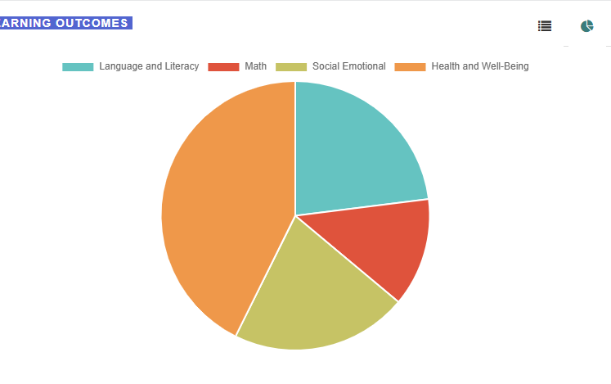
Learning Outcomes # of Opportunities
Language and Literacy 157
Math 89
Social Emotional 145
Health and Well Being 291

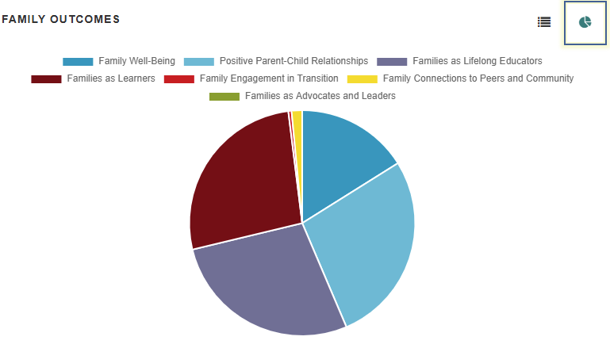

Family Outcomes # of Opportunities

Family Well-Being 245

Positive Parent-Child Relationships 419

Families as Lifelong Educators 421

Families as Learners 408

Family Engagement in Transition 7

Family Connections to Peers and Community 23

Families as Advocates and Leaders 0

