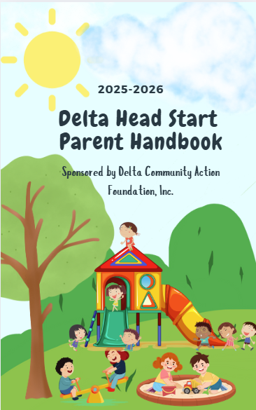
Family Name: ___________________
Draw Your Family Portrait:


Table of Contents
Draw Family Portrait………………………………………………………………………………………………..….…………………..….…...2
Table of Contents……………………………………………………………………………………….…………….…...…....3
Administration and Center Contacts……………………………………………………………………………….........................….4
General Information
Mission Statement, Welcome, Attendance………………………………………………………………….……..............,,…….…5
Arrivals & Departure, Child Abuse, Center Closings, ..
Communication, Code of Conduct………………………………………………………………………….………….………….....…...6
Confidentiality, Car Seats, Court Records, DHS Compliance,
Diapering, Drug/Smoke Free Environment, Field Trips…………………………………………………………………...........7
Home Visits, Non Discrimination Policy, Outdoor Play, Parent Handbook, Program
Improvements/Complait, Registered Sex Offenders, Security, Solicitations, Transitions,
Unattended Vechicle……………………………………………………………………………………………………………....…….…..........8
Weapons, Withdraw from Program……………………………………………………………………………….……..……..……….....9
Education Services
Curriculum-Teaching Strategies …………………………………………………………………………..…….…….………..……….…..9
Behavior and Guidance, Special Needs, Parents Role for Children with Special Needs…….………….....…..10
Family Services
Family Advocates, Family Parternship Agreements………………………………….……………………....……….……..…...10
Health Services
Screenings, Screening Authorizations, Accidents & Injury, Dental, Emergency Response…...................…11
Followups, Handwashing, Head Lice, Handwashing, Immunization, Medical Conditions…………..............12
Mealtimes, Medical Homes, Medication Administration Policy …………………………………..………..…………......12
Nutrition, Outside Food, Sooner Care, Exclusion, Special Diets, Special Occassions…….………...............….13
Mental Health Services
Behavior Plans, Exclusions………………………………,,,………………………….………………..………….………………….…….....14
Parent Engagement Services
Delta’s Awesome Dads, Family Literacy …………………………………………………………….………...……………..…. ......14
Parent Meetings, Parent Code of Contact, Policy Council, Raising a Reader, Ready Rosie............... ........15
DollyParton Imagination Station, Volunteer Qualifications………………………………………………....…........ ......…16
Vehicle & Pedestrian Safety, Blindspots ……………………………….……………………..….…………………………… ……..16
Community Resources…………………………………………………………………………….……….…….…......................... .……..17


Peter Masters conceptualized the National Head Start logo in 1965.
- The two squares represent early childhood by suggesting building blocks.
- The arrangement of the blocks represents stairs by which this can be accomplished.
- The vertical stripes represent the child and parent.
- The arrow pointing upward represents the direction out of poverty and on to the future.
- The colors, red, white, and blue represent the United States and the many opportunities it provides for its citizens.



DELTA HEAD START/EARLY HEAD START
308 S.W. 2nd Street, Lindsay, OK 73052

CENTERS ADDRESS PHONE # FAX # EMAIL
Comanche HS  K83-0052233 | 1030 Ash Ave  Comanche, OK 73529 | 580-439-2911 | 580-439-2947  (School Office)
Dibble HS  K83-0052247 | 100 Main  Dibble, OK 73031 | 1-833-324-1173  Ext. 182 | No Fax-have to  Scan & email | Tawana Whinery  twhinery@deltacaf.com
Duncan HS/EHS  K83-0021809 | 645 S. 12th St  Duncan, OK 73533 | 580-255-5571 | 580-255-5576 | Judy Tidwell  jtidwell@deltacaf.com
Lindsay HS/EHS  K83-0021445 | 14027 E CR 1518  Lindsay, OK 73052- | 405-756-3513 | 405-756-3514 | Kayla Forehand  kforehand@deltacaf.com
Marlow HS (Angels & Outlaws)  K83-0055612 | 807 S. 9th St  Marlow, OK 73055 | 580-658-9929 | 580-658-9929 | Rita Kilbride  rkilbride@deltacaf.com
PV Early Learning Ctr –  K83-0053963 | 405 Diffie Lane  Pauls Valley, OK 73075 | 405-207-9013 | 405-207-9013 | Marianna Mejia mmejia@deltacaf.com
Pauls Valley HS  K83-0022654 | 408 East Ave  Pauls Valley, OK 73075 | 405-331-3049 | 405-331-3049 | Alma Charqueño  acharqueno@deltacaf.com
Purcell Early Learning Ctr  K83-0020282 | 715 S 4th  Purcell, OK 73080 | 405-527-5551 | 405-527-1750(HS)  405-527-0024(EHS) | Valarie Jones  vjones@deltacaf.com
Purcell Pre-K/HS | 809 N 9th Ave  Purcell, OK 73080 | 405-442-0099  ext 219 | No Fax-have to  Scan & email | D’Lana Albright  malbright@deltacaf.com
Stratford HS  K83-0022342 | 241 N Oak  Stratford, OK 74872- | 580-759-2382  ext 213 | 580-759-8914  (School Office) | Stacy Gallup  sgallup@deltacaf.com
NAME LOCATION OFFICE # OFFICE FAX EMAIL
Karen Nichols, Executive Dir | Lindsay CAP | 405-756-1100 ext. 125 | 405-756-1104 | knichols7@windstream.net
Alecia Walling, Program Director | Lindsay CAP | 405-756-1100 ext. 126 | 405-756-1104 | awalling@deltacaf.com
Sheresa Patrick, Deputy Director | Duncan | 580-255-2536 | 580-255-5576 | spatrick@deltacaf.com
Angie Burk, Parent Manager | Lindsay CAP | 405-756-1100 ext. 130 | 405-756-1104 | aburk@deltacaf.com
Suzan Carroll, ERSEA-Health Manager | PELC | 405-527-5551 ext. 235 | 405-527-1750 | scarroll@deltacaf.com
Sue Early, Nutrition Manager | Duncan | 580-260-2024 | 580-255-5576 | searly@deltacaf.com
Shelby Jarrett, Dis Health Spec | Pauls Valley | 405-518-4125 | 405-207-9013 | sjarrett@deltacaf.com
Sandra LaGrow, EHS Manager | PELC | 405-527-5551 ext. 221 | 405-527-1750 | slagrow@deltacaf.com
Teresa Pruett, Ed Manager | Lindsay CAP | 405-756-1100 ext. 131 | 405-756-1104 | tpruett@deltacaf.com
Jessica Hill, QA Specialist | Pauls Valley | 405-756-1100 ext. 133 | 405-756-1104 | jhill@deltacaf.com
Rochelle Brand, Health Spec | Lindsay CAP | 405-756-1100 ext. 132 | 405-756-1104 | rbrand@deltacaf.com
RuGenia Baxter, Health Spec | Duncan | 580-260-2252 | 580-255-5576 | rbaxter@deltacaf.com
Sherri Herrington, Education Spec | Pauls Valley | 405756-1100 | 405-756-1104 | sherrington@deltacaf.com
Cheri Dominey, Family Advocate | Duncan | 580-255-5571 | 580-255-5576 | cdominey@deltacaf.com
Patty Jones, Family Advocate | Purcell - PELC | 405-527-5551 | 405-527-1750 | pjones@deltacaf.com
Trisha Martin, Family Advocate | Pauls Valley | 405-518-4125 | 405-207-9013 | tmartin@deltacaf.com
Jamie Tow, Family Advocate | Duncan | 580-255-5571 | 580-255-5576 | jtow@deltacaf.com
Jenny Morrison, Family Advocate/Subsidy | Lindsay | 405-756-1100 | 405-756-1104 | jmorrison@deltacaf.com
Lupe Villarreal, Subsidy | Duncan | 580-255-5571 | 580-255-5576 | lvillarreal@deltacaf.com
Martha Bollman, Admin Assistant | Lindsay CAP | 405-756-1100 ext. 121 | 405-756-1104 | mbollman@deltacaf.com
Joshua King, IT Tech Spec | Lindsay CAP | 405-756-1100 ext. 127 | 405-756-1104 | jking@deltacaf.com

Mission Statement

Our mission is to teach children and reach families by working together with families, communities,

and creative partnerships through
comprehensive high-quality services.
Thus, empowering families
to shape the future, one child at a time.
Welcome,
Welcome to Head Start! Head Start is ready to partner with you on your child's journey toward school readiness and lifelong success. Your role as your child's first and most important teacher is recognized, and Head Start is committed to supporting you. Head Start is a comprehensive approach that nurtures the whole child—academically, socially, and emotionally—while also empowering families through resources and support.
There are some basic things we want you to remember as your child begins his/her educational experience.
- School attendance, punctuality, and a good night’s sleep are all fundamentals for student success.
- Collaborative partnerships that involve parents, families, and staff are the most beneficial to the successful educational experience of the child.
- Parent involvement is fundamental to your child’s overall success.
A fantastic year of learning, growth, and building a strong foundation for your child's future is anticipated!

Alecia Walling
Program Director

General Information
Attendance
The primary goal of Head Start is to prepare children and families for Preschool. Attendance is a very important part of that opportunity. Absences can result in missed learning experiences, missed healthy meals, and opportunities for social skills development. Delta Head Start understands there are times when children cannot attend. Your child should stay home if sick, so they do not expose other children and staff, and so they can get needed rest, but please call us and let us know. Your child will not be able to attend school if any of the following symptoms are present: A temperature over 100.4 degrees. If your child feels warm or is complaining about being warm, take their temperature. To return to school, the child must be fever free for 24 hours and without the use of fever reducing medication like Tylenol or Ibuprofen. Rash or suspected contagious disease, a note from a healthcare provider will be required before the child can return to school. If a child comes to school with illness symptoms, the parent will be contacted immediately to pick up the child.

Head Start has implemented a policy for attendance to ensure children receive necessary instruction for school readiness. Parents must inform the center within an hour of classroom opening if their child is going to be absent. If a child is absent three consecutive days without notification or has irregular attendance, staff will attempt to contact the parent, if absent 4 days or sporadically staff will attempt contact and attempt home visits, or these actions can result in your child being dropped from the program.

Arrival/Departure for Children
Arrival: In public school who collaborate with Head Start, we will follow the public-school procedures for arrival and departure. Your child will become the responsibility of Head Start when the designated time during the day for Head Start begins and ends.
At enrollment parents fill out the Emergency Contact/Pick-up list with name, address, phone number, and relationship of anyone they give permission to pick up their child from school. PLEASE make updates as needed.
a. People listed on the enrollment forms as authorized pick-up are the only people allowed to pick up a child. They may be required to show ID, if staff is not familiar with them.
b. The center must have written or verbal notification from parents before releasing a child to anyone else.
2. Parents will accompany children into the classroom each day. The parents will sign in and out for their child daily with their signature and contact information. Refrain from being on the phone during drop-off and pick up.
3. Children must be picked up promptly.
4. Our “late policy” is as follows and will be strictly enforced:
a. Staff will contact parents if the child is still in the center past pick up time, if parents cannot be reached within 15 minutes after the scheduled pick-up time, then all other numbers on the emergency contact sheet will be called.
b. If no one can be reached within 45 minutes after the scheduled pick-up time, then the local law enforcement agency and Child Protective Services will be contacted.

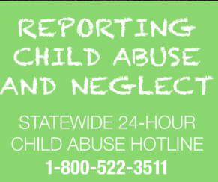
Child Abuse Delta HS/EHS follows Oklahoma's definitions of abuse and neglect, and all facilities must follow reporting procedures for child safety. Staff, parents, and volunteers must report suspected abuse or neglect to the authorities, while Delta staff are not responsible for investigation. Cooperation and confidentiality are expected, in accordance with Oklahoma State Law # 304, Crimes and Punishments, Section #846 Performance Standard 1304.52(k)(3)(I), 1304.22(a)(5)

Center Closings/Weather
The School District determines delays, early releases, or closings for Head Start classrooms, which will be broadcast on local radio and television stations if public schools are closed.

Communication
Communication is an integral part of building a relationship between parents and staff. By working together,
we can prepare children to be successful and ready for school. We offer many options to communicate with administrative staff, teachers, and family advocates.
Phone calls are screened, to allow active supervision in the classroom. However, in the event of an emergency the teacher will come to the phone. Otherwise please, leave a message and teachers will call as soon as possible. Parent/Teacher conferences are held twice a year, and home visits are held twice a year. Regular notes and newsletters are sent out. Emails/phone calls/texts, flyers and newsletters, parent committee meetings/policy council and family literacy meetings are opportunities to share. The admin and center phone numbers are provided in this booklet.

Code of Conduct
The program requires parents to behave appropriately, avoid aggressive or abusive behavior, and any threats may result in legal action and potential suspension of their child's enrollment.

Confidentiality
All children’s files will be maintained in a locked file cabinet and reviewed by Head Start staff only, unless legally bound by law. Confidentiality must be maintained in and outside of the classroom. Staff, parents, and volunteers will not discuss any information that is of a confidential nature about children, families, or employees,

Child Car Seats
Oklahoma law requires every child 8 years old and younger to be properly secured in a child passenger restraint system. Follow these guidelines to keep children safe:

- 0-2 years: By law, children under 2 (or until they outgrow the top height or weight recommendations) must be properly secured in a rear-facing car seat.
- 2-4 years: Must be in a car seat until age 4
- 4-8 years: Must be in a car seat or child booster seat until at least age 8, unless the child is taller than 4’9”.
- 8 years or taller than 4’9”: Should wear a seat belt
- Regardless of age, the back seat is always the safest place for children.
- Buckle them up, every trip, every time. It’s the law.

Court Records
Custody is a legal issue requiring cooperation between staff and parents. Head Start encourages families to resolve differences. A child’s birth certificate determines maternity and paternity, as required by law we will release children to non-custodial parents if no current court orders are on file.

DHS Compliance
Centers display Oklahoma Department of Human Services notices, Child Welfare Investigative Notifications, and Day Care Licensing Compliance Reports, with findings posted in entrance and Parent Area.

Diapering/Toileting Policy
Delta helps children with elimination needs, including diapering and toilet training. Staff are trained to reduce cross-contamination risks. Early Head Start children’s diapers are free during their hours of attendance. Families can bring their own brand of diapers if a specific brand is needed. Supplies must be clearly labeled with the child’s name, doctor’s name and instructions and stored at the diaper changing area, but out of reach of children.
Delta will also assist all families with toilet training for their children. Delta adheres to Day Care licensing standards, including requiring doctor's notes for creams and ointments, and not using powders due to respiratory issues.

Drug/Smoke Free Environment
In accordance with state laws, no alcohol, drugs, tobacco, vaping or other recreational substances will be allowed on Head Start property or in collaboration facilities at any time including field trips, pickup/ drop-off or at any Head Start activity.

Field Trip
Field Trips are beneficial for children, but only Head Start classrooms can participate. Early Head Start children are not allowed. Requests must be submitted to the Education Manager. Three-year-olds must have a parent accompany them, and parents must provide transportation. Non-Head Start children are responsible for their adults, and parents can only supervise their own child.

Home Visit/Parent Conference
Head Start teachers will conduct two parent/teacher conferences and two home visits to discuss child progress, address concerns, and gather questions and suggestions.

Nondiscrimination Policy
In accordance with Federal law, this institute is prohibited from discrimination on the basis of race, color, national origin, sex, age, or disability. To file a complaint of discrimination, write USDA, Director, Office of Civil Rights, Room 326-W, Whitten Building, 1400 Independence Ave. SW, Washington, DC 20250-9410 or call 202-720-5964 (voice and TDD).

Outdoor Play
Outdoor play is mandatory in daily activities, with a minimum of 30 minutes per child. Children with disabilities or illnesses should not be present. Childcare licensing standards and child/staff ratio are maintained. Oklahoma weather is unpredictable, so appropriate gear is provided. Shoes should be closed toes.

Parent Handbook
This handbook is available at deltaheadstart.com for your convenience.

Program Improvements/Complaints Concerns or suggestions about the program should be addressed with your child’s teacher, center director or a manager. Alecia Weatherford, Program Director at 405-756-1100, is also available for questions. We have a community complaint policy, and it is available upon request

Registered Sex Offenders
No person who is registered as a sex offender is allowed to enter or loiter within 500 feet of any Head Start center/classroom. A registered sex offender, who is a parent of a child enrolled in the program will not be permitted to attend any onsite or off site. Drop off and pick up should be facilitated quickly and respectfully by all parties.

Security
We have centers and public-school settings that are monitored by various security systems. Most of them you will need to ring a bell or go to the office to check in. We ask our parents to respect the requirements and respond appropriately.

Solicitation Policy
Parents and staff are prohibited from soliciting funds or supplies from local businesses or the community. All inquiries should be directed to the Program Director and be approved by the Program Director prior to solicitation.

Transitions
Transitions are opportunities for continuous learning and growth, and as your child's first teacher, you play a crucial role in a successful early transition. Showing confidence and support throughout the year helps create a secure environment.

Unattended Vehicles
Children should never be left alone in or around cars, even for a minute, as it can lead to serious injuries or deaths. Parents and caregivers should prioritize their children's safety over their convenience. Always set the emergency brake when parking.

A person can face child endangerment or neglect charges for leaving a child alone in a vehicle, all instances will be reported. Should you find a child in an unattended vehicle call 911 and report it, if the child is in distress, remove them from the vehicle as quickly as possible.

Weapons/Firearms
The policy prohibits carrying firearms, ammunition, or weapons on agency property.

Withdrawal from Program
To withdraw your child from the Head Start program, please notify your center director and sign a form. If you are moving to one of our service areas, we will try to transfer your child, pending openings

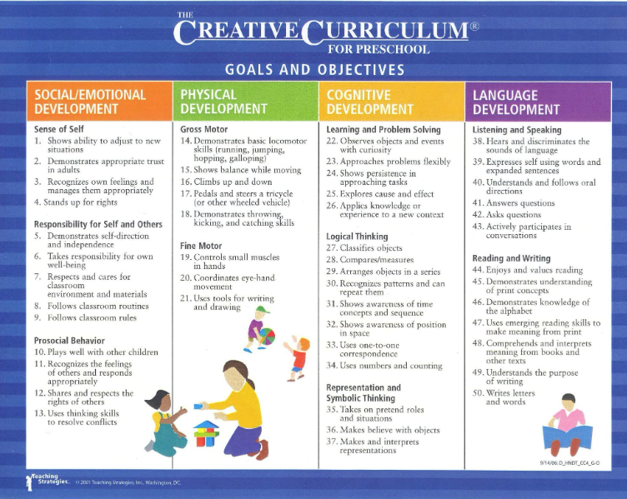
EDUCATION SERVICES
The education component of our program focuses on preparing children for success in kindergarten and life through a quality educational foundation, using Creative Curriculum. We aim to stimulate curiosity and
Learning through play by creating an environment and experiences that stimulate learning, while incorporating local communities' ethnic and cultural characteristics. Teaching Strategies Gold is used for lesson planning and individualization (in Head Start only classrooms, classrooms in public schools utilize the school’s curriculum and supplement with TSG) and children engage in free choice of daily activities, learn to make choices and develop social skills. We prioritize social emotional development, health, nutrition, and self-help skills.

Curriculum- Teaching Strategies
Delta uses Creative Curriculum for our daily teaching goals. The Creative Curriculum meets state guidelines of the Oklahoma Early Learning Guidelines for infants through preschool, as well as the Head Start Early Learning Outcomes Framework. We access information for that through the Teaching Strategies program. Within that program, parents have an option of joining the Family Portal. They will receive an invitation and a pin in their email. They will then go to family.teachingstrategies.com to set up your account. Enter the email and pin provided and follow the instructions to verify the account. Then you will be able to access information about your child's learning, communicate with the teacher and utilize resources like the digital library and family friendly activities. which may not be available for the first 45 days.

Behavior and Guidance Policy
The program promotes positive behavior management through positive reinforcement methods, including praise, encouragement, and clear expectations, with teachers responsible for discipline and avoiding corporal punishment. Corporal punishment, emotional or physical abuse, unnecessary restraining, humiliation, isolation or denial of food, water, recess or bathroom privileges are not allowed.
Praise and positive reinforcement are effective methods for the behavior management of children. Teachers are responsible for discipline in the educational setting
Short-term exclusion is limited to severe incidents where a child cannot regain composure, and if warranted regularly, a behavior plan will be implemented by the team and parent.


SPECIAL NEEDS SERVICES
Delta HS/EHS focuses on serving children with disabilities and their families, with a minimum 10% enrollment reserved for special needs children, diagnosed or discovered through screening. Our program aims to unite children with diverse strengths and needs, promoting understanding of differences and providing opportunities for growth and development in an inclusive environment.
Teachers will monitor children's progress through observations and assessments throughout the year and collaborate with families to plan activities in both home and school settings. We aim to empower families to advocate for their children using community resources, ensuring each child receives a "Head Start" in life.

Parents Role for Child with Special Needs
Parents maintain a child's special needs records, keeping them confidential. They can review records upon request. Delta Head Start provides training and modeling to help parents advocate for their child's needs.

FAMLY SERVICES
The Family and Community Partnership staff assist families in their growth and development by building trust, identifying goals from a strength-based perception. Working with families to define and direct their chosen goals for their families by providing resources, referrals, and training in nutrition, health, and childhood development.

Family Advocates
Family Advocates in each county provide information, resources, and support for family goals, health records, and follow-up screenings. They also assist with forms for physical and dental visits. If you take your child to a provider, please ask your family advocate for a form to have them complete for any physical or dental visits completed.

Family Partnership Agreements
The Family Partnership Agreement process enhances children's quality of life. Family Advocates and still will assist the family to identify the goals they want for their family, provide resources, information, and referrals, promoting personal growth, while encouraging parent engagement and knowledge of their community resources.

HEALTH SERVICES
The Head Start program prioritizes health, focusing on prevention, early diagnosis, and treatment which may impact learning. Delta adheres to federal requirements in the HS Performance Standards and Caring for Our Children, ensuring children receive up-to-date physical, dental, immunization, blood lead, vision, and hearing screenings within 45 days of enrollment. Parents are responsible for follow-ups to findings and provide documentation of that follow-up to the program.
Physical Screening
The Early Periodic Screenings Diagnostic Treatment physical is required for all children within 90 days.
Dental Screenings
Exams are also required within the last 12 months, with follow-ups essential for good oral health. Parents are encouraged to continue taking their child's well-baby dental visits every six months.
Hearing/Vision Screenings
The program uses the OTO Acoustic Emissions screener for newborn screenings, and Spot Vision Screening for vision issues.
Speech Screenings
Speech is screened using tools from local education agencies.
Developmental/Behavioral Assessments
The ASQ-3 Ages and Stages Screening Tool assesses thinking, motor skills, and language abilities. The ASQ: SE is used for social emotional development.
Growth Assessment
Uses the child’s height and weight to calculate the child’s Body Mass Index (BMI). This calculation is used to determine if your child is growing appropriately.
Blood Lead Screenings
Lead screenings are required by the state of Oklahoma at 12 months and 24 months with one test required before 6 months of age. Delta now has staff training and the capacity to do these screenings onsite.
Accidents & Injuries
We have a designated First Aid area, trained staff, and injury prevention techniques to handle accidents. Children are treated immediately, a report completed for you to sign. For any immediate danger a ambulance will be called to transport the child. Parents are notified as soon as possible of head injuries and should report to the site. If you can’t be reached, we will contact the others on your pickup list next.

Authorization for Screenings
All screenings will require parent/guardian written permission before being administered that are signed at enrollment. Parents will be made aware of the dates these are to be done at the center.

Dental Health
Delta aims to enhance dental health by providing daily fluoride toothpaste and assistance to children while brushing their teeth and offering nutritional food to support effective oral hygiene.

Emergency Response Plan
Emergency plans are in place for each site with an EHS/HS classroom, with evacuation routes posted. This plan provides guidelines for response in a variety of situations, such as environmental hazards or spills, bomb threats, severe weather, etc. Teachers and children conduct drills for preparedness. When located in public schools we will follow their instructions. During emergencies, we ask for your help in the following ways:
- If you would like to pick up your child due to predicted bad weather, early pick-up of children is advised, emergency procedures ensure safety and prevent doors from opening after the storm arrives.
- Please do not call the school-we must have the lines open for emergency calls.
- Post-crisis does not immediately drive to the center due to potential debris.
- Local TV & radio stations are consulted for further information and direction

Follow ups
Delta HS/EHS and parents will collaborate on medical and dental follow-ups for children after screenings. Parents must accompany children on follow-up visits, will be notified if a problem is found during the screening process. You will be expected to provide follow-up treatment documentation from doctors/dentists, within 30 days.

Handwashing/Hygiene
Our goal is to instill healthy hygiene habits in children, promoting lifelong health. We will wash hands frequently throughout the day before and after bathroom breaks, before food is served, after outdoor play, etc.

Head Lice
The center checks children regularly for signs of head lice, notifying parents if found. Children should not be excluded or sent home early due to lice. If present, avoid head-to-head contact and headgear sharing the rest of the day. Treatment is required at night, and if live bugs are present, the child will return home and may return after they are treated.

Immunizations
Immunizations are crucial in early care and education programs to prevent disease spread. Oklahoma Day Care Licensing laws mandate proper immunizations, and a copy is required upon admission as well as any updates should be turned in. A short-term exclusion policy applies for children who are non-current immunizations.

Medical Conditions
Children with medical conditions or limitations must provide a physician's medical plan before attending the first day of school, for conditions that arise throughout the year the medical plans must be in place before being admitted into class. The forms needed can be obtained from a family advocate or health specialist. They must be updated when treatment is discontinued and signed by the physician.

Mealtimes
Formula and baby food will be provided at no cost to the parents. Breast milk must be labeled with an infant’s name, date of expression and must be refrigerated immediately. Infants are fed on demand, with staff holding them during all feeding times. Parents who want to take their child off formula before age one (12 months) or change the formula, must have the child’s doctor’s signature with the date a Medical Statement Form.
Meals are designed to be casual, allowing adults and children to interact and hold conversations while eating. Adults eating with children will eat the same food unless a doctor’s note is provided. Snacks are served in full day programs in the afternoon. Food will not be used as a form of discipline. Children are encouraged to try new foods they are continually offered. Hands are washed before meals with soap and water.

Medical Homes
We will collaborate with parents to ensure each child has a medical home, ensuring timely access to necessary services.

Medication Administration Policy
When possible, parents should schedule medication administration with their child during times when the child is under parental supervision. Classroom medication administration follows specific procedures, including:
- Giving the first dose at home
- Providing documentation from the physician
- Before administration of medication, parent & physician signatures are required on a medication authorization
- Medication is for chronic condition or is part of a prescribed therapeutic treatment
- Physicians can sign a medication authorization for up to six (6) months for prescribed medication to be given when symptoms occur.
- Parent & Physician must sign a medication authorization
- Prescriptions must match the authorization
- Over-the-counter medication must be labeled with the child's name, dosage amount, time, physician name, and expiration date
- School nurses may be used when available.

PLEASE NOTE: Do NOT put the medicine in your child’s backpack.
You must take the medication to school and give it to your child’s teacher. Medication must be in its ORIGINAL container whether it is prescription or non-prescription. Only staff that are trained in medication administration will give medications to students.

Nutrition Services
Delta adheres to USDA/CACFP, Oklahoma State Licensing, National Performance Standards, and agency policies for meal guidelines. We do maintain kitchens in centers outside public schools, providing children with 2/3 of the recommended daily requirements. Breakfast and lunch are served daily, and a Registered Dietician is available for nutritional assistance. Menus are culturally and developmentally appropriate for children's ages.

Outside Food
We must restrict food prepared off site due to health considerations, including allergies, food sensitivities, choking concerns and nutritional content and religious food preference. Any food brought toa Head Start classrooms must be approved by the teacher, packeted from a licensed facility or hermetically sealed. The only exception is family functions where parents are present and have the discretion to partake in the event or not.

How to apply
You may download the English or Spanish application, fill it out and mail it in. If you need help filling out the form, call the Sooner Care Helpline at 1-800-987-7767.

Short Term Exclusion Policy
Children and/or adults with illnesses or symptoms will be excluded from the Head Start/Early Head Start program according to recommendations made in the Caring for Our Children.

Special Diet Guidelines
Special dietary guidelines for children with allergies or religions preferences require a written order from their medical provider or religious council.

Special Occasions
On special occasions, Parents can bring nutritional snacks to school, but prohibited foods like peanuts, grapes, raisins, hot dogs, popcorn, and limited sweets are not allowed due to dental health and childcare licensing.
All food must be from a licensed facility or in individually wrapped packages.
MENTAL HEALTH SERVICES
We recognize the importance of mental health services to children when we encourage healthy emotional and social development. A mental health professional is available to help teachers and parents encourage behaviors which move children in the direction of cooperation, making friends and appropriate choices, developing a strong sense of self-esteem and coping with life's challenges. Mental health staff regularly visit classrooms, Early Head Start classrooms, throughout the program year to support the social-emotional needs of children, families, and staff. They may offer suggestions or strategies to teachers regarding any child in the program. If an individualized child-specific intervention is recommended requiring direct follow-up, a parent conference will be scheduled to discuss concerns and suggest strategies. At that time, an intervention plan will be developed with input from the parent and classroom team members.

Head Start will provide information, consultations, and upon request on-site training for families on relevant mental health issues. We also assist parents in guiding the referral process when necessary. If it seems your child could benefit from individual attention, your signed permission will be requested before any further services are offered.

Behavior Plans/Exclusion
Occasionally, children present dangerous behavior toward themselves or others that potentially could cause injury. Teachers will respond with positive guidance, isolate any potential threats of injury, and will communicate with the parents. An observation will be made of the situation by the Disability Manager to determine the steps to be taken. Short-term exclusion may be warranted, a behavior plan will be made which will include the team of teachers, parents and specialists to work together on any areas of concern.

PARENT ENGAGMENT SERVICES
Head Start has emphasized family engagement since 1965, supporting families as the primary influence in their child's lives. Delta HS/EHS offers opportunities for families to participate in learning experiences, such as classroom volunteering, parent committee membership, Policy Council, Ready Rosie, Fatherhood Activities, Family Literacy Activities and at home using Teaching Strategies or Raising A Reader programs. Volunteering in the classrooms is encouraged. We do have an open-door policy in classrooms, however, heads up to your teacher is appreciated. In collaboration classrooms, building supervisors may recommend signing in at the front, please check with them for their processes.


Delta's Awesome Dad's (DADS)
Delta aims to enhance the bond between your child and a positive male role model in their life. In Head Start all that male has to do to attend is to be a positive male role model for your child. This can be a biological father, stepfather, grandfather, uncle, brother, etc. We host two annual DAD’s activities or events, including one home project and one classroom activity. Any positive male role model can participate with your child, whether they live in the home or not.

Family Literacy
There will be two Family Literacy Activities held each year. These can be held at the same time as a Parent Meeting is held. Where you bring your child and complete activities that focus on math, literacy, science, and art. Head Start respects parents as their child's first teachers and encourages lifelong learning beyond the school setting. Teachers will invite you to join Teaching Strategies, which has many ideas for engagement specific to your child’s needs.

Parent Meetings
Every year a Parent Committee consisting of enrolled Early Head Start and Head Start parents is developed at each center. Four meetings are held annually, including the first, Parent Orientation. At the first meeting, a President, Vice President and a Secretary are elected as well as the Policy Council Representative and goals for activities, projects, field trips, and common experiences are decided upon throughout the year.

Additional meetings are scheduled by the center staff and officers on or before November 15, February 15th and April 15th, notes will be posted on the door of your center and sent home at least a week before the meeting occurs along with reminders on the day of the meeting. There will be a short training at each meeting, topics include child development, behavior and guidance, and financial literacy in addition to a business meeting.

Parent/Volunteers-Code of Conduct
Parents and volunteers are expected to respect each child's unique identity, avoid stereotyping, follow confidentiality policies, and leave no child alone unsupervised. Volunteers will not be left alone with children without a paid staff member. They should not discipline children and should reflect positively on the program. Delta Head Start will not tolerate behavior that violates the Code of Conduct, including threats, physical punishment, and foul language. These are cause for immediate dismissal.

Policy Council
The Policy Council, a key component of the Head Start program, comprises elected parent representatives and community members, with at least 51% being parents or guardians of enrolled children, ensuring diverse perspectives.
- Program Planning and Development: Approving program goals, budgets, and work plans.
- Policy and Procedure Approval: Reviewing and approving program policies and procedures.
- Recruitment, Selection, and Enrollment: Participating in decisions about recruitment, selection, and enrollment
- Personnel Recommendations: Making recommendations regarding hiring and staffing.
- Grant Applications: Reviewing and approving grant proposals and amendments.

Raising a Reader

Delta is a Raising a Reader State Affiliate, offering red bags with 3-4 quality children's books for parents to share with their children. Families will sign out the material and are asked to return all material, to participate further. Only one bag will be sent home at a time. Please complete a individual volunteer time sheet and return it with the bag.

Ready Rosie
Ready Rosie is a mobile app for parents to encourage their child's learning and strengthen family bonds. It focuses on infants to 3rd grade, offering activities and videos. Parents must be invited, respond to texts or emails, recreate the activity with their child and complete volunteer time sheets monthly, (available from your teacher). Text and emails will be sent out each Monday.

Dolly Parton Imagination Library- Sends your child a free book each month from 1 month to 5 years. Sign up on their website. It’s FREE!!

A parent must register at this website and reside in

- Comanche, Duncan or Marlow-
https://imaginationlibrary.com/usa/affiliate/OKSTEPHENS/

- Linday, Pauls Valley, Maysville, Erin Springs or Stratford-https://imaginationlibrary.com/usa/affiliate/OKGARVINCO/

- Linday, Pauls Valley, Purcell or Maysville
https://imaginationlibrary.com/usa/affiliate/OKMAYSVILLE/

Volunteer Qualifications
Volunteers must be at least 16 years old and screened for communicable diseases. They are responsible for the safety and well-being of small children and must have physical and mental capabilities to make responsible decisions. Teachers will direct volunteer activities, and regular training and mentoring are provided. Volunteers are not counted in child/adult ratios for Child Care Licensing, are not left alone with children for any reason, and those with pending criminal charges may not be on childcare premises.

Vehicle and Pedestrian Safety
Children under 9 lack the hearing, peripheral vision, and judgment capabilities to safely navigate busy streets. They become distracted and excited, making it difficult for caregivers to hold hands. Do it anyway, this is non-negotiable. To help, follow these guidelines:
- Teach children to stop immediately when instructed
- Walk facing traffic,
- Avoid crossing between parked cars
- Teach them to "Stop, Look and Listen," look both ways before crossing the street, stop at the curb, look both ways, watch not only stopped vehicles but for approaching vehicles, even when crossing on a green light.
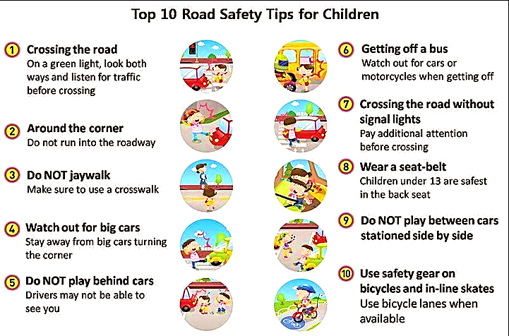

RESOURCES to help you navigate your parenting path
Addiction Help
www.AddictionHelp.com
Assistance with addictions, mental health and bullying.

Autism Speaks
www.AutismSpeaks.org
Identifying signs of autism, plus services and support for children through adults.

Centers for Disease Control and Prevention -
www.cdc.gov/ncbddd/ChildDevelopment/
Resources for disease control, as well as parenting tips

American Academy of Pediatrics
www.KidsHealth.org
Evidence-based information to help guide you on your parenting journey.

Conscious Discipline
www.conscious discipline.com
Evidence-based, trauma-informed approach to parenting.

Baby Center
www.BabyCenter.com
"The world's #1 partner in parenting"

Child Safety
https://www.ConsumerNotice.org/products/child-safety/
Child safety guide that covers babyproofing, food safety basics, toy risks and more.

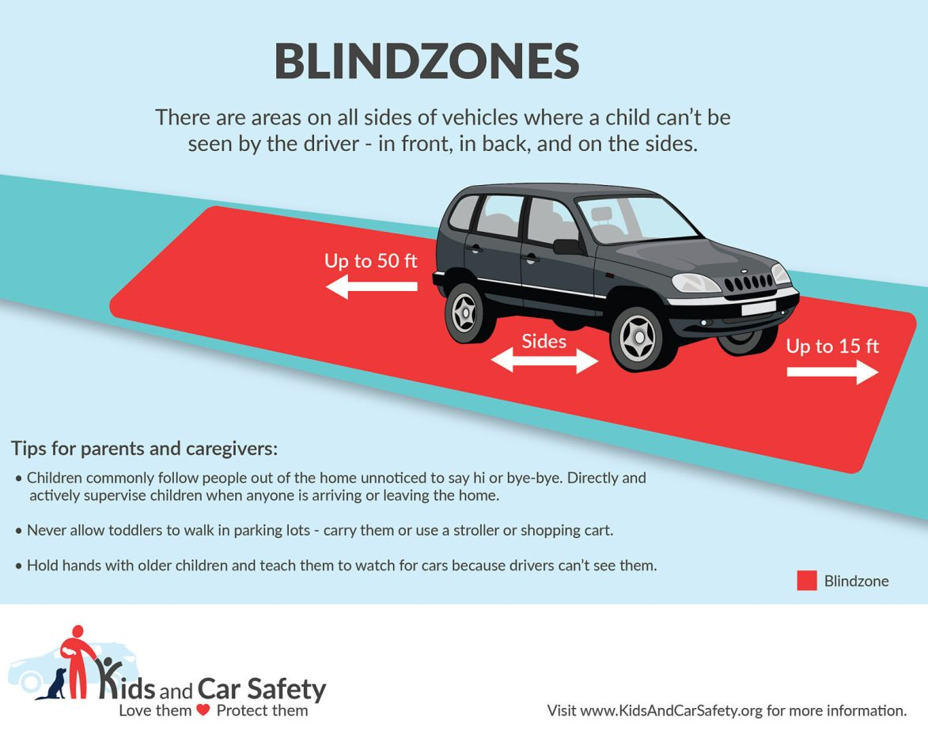
National Parenting Education Network
www.NPEN.org
Encourages information sharing, development and networking opportunities for parents.

Poison Control
https://triage.webpoisoncontrol.org/who
Download the Poison Control App so you will have it at your fingertips. Also be sure to save their number on your contacts.
Poison Control
1-800-222-1222

