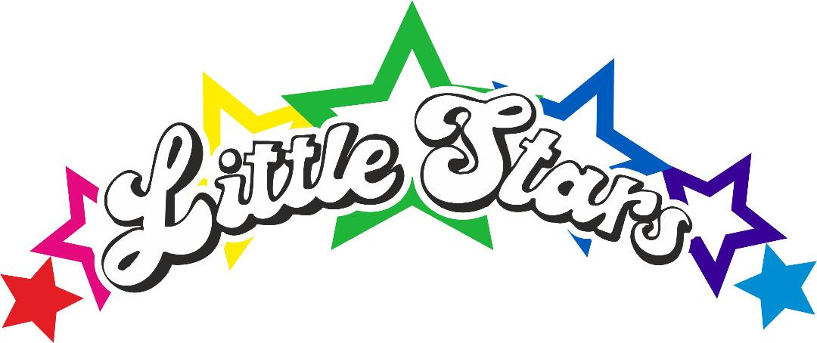

FOOD, HEALTHY EATING & ALLERGY POLICY

At Little Stars we encourage children to develop a positive attitude to food and healthy lifestyles. This is achieved through adopting a whole nursery approach which encompasses children, their families, and staff.

Introduction
This policy recognises that children under the age of 5 years have different nutritional needs from those of older children and adults. They have a high energy and nutrient requirement in relation to their size. Early Years is an important time to shape food preferences and habits, by allowing children to make their own selections through guided choice; this can have a positive impact on health in later life.
This policy covers general nutrition guidance; children have individual needs which should be acknowledged. If parents/carers have any concerns they should discuss these with their Health Visitor, GP or Dietician.

General
- Those responsible for food preparation and handling of food must be competent to do so, and all catering staff will have the appropriate food hygiene/safety qualifications. All staff receive training in Food Hygiene.
- We do not allow meals to be brought into the nursery that has been made at home and needs reheating.
- Staff will be good role models for healthy eating.
- No nuts will be used in any of the recipes for meals produced on site however we cannot guarantee an environment free from any food product including nuts due to manufacturers’ disclaimers on most products.

Allergies/Food Preferences/Special Diets
- The nursery will obtain and record necessary information from parents/carers regarding any special dietary requirements, preferences, or food allergies in advance of the child being admitted to the nursery.

Meal Times
- Nursery staff will pro-actively involve children at mealtimes to create a social occasion which provides opportunities to promote children's social and educational development as well as encourage good eating habits and table manners.
- Fussy eaters will be encouraged (but not forced) to eat. Praise will be given when the child eats, food will be removed without judgement if the child refuses food.
- Children will be given adequate time to eat their meals.
- Babies will be served food using an appropriate weaning spoon and also given their own spoon; they will not be discouraged from using their hands to eat their food as this is part of their development.
- Children will be given the appropriate utensils and crockery according to the meal served. Where it is part of a child’s culture, or developmentally appropriate, to eat with their fingers or chopsticks, this will be encouraged and supported.
- Older children are encouraged to serve themselves independently with assistance where required to pour their own drinks, lay the tables etc.

Snacks
- Snacks are offered between meals where required to ensure children receive appropriate levels of energy and nutrition, for example at mid-morning and mid-afternoon.

Drinks
- Children will always have access to drinking water.
- Children under the age of 12 months will be given breast or formula milk
- Children over the age of 12 months will be given whole cow's milk unless agreed with parents to keep on formula or breast milk.
- Children who do not drink water or milk may bring juice from home.

Celebrations and Rewards
- The nursery will encourage staff to be innovative in the way birthdays and festivals are celebrated, e.g. without the use of foods high in added sugar and salt.
- When a child has a birthday at nursery you may bring in a birthday cake for them to share and celebrate with other children. The cake will be sent home with the child at the end of the day with parents/carers with a list of the allergens. Because of special diets and allergies, we regret we are unable to accept cakes made by parents.
- Parents/carers will be consulted over appropriate ways to celebrate ethnic/cultural and religious occasions.

ONLY ONE TREAT
1 snack size of any variety crisps or cake / biscuit
No nuts No fizzy No Sweets

If you have any issues with your child’s eating habits, please don’t hesitate to speak with a member of staff and we will work closely with you to initiate a plan

ALLERGY POLICY
Food allergies are estimated to affect 1% or 2% of the adult population and are more prevalent in infants and children. The most common allergenic foods are eggs, milk, fish, shellfish, peanuts, soya, wheat, tree nuts and seeds.

Allergies to certain foods can be particularly acute. If a child suffers from a severe food allergy, we need to know the exact ingredients in their food, because even a tiny amount of the allergenic food could result in a severe reaction.

A full risk assessment will be completed on an individual basis.

We take steps to:
• Make sure we know which children suffer from an allergy

• We will exclude any food that may lead to severe allergy wherever possible within the setting where possible.

• Information about those children suffering severe allergic reactions will be displayed in the kitchen, an allergy list at times where food is served ie, breakfast, snack, lunch, dinner and cooking activities and children that have allergies will be provided food on an allergen plate as a visual for staff to ensure allergy safety.

• Ensure that staff are aware of Company Policy of administration of medication and First Aid.

• Provide staff training in dealing with allergies, how to identify people having a reaction and how to deal with the reaction itself.
- Ensure a no sharing food policy between children and staff and children.
- Ensure approval of piriton consumption for emergency use.

Current Allergies of Importance.
Due to a severe seed and nut allergy requiring an epi pen we are a no seed or nut nursery.

Updated June 25. KLS.

