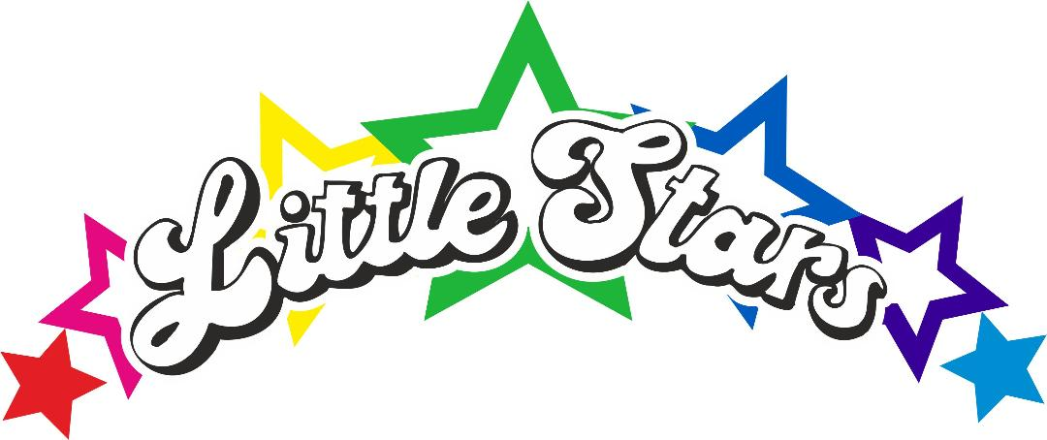
EYPP Policy.
Little Stars believes that, by having the highest expectations of all learners, the highest possible standards will be achieved.
The nursery receives additional funding in the form of EYPP for those children who meet one of the following criteria.
From April 2015, pre-school children who receive early education and meet one or more of the criteria below would become eligible for the EYPP.
Income based Jobseeker’s Allowance
Income related Employment and Support Allowance
Support under part vi of the Immigration and Asylum Act 1999
The guaranteed element of State Pension Credit
Child Tax Credit
Universal credit
Children may also be entitled to EYPP if they are being looked after by the local authority or have left care through adoption special guardianship order or a child arrangements order.
Our objectives.
1 To provide additional educational support to raise the achievement of our pupils in receipt of the EYPP.
2 To narrow the gap between the educational achievement of these pupils and their peers.
3 To address underlying inequalities, as far as possible, between these children and others.
4 To ensure that EYPP funds reach the pupils who need them most.
5 To make a significant impact on the education and lives of these children.
6 To work in partnership with the parents of the children to collectively ensure their success.
Our Strategies
1 Assigning an EYPP lead teacher to champion the educational needs of the EYPP recipients and ensure the implementation of this policy. The EYPP teacher at Little Stars is Sharna.
2 Ensuring EYPP funds can be identified within the budget.
3 The EYPP teacher in consultation with the manager and parents, will decide how funds are spent.
4 Assessing the individual provisions required for each pupil in receipt of EYPP.
5 Ensuring the impact of EYPP is evaluated and measured to ensure it is working best for each family.
Policy updated 7.10.25 KLS.

