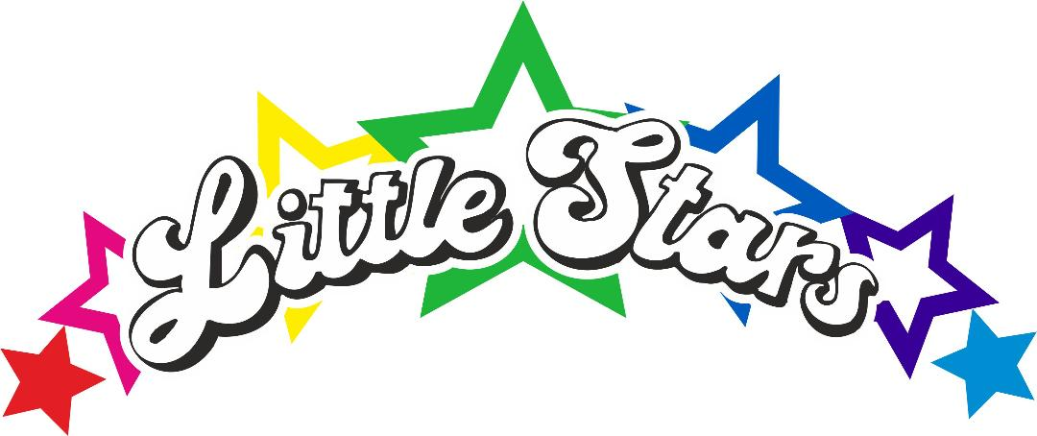
Accident and Injury Policy.

At Little Stars we regularly review our policies, procedures and risk management plans to try to prevent accidents from occurring and keeping our nursery as safe as we can, that being said unfortunately accidents can occur at any time and our priority is to respond to them to support children as best as we can.
At all times the EYFS guidance will be adhered to with regards to ratios, supervision and emergency planning.
Injuries will be communicated to parents via our famly app at the earliest opportunity after dealing with the incident.
When a head injury occurs our procedure is to contact a parent via a phone call, that is due to the potential severity and continual supervision after a head injury that is required. We will also make sure medical injury advice is sourced and shared with parents, so they understand what to consider after a head injury. If we feel it is best to seek advice from a professional, we will ensure this advice is shared.
When a serious medical injury or concern occurs parents will be contacted to collect the child, or an ambulance may be called. The child's key person or a member of the senior team will stay with the child until a parent can be with the child.
In keeping with our safeguarding training, we will not take photos of children's injuries for parents or social workers/integrated front door. It is best practice that injuries are shared in person.
All staff at Little Stars are required to hold First Aid qualification and update this in line with requirements which currently are every 3 years.

Policy updated 6.2.25 KLS.

