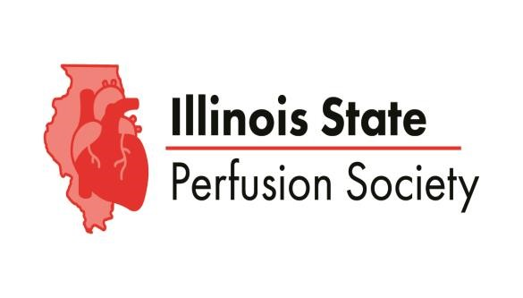

31st Annual Educational Conference

In Person at Pinstripes, Oak Brook, IL and Virtually via Zoom
November 7th, 2026

Academic Agenda and Schedule of Events
Times Listed in Central Time

0630: On-site Registration Opens, Vendor Exhibits Open, Light Breakfast Served

0645: Webinar Opens, via Zoom
0645: Conference Opening Welcome, Ryan Piech, MS, MBA, CCP
Illinois State Perfusion Society President’s Welcome

0700-0720: Rawan Bayazeid
Student, Rush University School of Cardiovascular Perfusion, Chicago, IL
“The Role of ECCO2R in Avoiding Invasive Mechanical Ventilation in Patients with COPD”

0720-0800: Kumaran Shanmugarajah, MD, PhD
Transplant Surgeon, Director Organ Perfusion Laboratory,University of Chicago Medicine,Chicago, IL
“The Perfusionists’ Increasing Role in Liver and Multi-Organ Transplantation”

0800-0840: Emily Thunstrom-Kahring, BS, CCP
President ABCP, Senior Perfusionist, Children’s Hospital of Minnesota
“I Like Oxygen: The Impact of DO2i on Cardiac Index in Pediatric Perfusion”

0840-0920: Alex O’Donnell, MS, CCP
Senior Perfusionist, Advocate Hope Children’s Hospital, Oak Lawn, IL
“Reflecting on the Perfusionist’s Role in Acute Decision Making”

0920-1000: Josene Carlson, BSN, RN, CCP
Global Senior Clinical Services Manager, Quest Medical, Nordson Medical, Allen, TX
“The Use of Quest MPS3 in Pediatric Patients ”

31st Annual Educational Conference

In Person at Pinstripes, Oak Brook, IL and Virtually via Zoom
November 7th, 2026

1000-1040: Kristen Nelson-McMillan, MD
Pediatric Cardiac Intensivist, Advocate Hope Children’s Hospital, Oak Lawn, IL
“The Role of Platelets in MCS: The Love-Hate Relationship”

1040-1120: Miroslav P. Peev, MD FACS FACC
Assistant Professor of Surgery, Associate Program Director, Cardiothoracic Surgery Fellowship
“Review of New Surgical Strategies for Aortic Surgery: When Is Too Crazy, Too Crazy”

1120-1215: ISPS Award Presentations, Working Lunch, Vendor Exhibits

1120-1130: Walter Foody Memorial Scholarship Award Presentation
3rd Annual Scholarship Award Presented to Outstanding Perfusion Student
In Honor and Remembrance of Walter Foody, CCP

1130-1215: Shelley Brown, CCP, LP
Director, Chief of Perfusion, Allegheny Health Network, Pittsburgh, PA
“Ghost and the Machine – Perhaps Least Known and Most Impactful”
Working Lunch Virtual Presentation

1215-1300: Bill Nicotra, MSL, CCP
Director, Cardiac Essential Pharmaceuticals, Durham, North Carolina
“Comparing Single-Shot Cardioplegia Techniques: Which Solution Reigns Supreme

1300-1340: Greg Mork, BA, LP, CCP, FPP
Staff Perfusionist, Rush University, Instructor, Department of Cardiopulmonary Sciences
“AMSECT Update on Current Perfusion Practices: Impact to the Profession”

31st Annual Educational Conference

In Person at Pinstripes, Oak Brook, IL and Virtually via Zoom
November 7th, 2026

1340-1420: Ken Noda, PhD, CCP
Associate Professor, Director of Research in Transplant Surgery, University of Chicago
“Recent Advancements and Upcoming Therapies in Ex-Vivo Organ Perfusion ”

1420-1440: Franklin Bernardo
Student, Rush University School of Cardiovascular Perfusion, Chicago, IL
“Novel ECMO Strategies for Reduction of Therapy Duration”

1440-1500: Antonio Presta
Student, Rush University School of Cardiovascular Perfusion, Chicago, IL
“The Impact of GLP-1 Receptor Agonists on Outcomes Following Cardiopulmonary Bypass”

1500: Closing Remarks, Meeting Adjournment

1500-1800: Open Bar & Cocktail Hour, Bowling, Bocce Ball



The Illinois State Perfusion Society is seeking
BOARD MEMBERS and COMMITTEE MEMBERS!

Join our fantastic team of Chicago-area perfusionists to give-back to your profession and colleagues by volunteering with the ISPS! Executive Board, Board, and Committee positions are open!

Contact any current board member OR
email: IllinoisPerfusion@gmail.com for more information! We look forward to working with you!

