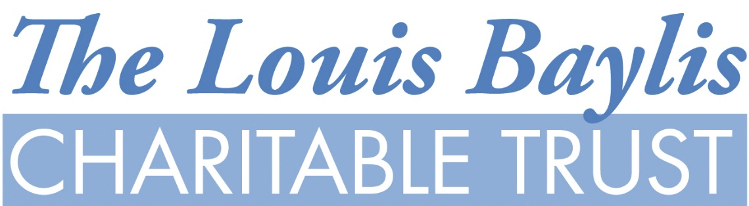

Louis Baylis Charitable Trust CIO

APPLICATION FOR GRANT

APPLICANT / ORGANISATION (inc. Reg. Charity No. if applicable)
CONTACT NAME
POSITION HELD
POSTAL ADDRESS (i.e. where mail deliveries can actually be received)
TELEPHONE
EMAIL
BANK DETAILS | Where possible we would like to distribute grants by bank transfer. If you are agreeable, please attach a copy of a bank paying in slip, statement or cheque in order that we can verify your account details. Otherwise, payments will be made by cheque.
What are the aims and purpose of the organisation and how long has it been operation? (For grants over £1,000 please enclose your most recent accounts)
For what project or event is the grant requested?
How much grant is requested?
How much is the total anticipated expenditure?
Have you applied for or received funding from other sources? If so, please details
What funds have you currently raised or set aside for this project?
How many people will benefit from the grant? (What area or community will be covered?
Does the project have a timescale?
For projects over £3,000 the Trustees may request you to provide a Business Plan. Has one already been produced?
For projects over £3,000 the Trustees may request an informal presentation from a representative or your organisation, would this present a problem?
DECLARATION
- THE INFORMATION PROVIDED IS CORRECT
- THE GRANT WILL ONLY BE USED FOR THE PURPOSE REQUESTED
- IN THE EVENT OF THE PROJECT NOT PROCEEDING THE GRANT WILL BE REPAID
- I, THE UNDERSIGNED, AGREE THAT THE LOUIS BAYLIS TRUST MAY HOLD ON FILE ANY PERSONAL INFORMATION CONTAINED IN THIS APPLICATION, SUCH AS, MY NAME, E MAIL ADDRESS, PHONE NUMBER AND POSTAL ADDRESS FOR THE PURPOSE OF CONTACTING ME ON BEHALF OF THE CHARITY I REPRESENT.
Form completed by:

Signed: Date:

APPLICATIONS OVER £1,000 WILL ONLY BE ACCEPTED FROM ORGANISATIONS
INDIVIDUALS WILL ONLY BE CONSIDERED IN EXCEPTIONAL CIRCUMSTANCES

PLEASE NOTE: GRANTS ARE OFTEN DISTRIBUTED BY MAIL SO IT IS IMPORTANT THAT THE ADDRESS YOU QUOTE ABOVE IS ONE WHERE MAIL CAN ACTUALLY BE RECEIVED

Completed application forms should be sent to:

The Administrator
Louis Baylis Trust
PO Box 4832
MAIDENHEAD,
SL60 1JQ

Emails: info@louisbaylistrust.org.uk

