JOHN SHORT & SON
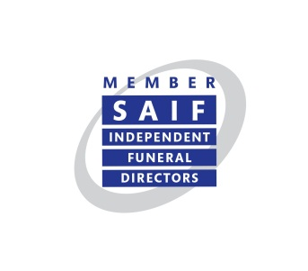

Registered No. 4928980 England

COMPLAINTS PROCEDURE

The desired outcome of every SAIF funeral director is to complete the funeral with professional care and that the funeral service brings comfort to family and friends.
However, very occasionally, sometimes things don’t work out, and the client and their family are disappointed with something omitted or not delivered in the manner expected.
In these rare occasions we have set about the following explanations how a complaint can be made, and as we expect there to be courtesy and respect towards the client by the funeral director, we also expect the client to treat the funeral director with courtesy and respect
Our commitment to clients

We are committed to ensuring that:

- Making a complaint is as easy as possible for you.
- We treat your complaint seriously.
- We will deal with your complaint promptly and in confidence.
- We learn from complaints and use them to review and improve our service.

What is a complaint?

A complaint is when you tell us you are not happy about any part of the services or products we provide.

How to make a complaint

If you wish to make a complaint, please complete our complaints form which can be found:

We can only accept a complaint within 12 months of the date of when the funeral service took place. However, if you feel that there are extenuating circumstances when you are unable to complain within the given time then please let us know.

By email [johnshortandson@outlook.com]
Your complaint will be acknowledged within 3 working days and fully investigated within 10 working days. You will be written to no later than 10 working days after making your complaint with the outcome of the investigation.
Please be advised that there may be circumstances such as holidays, sickness, a third party or those beyond our control where we will be unable to resolve your complaint within 10 working days. We will keep you updated as to the progress of your complaint, and you do have the right to raise this with our trade body if you feel that the complaint is taking too long to resolve.

- Please be advised that we will accept complaints from the client (this is the person who arranged the funeral and entered into a contract with us). If you are not the client, then we will require written authority from the client.

- All complaints must be made in writing. This is to ensure that accurate information is relayed from both sides and there is a full record of what was said by each party.

If You are Still Unhappy

If you are still unhappy with our response you can contact The National Society of Allied & Independent Funeral Directors (SAIF) in any of the ways listed below:

By email – standards@saif.org.uk

By visiting the SAIF website and to view SAIF’s Complaints Policy - https://saif.org.uk/about-saif/complaints/

In writing to –
Standards
The National Society of Allied and Independent Funeral Directors
SAIF Business Centre 3 Bullfields Sawbridgeworth Herts CM21 9DB

By phone – Tel: 0845 230 6777 or 01279 726 777

By fax – Tel: 01279 726 300

Your complaint will be acknowledged within 7 days then fully investigated. Please see SAIF’s Complaint Policy for full details https://saif.org.uk/about-saif/complaints/

Please note that The National Society of Allied and Independent Funeral Directors (SAIF) will not investigate a complaint unless the internal complaints procedure of the Funeral Directors has been exhausted.

