
MICHAEL’S RESTAURANT
ST. PATRICKS CELEBRATION
TUESDAY, MARCH 17, 2026

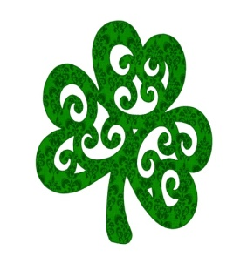
SERVING AT 4:00p.m.

MENU

IRISH LAMB STEW - $19.95
Served on egg noodles

NORWEGIAN SALMON - $27.95
Served with parsley buttered potatoes and cabbage

KANSAS CITY SIRLOIN STRIP - $39.95
Served with parsley buttered potatoes and cabbage

CORNED BEEF AND CABBAGE with Parsley Buttered Potatoes - $19.95

All above served with a cup of split pea soup

CORNED BEEF SANDWICH with Chips - $14.95

