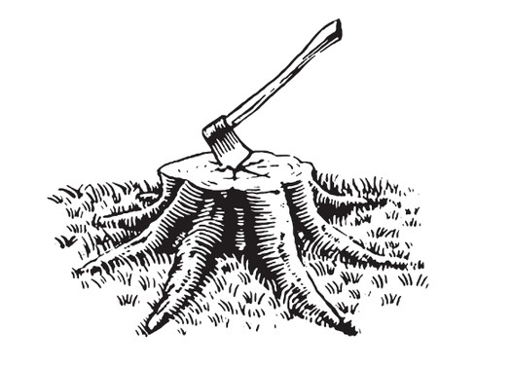
The Old Hatchet
Buffet Menu

£15.50 PER HEAD

Quiche
Sausages Rolls
Selection of Sandwiches
Tuna & Cucumber
Egg Mayo
Cheese & Tomato
Ham & Mustard
Homemade Cakes and Scones
Tea and Filter Coffee

PICK ANY 5 ADDITIONALS FOR £22.50 PER HEAD

Chicken Wings
Honey & Mustard Chipolatas
Mozzarella Sticks
Veggie Spring Rolls
Halloumi Fries
Onion Rings
Garlic Bread
Nachos
Mac & Cheese
Potato Salad
Pasta Salad
Mini Pork Pies
Mixed Pizza Slices
Hummus Crustini
Tomato & Red Onion Bruschetta
Arancini Balls
Loaded Potato Skins
Selection of Mini Desserts

We cannot guarantee our dishes are totally allergen free. For allergy information please ask your server. Dishes with poultry or fish may contain bones.
An optional service charge of 10% will be added to tables. For any other information please visit our website: oldhatchet.co.uk

