

Dear Vendor:

Attached is the Tinley Park Convention Center’s Exhibit Services Packet.

In order for us to give you the best possible service, please verify with your Show Coordinator as to what is included in your booth rental. For additional requests and requirements, please use the attached forms.

All rates are per show day and advanced payment in full via credit card is required at least 5 business days prior to your first show day, otherwise “day-of” rates will apply. Please note that even though we only require items to be rented for show days, all advance ordered items will be in place for vendor load-in.

Corporate checks may also be used for payment if received by the due date. The check should be made out to “Tinley Park Hotel & Convention Center, LLC” and mailed with attention to CS Department at the address below.

Receipts for payment can be provided within 90 days of payment received date.

Please scan completed forms and e-mail to cs@eventpcc.com. Once your order is received and reviewed, we will send you an order confirmation via e-mail within 72 business hours. If you do not receive a confirmation, please contact the Convention Services Team at the number or e-mail listed below.

For your convenience, please note that the Tinley Park Convention Center offers free Wireless Internet access throughout the facility. This internet is shared bandwidth and speed is not guaranteed. If you are running a web presentation or require dedicated, guaranteed bandwidth, please use the order forms attached.

We would like to thank you for your business and your cooperation while at the Tinley Park Convention Center. For questions, please contact the Convention Services Team at 708-342-5485 or via e-mail at cs@eventpcc.com. In order to ensure your question gets answered in the timeliest manner, email is recommended.

Convention Services Department
Tinley Park Convention Center
18451 Convention Center Drive
Tinley Park, IL 60477
cs@eventpcc.com


Exhibit Services Order Form

Event Name:_HCA Product Show__________ Booth #______________
Vendor Name ________________________________________________________________________
Address: ____________________________________________________________________________
City: _________________________________________ State: ________________ Zip: _____________
Phone: _____________________________________ Fax: ___________________________________
E-Mail:______________________________________________________________________________
Your booth will come with the following:
Vendor Booths: (1) 6ft table with linen & skirting (2) chairs and a wastebasket
Orders must be received one week before the event to qualify for advanced order rates.
 |  | Advance Order  Daily Rates | Day-of Order  Daily Rates | Quantity | #  Of Days | Subtotal
Electrical
110V 20Amp (2,200 watt) |  | $75 | $155 |  | x1
If anything beyond a standard electric drop is needed-please inquire
IT / Audio Visual
Phone Line |  | $75 | $100 |  | x1
Power Strip / Extension Cord |  | $20 | $30 |  | x1
Laptop PC |  | $220 | $270 |  | x1
Laptop Mac Book Pro |  | $250 | $300 |  | x1
LCD Monitor 32” |  | $225 | $275 |  | x1
LCD Monitor 42”, stand |  | $650 | $700 |  | x1
Plasma Monitor 50”, stand |  | $850 | $900 |  | x1
DVD Player |  | $75 | $100 |  | x1
BluRay Player |  | $125 | $150 |  | x1
Exhibit Services
Flip Chart |  | $75 | $100 |  | x1
Easel |  | $25 | $35 |  | x1
Whiteboard |  | $75 | $100 |  | x1
Coat Rack |  | $25 | $30 |  | x1
6'x18” Table, wood-finish, no linen |  | $10 | $15 |  | x1
6’x30” Table, tablecloth, skirt |  | $15 | $20 |  | x1
6’ x 30” Table, counter height, tablecloth, skirt |  | $25 | $35 |  | x1
3’ Highboy w/tablecloth |  | $15 | $20 |  | x1
Chair |  | $5 | $10 |  | x1
Bar Stool (advanced order only) |  | $25 | $30 |  | x1
Waste Basket |  | $10 | $15 |  | x1
Waste Can 32gal |  | $35 | $45 |  | x1
Floor Protector*** |  | $25 / 100 sq ft | $45 / 100 sq ft
Other
Bottled Water / 16.9oz |  | $3.00 | $3.00
Assorted Sodas / 10oz |  | $3.00 | $3.00
Ice (20 lbs) |  | $20.00 | $20.00
S-Hooks (For Sign Hanging) |  | $1.00 | $2.00
***Booths containing vehicles are required to either bring in their own floor protector or purchase through us. |  |  |  | Total

Dedicated Internet Quote:
To receive a quote for dedicated internet, please complete the following information:
Would you prefer a hardwired line or private wireless network?
____________________________________________________________________________________
How many devices and what type of devices would be connecting?
____________________________________________________________________________________
What will you be using the internet for? (i.e. Video Streaming, Online Presentation, Online Registration)?
____________________________________________________________________________________
Is there a minimum requirement of bandwidth need that you are aware of? (1.5mbps increments)
____________________________________________________________________________________
If you require additional items that are not listed on this order form, please detail them here and we will provide you with a quote:

____________________________________________________________________________________________________________________________________________________________________________________________________________________________________________________________________________________________________________________________________________________________________________________________________________________________________________________________________________________________________________________________________________________________________________________________________________________________________________________________________________________________________________________________________________________________________________________________________________________________________________________________________________________________________________________________________________________________

Credit Card Authorization
(Please Print)
I, _______________________________________ on __________________________ hereby authorize the Tinley Park Convention Center to charge my credit card for all charges listed on the attached “Exhibit Services Order Form”.

Payment is not valid without a photo copy of the front and back of your credit card attached to this order.

Credit Card Information

___ Visa ___MasterCard __Amex __Discover

Name (as it appears on the card):___________________________________________

Credit Card Number: ____________________________________________________

Expiration Date: ____________________________ Security Code: _______________

Billing Address: _________________________________________________________

City: _________________________________ State: ___________________________

Authorized Signature: ____________________________________________________

Please list below any onsite contacts who are permitted to add-on additional items onsite if requested:

Dear Exhibit Vendor:

Please find the attached information regarding Shipping & Receiving for the Tinley Park Convention Center.

Please note that shipments will not be accepted more than 3 days in advance if you ship direct.

Please note delivery of your shipment to the show and your booth may be delayed if the attached forms are not completed and returned prior to the show.

Thank you,

Tinley Park Convention Center Management

Shipping & Receiving Forms

If you wish to ship directly to the Convention Center, please complete the following forms and send to cs@tphicc.com Please note shipments will be refused prior to 3 days before the event.

Make sure your shipping labels are addressed as follows:

Event Name
(Vendor Name & Booth #)
18451 Convention Center Drive
Tinley Park, IL 60477

Event Name: ________________ Booth #_____ Vendor Name: ________________________________
Address: ____________________________________________________________________________
City: _________________________________________ State: ________________ Zip: _____________
Phone: _____________________________________ Fax: ___________________________________
E-Mail:______________________________________________________________________________
 |  | Description (Case, Box, Skid) | # of Pounds
Piece #1
Piece #2
Piece #3
Piece #4
Piece #5
Piece #6
Piece #7
Piece #8
Piece #9
Piece #10
Total # of Pounds
Rate Per Pound |  |  | X $.99
Total
*$5 Minimum Charge

Credit Card Authorization-Shipping
(Please Print)
I, _______________________________________ on __________________________ hereby authorize the Tinley Park Convention Center to charge my credit card for all charges listed on the attached Shipping Form.

Payment is not valid without a photo copy of the front and back of your credit card attached to this order.

Credit Card Information

___ Visa ___MasterCard __Amex __Discover

Name (as it appears on the card):___________________________________________

Credit Card Number: ____________________________________________________

Expiration Date: ____________________________ Security Code: _______________

Billing Address: _________________________________________________________

City: _________________________________ State: ___________________________

Authorized Signature: ____________________________________________________

GENERAL
VENDOR INFORMATION

In order to assist you during your time at the Convention Center, we have put together this informational packet with some helpful tips and reminders. Attached to the packet are two maps. Map 1 is of the exterior of the Convention Center and will help with loading/unloading and parking information. Map 2 is of the interior of the building and details the location of all of the meeting rooms and facilities. Please review in detail to ensure your time is as successful as possible. If you have any questions, please feel free to contact a member of our staff.

Thank You,
Tinley Park Convention Center Management

EXHIBIT SERVICES
The Exhibit Services Desk for your event will be located in the Sales Office off of the South Lobby. The hours of operation are Monday – Friday 8 am – 5 pm. If you should need assistance outside of these hours, please pick-up any of the house phones located throughout the Convention Center and ask to speak to an Operations Manager. Be prepared with your booth name and # (if applicable) so that our team can locate you as needed.

LOADING / UNLOADING
Per Tinley Park Convention Center Policies, only items that can be carried in are permitted to be brought in through the front doors. Any items that are on wheels or require a dolly or cart must be loaded in through one of our loading areas. The loading area that has been made available for your event is the South Overhead Garage Door and/or South Dock. Please see Map 1 for location.

The Tinley Park Convention Center does not supply any carts, dollies, flatbeds, etc. If you need to rent a flatbed, pallet jack or housemen assistance with loading or unloading, use the attached Exhibit Services Order Forms.

PARKING
In order to maximize parking potential for your event, we ask that all vendors park in the East Parking Lot located behind the hotel after load-in is complete. See Map 2 for location. For your convenience, please use the Hotel’s East Entrance also seen on Map 2. Once inside, follow the directional signs to the Convention Center.

FOOD & BEVERAGE
The Tinley Park Convention Center does not permit any outside food and beverage into its facility and retains exclusive right over selling of food and beverage. We appreciate your cooperation in this matter and have multiple food service options located onsite.

MARKETPLACE
The EVEN Hotel offers a 24-hour marketplace for you to purchase beverages, snacks, and sundry items. The marketplace is located next to the Front Desk in the Hotel Lobby.

SHIPPING & RECEIVING
If you have completed the previous Shipping/Receiving Forms and ship items in advance, all identifiable advanced shipments will be delivered to the booths within the show. If you believe that you shipped advanced materials and do not see them when you arrive onsite, please visit the Exhibit Services Desk. Please be prepared with your carrier information (i.e. FedEx, UPS) and relevant tracking numbers.

If you have empty pallets or crates to be stored for the duration of the show, please visit the Exhibit Services Desk.

If you have items to be shipped out following the show and you will be shipping out via your preferred carrier (including UPS and FedEx), and wish to have them picked-up directly from the Convention Center:
- You must have outgoing labels on the items.
- You must arrange for pick-up. UPS or FedEx will not pick-up your materials at the Convention Center unless you call and arrange for the pick-up.
- These items should be brought to the Sales Office located off the South Lobby. If the door is closed, please leave the items outside the office door. If you are physically unable to move your items to the Sales Office, please alert a member of the Convention Center Staff.
- All items must be picked up 1-2 days post event.

If items that are left behind in the exhibit hall, they may be disposed of at the discretion of the Tinley Park Convention Center.

SIGNAGE
The Tinley Park Convention Center does not allow any items to be taped, tacked or adhered to our walls or doors and we appreciate your cooperation in this matter. Items may be hung from pipe & drape using S-Hooks. If you need to rent additional drape, hooks or assistance with hanging any signage, please use the attached Exhibit Services Order Forms.

POLICIES & PROCEDURES
This packet only touches on a few of the key points about the Tinley Park Convention Center. As a vendor here, you are responsible for abiding by all of the facility’s policies and procedures which are publicized online at http://www.tinleyparkconventioncenter.net/exhibitor/. If you would like a printed copy or a Facility Emergency Guide, please visit the Exhibit Services Desk once you arrive onsite.
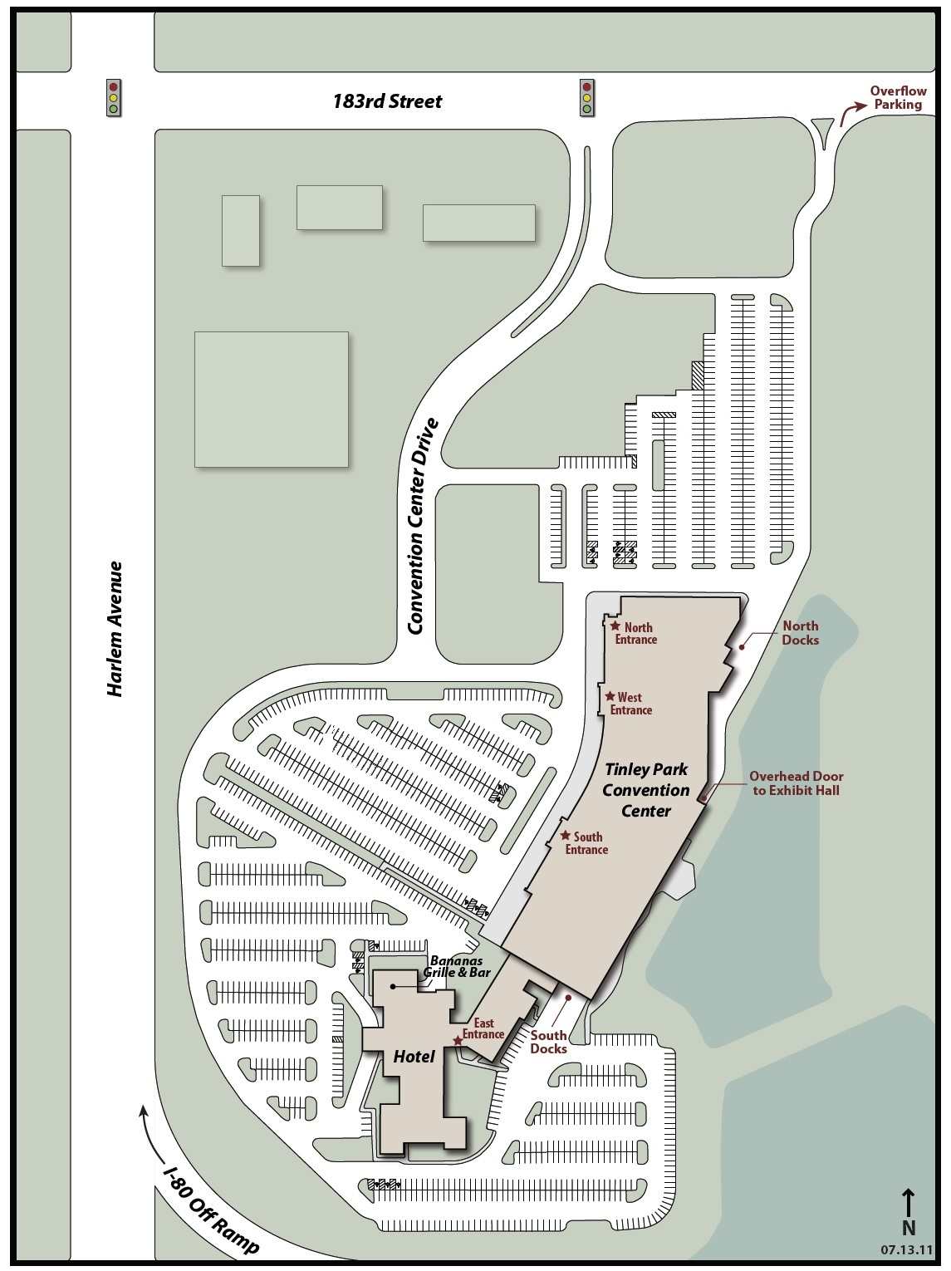
MAP 1
MAP 2

