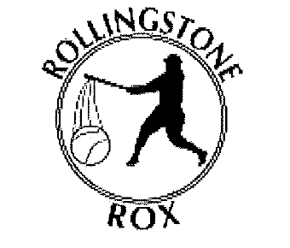
Rollingstone Youth Sports would like to extend an invitation to your teams for our annual Joe Slavin Memorial Summer Youth Baseball Tournaments in Rollingstone, MN. We will be holding tournaments for 8U, 10U, 12U and 14U Baseball. The dates for these tournaments are as follows:

- 8U: Saturday July 11th (1 day tournament)
- 10U: July 18th and 19th (2-day tournament)
- 12U: June 27th and 28th (2-day tournament)
- 14U: July 11th and 12th (2-day Tournament)

Games are played at our city park ball fields for 12U and 14U, the Field at Rollingstone Community School will also be utilized for the 8U and 10U tournaments. The park fields have two pavilions, restrooms, playground equipment, batting cages, tennis courts and plenty of green space. The School Field also has a playground and plenty of green space.

Our tournaments are intended for Rec Level teams with Travel/Tryout Teams not permitted. Tryout and Travel Teams are prohibited, for Wisconsin teams this tournament is for lower/silver teams. No Gold or Travel teams allowed.

We schedule 2 sanctioned umpires for all 12U and 14U tournament games. Our concession stand will be open for all tournaments with plenty of items to choose from.

If you would like to register or have any questions about the tournaments, please call or send an email. My phone number and email address are listed below. I will gladly email you the registration form(s) for whichever age group you are interested in.

Thank you for considering RYS as a tournament destination for 2026. We look forward to seeing you in Rollingstone to play some great summer baseball!

J.R. Larkie- Tournament Coordinator
Email- rollingstonerox@gmail.com
Phone- 507-459-9893

