

Telephone User Guide

NEC SV9100

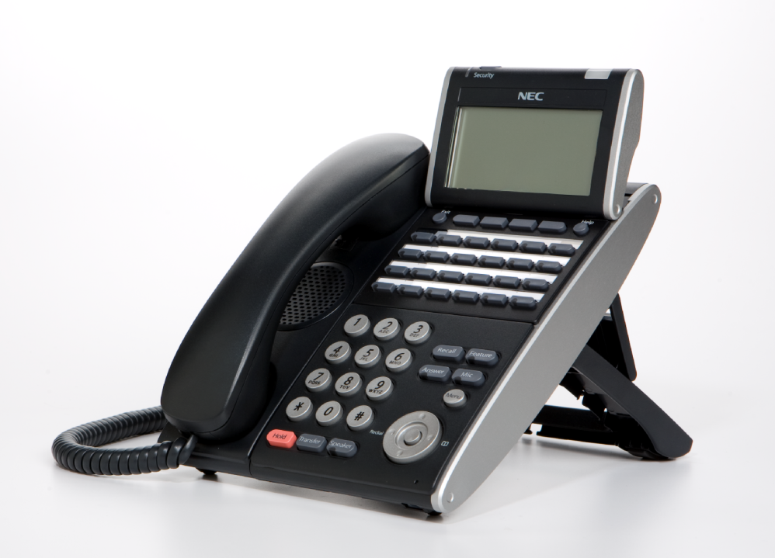

Phone: 714.855.4577
www.tritoncomm.com

Quick Reference Guide
NEC SV9100

Function Function Description
GREEN LED Your Call
RED LED Somewhere else in building (on another handset)
SOLID RED OR GREEN Station with call in progress or with a call on exclusive hold
SLOW FLASHING LED A call that has been placed on hold
FAST FLASHING LED An incoming call

ANSWER A CALL Handsets which have line keys:
If your handset rings on incoming calls, lift handset
OR
If your handset does not ring, Lift Handset and press the line key
OR
While on a call, ask caller to hold, then press “ANSWER” key (Only on ring assigned handsets)

Handsets which have CAP and Park keys:
If your handset rings on incoming calls, lift handset (call will appear on CAP key) OR
If your handset does not ring, Lift Handset and press P/U soft key x 2

INTERNAL CALL PICKUP When you know the extension that is ringing and want to pick up that call:
- Lift Handset
- Dial * * Extn No.

HANDSET RECEIVER
SPEAKER VOLUME USING THE UP/DOWN KEY
- Handset Receiver volume press up/down key in off hook status or during
call
HANDSET - - - - - - - - - - -

- Ring volume press up/down key when station is ringing.
RING - - - - - - - - -

- Speaker volume press up/down key during speakerphone operation or
during the call
SPEAKER - - - - - - - - -

- LCD Screen Contrast press up/down key in the on-hook status
LCD- - - - - - - - -

MIC / MICROPHONE To Turn your microphone On/Off for hands free only:
LED on Mic key shows the status of the built-in microphone
Press MIC button
(Red light indicates MIC is on)

HANDSFREE To make a hands free call,
- Press Speaker key,
- Dial Extension number OR Dial “0” for an outside line THEN phone number

MAKE A CALL Internal Calls
- Lift Handset or Press Speaker
- Dial Extension number

External Calls
Lift handset or press Speaker


- Press “0” then dial phone number
OR
- Press Redial then 3 digit code speed dial code

HOLD To place a call on hold:
- Press Hold button once.

To place a call on exclusive hold (no-one else can pick up your call)
- Press Feature
- Press Hold

To place a call on hold using Park keys:
- Press the first available Park button once.

TRANSFERING CALLS To Transfer a call to another extension:
- Press Hold to put the call on hold
- Dial Extension Number or press One Touch Key,
- Announce call
- Press Transfer OR Advise of line number
- Hang up. Call is transferred.

To transfer calls from a cordless phone (Panasonic):
- While speaking on an outside line:
- Press Recall button (which puts the call on hold),
- Dial Extension number,
- Announce the call and hang up.

Transferring to
Voicemail To transfer a call to a person’s voice mail:
- While speaking to the outside line,
- Press Hold
- Dial Person’s extension number
- Press “8”
- Press Transfer
- Hang Up

TRANSFER OFFSITE Transfer an incoming line to another outside line
While talking to the incoming call
- Press Hold key
- Select an outside line
- Dial Phone number
- Announce you will be transferring call
- Press Transfer key
- Hang Up

REDIAL To dial the last number phoned:
- Press Redial key without lifting handset
- Press # To redial last number

OR

- Press List Soft key to search for desired number
- Then Redial Soft key
- Press Up/Down Key to search number
- Then Lift handset or press Speaker to place the call

CORDLESS PHONE To make calls –

- Press Talk/on or green phone key,
- dial 0, then
- dial Phone number

To answer calls,
- press talk/on or green phone key symbol when ringing

To Transfer calls –

- Press Recall/Flash to Hold.
- Dial Extension number, announce,

INTERNAL PAGING To make an internal page through all desktop handsets:
- Press ICM menu option for intercom
- Press Inpg menu option for Internal Page
- Press “0” which is group no 1 for all internal page
- Lift Handset and make announcement
- Hang up

OR Manually:

- Lift Handset
- Dial 701
- Press “0” (for all Zones)
- Make Announcement and replace handset
(Note: This feature is announcement only-extensions cannot reply)

EXTERNAL PAGING To make an external page through a Paging Horn:

- Lift Handset
- Dial 703
- Press “0” (for all Zones)
- Make Announcement and replace handset
(Note: This feature only works if an external speaker is installed)

COMBINED PAGING To page both internal & external zones:
- Lift Handset
- Dial *1
- Make Announcement and replace handset

CONFERENCE CALLS To set up a Conference Call:
While on an Outside call or connected to your first party

- Press Conf Key on Display
- Dial an outside line or second party
(When called party answers)
- Press Add key on screen
(Repeat steps 2-4 to add more parties. Maximum of 16 internal or external parties can be conferenced).
- Press Begin to start conference

To exit a Conference without affecting the other parties:
- Hang up

MISSED CALLS To view numbers of calls missed on your handset
Your handset will display this symbol
- Press Centre button on the Jog Dial
- Press Centre button on Jog Dial to select Missed Calls
- Scroll Down soft key to desired number
- Lift Handset to call – Handset will dial automatically
OR
- Press DEL soft key to delete
- Press Store soft key to save

SET INTERCOM TO EITHER
RINGING OR HANDSFREE To select your intercom to be hands free:
- Press Speaker
- Dial 721
- Press Speaker to hang up

To select your intercom to be ringing:
- Press Speaker
- Dial 723
- Press Speaker to hang up

SELECTABLE RING TONES To CHANGE your Extension’s incoming ring tones:
- Press Speaker key
- Dial 720
- Dial 1 to set intercom ring, or 2 to set external call ring
- Dial Code for the ring pattern you wish to hear:
1 = High 5 = Ring Tone 2
2 = Mid Range 6 = Ring Tone 3
3 = Low 7 = Ring Tone 4
4 = Ring Tone 1 8 = Ring Tone 5
- Press Speaker to Hang Up

To Listen to the Incoming ring choices
- Press Speaker and Dial 711
- Dial 1 to listen to intercom ring
- Dial 2 to listen to external call ring
Then for INTERCOM
- Dial 1-8 Code for ring pattern
Or for EXTERNAL CALL
- Dial 1-3 (ring) 4-8 (melody)
- Press Speaker to Hang up

STATION NAME ASSIGNMENT To assign a name to your extension number:
- Press Speaker
- Dial 700
- Press Hold
- Enter your Name - up to 12 digits(## for space. # between digits on same key)
- Press Hold
- Press Speaker to hang up
To program any extension’s name:

- Press Speaker
- Dial 700
- Enter Extension Number to be named
- Enter the Name – up to 12 digits
- Press Hold
- Press Speaker to hang up

CALL FORWARD ALL
CALLS TO ANOTHER
EXTENSION OR OFF-SITE To set via menu on the screen:

- Press PRG Soft Key
- Press C/Fwd Key
- Press All Key
- Press Set Key
- Dial The Extension Number
OR
- Dial “0” for an off-site number, then dial the number
(eg: 0, 0418710111)
- Press Speaker key to hang up

To set on a handset without a display screen:
- Press Speaker
- Dial Call Forward Code - 741 for immediate
- 744 for busy/no answer
- Dial 1 to set
- Dial extension number
- Press Speaker

To deactivate:
- Press PRG
- Press C/fwd
- Press All
- Press Cancel
- Press Speaker
Hang up

CALL FORWARD YOUR
HANDSET TO VOICEMAIL
IF BUSY/NOT ANSWERING
To set via menu on the screen:
- Press PRG Soft Key
- Press C/fwd Soft key
- Press Arrow end option on menu
- Press B/NA for Busy/No Answer
- Press Set
- Dial “200” for voicemail
- Press Speaker key to hang up

To Cancel
- Press PRG Soft Key
- Press C/fwd
- Press Arrow end option on menu
- Press B/NA
- Press Cancel
- Press Speaker to hang up

DO NOT DISTURB To Activate via Menu on the screen:
- Press PRG Soft Key
- Press DND Soft Key
- Press Set Soft Key
- Press All Soft Key

To Deactivate via Menu on the screen:
- Press PRG Soft Key
- Press DND Soft Key
- Press Cncl Soft Key for Cancel

To Activate On and Off on a handset without display: (Leave Handset Down)
- Press Speaker
- Dial 747
- Dial DND Option Code 1 = Block incoming calls
2 = Block internal intercom
3 = Block All calls
4 = Block Call Forwards Only
0 = Cancel DND

BACKGROUND MUSIC Can be played through telephone speaker
To set and cancel
- Press Speaker
- Press 725
- Press Speaker

ALARM CLOCK To activate an alarm:

- Press Speaker
- Dial 727
- Dial Alarm Type 1 – Sounds Only Once
2 – Sounds each day at preset time
- Dial Alarm time (24 hour clock) (A confirmation tone will be heard)
- Press Speaker to hang up

To silence an alarm:

- Press Exit

To check a programmed alarm time:

- Press Help button
- Dial 727
- Dial alarm type 1 or 2
The programmed time displays
- Press EXIT

To cancel an alarm:

- Press Speaker
- Dial 727
- Dial alarm type 1 or 2
- Dial 9999
- Press Speaker to hang up

CHANGING THE TIME Note – Must be done from reception or main handset
Leave Handset Down
- Press Speaker
- Dial 728
- Dial two digits for the hour (24 hour)
- Dial two digits for the minutes
- Press Speaker to hang up

NOTE: The date can only be set / changed in system programming

BARGE IN (INTERRUPT A CALL)* Note - Must be activated in programming
- Lift Handset
- Dial 710
- Dial Busy Extension (The extension user will hear a warning tone).

ROOM MONITOR Room monitor lets an extension listen to the sounds in co-workers area, for
example, a receptionist could listen for sounds in the warehouse when it’s
left unattended.
NOTE: (A Room monitor key must be programmed. Room monitor must be
activated at the extension initiating the monitor and at the extension that is to be
monitored. You can only listen to one extension at a time.)

To activate Room Monitor from initiating extension:
- Press Room Monitor key
- Dial Extension number you are at
(You can place and answer calls whilst monitor is active)

To activate Room Monitor from extension to be monitored:
- Press Room Monitor key
- Dial Extension number you are at

DIRECTORY DIALLING Displays a list of Speed Dials, Extensions, Personal Speed Dials, and the Telephone Book to select from:
To Access The Telephone Book directly:
- Press on the Jog Dial
OR
For all other lists:
- Press Dir soft key (for directory)
- Press Soft key (according to list)

SPD – Speed Dials
EXT – co-worker’s Extensions
STA – Personal Speed Dials
TELBK – Telephone Book
THEN
- Dial The first letter of the name you are looking for
- Press Soft Key to jump to that section
- Press Arrow up or down to scroll through the list
- Lift Handset or press Dial Soft Key or press Speaker to place call

To cancel Directory Dialling:
- Press Exit key

SYSTEM SPEED DIALLING
To Store Abbreviated Dialling number:
- Press Speaker key.
- Dial 753
- Dial Speed Dial Code - System 001 to 999
- Dial Telephone Number you want to store (no leading 0 required).
- Press HOLD.
- Enter Name of the company or person using the keypad.
(## for space, # to move cursor if two digits on same key)
- Press HOLD.
- Press Speaker to hang up.

To Dial Abbreviated number:
- Press DIR soft key menu button,
- Press SYS soft button,
- Enter First letter of their name,
- Press Arrow keys to scroll,
- Lift Handset to dial

OR

If you know the code you wish to dial:
- Press Redial
- Dial Code (eg:001-899),
- Lift Handset or Press Speaker

Access Speed Dials from Cordless
- Press Talk/On Button
- Press #2
- Dial Speed dial code

Check Abbreviated Dialling numbers:
- Press Help
- Press Redial key
- Dial Abbreviated Dialling Code and check number
- Press Exit when finished

PROGRAMMING ONE TOUCH BUTTONS

Program One Touch Buttons for External Phone Numbers:

- Press SPK
- Dial 751
- Press KEY you wish to program
- Enter 01
- Enter 0 for an outside line
- Enter Phone number
- Press HOLD
- Press SPK

Program Function Buttons for Internal Extensions:

- Press SPK
- Dial 751
- Press KEY you wish to program
- Enter 01
- Enter Extension Number
- Press HOLD
- Press SPK

Program Function Buttons for all other features:

- Press SPK key
- Dial 751.
- Press Key you want to program.
- Enter 2-digit key function (see next page)
- Press HOLD
- Press SPK

Program Function Buttons for extension names:

- Press SPK key
- Dial 751.
- Press key you want to program.
- Enter 55
- Press Hold
- Press SPK

Program extension names:
- Press Ext Names Button
- Enter Extension Number
- Type The extension Name (remember # for space, Conf for backspace)
- Press Hold
- Press SPK

Available 2-digit key function functions are:
- 00 Not Defined
    - 01 DSS/One-Touch Key
    - 03 DND Key
    - 04 BGM (ON/OFF)
    - 05 Headset Key
    - 08 Incoming Caller-ID List
    - 09 Day / Night Switch
    - 10 Call Forward-Immediate
    - 11 Call Forward-Busy
    - 12 Call Forward-No Answer
    - 13 Call Forward-Busy/No Answer
    - 14 Call Forward-Dual Ring
    - 15 Call Forward-Follow Me
    - 16 –Not Used-
    - 17 –Not Used-
    - 18 Text message set up.
    - 19 External Group Paging
    - 20 External All Call Paging
    - 21 Internal Group Paging
- 22 Internal All Call Paging
- 23 Meet-Me Answer to Internal Paging
- 24 Call Pickup for Own Group
- 25 Call Pickup for Another Group
- 26 Call Pickup for Specified Group
- 27 Abbreviated Dial-Common/Personal
- 28 Abbreviated Dial-Group
- 29 Repeat Dial
- 30 Saved Number Redial
- 31 Memo Dial
- 32 Meet-Me Conference
- 35 Call Back Request (camp on)
- 37 DND/FWD Override
- 38 Message Wait Button
- 55 Extension Name Edit
- 63 Restrict Caller-ID (ISDN)
- 45 Exclusive Hold
- 48 Voice Over
- 49 to Redirect
- 50 Account Code
- 66 CTI Comms
- 77 Voice Mail (In Skin)
- 78 Conversation Record
- 79 Automated Attendant
- SC 852:
- *00 Not used
- *01 Trunk Key
- *02 Trunk Group/ Loop Key
- *03 Virtual Extension Key
- *04 Park Hold Key
- *05 Loop key

TO SET YOUR PHONE TO DISPLAY A MESSAGE ON THE SCREEN WHEN SOMEONE DIALS YOUR EXTENSION (FOR WHEN YOU ARE OUT OF THE OFFICE):

Set up a Text Message Key first – Spkr 751, press spare button, dial 1801, press hold, press speaker
Then to set:
- Press Speaker Button,
- Press Text Message Key (programmed above)
Use the up/down keys to scroll through options
Select Option Code Below
Change time as appropriate, press speaker to set
01 In meeting until ___:___
Enter Time,
- Press Speaker button to set.

02 In meeting room
- Enter Time,
- Press Speaker button to set.

03 Come back
- Enter Time coming back,
- Press Speaker button to set.

04 Please call …….
- Enter Phone number,
- Press Speaker button to set.

05 Busy call after
- Enter Time,
- Press Speaker to set.

06 Out for lunch back at ……/…...
- Enter Time,
- Press Speaker button to set.

07 Business Trip back at ……/…….
- Enter Date,
- Press Speaker button to set.

08 Business Trip…….one day trip
- Enter Date,
- press Speaker button to set

09 Gone for the day.
- Press Speaker button to set.

10 On Vacation until ……./…….
- Enter Date,
- Press Speaker button to set

To cancel
- Press: Speaker
- Press Test Message Key
- Press Speaker to hang up
* Techs can program custom messages if required, e.g. codes 11-20

SOFT KEY MENU (MENU’S ON DISPLAY SCREEN)

No. | Menu Item | Description
1 | Call History | 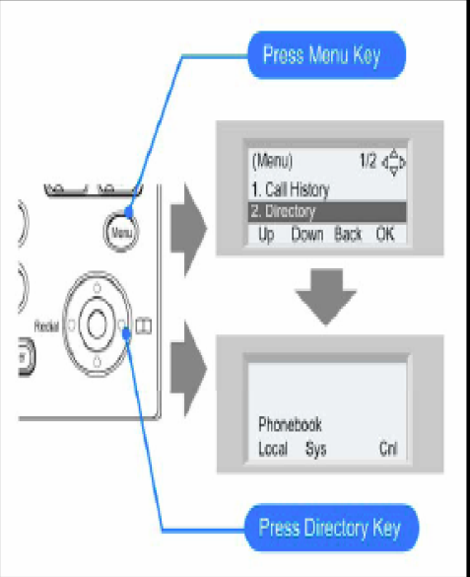  To view Call History. For details, see  Call History operation section.
2 | Directory | To use Directory function. For details see Directory operation section
3 | Tool | Uses when accessing external XML  Server. For details, please contact the system administrator.
4 | Call Function | Currently Not Used (greyed out)
5 | Setting | To set up the terminal such as ringing volume control, LCD display setting and download of Music on Hold.
6 | Presence | Currently Not Used (greyed out)
# | Favorite | By registering frequently-used features as favourite, the user can access these features with simple operation.
0 | Terminal Config | This item is used for Configuration setting of DT Series.

History Menu

LIST MENU | Key | Name | Description
 | 1 | REDIAL | Detailed info. of last call
 | 2 | CID | Former records

Directory Menu

Key | Name | Description
1 | REGIST | To add new data
2 | SEARCH | To find registered data
3 | SETTING
4 | Delete All | Delete all history

