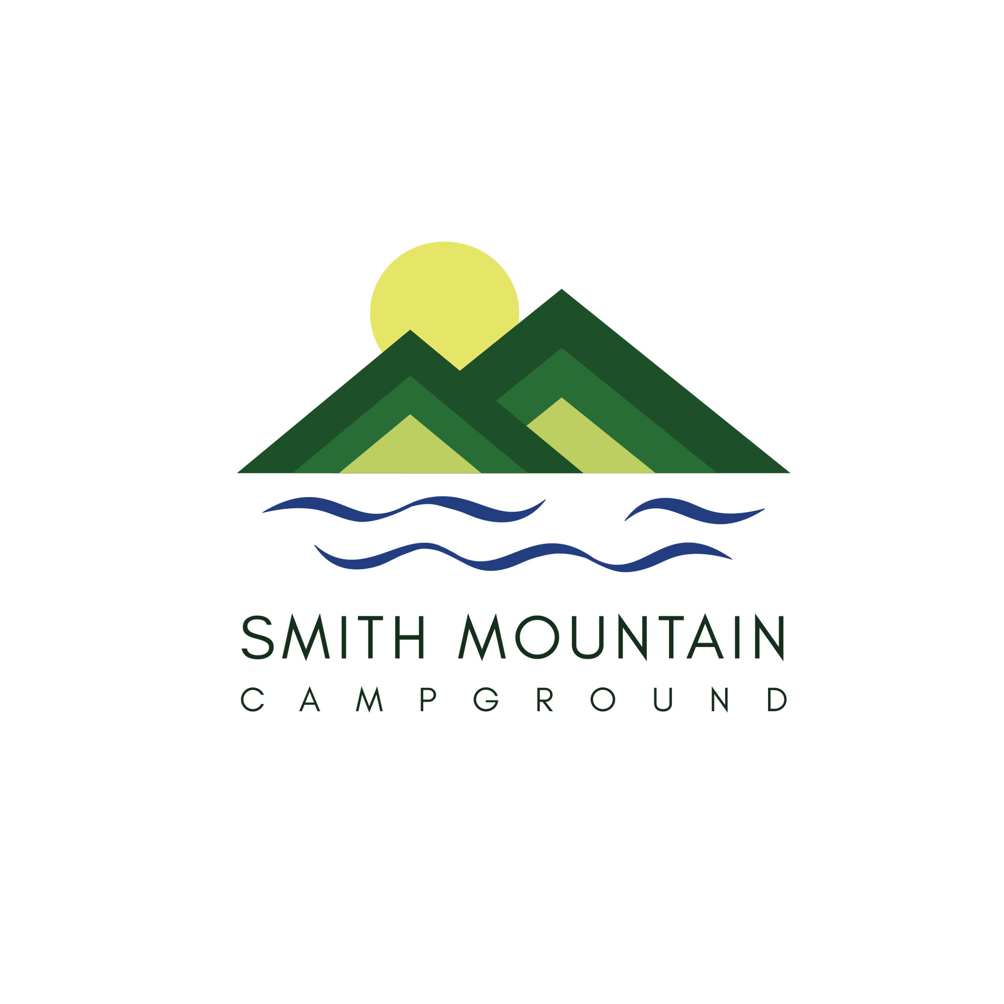

**Activities and Landmarks**

**Marinas (all are off of Smith Mountain Road)**

**The Dock at SML** - 6 min / 3.5 miles. ***Boat rentals***, dayslips, seasonal slips.

[(540) 565-0222](https://www.google.com/search?gs_ssp=eJzj4tVP1zc0TCtPyUmrSjI3YLRSNaiwsDBJMTE1TjRIMUkxSk0ztTKoMLU0MDdITTUzsjS1TLO0SPHiL8lIVUjJT85WSCxRKM7NAQDWShS3&q=the+dock+at+sml&rlz=1C1CHBD_enUS1053US1053&oq=the+dock+at+sml&gs_lcrp=EgZjaHJvbWUqDQgBEC4YrwEYxwEYgAQyCggAEAAY4wIYgAQyDQgBEC4YrwEYxwEYgAQyBwgCEAAYgAQyCAgDEAAYFhgeMgoIBBAAGIAEGKIE0gEINDQwMWowajSoAgCwAgE&sourceid=chrome&ie=UTF-8#)

**Magnum Point Grill & Marina** - 13 min / 8.3 miles. Restaurant, ***boat rentals****,* guided fishing tours, etc.

[(540) 576-3001](https://www.google.com/search?q=magnum+point+grill+and+marina&rlz=1C1CHBD_enUS1053US1053&oq=magnum+point+grill+and+marina&gs_lcrp=EgZjaHJvbWUyCQgAEEUYORigATIHCAEQIRigATIHCAIQIRigATIHCAMQIRigATIHCAQQIRigATIHCAUQIRirAjIHCAYQIRifBTIHCAcQIRifBTIHCAgQIRifBTIHCAkQIRifBdIBCDU0NjFqMGo5qAIGsAIB8QUWR8aTATSWbQ&sourceid=chrome&ie=UTF-8#)

**Gills Creek Marina** - 28 min / 20.7 miles. ***Boat rentals***, Annual Slip Rental and Guided Fishing Tours.

(540) 721-2451

**Free Boat Launching (Google Public Boat Ramp Near Penhook, VA)**

**Penhook #9 Boat Ramp** - 9 min / 4.3 miles - Largest free public boat launching (2 lanes), kayak, paddle board, etc. and lots of parking, fishing pier, picnic tables, restrooms, NO boat slips (just putting boat in water and getting it out)

**Anthony Ford Boat Ramp** - 8 min / 4.2 miles - Small public boat ramp with restrooms (1 launching lane), limited parking. This place is nice to launch paddle boards, kayaks, etc because it’s not busy. Great view of Smith Mountain from this launch.

**Grocery / Retailers**

**Penhook Minute Market** - Small Grocery Store - 4 Minutes / 1.8 miles

**Dollar General** - 8 Minutes / 4.8 Miles - West on 40 towards Rocky Mount

**Wal-Mart** - 22 Minutes / 17 Miles - West on 40 towards Rocky Mount

**Kroger Grocery Store** - 22 Minutes / 17 miles - West on 40 towards Rocky Mount

**Lowe’s** - 22 Minutes / 17 miles - West on 40 towards Rocky Mount

**Swimming / Hiking**

Unfortunately, the southern end of the lake is very limited in this area.

**Smith Mountain Cooperative Wildlife Reserve** - Seasonal

<https://dwr.virginia.gov/wma/smith-mountain-cooperative/>

Hiking, views of the lake from top of Smith Mountain, hunting, etc. There is an entrance just a few miles from the campground (up Jasmine Rd there is a parking lot, then hike to top)

**Smith Mountain Lake Community Park** - 37 min / 25 miles <https://www.playfranklincounty.com/Facilities/Facility/Details/Smith-Mountain-Lake-Community-Park-Beach-4>

Swimming beach, picnic shelter, walking trails, etc.

**Smith Mountain Lake State Park** - 40 min / 28 miles - swimming beach, hiking trails, etc.

<https://www.dcr.virginia.gov/state-parks/smith-mountain-lake>

**Sites to See / Things to do**

**Smith Mountain Trailhead** - 7 min / 2 miles

**Smith Mountain Lake Dam** - 15 min / 8 miles

**Booker T Washington National Monument** - 25 min / 19 miles

**National D-Day Memorial** - 1 hour / 41 miles

**The Coves** - <https://covesatsml.com> - 15 min - Great live entertainment with nationally recognized bands

**Restaurants**

**Mexico Viejo** which is probably 2 miles down the road from the campground. They have live music most Friday & Saturday nights during the season, corn-hole, outside dining, awesome margaritas.

**Carl’s Diner** - Local establishment with loyal following. Tucked away in a gas station at end of Liberty Road. Burgers, salads, sandwiches.

**Magnum Point Grill & Marina.**  It’s about a 10-minute drive from the campground but it is on the lake. Really good cheesesteak. Outdoor dining, live music during the in-season, trivia nights, etc. They also have boat rentals.

**The Mule.** It just opened about a month ago. It’s just open for lunch hours. Sandwiches and salads.