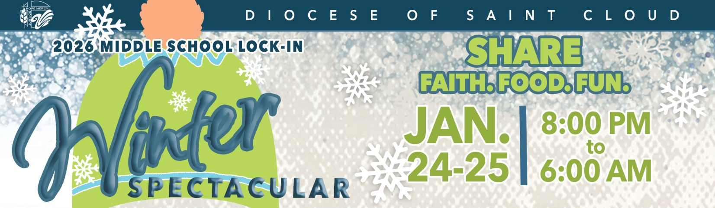

Youth Interest Form

What: An all-night lock-in for youth in grades 6, 7 and 8 at the YMCA in St. Cloud, Minnesota.
When: Saturday, January 24 - Sunday, January 25, 2026 (leave from Centre For Christ at 7 pm and return around 7 am)
Cost of Event: $50 until January 14 – after registration fee goes up to $60
Registration closes on January 21.
Parish Leader & Contact Info: Kathy Knoblach, 320-293-6980
Coordinated by: Diocese of Saint Cloud-Youth and Young Adult Ministries
Transportation to and from event: We are planning on taking a bus!

If a youth has specific accommodation needs or would benefit from an interpreter, please contact your parish leader.

Please remove the bottom portion of this page and return to your parish leader.

Please return this form with the fee to Centre For Christ (235 Main St. S.), or to your faith formation leader. Then look for an email with the link to the electronic permission form. The electronic permission slip must be completed by due dates. THIS IS NOT A PERMISSION SLIP.

Youth Name:

Email address for permission form:

Parent Contact Number:

