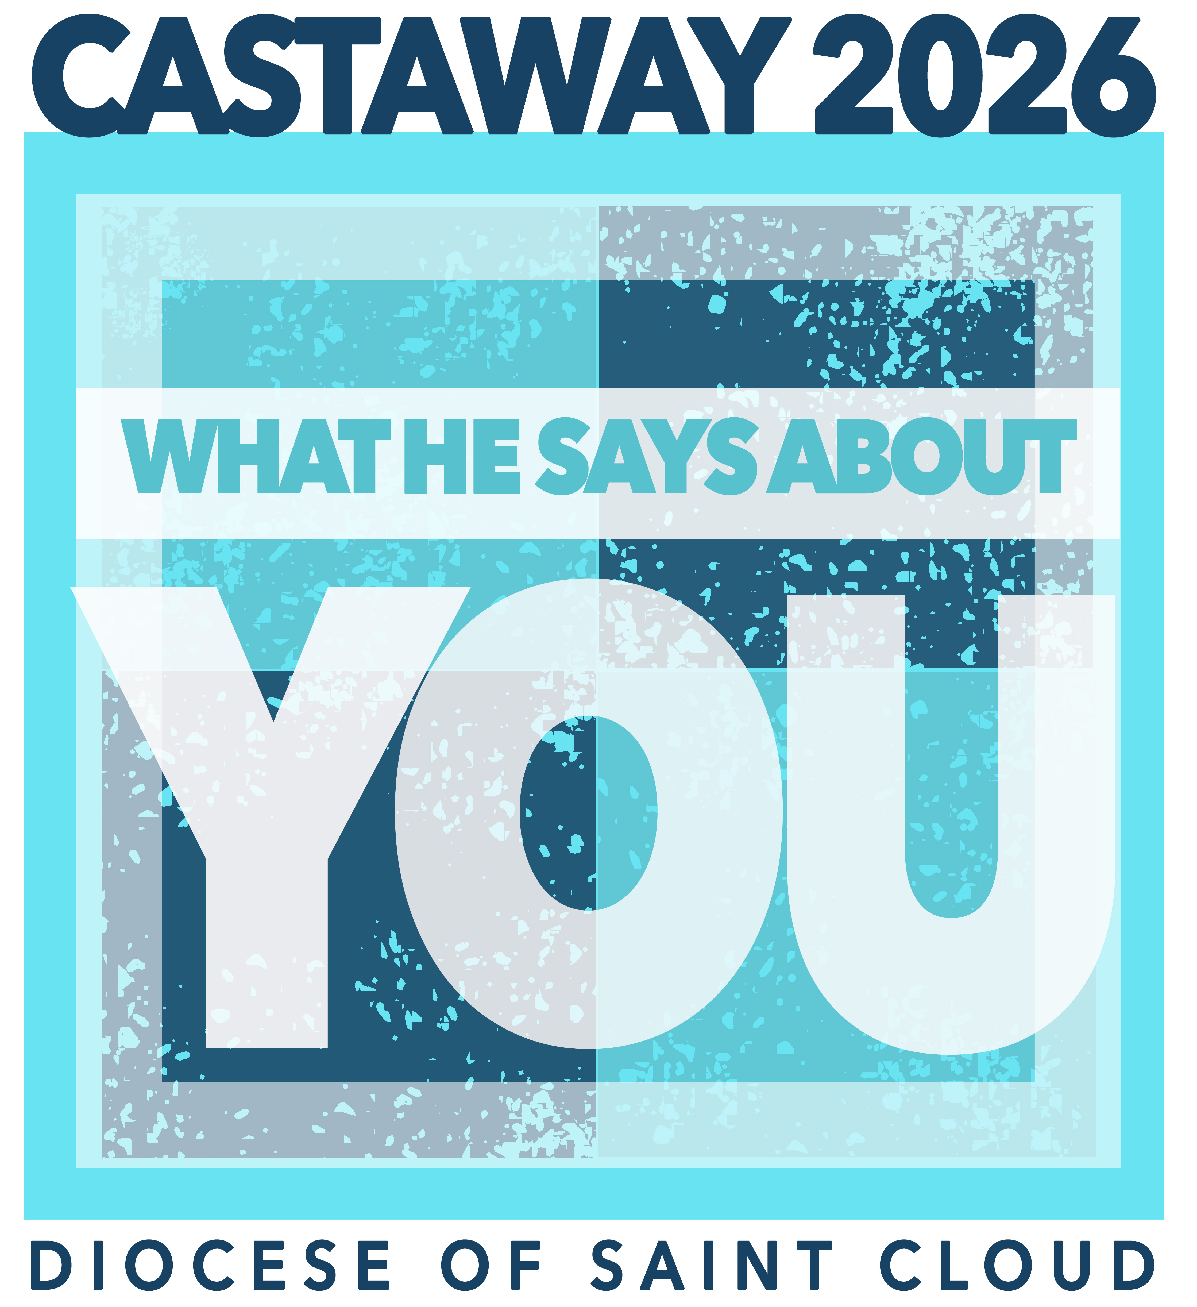

Youth Interest Form

Weekend retreat for youth in grades 9-12 at Castaway Club in Detroit Lakes, Minnesota.
Friday, March 20 – Sunday, March 22, 2026
Cost of Event: $210 until 2/11 – after registration fee goes up to $230 (please make checks to “Centre For Christ.”
Parish Leader & Contact Info: Kathy Knoblach, 320-293-6980
Coordinated by: Diocese of St. Cloud-Youth and Young Adult Ministries
Mode of transportation to and from event: Bus

If a youth has specific accommodation needs or would benefit from an interpreter, please contact your parish leader.Castawa
Please remove the bottom portion of this page and return to your parish leader.

Please return this form with $210 to your parish so they can email you the link to the electronic permission form. THIS IS NOT A PERMISSION SLIP FOR CASTAWAY.

Youth Name:

Email address for permission form:

Parent Contact Number:

Castaway offers t-shirts, long sleeve shirts and hoodies available for an additional cost. If you would like a shirt, please indicate style and size below. Shirt costs are given in the options below.

Shirt Style:
T-Shirt ($17) Long Sleeve Shirt ($22) Hoodie ($32)
Size:

- Small
- Medium
- Large
- XLarge
- XXLarge
- XXXLarge
- XXXXLarg

