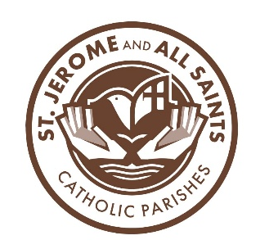

Religious Education 2026-2027
St. Jerome 9:30-11:00, All Sants 8:45-10:15

September 13 First Day of Class
September 20 Catechetical Sunday (no class)
September 27 Youth Sunday Gathering, St. Jerome 1:00-2:30

October 4 Class, Confirmation meeting for Candidates and Sponsors at All Saints (cafeteria) 8:45
October 18 Class

November 1 Class, Parent Meeting for First Reconciliation at All Saints (cafeteria) 8:45
November 15 Class
November 22 Youth Sunday Gathering, at St. Jerome 1:00-2:30

December 6 Class
December 20 Class

January 3 No Class
Wednesday, January 13 First Confession, St. Jerome 6:30 PM
January 17
January 24 Youth Sunday, at St. Jerome 1:00-2:30

February 7 Class; Confirmation Rite of Enrollment at Sunday Masses
February 21 Class

March 7 Class; First Communion Rite of Enrollment at Sunday Masses
March 14 Youth Sunday, St. Jerome 1:00-2:30
Saturday, March 20 First Communion Retreat St. Jerome 9-12

April 4 Class
April 18 Class; Confirmation at Rosary Cathedral 3:00 PM

April 25 First Communion practice-during regular class times
May 2 First Communion St. Jerome 8:30 Mass
First Communion All Saints 10:30 Mass

