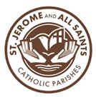
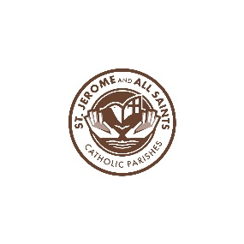

202026-2027 First Communion Religious Education Registration

We attend ______All Saints _______ St. Jerome Are your registered? ___Yes ___No

Child’s name ___________________________________

Adress _______________________________________________________________________________
Street City Zip

Date of Birth __________________________ Place of Birth ________________________________

Grade during 26-27 school year ____________________ School ______________________

Church of Baptism _______________________________

Address of Church where baptized _____________________________________________
If your child has not been baptized at St. Jerome or All Saints, kindly submit a copy of his or her baptismal certificate.

Parents’ Information
Father’s Name ___________________________________________________________________________
First Last Catholic? ____Y ____N

Mother’s Name___________________________________________________________________________
First Last Maiden Catholic? ____Y ____N

Preferred Email Address(s) _____________________________________________________

Preferred Phone Number(s) ____________________________________________________

Were parents married in the Catholic Church? ____Y____N
Have parents received First Communion and Confirmation? ____Y ____N
If not Catholic, are you interested in becoming Catholic? ____Y____N

Does the child have health issues/allergies? ___________________________________________________
____________________________________________________________________________________________
Emergency Contact other than a parent: Name _______________________________

Phone Number ________________________ Relationship ___________________________

We follow the guidelines put forth by the Diocese of Toledo.

Religious Education incorporates various media, activities, worksheets and dialogue along with our faith traditions of prayer, song and self-awareness. We host these sessions for your child’s spiritual and faith development.

I understand and agree that Mass attendance is the initial formation, and parents are the primary catechist of Religious Education.

Signature ___________________________________Date ____________________

Photos are taken during some celebrations, and your child may appear on the parish website and/or FB page for the purpose of demonstrating the faith community of All Saints, Rossford and/or St. Jerome in Walbridge Ohio.

Are you okay with your child appearing on social media? (Circle one) Yes/No

Office use: Registration $75 Cash____ Online _____or Check number __________

