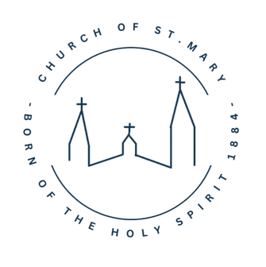

Church of St. Mary
Po Box 278 – Waverly, MN 55390
763.726.7300
stmarywaverly@gmail.com
www.stmary-waverly.net

7/29/25

“Meeting people where they are and joining them in their emotional state is how we love them well. One way people can show you their love is to cry with you. Scripture says, “Like one who takes away a garment on a cold day, or like vinegar poured on a wound, is one who sings songs with a heavy heart.” There is a great connection when people feel your pain and sorrow. When they allow themselves to slow down and not rush through their emotions, they can embrace your emotions. When you let people into your hurt and they genuinely hurt with you, it is a healing salve and a soothing balm to your soul.” -Good Grief, Lee Armstrong

- Have you allowed yourself to mourn in the presence of others?
- How would you feel if someone came, who didn’t have any words to say, but sincerely wept with you?
- How should you feel when people mourn with you? Rejoice with you?
- Have you asked God to help you mourn in the presence of others?
*****************************************************************

We would like to extend our condolences to you and your family for the loss of your loved one. We want you to know that we are here for you at St. Mary’s and that we have a Grief Group that currently meets at our Parish. Each of our group’s members have lost someone close to them. Spouses, son or daughters, parents, siblings. We understand the pain of loss and know how important it is to have someone walk along with you in your grief journey. We invite you to join us as we gather to share our joys and sorrows, as we grieve our loved ones.
Our upcoming meeting dates are August 14 and September 11 at 10 am in the Fireside Room. If you have any questions please contact Jessica at the Parish Office, 763-726-7300 ext. 32.

Other Meetings happening in our area:
Widows of Joy:1st Saturdays, 8:30 – 11 am, Holy Trinity, Winsted (specifically for widows)

Grief Share:
Loss of Spouse Event-Sept. 7, 2 pm, Freshwater Church, 138 W 1st Street, Waconia, 612-709-5213

All types of losses:
Aug 5-Oct 28, Tues, 6-8 pm, St Mark Lutheran, New Germany, 612-619-9610
Sept. 4-Dec. 4, Thurs. 4:30-6:15 pm, Buffalo Covenant Church, 763-682-1470
Sept. 30- Dec 30, Tues. 10:00-11:30 am, Lake Ridge Care Center, 310 Lake Blvd South, Buffalo, 763-404-4615
Suicide Loss Support Group/ 2B Continued:
2nd Monday of the Month, 7-8:30 pm, 305 7th St E, Glencoe, 320-854-4673

We do hope that you will consider joining our St. Mary’s Grief Group or one of these other groups, finding others to share your journey with you, is important for your healing process.
Sincerely,
Jessica, Deb & our members
St Mary’s Grief Group
140 + Years of Sharing Faith,
Bringing Hope and Living Love!

