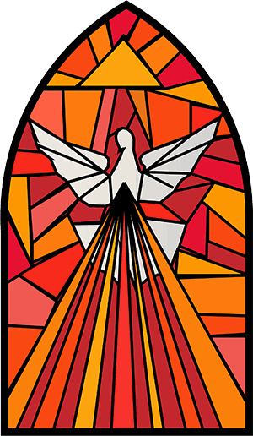
Grade 10

Confirmation

Grade 10
Confirmation – A Sacrament of Initiation

Welcome! 10th-grade is an adventurous year for our Faith Formation students and their parents. This is the year students will receive the Sacrament of Confirmation! Brandon & Cortney Steen are our Confirmation teachers, and they are ready to help your kids envision their roles as a Young Catholic Adults!

The 10th-grade class meets weekly on Sundays from 9:15-10:15 am at St. Mary’s, in the Youth Room-in the lower level of the Parish Center from September 20 through April 25, on the 3rd SUNDAY of the month, CLASSES WILL MEET AT 4 PM MASS, then have class from 5-6 pm. Our closing Mass will be on Sunday, May 2 at 4 pm, we encourage everyone to attend.

If your child was not baptized or had First Holy Communion at St Mary’s, Waverly, please make sure to provide a copy of their Certificates to the Parish Office by 9/15/26. We have a form to make sure we have their FULL NAME, & date of birth, as well as their SPONSORS’ name & phone number, PLEASE MAKE SURE TO FILL OUT THE SHEET BEFORE YOU LEAVE TONIGHT.

SUNDAY OBLIGATION & HOLY DAYS:
*Make sure to sign-in EVERY Sunday, on sheet, in the back of church.
*If you can’t attend St Mary’s, Grab a bulletin from the parish you attended! (bring to next class)
ATTEND ALL SUNDAY CLASSES & SPECIAL EVENTS (10 HOUR VOLUNTEER HOUR REQUIREMENT):
*Students will be expected to log AT LEAST 10 Volunteer Hours at church events, during the 2026/27 year. This is in addition to the service events planned throughout the year at: Wax Museum, The Lodge, Jail, Cornerstone, etc. Additional VOLUNTEER Examples are on the back of this sheet.
SPONSORS:
*Sponsors should plan to attend the Rite of Calling, Right of Sending and pick at least 1 class activity to accompany your student throughout the year. We also recommend meeting once a month on their own. (They can sign up in Flocknote for notifications, but best if you Communicate with them.)

Important Dates to Note:
The “Get to Know You” Dinner at Steen residence: Saturday, August 22 at 6 pm.
Rite of Calling: Sunday, October 25 at 10:30 am Mass (Sponsor attends)
Confirmation Retreat (St. Mary’s): Sunday, February 21 Check in 10 am, Ends with 4 pm Mass (parent help)
Rite of Sending: Sunday, May 16 at 10:30 am Mass (Sponsor attends)
Confirmation (Cathedral of St Paul): Sunday, May 23 at 2 pm am Mass. (Sponsor attends)

Lastly, we are introducing a weekly 4 pm Mass on Sundays, beginning September 20. As stated earlier, on the 3rd Sunday of the month, class will meet at 4 pm for Mass, then class from 5-6 pm. Also, last Sunday of the month, mass will be followed with a Potluck Dinner and activities. Everyone is invited to attend!

Father Blake Stacy Thomas (Director of Faith Formation Teachers: Brandon & Cortney Steen
763-726-7300 ext.31 763-234-0050
K+96Calendar Of Events
Get to Know You Dinner: August 22-6 pm: Steen Residence
Classes Dates | Volunteer Opportunities
9/20: 4 pm Mass & 5-6 pm/Class | Fall Festival: Sept. 12 & 13
9/27: 9:15-10:15 am/Class | 11/15: KC Pancake Breakfast 8-11am
10/4: 9:15 – 10:15 am/Class | 12/6: Cookie Walk (time to be announced)
10/11: 9:15-10:15 am/Class | 1/10: Forester Omelet Breakfast
10/18: NO CLASS MEA | 1/10: KC Pancake 8-11 am (date may change)
10/25: Rite of Calling 10:30 am (Sponsor Attend)  Lodge Visit follows | 2/19: Stations & Soup Suppers  (Times will be announced)
11/1: 9:15-10:15 am/Class | 2/26: Stations & Soup Suppers
11/4: 6:00 pm WAX MUSEUM | 3/5: Stations & Soup Suppers
11/8: 9:15-10:15 am/Class | 3/12: Stations & Soup Suppers
11/15: 4 pm Mass & 5-6 pm/Class | 3/19: Stations & Soup Suppers
11/22: 9:15-10:15 am/Class | 5/2: KC Pancake Breakfast 8-11 am
11/29: NO CLASS-Thanksgiving
12/6: 9:15-10:15 am/Class | Fall Parish Clean Up-TBD
12/13: The Lodge Visit (TBD) | Spring Parish Clean Up-TBD
12/20: 4 pm Mass & 5-6 pm/Class
12/27: NO CLASS-Christmas
1/3: 9:15-10:15 am/Class | Other ways to volunteer:
1/10: 9:15-10:15 am/Class | In classrooms
1/17: 4 pm Mass & 5-6 pm/Class | At Church: Reader, Usher, Altar Serving
1/24: 9:15-10:15 am/Class | Hospitality Weekends (donuts/4th Sat/Sun)
1/31: Jail Visit (TBD)
2/7: 9:15-10:15 am/Class | SCAN QR CODE TO LOG VOLUNTEER HRS:
2/14: NO CLASS | 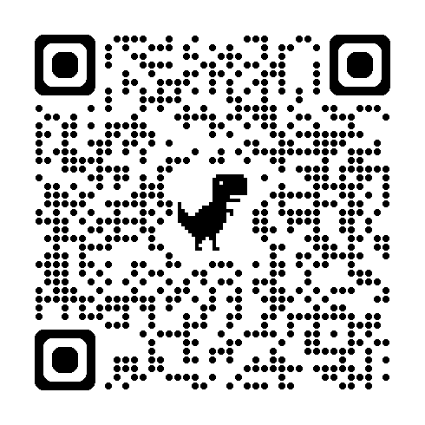
2/21:CONFIRMATION RETREAT 10 am-5 pm
2/28: 9:15-10:15 am/Class
Cornerstone Visit Date/Time TBD
3/7: 9:15-10:15 am/Class
3/14: 9:15-10:15 am/Class
3/21: NO CLASS-Spring Break
3/28: NO CLASS-EASTER | PARISH RECONCILIATION SERVICES
4/4: 9:15-10:15 am/Class | December 17- 6:30 pm
4/11: 9:15-10:15 am/Class | March 11- 6:30 pm
4/18: 4 pm Mass & 5-6 pm/Class
4/25: 9:15-10:15 am/Class
5/2: Closing Mass 4 pm
5/9: NO CLASS
5/16: Rite of Sending 10:30 am Mass
Arrive at 9:45 am (Sponsor Attend)
5/23: CONFIRMATION:2 pm - St Paul’s Cathedral
