The Crusader 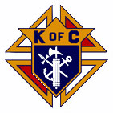

The Day of Our Lord October and November 2025

Official Publication of the Knights of Columbus-Waverly Council #1556

**Grand Knight’S Message**

Dear Brother Knights,

I hope you had a great summer. I am looking forward to my favorite season of the year which is Autumn. I would like to thank everyone for your dedication and help at St. Mary’s Fall festival! I believe our festival was a great success thanks to all the volunteers.

As we look forward to November, I would like to remind everyone that Father Blake will be having a memorial Mass on Thursday November 13 at 5:30pm for KC members who passed away during the past year. There will be a light lunch afterwards. I hope you will be able to participate. May God Bless each of you and your families!

Sincerely,

Clint Fall

Grand Knight

COMING EVENTS

November 9 – Officers and General Meeting. 9:15am. KC Hall.

November 13 – KC Memorial Mass. 5:30pm. St. Mary’s Church.

November 15 – Special Olympics Bowling. Bloomington. 7:00am.

November 16 – Pancake Breakfast. Proceeds to Youth Group. 8:00 – 11:00am.

December 7 – Officers and General Meeting. 9:15am. KC Hall.

January 3 – Bingo. Proceeds for student loans. 6:30pm. 12 games. KC Hall.

January 6 – Officers and General Meeting. TUESDAY, 6:30pm. KC Hall.

January 11 – Pancake Breakfast. Proceeds for Hall Maintenance. 8:00-11:00am.

January 24 – Winter Social. 6:00pm. KC Hall.

**YOUR PRAYERS ARE REQUESTED** Randy Hasse, Mary Amborn, Larry Poppler, Father Martin Shallbetter, Missy Sinkler, Richard LaFave, Margaret Jordan, Dorothy Novak, Cassie Spike, Vince Halliday, Diane Blake, Jen Remer, Agnes Smith, Jonathan Padden, George Althoff, Julie Winsperger, Diane Carlson Evans, Carolyn Nieman, Brenda LePage, Jason Mader, Mary Martin, Carol Pollock, Rosie Jacobson, Ken Schoenfelder, Brinlee Dongoski, Mary Klingelhoets, Geri Smith, Walter Marketon.

Remember in your prayers: **our priests,**those on our parish prayer list, our veterans and service men and women.

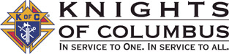

knight light – A Cop Pulled Over an Elderly Man…

An elderly man was spotted driving erratically down the street. When he passed a police car, he was quickly

stopped. The time was 2 a.m.

The cop got out and came to the driver’s window. “Where are you going this late?”

The man replied, “I’m on my way to a lecture about alcohol abuse and the effects it has on the human body, as

well as smoking and staying out late.”

The officer then asked, “Really? Who’s giving a lecture at this time of night?”

The man replied, “That would be my wife.”

[This Photo](https://napcrafty.blogspot.com/2013/) by Unknown Author is licensed under [CC BY-SA-NC](https://creativecommons.org/licenses/by-nc-sa/3.0/)

AGENT’S MESSAGE - -

Joe Remer – Field Agent

(612) 272-8635

**Congratulations**

**to the Fall Festival 50/50 raffle winners**

**Hailey Rios $830**

**Charlie Swartzer $1010**

Lecturer Wayne Arnold’s Message –

Brother Knights, I salute you ! Vivat Jesus

Today I want to talk to you about a recent event that many people probably heard about on the news but did not pay much

attention to very long. A young man named Charlie Kirk was assassinated September 10th while speaking at Utah Valley University. He was only 31 years old. His death by an assassin’s bullet came just 14 days after 2 Catholic school children were shot and killed and another 30 were injured when a transgender 22 years old shot them through the stained-glass window of Annunciation Catholic Church in Minneapolis. It is hard to understand these violent actions, but it is very important that we try. As Knights, our role as leaders and protectors in our families and churches is not just symbolic. There is evil in the world, and it is not just a problem in some big city on the east or west coast. It is all around us even in our small towns. I am sure the

town of Orem, Utah, about the size of St. Cloud Minnesota, never thought that it would produce a young transgender man who would take a rifle and shoot a defenseless, unarmed, Charlie Kirk sitting on a stage, just because the shooter did not like what Charlie believed in. And here in Minnesota, how could we similarly produce a troubled young person willing to shoot little children through a church window?

To answer these questions, it is helpful if we understand who Charlie Kirk was and what his message was. To be totally honest, I had never listened to one of his speeches or attended one of his rallies. It was not that I disagreed with anything he spoke about or his politics, but national discussions, world events and politics seem distant for me to waste any brain cells on. So I

didn’t…. And then the two shocking shootings happened. What the heck was that all about??! Who was this Charlie guy? Why is our President, most elected officials, nearly every church leader of every denomination including the Pope, talking about Charlie? This is why I picked Charlie as our subject today.

Charlie was married to a devote Catholic, Erika. They have two children, a one-year-old son and 3-year-old daughter. Charlie’s Mother was baptized Catholic but Charlie attended Presbyterian church as a youth. After dropping out of community college, Charlie had a powerful Christian awakening and became a very active speaker to college youth about faith in Jesus as well as

American patriotic values. Charlie had a phenomenal memory and debating ability. He daily would host debates at universities on faith, American family values, and American patriotism. He could easily memorize facts and information and could best even the smartest college professors on American history, the law, and Bible history. Charlie was a brilliant debater. He was direct, and always could back up his statements by quoting from memory tons of data. Let me give a hypothetical example. I am using real data but a made up conversation to illustrate how his speeches typically worked. Let’s say he was speaking at a college in Rhode Island and someone walked up to the open mic and said something like ‘abortion must be legal because women get raped.’ Charlie would calmly reply by clearly saying rape is an unspeakable mortal sin. But he also would say that every abortion is murder and also a mortal sin according to the Ten Commandments. Next, from memory and without notes, he would quote exact demographic data and statistics in Rhode Island; that there were 402 reported rapes last year in the state with 16 that led to a pregnancy. He would then make the point that even though there were 16 pregnancies caused by

rape, there also were 1380 voluntary abortions last year in the State of Rhode Island. He then would ask the student that raised the abortion question whether she thought that legalizing the murder of 1380 unborn children through abortion could prevent or undo those 16 horrible rapes that led to pregnancy. Of course she could not answer him and would walk away from the mic. Charlie almost never lost a debate no matter how horrific the topic.

Charlie Kirk founded an organization in 2012 called Turning Point USA that hosted open and candid discussions and debates daily with high school and college students on the blessings from the Christian faith and dedication to American patriotic values. Charlie was conservative and he persuasively argued in favor of traditional marriage of one-man and one-woman, the American work ethic, staunch American patriotism and support to the military, police, anti-abortion, and that men should not compete in women’s sports. He openly stated that there is an alarming rise in mental illness of youth regarding their gender, caused by high school teachers and college professors indoctrinating America’s youth to Hollywood’s moral standards. Charlie forcefully defended freedom of speech for both liberal and conservative points of view. He was very anti-woke and sounded a lot like someone from our parent’s generation on faith, family and patriotism. TPUSA was aimed at teaching high school and College youth the truth about Jesus and its connection to American Exceptionalism. Charlie did 330 speeches a year, 2 podcasts per day, a 3-hour radio program per day, and had a staff of 458 employees all dedicated to bringing people into a relationship with Jesus. His shows were extremely popular. TPUSA currently has 900 college chapters. Following his assassination, there are now over 62,000 applications for new TPUSA chapters at universities and high schools across the US. In comparison, there are 17,000 KC chapters in the US.

His success caught the attention of presidential candidate Donald Trump. Though Charlie did not agree with everything Trump said or did, Charlie Kirk became very involved in shaping the Make America Great Again philosophy. Charlie is credited with a dramatic change in voting patterns of youth from liberal to conservative. But politics was not his motivation. His main focus was strongly presenting Christian values and faith, and calling young people to accept Jesus into their lives. He then encouraged them to vote according to that faith and those values. Charlie taught that all Christians, especially the young, should be bold and speak out about their Christian faith and their patriotic values as Americans. He said passive faith is barely any faith at all. He said we should not be ashamed to be Christian or American. We should not be afraid to love God and Country.

Charlie Kirk put his faith out for everyone to see. His beliefs were not ‘way out there’ radical hippie stuff. Much of it sounds like it could be straight out of the Catholic Catechism. Charlie attended Mass with his Catholic wife Erika, and they had their marriage blessed in the Catholic Church. Though he was Evangelical Protestant, he had hinted recently to at least one Catholic

Bishop that he was strongly considering joining the Catholic faith. The many speeches he gave on faith were not fringe Christianity. It was mainstream and he tied it together with patriotism. He said American society sorely needed to bring Christian faith back into the public square and into our government. He forcefully asked why should those with no faith, no moral compass, and those addicted to woke liberal social media determine the direction of our county?

As I researched what Charlie said and taught, I see now why he was popular. His message was simple and spot on correct: Without God, society breaks down. Preventing the further decline of our country starts with each of us and our faith. We don’t need to be up on a stage with a microphone proclaiming Jesus. But we do need to be willing to speak openly and honestly to family and friends about what we know to be God’s truth. We can’t just hide our faith in some dark corner

and only bring it out for one hour at Mass on Sunday.

We should be very proud to be a Catholic. Very proud to be an American, and very proud to be a Knight. Even a tiny gesture about our own faith like silently making the sign of the cross and saying grace in a restaurant before eating can cause someone else to think about their faith. The Holy Spirit will use even our smallest acts to help change lives. The more mainstream Christian faith is seen every day in our society, especially in our young people, the more people will think

about and possibly return to the faith. Bottom line is Jesus taught us not to put our lamp under a basket. This was Charlie’s message.

Charlie Kirk was a gift from God and will be greatly missed. We should pray that God raises up more brave young men and young women willing to speak the truth, no matter the personal cost. Eternal rest grant unto him Lord, and let your perpetual light shine upon him. May his soul, and the souls of all the faithful departed through the mercy of God, rest in peace.

Brother Knights, I salute you ! Vivat Jesus

**Highlights from our COR 5 meeting on The Holy Mass**

video explaining the Holy Mass: https://youtu.be/NQfiwW52tmI?si=DqJAkmX4fogJdxNv

1. The Third Commandment says we are to “keep Holy the Sabbath.” The Bible teaches that Sunday is supposed to be the weekly day of rest and worship. This is a very easy commandment for a man to break. What do you do to try to keep Sunday holy for you and your family?
2. Have you ever met a Catholic who did not have an opinion on something that they did not like about their local Mass? To hot, to cold. Too much music, too little or wrong kind of music. Too loud, too soft. When we worry about something we don’t like, do we let it distract us from worshiping God?
3. Unless we are an exception due to age or our medical condition, do we observe the required one hour fast from eating and drinking before Mass? Water and medicines are always OK but not food, soda, coffee, tea, gum, etc.
4. Did you know that receiving Communion weekly is encouraged but is ‘required’ only one time per year for a Catholic (traditionally during Easter)? Yet it is a sin for Catholics to not attend Mass every Sunday unless of age, illness, or other significant reason. Do these two rules make sense when we look at them side by side? Do some Catholics under-value the importance of the other things happening at Mass besides Communion? Did you know that venial sins are forgiven at the first part of Mass? The Homily is extremely important learning. Worship of our loving God is SUPER important.
5. We should never receive Communion if we have unconfessed mortal sin. It adds another mortal sin to receive Communion when you have unconfessed mortal sin. It is required to go to Mass every Sunday and Holy Day of Obligation. But it is the right choice to participate in the other parts of Mass but not to take Communion if you

have unconfessed mortal sin. Get to Confession as soon as possible. It is stupid to store up mortal sins for a whole

year just to go to Confession once in Lent. Go ASAP and then you can take Holy Communion at the very next Mass!

1. Do Catholics sometimes forget that God is physically in the room during Mass and is more interested in our hearts than our clothes? If we wear clothes with the purpose to show our personal reverence to God and respect for the Mass, that is good. If we choose our clothes to impress or distract other parishioners, or to get a date, or show off how much money we have, that is not good. If Jesus invited you to meet with him, what would you wear to that meeting? A “T” shirt with “AC/DC” on it, advertising for your employer or favorite ball team? Of course not. You would dress like you are meeting the King of Kings. Dress that way for Mass!
2. If you were invited to spend one hour in person with your favorite celebrity like a TV star, singer, President of the

United States (pick your fav – Obama or Trump) would you be excited? Would you be a little afraid? Would you dress

up? Would you try to arrive early? Compare that celebrity meeting to how you feel about being invited to Sunday

Mass with Jesus every week. Which meeting should we be most excited about?

**Highlights from our COR 6 meeting on Confession**

It is REALLY important to learn about the Ten Commandments, mortal sin, and the Sacrament of Reconciliation. Why? Because everyone of us WILL live forever. Whether we are a believer in Jesus or not. Whether we are Catholic or not. Whether we are active in our faith or not. Human souls are an eternal thing. Once created, it never ends. The big question is where we want to spend that eternity. Either Heaven or Hell. There is no “opting out.” It is fully within our control to choose where we will go. The Father gave us the Ten Commandments so that we know what soul killing sin is. Jesus gave us the Church to teach us, help us avoid sin, and receive forgiveness.

Many, if not most, Catholics assume the ONLY ‘deadly’ sins are the biggies like murder, robbery, or adultery. In truth there are many other mortal sins. For example, taking Communion with an unconfessed mortal sin on our soul is itself another mortal sin. So how do we avoid “accidently” piling up deadly stains on our soul? KNOWLEDGE is the first key part. We need to know the Ten Commandments. We need to use tools like a church approved “Examination of Conscience” such as the one recommend by the Archdiocese of Minneapolis and St. Paul. I guarantee, it is a game changer. The second key part is how often do we go to Reconciliation. I admit I have a bad and risky habit where I usually store up my sins and put off going to Confession to only once per year during Lent. I tell myself, ‘I am not a bad guy.’ I have not robbed any banks. I go to church a lot. This kind of thinking is so stupid. We know not the day or the hour of our death, so why do we gamble with our eternal life? Dying with mortal sin on our soul is a permanent ticket to Hell. There is no “do over” or any guarantee that God will give us a get out of jail card. We make our own choice. By comparison, Confession is so quick and easy, takes 10 minutes max most of the time, especially if we get good at it by going monthly during the year. Jesus paid for our sins on the Cross, and gives it to us for free. Satan on the other hand puts ideas in our head that we should be too embarrassed to go to a priest. It is really stupid to hold onto our sins month after month (or year upon year) because of our pride or some unfounded fear. It is so easy to get rid of our mortal sins. Jesus gave us this gift. All we have to do is spend just a little time with an examination of conscience. The Holy Spirit will remind of us of something sinful we need to confess. Then with a contrite heart (we must regret our sin) we then see the priest. He will not lecture us, judge us, or embarrass us. Jesus gave us this air-tight way to clean our souls and spend eternity in Heaven. We only need to take Jesus up on his free gift. Did you know that it is very common for the Pope and many Bishops and priests to go to confession every week or even every day? If they feel that

is needed, what do they know about heaven and sin we don’t?......

One quick comment about non-mortal sin called “venial” sin. These minor sins can be confessed at a formal Confession, and we are encouraged to do so. But these venial sins can also be forgiven in the first part of every Holy Mass. We still need to call them to mind when the Priest invites us to early in the Mass. If we then sincerely regret that sin, they are then forgiven as we say the “I confess to Almighty God, and to you my brothers and sisters that I have gravely sinned…” prayer at Mass. But mortal sins are NOT forgiven this same way at Mass. Those only are removed from our souls by making a good Confession to a Priest. The Priest, on behalf of Jesus, will absolve us of our mortal sins. That is why during our time in Confession it is really important to focus on the mortal sins FIRST that we need to have forgiven. After we confess those, then we can talk about the little stuff.

**ATTENTION KNIGHTS – You can also read the Crusader on the St. Mary’s website:** [**www.stmarys-waverly.net**](http://www.stmarys-waverly.net)**. Under the Get Involved tab you will be directed to open the attachment for the latest Crusader.**

knight light –

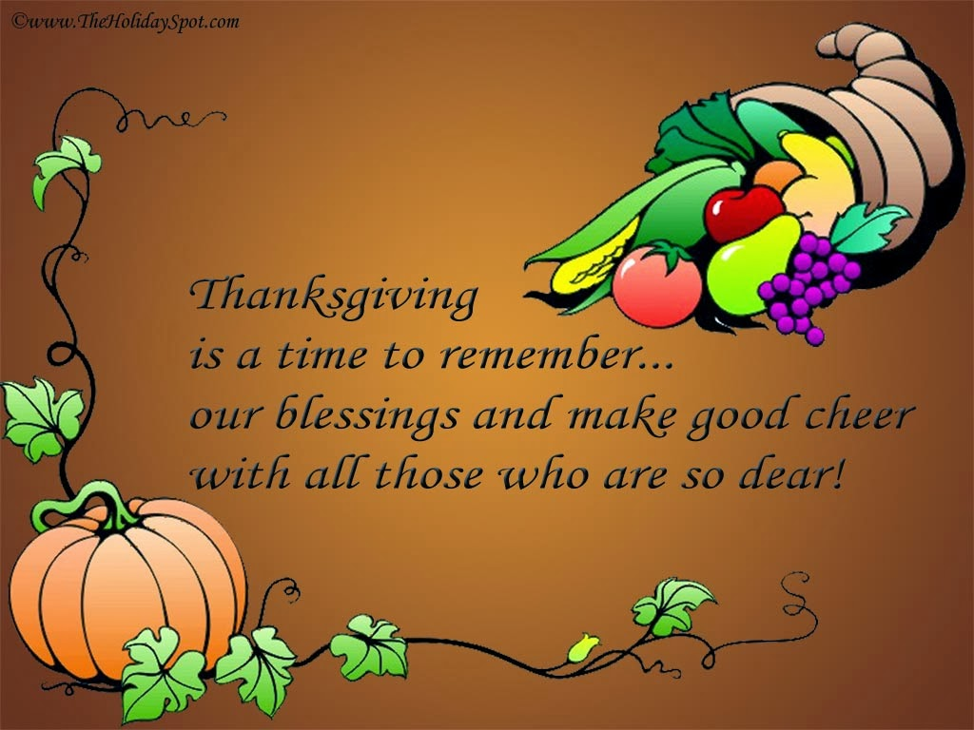

[This Photo](https://napcrafty.blogspot.com/2013/) by Unknown Author is licensed under [CC BY-SA-NC](https://creativecommons.org/licenses/by-nc-sa/3.0/)