The Crusader 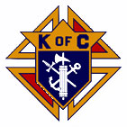
The Day of Our Lord June and July 2026
Official Publication of the Knights of Columbus-Waverly Council #1556
Grand Knight’s Message
Dear Brother Knights,
I hope each of you and your families have experienced an enjoyable Spring. The 1st day of summer is June 21 and we look forward to a busy KC schedule of events. I would like to thank each of you in advance for your generous service of time and effort toward the success of our Knights of Columbus Waverly Council allowing us to participate and support needy charities.

One of our largest and busiest events is Waverly Daze held July 10-12. The event includes a food stand, parade, and breakfast along with many activities. This event requires a significant amount of help from our dedicated Knights and their families. We sincerely appreciate your commitment of time and needed help in order for this event to be successful! I would also like to thank a number of Knights for the significant work they have already done toward planning this event including sourcing of the food, beverages and supplies. Your efforts do not go unnoticed!

I would also like to invite all Knights to our Cor meetings being held one evening each month. Please see our church bulletin for time and dates. The meetings provide an excellent opportunity to learn and share your faith through prayer, formation, and fraternity. We encourage each of you to attend a session and experience for yourself the mission of Christ centered brotherhood. Food and beverages are supplied FREE at each meeting. Please come and bring a friend.

May God Bless each of you and your families,
Clint Fall
Grand Knight

COMING EVENTS
June 19/20 – Winstock Parking.
June 28 – Good Neighbor Days parade.

July 7 – Officers and General Meeting. TUESDAY. 6:30pm. KC Hall.
July 10-12 – Waverly Daze (Breakfast. Hamburger Stand. Parade. (See attached Worklist. Contact the Captain of your shift if you need to make changes.)

August 9 – Officers and General Meeting. 9:15am. KC Hall.
August – TBD – Montrose Days Parade.

September 8 – Officers and General Meeting. TUESDAY. 6:30pm. KC Hall.
September 11-12 – St. Mary’s Fall Festival.

Please save the 2026-2027 Activity Calendar attached to this Crusader.
OUR PRAYERS ARE REQUESTED Father Blake and his family at the death of his brother, Family of Randy Hasse, Family of Cassie Spike, Family of Diane Carlson Evans, Family of Arleen Peterson, Family of Father Martin Shallbetter. Donald Sykora, Garrett Dongoski, Wayne Arnold, Maggie Smith, Chris Robinson, Janice Sykora, Tony Lachermeier, Berneal Decker, Jim Franske, James Dongoski, Bernie Reardon, Stephanie Brown, Luke Cain, Mary Amborn, Margaret Jordan, Dorothy Novak, Vince Halliday, Diane Blake, Jen Remer, Jonathan Padden, George Althoff, Julie Winsperger, Carolyn Nieman, Brenda LePage, Carol Pollock, Rosie Jacobson, Ken Schoenfelder, Brinlee Dongoski, Mary Klingelhoets, Walter Marketon, Agnes Marketon, Tom Sykora, Fran Luhman, Christine Kindt.
Remember in your prayers: our priests, those on our parish prayer list, our veterans and service men and women.
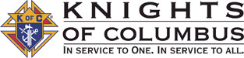

Council #1556 Officers 2026-2027
Chaplain - Fr. Blake Trustees – 1st - Jeff Lavigne
Grand Knight - Clint Fall 2nd - Jason Uecker
Deputy Grand Knight - Larry Cramb 3rd - Larry Poppler
Chancellor - Dan Boesen
Recorder - Ryan DeMars
Treasurer - Don Whitaker
Financial Secretary - Duane Janikula
Warden - Richard Stommes
Lecture and Advocate - Wayne Arnold
Inside Guard - Dale Segler
Outside Guard - Jack Brown

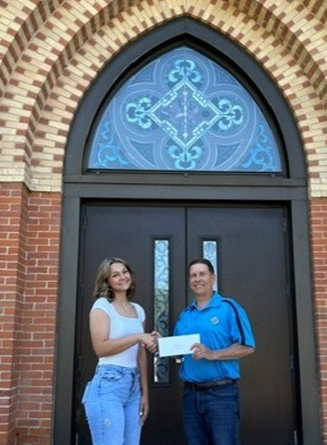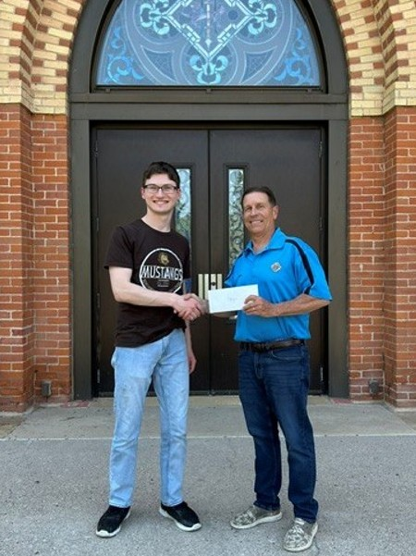
CONGRATULATIONS
2026
SCHOLARSHIP WINNERS
Morgan Sawatzke
and
Ethan Pavlenko
We are proud of you!!
Lecturer Wayne Arnold’s Message – Lecture 104 – HOLY SPIRIT
Brother Knights, our celebration of Pentecost is Sunday, May 24th. Many, if not most, Catholics do not understand the Holy Spirit. To be honest, many people look at Pentecost Sunday as just the Sunday after the fishing opener and also after Mother’s Day. Beyond that, Pentecost is viewed as ‘no big deal.’ This is a huge mistake. So, what is the Holy Spirit?

As we Catholics know, Jesus went up to Heaven and then asked God the Father to send the Holy Spirit to help the
Apostles and the early Church. We all know this. But if I were to ask you what is the Holy Spirit and what has the Holy Spirit done for you today, what would you say? If you were at our Cor meeting a few months ago, you heard me repeat a couple of times my pet peeve that most Catholics and Christians believe that the Holy Spirit is a white pigeon. NO! The Holy Spirit is not a bird, a spirit animal, not wind, and certainly not the Force that a Jedi Knight needs to use a light saber.

So, what is it? Brothers, that too is the wrong question. The correct question is “who is He?” We Knights of Columbus always start our meetings by making the Sign of the Cross, invoking the Name of the Father, the Son, AND the Holy Spirit. But too often, the Holy Spirit is treated as the “forgotten” member of the Blessed Trinity. We easily picture God the Father. He is the old guy with a really long white beard, usually sitting on top of a bunch of clouds pointing his finger. We have even more pictures of Jesus in our churches. But the Holy Spirit? We Catholics don’t have a picture of Him as a person. But the Holy Spirit IS a person. Most times we reduce Him to a vague “divine force,” or just a “good feeling”. Sometimes we may think He is the little voice in our head saying “don’t eat that second piece of cake.” Sadly, many of us Catholics don’t view Him as particularly important even on Pentecost Sunday.

But brothers, the Catholic Church teaches us that the Holy Spirit is ‘fully God, consubstantial with the Father and the Son, adored and glorified.’ By the way, the word ‘consubstantial’ means the Holy Spirit is made of the same stuff as the Father and the Son. God the Father is a person, Jesus is a person, and the Holy Spirit is a person.

As Knights dedicated to our missions of charity, unity, and fraternity, we cannot afford to treat the powerhouse of the Church as a passing thought that does not matter very much.

So, let’s review the basic teachings: Who is the Holy Spirit? As the Nicene Creed says: “I believe in the Holy Spirit, who is the Lord, the giver of life, who proceeds from the Father and the Son, who with the Father and the Son is adored and glorified, who has spoken through the prophets.” The New Testament is chocked full of examples of the Holy Spirit teaching, rescuing, answering prayers, healing and raising the dead at the request of the disciples.

I want you to think about something: God is in Heaven, right? Jesus ascended and also is in Heaven at the right hand of the Father, right? Both of them are in Heaven this very moment. But Scripture tells us that the Holy Spirit is here, on earth, WITH US RIGHT NOW! That is what Pentecost is all about. Jesus asked the Father to send us the Holy Spirit, and He did it. Not just 2000 years ago, but right now among us every day, and right here in this room. God is not a distant god off somewhere sitting on a cloud, reading prayers texted to his cellphone. God, in the person of His Holy Spirit, is here with us and in us every moment of every day. Doesn’t it therefore seem kind of dumb to ignore the Holy Spirit and think of Pentecost as no big deal? He is a huge deal. Pentecost is a huge deal!

The Holy Spirit is the Advocate who stands beside us, strengthening us to be men and women of faith in our hostile world.
- He is the one that comes upon the Eucharist on Sundays.
- He is the one in the confessional with us forgiving us our sins.
- He is the one with our children and grandchildren when we pray through our tears that God please help them with the mess they are in.
- He is the one that hears every one of our prayers and carries them to the Father.
- He is especially with us when we lie in the hospital bed asking Jesus for healing and mercy.

Without the Holy Spirit, our faith would be only a set of ancient rules like the Jews had after their temple was destroyed. Because of the Holy Spirit, our faith is a living relationship with God the Father and with Jesus our Savior. For a Knight of Columbus, the Holy Spirit is the source of the courage we need to stand up for our families, our Church, and our communities.

To help us understand what the Holy Spirit does for us, our Church teaches there are 7 Gifts of the Holy Spirit: Wisdom, Understanding, Counsel, Fortitude, Knowledge, Piety, and Fear of the Lord. Our Church also teaches there are ten types of benefits we receive from those Gifts of the Holy Spirit: Love, Joy, Peace, Patience, Kindness, Goodness, Faithfulness, Gentleness, Self-control, and Endurance. We will explore these at a future Cor meeting because they are extremely important subjects all Catholics should know. But let me summarize what Catholics should remember about the Holy Spirit:
- The Holy Spirit is a Person: Not an ‘it,’ a white bird, a wind, or a fuzzy feeling.
- The Holy Spirit is God: the third person of the Trinity.
- The Holy Spirit is the love between the Father and Son.
- The Holy Spirit is our Helper, Counselor, and Comforter.
- The Holy Spirit Empowers: He actively gives us every good gift in our lives to help us be Christ-like and proclaim Jesus as Lord and Savior in our families, parish, and KC Council.

There is much more to say, but let’s end here with a challenge: Ask the Holy Spirit to come into your life. Ask him to help you pray, eat, sleep, be healed, confess your sins, forgive others, and guide you every moment of every day. My favorite time to do this is every Sunday when kneeling just after Holy Communion. We also should ask the Holy Spirit every morning to be part of our life the coming day, and call on Him during the day when we need help or even just to thank him for God’s grace, mercy, and beauty in our life. You will be amazed at what happens if you talk to, and
are open to, the Holy Spirit every day!

Take Home Summary from COR11 “Purgatory.”
At this COR session we explored a key building block of our faith: what happens when we die? What is Purgatory? The official teachings of the Catholic Church regarding death and Purgatory are:
A) Immortality of the Soul: While physical human bodies die, the Catechism of the Catholic Church teaches that the human soul is immortal and does not perish upon separation from the body.
B) Particular Judgment: At the moment of death, a person’s soul is immediately judged by Jesus. Depending on this judgment, the soul enters heaven (potentially through a period of purification in purgatory) or the soul goes to hell forever.
C) The Last Judgment: Every soul will be reunited with its resurrected body just before the Last Judgment. This event will occur when Christ returns in glory, marking the final word on history and revealing that God’s justice and love triumph over all injustices and evil.
D) Pray for the Dead: Catholics are encouraged to pray for the dead as a spiritual work of mercy. Prayers are offered for the deceased to aid their journey. This ancient practice is rooted in the belief that while death ends earthly life, it does not end the “Communion of
Saints”, which is the spiritual bond between the living on earth, the souls being purified, and the saints in heaven. Our prayers support souls in need of purification before entering heaven. This belief is based on 2nd Maccabees 12:44-46. The most significant prayers often
used to pray for our deceased is the Holy Mass, praying the Rosary, and visiting cemeteries.
Key things we learned in the videos:
1) Jesus tells us in Matthew that “the gate is wide and road is broad that leads to destruction…and narrow is the gate that leads to life. And those that find it are few.”
2) Why is death mysterious? The answer is if Jesus wanted us to know every detailed step in the process, he would have told us. He is God, we are not. But Jesus did tell us exactly what we need to know most of all: Faith and Trust in Jesus is the centerpiece of God’s perfect plan, and Jesus is the only way, the truth, and the life.
3) The Necessity of Purity: In Revelation 21:27, we learned that nothing unclean can enter Heaven. Purgatory is the final stage of sanctification, where Christ cleanses each soul of lingering attachments to sin and worldly desires. Persons that die with unrepented mortal sin officially do not go to Purgatory or Heaven. They are destined for hell. Jesus alone, in his mercy, will decide what happens for each and every soul.
4) Purgatory is not a “do over” for those who ignored God. It is strictly for those who have a relationship with Christ but are not yet fully perfected at the time of their death.
5) Christ’s Work, Not Ours: It is Christ’s own mercy and love that performs the purification of souls in Purgatory. We do not “earn” our way out. We are cleansed by Jesus’ effort alone, not through anything we do in Purgatory.
6) Purgatory is like the analogy of breaking a window. While an apology (confession) grants forgiveness, the “broken window” (the impact of sin) still requires repair, which is part of what is addressed either by acts of penance on earth or in Purgatory.
7) Fr. Mike Schmitz emphasizes that the purpose of Purgatory is to prepare us to love God as He deserves. But God’s “Plan A” is for us to undergo that same transformation here while we are still alive on earth. God gives us every grace now in this life to become the people we are meant to be. If we embrace Christ and our daily sufferings and duties, we can be purified in this world and then spend very little or no time in Purgatory. Purgatory is therefore a merciful “Plan B” where Jesus will sanctify us of non-mortal sins and stains from sins we properly confessed. Plan A is a better goal for us than Purgatory. Thoughts?

8) Videos Used:
1) Catholic Purgatory https://youtu.be/AZPS76AQwx4?si=tsQWj0H1VAtAXSFG
2) Is Purgatory Real: https://youtu.be/x2Su9eSyDV8?si=wQs-IZyU2YIcOJeB
3) How to Skip Purgatory: https://youtu.be/Lg9YbZVPqa4?si=fNXOEyYc1KEjz6h3
4) Chaplet of Devine Mercy: https://youtu.be/Zc1RlvIYeLA?si=MD4RKa8KM_NekQVQ
Take Home Summary from COR12 the “7 Sacraments.”
Too often, even as adults, we carry around a child-like view of the sacraments. We treat them like a spiritual drive-thru where we go to “get” something. We pull up to the window, place our order, receive our grace, and drive away. In this fast-food view of the Catholic faith, we think the sacraments are entirely about us. Everything is measured by what we want and what we “get” by being a Catholic. We live with one eye on the stopwatch, and the sacrament better not take too long because “MY” time is valuable. But our perspective misses entirely what Christ actually intends for us when he gave us the 7 Sacraments. He did not suffer and die on the Cross for us to have a fast-food religion.

Some key things to remember:
1) The Catholic Church officially recognizes seven sacraments; most practicing Catholics will receive most of these sacraments throughout their lives. The sacraments fall into three basic groupings: Sacraments of Christian Initiation (Baptism, Eucharist, Confirmation); Sacraments of Healing (Penance/Reconciliation, Anointing of the Sick), and Sacraments of Service (Matrimony, Holy Orders).
2) Jesus designed the sacraments for us: to make us worthy of the Father. They also give us the power to serve and proclaim what Christ did for us.
Here are how sacraments work:
3) Sacraments are Christ-instituted, not church inventions. Jesus explicitly commands these actions in Scripture (e.g., John 3 for Baptism, John 6/Matthew 26 for Eucharist, John 20 for Confession). They have continuous historical authority from Jesus.
4) The Eucharist is particularly important. Mass and the Eucharist is an offering to God, not a show to entertain us. The Greek word Eucharistia means thanksgiving. The priest offers the sacrifice on behalf of the people, and we must mentally place our own
hearts onto that altar to join with Jesus’ offering of Himself to the Father. This is the whole point of Mass – giving to God. We need to bring intentional prayers, our personal struggles, fears, sorrows, successes and joy to Mass. We then offer them to God through Jesus during the consecration at the altar! We should not arrive to Mass unprepared, or expecting to be entertained.
5) We need to move away from treating God like a ‘get out of jail card.’ Loving God for who He is (His goodness, beauty, and justice) is key. It is not just for what He may give us.
6) Living a sacramental life bears fruit in charity. We receive God’s love so we can turn around and be Christ’s hands, feet, and voice to our families, parishes, and communities. Our job is to share the saving power of Jesus Christ with others. Sacraments empower us, not reward us. We don’t deserve anything, but we owe everything!
7) Sent on Mission: Sacraments give us grace not just for our benefit, but to serve. After experiencing the sacraments, we are dismissed from Mass to “go in peace, glorifying the Lord by your life”. Those are not just empty words. We are supposed to DO SOMETHING with the gifts God gives us in the Sacraments!!

Videos Used:
All Catholic Sacraments: https://youtu.be/iatWRs9M_I8?si=VCw9JMS3xvswfH8c
What Are The 7 Sacraments? https://youtu.be/mrjwKEYyBpg?si=QWi_C18N6OVdrFy8
The 7 Sacraments: https://youtu.be/V8PkPtvBD4k?si=t9AsxguSkv7ZAckE

knight light - SMARTEST PEOPLE IN THE WORLD
A doctor, a lawyer, a little boy and a priest were out for a Sunday afternoon flight on a small private plane. Suddenly, the plane developed engine trouble. In spite of the best efforts of the pilot, the plane started to go down. Finally, the pilot grabbed a parachute, yelled to the passengers that they had better jump, and then he bailed out.
Unfortunately, there were only three parachutes remaining. The doctor grabbed one and said "I'm a doctor, I save lives, so I must live," and jumped out.
The lawyer then said, "I'm a lawyer and lawyers are the smartest people in the world. I deserve to live." He also grabbed a parachute and jumped.
The priest looked at the little boy and said, "My son, I've lived a long and full life. You are young and have your whole life ahead of you. Take the last parachute and live in peace."
The little boy handed the parachute back to the priest and said, "Not to worry, Father. The 'smartest man in the world' just took off with my back pack."

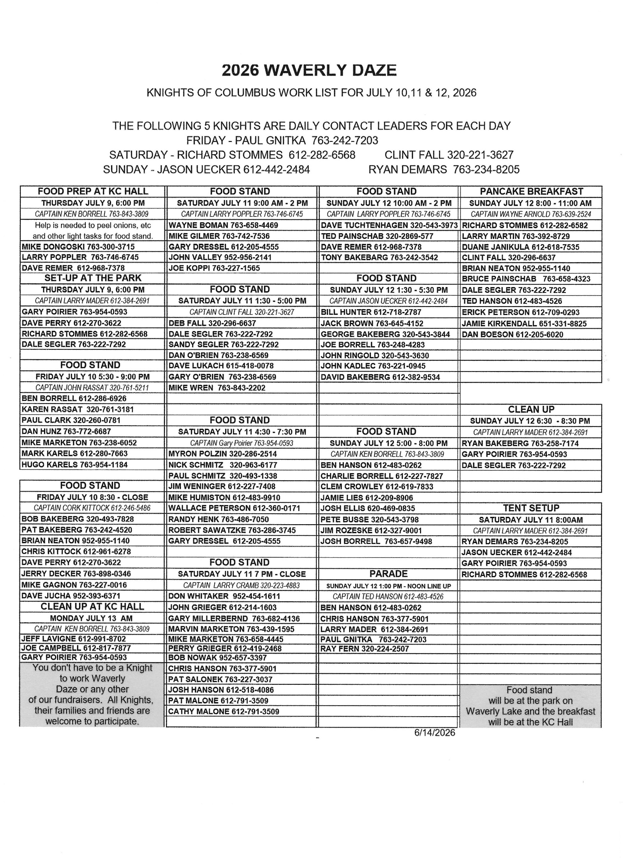
AGENT’S MESSAGE - - Joe Remer – Field Agent (612) 272-8635

ATTENTION KNIGHTS – You can also read the Crusader on the
St. Mary’s website: www.stmarys-waverly.net. Under the Get Involved tab you will be directed to open the attachment for the latest Crusader.

