The Crusader 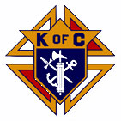

The Day of Our Lord June and July 2025

Official Publication of the Knights of Columbus-Waverly Council #1556

**Grand Knight’S Message**

Dear Brother Knights:

This is my last letter as your Grand Knight. I want to thank you for allowing me to be your Grand Knight

for the last two years. I am truly honored to have served you.

Our next major event is Waverly Daze. Please keep July 11, 12 and 13, 2025 open. This event is so large

it will take every Knight and every family member available to work. We have already been working

toward this event. Richard Stommes has already secured a donation of 900 pounds of ground beef for

one third pound burgers. John Rassat has already secured all the charcoal needed. Others are working

at getting 180 six packs of soda and 40 cases of Spring Water. We hopefully will serve over a thousand

customers that weekend.

Again, thank you for allowing me to be your Grand Knight.

Grand Knight, Larry Poppler

COMING EVENTS

June 29 - Good Neighbor Days parade. CANCELLED.

July 8 – Officers and General Meeting. TUESDAY. 5:30pm. KC Hall.

July 8 – Installation of Officers. 6:30pm. (Following General Meeting.) Lunch to follow.

July 11-13 – Waverly Daze**. (See ATTACHED WORKLIST. If you are unable to make it for the assigned shift, please contact the Captain.)**

August 11 – Officers and General Meeting. 9:30am. KC Hall.

August 17 – Montrose Days parade.

September 6/7 – St. Mary’s Fall Festival.

**YOUR PRAYERS ARE REQUESTED**

Family of Bill Mevissen, Family of Mark Kunkel, Family of Lloyd Rassat, Family of Lorraine Kittock, Family of Dale Lorentz, Dorothy Novak, Family of George Karels, Jr., Mary Sandquist, Cassie Spike, Dennis Lorentz, Natalie Caouette, Vince Halliday, Aggie Schmitz, Jen Remer, Diane Blake, Agnes Smith, Jonathan Padden, George Althoff, Julie Winsperger, Diane Carlson Evans, Carolyn Nieman, Brenda LePage, Jason Mader, Louis Taylor, Mary Martin, Carol Pollock, Rosie Jacobson, Ken Schoenfelder, Brinlee Dongoski, Gracelyn Schwindel, Amber Schwindel, Garrett Dongoski, Mary Klingelhoets, Geri Smith, Walter Marketon.

Remember in your prayers: **our priests,**those on our parish prayer list, our veterans and service men and women.

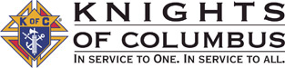

knight light –

### **The Bridge**

A man walking along a California beach was deep in prayer. All of a sudden he said out loud, "Lord, grant me one wish." Suddenly the sky clouded above his head, and in a booming voice the Lord said, "Because you have TRIED to be faithful to me in all ways, I will grant you one wish." The man said, "Build a bridge to Hawaii so I can drive over anytime I want to."  
  
The Lord said, "Your request is very materialistic. Think of the logistics of that kind of undertaking. The supports required to reach the bottom of the Pacific! The concrete and steel it would take! I can do it, but it is hard for me to justify your desire for wordly things. Take a little more time and think of another wish, a wish you think would honor and glorify me."  
  
The man thought about it for a long time. Finally he said, "Lord, I wish that I could understand women. I want to know how they feel inside, what they are thinking when they give me the silent treatment, why they cry, what they mean when they

They say 'nothing,' and how I can make a woman truly happy."  
  
After a few minutes God said, "You want two or four lanes on that bridge?"

AGENT’S MESSAGE - -

Joe Remer – Field Agent

(612) 272-8635

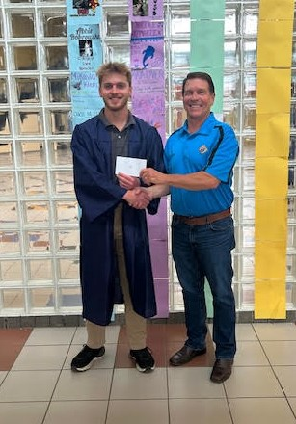 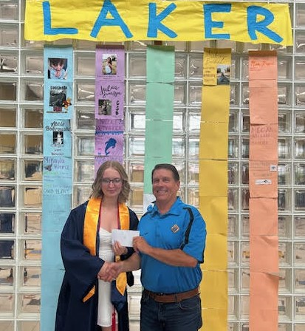

**CONGRATULATIONS**

**SCHOLARSHIP WINNERS**

**ELIJAH KARELS**

And

**ELLIE SWART**

**Best of Luck for your future and for the future of all 2025 graduates!**

Lecturer Wayne Arnold’s Message -

It has been an interesting time for the Catholic Church.  While today I had planned a different topic to talk about, the sudden naming of Cardinal Robert Prevost as Pope Leo 14th is hard to not talk about.  But what really motivated me to switch subjects was my older sister, Caroline.  Caroline married an inactive southern Baptist from Oklahoma and together they rejected the Catholic Church and joined a typical “one of a kind” Protestant church in Virginia where the pastor and elders decide what the Bible means.  As I explained in my previous talk on Protestantism, most Protestant churches don’t agree with each other, but they do tend to agree on one thing.  They particularly do not like the whole concept of a “Pope.”  What fascinates me most though, is they, like the media, pay closer attention to what the Pope does and says far more than we Catholics do.

So it should not be a big surprise that my sister knew that Cardinal Prevost was selected as Pope way before I heard about it.  Minutes after there was white smoke in Rome, she texted to my cell phone links to her church’s freshly made video criticisms saying that Pope Leo would be a disaster and even more liberal than Pope Francis on LGBT, climate change, etc to name only a few from their list of grievances.  My first thought to myself was “and why do you care?  You guys are not even Catholic?”  But just like when I was a little boy, I knew arguing with my older sister never got me anywhere so I did not reply.  I let her text message sit unanswered for a day.  I then replied with a few words of encouragement that Pope Leo appears to have many good qualities like being raised in the Midwest so he could really have good perspective on what the Catholic Church in the US needs to focus on.

But in the media right now there is a deluge of people, just like my sister, who are giving their final verdict on the new Pope.   The media is putting words in his mouth before the guy even has a chance to figure out where the closest bathroom is to his new office at the Vatican.  Put yourself in his shoes.  Imagine what it would be like to be told you are instantly responsible for 1.3 BILLION ‘stiff neck’ Catholics.  You are responsible for 221,700 parishes, and of course you are boss to 5400 Bishops and 406,996 Priests. How hard could that job possibly be…?

I would like to show you a relatively short video from Fr. Schmitz on our new Pope.  If there is interest, next month I will then explain what the actual duties and responsibilities of a Pope are.  Even more important, I can explain what power a Pope does not have, even though the media thinks he does.  Here is a spoiler alert on that topic, NO POPE CAN MAKE CHANGES TO THE CATHOLIC FAITH.  OUR CATHOLIC FAITH COMES FROM JESUS CHRIST.  PERIOD.  Our first Pope – Peter - and all those that follow him had one main job:  Proclaim the teachings Jesus Christ gave us to the whole world.  That is also Pope Leo’s main job.  Please pray for our new Pope!

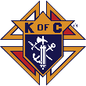**Brother Knights, Show me your Rosary!               Pray it often!**

SYNOD

Brother Knights, I salute you ! Vivat Jesus

Back in 2018 Father O’Hotto told us about Archbishop Hebda’s plan for a Synod so he could hear feedback from all the Parishes. Beginning before Covid in 2018, all parishes in our Archdiocese were instructed by Archbishop Hebda to identify the most important things that our Church and Archdiocese needed to help our Church grow. Many hundreds of sessions were held at parishes all over our Archdiocese. Even though interrupted by Covid shutdowns, parishes sifted and discussed and argued and re-sifted again this information until it was distilled down to 40 major topics, called “propositions.” In 2021, the Archbishop then requested each parish to identify two of its members who would attend a 3-day Synod in St. Paul to discuss and vote on which of the 40 were the most important priorities that we believed the Holy Spirit was calling the Archdiocese to focus on.

In 2022, Gloria Janikula and I were asked by Father O’Hotto to represent St. Mary’s at this Synod. After many months of long training and preparation sessions, we and two parishioners from each of the 200+ parishes as well as a hundred priests, nuns, and deacons met. The Synod was three very long days of prayer, adoration and meetings. The longest single session spanned 14 hours. In groups of six per table at Cretin Derim Hall, we prayed a lot, discussed, argued, and finally voted on what each of us believed to be the most important things that our Parishes should work on. The total votes each proposition received from the 500 Synod members was then given to the Archbishop.

After almost a year of further discussion between the Archbishop and his staff, Archbishop Hebda wrote a 100 page pastoral letter to all parishes telling us which priorities he had chosen for all parishes to work on the three years from 2022-2025. All parishes, including ours, were then instructed to create Synod Evangelization Teams of 12 members in each parish to begin implementing the new priorities from Archbishop Hebda. Fast forward two years to 2024. In 2024 Archbishop Hebda decided that he wanted another synod 2026 to 2029. Father Blake asked LuAnn and I to be delegates to this new synod. This Synod was held June 7. Instead of being a three-day event, this one was just one exhausting thirteen-hour day.

Much like the first Synod, this one had much prayer, discussion, and debate on what the key things are that each Catholic parish needs to do so the whole Church can grow and thrive. We then voted, and the top three vote-getters were identified. Archbishop Hebda will review that vote over the coming months and will again write a letter regarding which priorities are on deck after the current three have been completed by all parishes. But before I tell you about the top propositions, I need to answer one question you likely are asking yourself right now. Why should you care about the synod? Answer: We Knights all know it is our very core pledge as Knights to support our priests. It is even a greater duty for us to support our Archbishop as he guides our local 200+ Catholic Churches.

Our Archbishop is asking for our help now. That is why we must care and answer his call So let me do a fast summary of the first three major priorities which all parishes are currently working on now from the first Synod in 2022. Then I will tell you what the three top vote getters were in Synod 2025 yesterday. Now don’t worry, I will give you the waterskiing summary of them. Each proposition is about one page long. I am going to give you one to two sentences max on each. Here are the top three marching orders given to every parish after the 2022 Synod that we are working on now:

1. Synod 2022: Small Groups – “Create or grow a small group ministry at every parish that fosters personal relationships, builds community and provides formation to help parishioners learn about their Catholic faith and grow as disciples of Christ.” Here is a side note: Dan, Clint and I launched Cor to be the ‘small group’ for we Knights. While Knights are encouraged to join any of the small groups that have been started or were already meeting at St. Mary’s, we felt that we needed to create a KC-friendly small group where Knights and other men can eat, drink a beer, learn about our faith and talk about it with other men. Our motto is “bring a friend.” He does not need to be a Knight or even Catholic. Just any guy over 18.)

2. Synod 2022: Education for the Mass – “Educate God’s people on the beauty, form and meaning of the Mass, with special emphasis on the Real Presence of Christ in the Eucharist.” A side note on this one: This proposition is currently being worked by most parishes. In the future we in our parish and KC Council need to learn more about what happens at Mass. The more we know about it the more we and our kids will love it. Please let me know any questions you have about our Catholic faith or the Mass and I will research them and share that with the council.

3. Synod 2022: Parents as Primary Educators – “Teach and inspire parents to understand and fulfill their responsibility as the first teachers of their children in the ways of faith.” This one is just in the beginning of being rolled out to parishes over the next year or so. However, Rochelle, Jesse and many others are already working very hard to inspire parents to help teach the faith to their own children. We need to support them 110%.

OK, I quickly will now read to you the short summary of top vote getters from the 2025 Synod yesterday that all parishes will begin to work on in the next few years. The top vote getters were:

1) Synod 2025: Discipleship in Daily Life – “Teach individuals and families the art of Christian living in the modern world to be a witness of the abundant life for which God created us.” An example of this would be keeping Sunday holy instead of being just like any other work day. Another would be how do we keep our kids and grandkids from being drawn away from the Catholic faith by social media and pop culture? Etc.

2) Synod 2025: Adult Faith Formation – “Create or strengthen an intentional formation plan at every parish to help adults and families in all stages of life to live and witness to the faith in our culture today.” This one is not rocket science but is very important: If we don’t know why our Catholic faith is special, how can we tell others about it or keep our children from walking away from the faith to some other religion that looks more fun, has softer chairs, and fewer rules, etc? How can we encourage them to come back to the Catholic faith if they already have left? We must learn our faith well so that we can tell our children and grandchildren why the Catholic faith IS SPECIAL.

And the third top vote getter at the Synod this year was:

3)Welcoming and Hospitality – “Foster an intentional culture of welcoming and hospitality that seeks to encounter people where they are and open wide the doors to Christ for them.”

Brother Knights, these are the top three this year. As more instructions come out from the Archbishop and he decides which ones he wants us to focus on, I will update you. I do ask you to prayerfully consider joining a small group such as Cor or one of the others in our parish. I know that the Archdiocese left a bad taste in all of our mouths over the small group leader training. I am truly sorry for my part in that. The Archdiocese has picked itself up and dusted itself off. I ask you to please forgive that bumpy road and please remember every Knight is called to grow in faith and share it with their children and others. The Archbishop is again asking us to do precisely that. Small groups are the key first step of renewing our local Catholic Church. We need your help on this and the coming work of both the 2022 Synod as well as the 2025 Synod. THANK YOU !

**Brother Knights, Show me your Rosary!               Pray it often!**

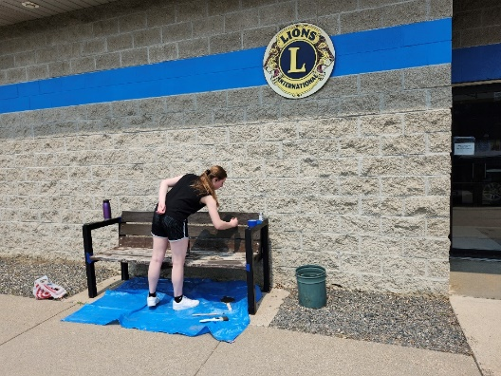

[Sidebar Title]

**THANK YOU TO**

**LAUREN DEMARS**

**FOR REFRESHING THE BENCHES OUTSIDE THE KC HALL.**

**They looked wonderful in time for Memorial Day.**

**We appreciate you, Lauren!**

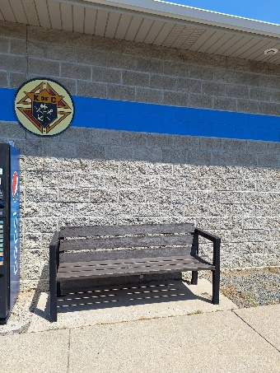

**ATTENTION KNIGHTS** – You can also read the Crusader on the St. Mary’s website: [www.stmarys-waverly.net](http://www.stmarys-waverly.net). Under the Get Involved tab you will be directed to open the attachment for the latest Crusader.

knight light –

**Elderly Woman’s Honesty**  
The pastor asked, “What do you want to thank God for today?”  
Elderly woman: “That I remembered it was Sunday.”

