The Crusader 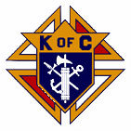
The Day of Our Lord February and March 2026
Official Publication of the Knights of Columbus-Waverly Council #1556
Grand Knight’S Message
Dear Brother Knights.
It was nice to see so many of you brave the cold and attend our KC Winter Social.
I agree with Father Blake’s message: “It is very cold outside, however nice and warm here at the Winter Social”. Once
again, congratulations to Larry Poppler for being named our KC Knight of the Year. In addition, congratulations to Jack and Stepanie Brown family as the 2025 KC Family of the Year!

As we approach spring, Lent begins on Ash Wednesday, February 18, 2026. It marks the beginning of the 40-day season of prayer, fasting, and almsgiving which prepares each of us for Easter Sunday, April 5, 2026. I pray that each of you and your families have a blessed Lenten season!

May God Bless each of you and your families,
Clint Fall
Grand Knight

COMING EVENTS
March 8 – Officers and General Meeting. 9:15am. KC Hall.
March 15-27 – Turkey Leg Ordering.
March 15 – Pancake Breakfast. Proceeds for religious retirement. 8:00-11:00am.

April 12 – Officers and General Meeting. 9:15am. KC Hall.
April 12 – Turkey Leg Pickup. 8:00am to 11:00am. KC Hall.

May – 3 – Pancake Breakfast. Proceeds for scholarships. 8:00-11:00am.
May 12 – Officers and General Meeting. TUESDAY. 6:30pm.
May 16/17 – KC State Convention

June 8 – Officers and General Meeting. 9:15am. KC Hall.
June 19/20 – Winstock Parking.
June 28 – Good Neighbor Days.

OUR PRAYERS ARE REQUESTED Family of Bill Mevissen, Family of Geri Smith, Berneal Decker, Mike Kuske, Jim Franske, James Dongoski, George Bakeberg, Bernie Reardon, Jim Mader, Stephanie Brown, Randy Hasse, Dave Padden, Luke Cain, Mary Amborn, Father Martin Shallbetter, Richard LaFave, Margaret Jordan, Dorothy Novak, Cassie Spike, Vince Halliday, Diane Blake, Jen Remer, , Jonathan Padden, George Althoff, Julie Winsperger, Diane Carlson Evans, Carolyn Nieman, Brenda LePage, Mary Martin, Carol Pollock, Rosie Jacobson, Ken Schoenfelder, Brinlee Dongoski, Mary Klingelhoets, Walter Marketon.
Remember in your prayers: our priests, those on our parish prayer list, our veterans and service men and women.
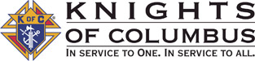

To Order Turkey Legs that will be ready for pickup on April 12:
Contact Larry Poppler (763) 746-6745 or
Mike Humiston (612) 483-9910

knight light –

During Lent, a devout parishioner wanders through heavy rain through hamburger huts and steak places into Mount Angel’s monastery and asks for shelter. He arrived just in time for dinner and received the finest fish and chips he’s ever tasted.
He walks into the kitchen after supper to thank the chefs. “Hi, my name is Brother Michael, and this is Brother Francis,” he is greeted by two brothers.
“I’m delighted to meet you. I just wanted to say thank you for a delicious dinner. I had the finest fish and chips I’d ever had. Who cooked what, just out of curiosity?”
Brother Michael replies, “Well, I’m the fish friar.”
The man turns to the other brother and says, “Then you must be . . .”
“Yes, I’m afraid I’m the chip monk.”

AGENT’S MESSAGE - -
Joe Remer – Field Agent
(612) 272-8635

SUCCESSFUL BREAKFAST AND HAM DINNER
Breakfast proceeds: approx. $900
Ham Dinner, bingo and meat raffle proceeds: approx. $2,700.

Thank you to all who helped to make these events successful.

Just a reminder that if you have not paid your 2026 KC dues yet, please take time and get them in. Please use the envelope we sent out or send them to P.O. Box 276, Waverly MN 55390. Thank you. If there is financial reason for not getting them in please call me and i will take care of them for you. Duane Janikula 612-618-7535

The Winter Social was enjoyed by all. The program included a delicious dinner followed by short remarks from Grand Knight Clint Fall, Father Blake, Wayne Arnold and State Warden Michael Bass Smith. Highlight of the night is always the awards where Council members are recognized for their contributions.
CONGRATULATIONS
LARRY POPPLER – KNIGHT OF THE YEAR
JACK & STEPHANIE BROWN FAMILY –
FAMILY OF THE YEAR

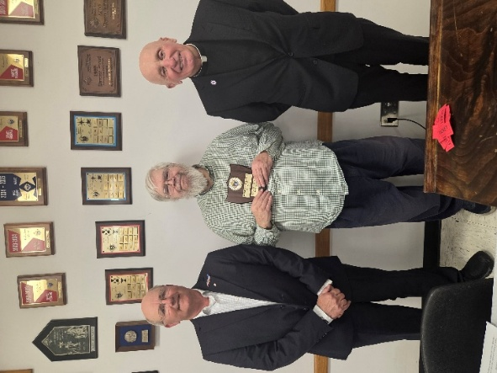

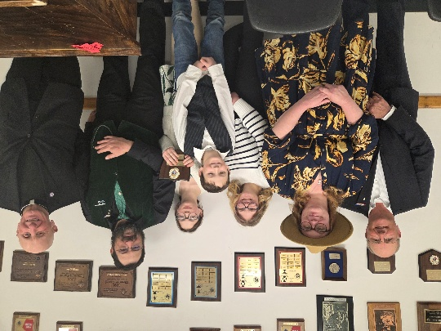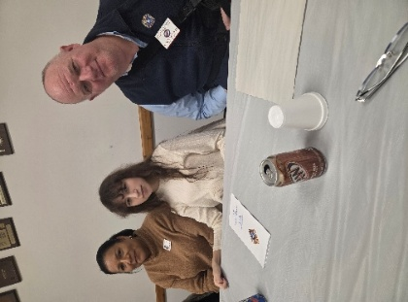
State Warden Michael Bass Smith,
his wife Anette and daughter Aston.

Lecturer Wayne Arnold’s Message – Reading the Bible
Brother Knights, I salute you ! Vivat Jesus

One of the most common New Year’s resolutions for Catholics is that they plan to read tthe Bible in the coming year. This is a great resolution. But most people give up or get bogged down with details like thinking they need to buy a new bible. Others say they are too old. Still others say the Bible is too hard to understand. Most of us think we already hear the whole
bible just by going to Sunday Mass. Nope. If we attend EVERY daily Mass and EVERY Sunday Mass for three straight years we would still only hear 71.5% of the New Testament and just 13% of the Old Testament. And how many of us actually attend EVERY daily and Sunday Mass?

Today I want to help us get past the excuses and reasons to NOT read the Bible. Some Catholics believe we are not supposed to read our bibles. Maybe that was true centuries ago, but all 9 of our recent Popes in our lifetime have said Catholics should read the Bible.

Here are examples:
-Pope Pius 12th laid the ground work in 1943 for Vatican II’s and called for reforms to encourage all Catholics to read the bible.

-Pope John 23rd convened Vatican II in 1962 which directed that the bible be translated into local languages so Catholics could read it themselves. He stated: “Ignorance of the Scriptures is ignorance of Christ.”

-Pope Paul 6th stressed in 1965 the Bible has a central role in personal study for Lay people, not just the clergy. He exhorted all Christian faithful to “gain the surpassing knowledge of Jesus Christ by frequent reading of the scriptures.”

-Pope Saint John Paul 2nd said the Bible is a vital spiritual resource and Catholics must make it a core part of their personal prayer and evangelization.

-Pope Benedict 16th said “Drawing close to the biblical texts, especially the New Testament, is essential for believers….”

-Pope Francis urged all Christians to carry a pocket bible and read a few verses every day. In an apostolic letter he said: “May the example of St. Jerome, who placed the Bible at the Center of his life, awaken in us a renewed love for the Sacred Scripture and the desire to live in a personal dialogue with the word of God.”

- Pope Leo recently said “The Church draws life not from herself but from the Gospel.” Everyone should have access to a Bible so they can “encounter the God who speaks, shares his love and draws us into the fullness of life.”

Brother Knights, reading the Bible ourselves is a VERY Catholic thing. Our devotion to the Word of God must be as strong as our devotion to the Blessed Mother and attending Mass.

Here are some tips how to start:
1. Nobody is too old to start. The older we get the more we need the help and comfort we find in the Bible. We all will stand before Jesus someday soon, and it is never too late to get right with God, learn what Jesus taught and how he wants us to live.
2. You very likely don’t need to go buy a new Bible. Just pick one in your house that talks in plain, modern, English. We are not made holy by reading old English phrases like ‘thou shalt not goeth with thy brethren to Walmart to buy-eth a new-eth bible.”
3. If you only have a Protestant bible that is easy to read, use it. Any differences are tiny in the big picture. You will not go to hell or be kicked out of the Catholic Church. When we read a bible, it is not the book or version that matters. It is what the Holy Spirit reveals to us as we read it that matters.
4. If you don’t have any Bible at home, pick up a FREE copy of “The Word Among Us” at Church. They have bible readings for every day of the next month and an excellent short thought for the day based on that day’s Bible readings. They are available on the back table after mass towards the end of the month for the next month’s readings. They do go
fast.
5. If you are comfortable with your phone or computer, another option is there is a website called “USCCB,” which stands for United States Conference of Catholic Bishops. It has all of the daily readings and even the whole Bible on-line for free. And if you want, it even will read the readings out loud if you want to just sit and listen to them. There also are
many other free on-line Catholic bibles.
6. If you really would like your own bible but can’t afford one, let me know. I would be honored to give you one!
7. Ok, so you have a bible, or the “Word Among Us” booklet and now where do you start?
A. Pray first and every time before reading scripture. Ask the Holy Spirit to open your
heart and mind to God&#39;s truth.
B. If you are using the Word Among Us, just look for today’s date. It has all of the day’s
bible verses right there. After you read the readings for today’s daily Mass, then flip to
the front of the booklet and find today’s date to read a nice, short, “thought for the
day” why the bible teaching you just read is important.
C. If you are going straight to the big book on the coffee table, DO NOT, I REPEAT, DO
NOT go to page one of the Old Testament book of Genesis. So many people give up
reading the Bible if they begin in the Old Testament. It is far too dry. Instead, start
reading the Gospel of Mark in the New Testament. Read just one to two chapters per
day and let the Holy Spirit reveal why the passage you just read is important in your
life. End with a quick Our Father or a Hail Mary. 15 minutes of your time, tops. Then
do it again tomorrow.
D. It is OK to write in your bible as you read. Take notes, underline, use a highlighter.
Write down what you think it means to you or questions you have. You will not be
struck by lightning if you write in your bible.
E. After finishing the Gospel of Mark, I recommend either reading Mathew, Luke or John,
(or all of them!) Some people decide that after Mark they prefer to read the Book of
Acts since it follows nicely after Mark and shows how the early Catholic Church then
began to grow after Jesus rose from the dead. Either way is great.
F. After finishing the Gospels, read the New Testament Letters from Paul, Peter and the
other Apostles. But I recommend not reading Revelations. It is too confusing and in
some ways makes little sense. Read that book the very last.
G. After you are done with the New Testament, then start reading the Old Testament. The
first five books of the Old Testament explain the covenant between God and his
people. It is where the ten commandments came from. It also lays the foundation for
Jesus as savior, which is God’s new covenant with us in the New Testament.
H. If you find a verse, or even a whole Bible book that seems really confusing, SKIP IT
and move on. The Bible is a library of 73 separate books. There were at least 40
different people who wrote those 73 books. Don’t get hung up with their different
styles.
I. Reading the Bible should not be speed reading. Take time to think about what you
just read and what it teaches you about Jesus, the Father, and the Holy Spirit. Go
slowly and let the Holy Spirit talk to you. After you finish the whole bible, do it again!

So these are my tips to help us keep our New Year’s resolution to read the bible. If you come to our next Cor meeting, we will be talking more about cool ways to read the Bible that were created by Jeff Cavins and Father Michael Schmitz. As Knights, please remember what our current Pope and the 8 who preceded him have strongly urged the faithful: “Ignorance of the Scriptures is ignorance of Christ.”
Brother Knights, Show me your Rosary ! Pray it often !

Take Home Summary from COR8 “Reading the Bible”

➢ Catholics do not read the Bible. Most of us scoff at our Protestant friends and we say ‘we hear the Bible at Mass, so why should we read it ourselves?’ But is that really true? No. If you attend Mass every Sunday AND every daily Mass per year for three years, you will still only hear 71% of the New Testament, and less than 20% of the Old Testament. Readings at
Mass are a GREAT start, but the context of what Jesus was doing and why he did them gives a much bigger picture that is critical to understanding our faith. But Catholics often say the Bible is too hard to read. It is too complex. Let me be blunt: Those reasons don’t hold water. It is not written in Latin anymore. The past 9 Popes have urged the Catholic faithful to start reading their Bibles. There are many different ways to successfully read the Bible: 1). For Newbies, read the Gospel of Mark and then Acts of the Apostles. 2). For the more experienced, read the whole New Testament end to end. 3). For the really hard core, read the Bible cover to cover in order. But this is best as a second time through the Bible, not the first. 4). Father Michael Schmitz and Jeff Cavins have teamed up to create daily podcasts where they read the whole Bible to us in one year. Takes only 25 minutes per day. Totally free. Plus they explain difficult teachings. They make the Bible much easier (and
fun) to understand and to take to heart. The key to their method is they focus on the 14 books in the Bible that are a timeline in order starting with Creation. Here are those 14 books in the timeline order: Genesis, Exodus, Numbers, Joshua, Judges, 1 Samuel, 2 Samuel, 1 Kings, 2 Kings, Ezra, Nehemiah, 1 Maccabees, Luke, and Acts. The other books provide more details and examples, but the main path through the bible story is the 14 listed books in this order.

➢ Please consider becoming a Bible-reading Catholic. There is no story in human history more important to each one of us and our family’s salvation than what is in those 73 books we call the Bible. One final tip. If a chapter, or book is too confusing or boring, SKIP IT. Come back to it later. The key thing is do not give up reading the Bible ! Find a method that
works for you and stick with it!

Videos Used:
1)Fr Michael Schmitz The Bible in 10 Minutes:
https://www.youtube.com/watch?v=Jm3b4Q98Vx8&amp;list=PLifViogRg9v06uWK-rnhdo-
xWeOlsJHgh&amp;index=1&amp;pp=gAQBiAQBsAgC
2) Fr Michael Schmitz Bible in a Year promo:
https://www.youtube.com/watch?v=VLkfaapmddI&amp;list=PLifViogRg9v06uWK-rnhdo-
xWeOlsJHgh&amp;index=2&amp;pp=gAQBiAQBsAgC
3) Reading the Bible with Jeff Cavins:
https://www.youtube.com/watch?v=OJwE5LhjfXE&amp;list=PLifViogRg9v06uWK-rnhdo-
xWeOlsJHgh&amp;index=3&amp;pp=gAQBiAQB0gcJCU8KAYcqIYzvsAgC
4) Fr Michael Schmitz Preparing for the Bible in a Year Journey
https://www.youtube.com/watch?v=qvROgfajuMY&amp;list=PLifViogRg9v06uWK-rnhdo-
xWeOlsJHgh&amp;index=4&amp;pp=gAQBiAQBsAgC

ATTENTION KNIGHTS – You can also read the Crusader on the St. Mary’s website: www.stmarys-waverly.net. Under the Get Involved tab you will be directed to open the attachment for the latest Crusader.

knight light –

Bent over and obviously in pain, the old man with a cane hobbled laboriously through the sanctuary and into the pastor’s office while the choir practiced.
Ten minutes later, he came out, walking upright and moving gracefully and quickly.
“Good gracious,” the choir director exclaimed. “Did the pastor heal you by faith?”

“No,” the old man said with a smile. “He just gave me a cane that wasn’t six inches too short!”

