The Crusader 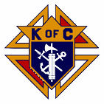
The Day of Our Lord December 2025 and January 2026
Official Publication of the Knights of Columbus-Waverly Council #1556
Grand Knight’S Message
Dear Brother Knights,
It is hard to believe that we are near the end of another busy year. I would like to thank each of you for your personal support and for your dedication to our wonderful council. I am also grateful to be able to get to know many of you more on a personal basis as we work together on the many charitable fundraising events throughout the year. I pray that each of you and your families experience a Blessed Merry Christmas and a Safe, Healthy and Happy New Year! We hope to see everyone at our KC Winter Social
at 6pm on January 24, 2026.

May God Bless each of you and your families,

Sincerely,
Clint Fall
Grand Knight

COMING EVENTS
January 3 – Bingo. Proceeds for student loans. 6:30pm. 12 games. KC Hall.
January 6 – Officers and General Meeting. TUESDAY, 6:30pm. KC Hall.
January 11 – Pancake Breakfast. Proceeds for Hall Maintenance. 8:00-11:00am.
January 24 – Winter Social. 6:00pm. KC Hall.

February 8 – Officers and General Meeting. 9:15am. KC Hall.
February 14 – Ham Dinner/Meat Raffle. 4:00pm to 7pm dinner. Bingo starts 7:00pm.
Parish Center.

March 8 – Officers and General Meeting. 9:15am. KC Hall.
March 15-27 – Turkey Leg Ordering.
March 15 – Pancake Breakfast. Proceeds for religious retirement. 8:00-11:00am.

YOUR PRAYERS ARE REQUESTED Randy Hasse, Dave Padden, Luke Cain, Mary Amborn, Larry Poppler, Father Martin Shallbetter, Richard LaFave, Margaret Jordan, Dorothy Novak, Cassie Spike, Vince Halliday, Diane Blake, Jen Remer, Agnes Smith, Jonathan Padden, George Althoff, Julie Winsperger, Diane Carlson Evans, Carolyn Nieman, Brenda LePage, Jason Mader, Mary Martin, Carol Pollock, Rosie Jacobson, Ken Schoenfelder, Brinlee Dongoski, Mary Klingelhoets, Geri Smith, Walter Marketon.
Remember in your prayers: our priests, those on our parish prayer list, our veterans and service men and women.
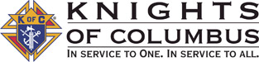
Brother Knights: You will receive a mailing in the next week or so regarding your 2025 dues. The information indicates the amount of your dues and a return envelope to send them back. Thank you for being prompt in doing so.
Any questions, please give me a call 612-618-7535.
Duane Janikula, Financial Secretary

knight light –


We pray this Christmas holds for you
The fullness of God's peace,
And the joy of the true meaning
For this wonderful time of the year —
And may God's love and hope be yours
To share with family and friends,
For God's love is a wonderful gift
That gives everlasting life.
Merry Christmas!

This Photo by Unknown Author is licensed under CC BY-SA-NC

At the KC Memorial Mass in November, we remembered Brother Knights who died in the past year.
Ed Burns, Dale Lorentz, Mark Kunkel. May they rest in peace.

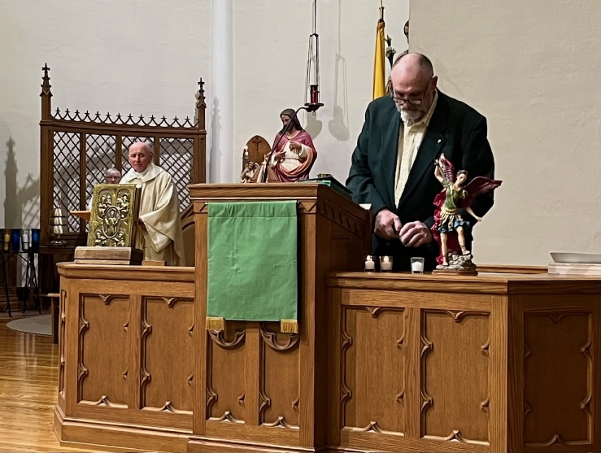

AGENT’S MESSAGE - -
Joe Remer – Field Agent
(612) 272-8635

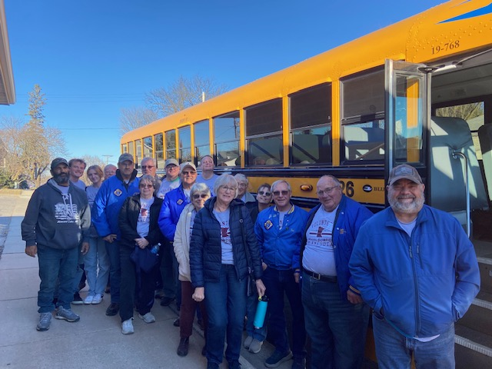
THANK YOU, VOLUNTEERS!
Your participation in the Special Olympics Bowling Event in November was much appreciated. Our Council had great representation and all who volunteered came away with a good feeling and new bowling friends!
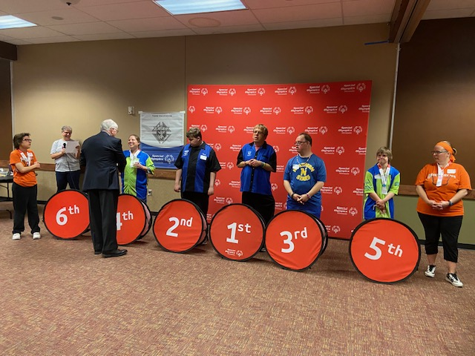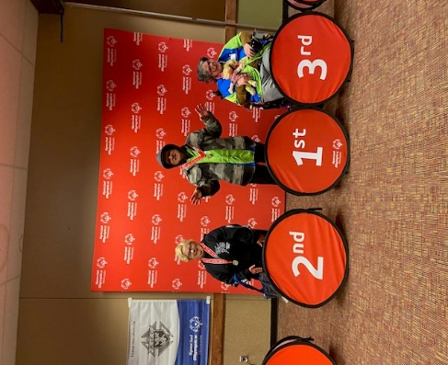
Lecturer Wayne Arnold’s Message – THE BIBLE
As you may recall, I have told you about my older sister that decades ago left the Catholic Church and joined a non-denominational Protestant Church in Virginia. While she has never said it out loud, I think she has always been worried about my Catholic faith and she sees it as her job, as the older sister, to “save” her little brother, Wayne. I get lots of texts each month pointing me to some preacher’s talk on one Protestant subject or another. And for my birthday in January, she even bought me a gigantic Founder’s Bible. It is actually a very beautiful Protestant Bible with amazing art. I will
tell you about it in a few minutes, but I have a bit more context about my sister.

My sister is very conservative, probably more conservative than our current President. She retired as a full commander in the US Navy, been married 50+ years to a sailor from the USS Enterprise, has two sons that are retired Marines, and a Grandson now in the US Naval Academy. She is super patriotic and also into the amazing history of how our great nation and her state of Virginia were founded. With this being her background, it makes sense that she would send me a
“Founders Bible.” Until it arrived last December, I had never heard of such a thing. The Founder’s Bible is truly unique because in addition to its standard scripture pages it also gives examples from the personal writings and lives of our Founding Fathers how they were guided by particular scripture passages. There are many hundreds of such mini-stories and writings by the men that drafted the Declaration of Independence, the US Constitution, the documents creating the US
Supreme Court, etc, that are sprinkled next to related Bible scriptures. It is a Bible plus deep US history lessons in the same book.

Like a good little brother, every day I have been reading a chapter out of this Bible my sister gave me. I started with the Old Testament. I have made it through the first twelve books of the Old Testament in the Founder’s Bible, about 600 pages so far, and I just finished 2nd Kings, a really hard book to read. At the same time, I also have learned enough American History on the Christian founding of the United States that I could probably now teach 7th grade American History in the local
Catholic School. I am not complaining, it has been interesting and time well spent learning how the founders of our country, including our early Presidents, had a VERY strong Christian faith. It is also interesting how our woke schools have totally covered up that intense Christian faith of our founding fathers and mothers. Most of the colonists risked everything to come to this country to have the freedom to practice their faith without some European King telling them what to believe and how to worship God.

So with that background, let me tell you what I learned about the 1st and 2nd book of Kings I just currently finished in the Founder’s Bible. King David and then his son Solomon ruled Israel about 1000 years before Christ. They worshiped and obeyed God, most of the time. When they messed up, they repented. After they died however, Israel split in two, Judah and Benjamin in the south and then the northern 10 tribes called “Israel.” The 16 kings after King David and their subjects worshiped false gods such as Baal and a dozen other pagan gods. They totally forgot the covenant between God and
Abraham, Moses and David. As a result, over many hundreds of years, God allowed those Jewish kingdoms to be ravaged by war and eventually conquered. The pattern happened over and over, with the same bad result due to bad kingdoms. But then in the year 622 BC, King Josiah discovered a long-lost scroll of the Jewish Law of Moses in what was left of the great Temple in Jerusalem. It was kind of like finding a long-lost box in the basement. This scroll is what we now call the book
“Deuteronomy.” On reading its contents, King Josiah “tore his clothes, wept and repented” that he and Judah had turned so far away from God. He made all of Judah listen to the words from the Law of God. They repented and turned back whole heartedly to the one true God just as King David. God was pleased and Josiah’s kingdom prospered and was not destroyed. After King Josiah died, however, Judah went back to worshiping false gods. All of Israel and Judah suffered and repeatedly
were conquered over the next 600 years, first by neighboring pagan kingdoms and finally by the Greeks and Romans. Then Jesus was born as true God, true Man, and true King. Jesus gave the world a renewed understanding of God’s Law lost 600 years before when King Josiah died.

But as they say, history does repeat itself. Whenever the faithful stop reading the word of God and stop teaching it to their children, they end up worshiping money, possessions and seeking pleasure. Bad things then happen to them and their nations. Nations of the world today are just like the Jews of old, we don’t read and follow the Word of God. We forgot the faith in God. We are too busy. Did you know that from the days of Moses until the birth of Jesus, about 1500 years in total,
there were no books? Jewish children were required to memorize the Torah (which is the first 5 books we call the ‘Old Testament’). Back in the early days of the founding of the United States in the 1700s, Christian children from all denominations similarly learned to read using only the Bible. They MEMORIZED the Gospels. There were no other printed books besides the Bible at that time. In the US today, it is still very common for Evangelical Protestants to read and study their Bible daily. It is also common for active Evangelical families to require their children to memorize large amounts of scripture. While some Catholics study scripture and make their kids memorize parts of it, most Catholics have gotten soft. We take the easy road and assume that if we go to Mass the scriptures will be read to us so we don’t need to bother to read, study or memorize it ourselves. While the official position of the Catholic Church is that Catholics are strongly encouraged to personally read the Bible daily, most of us do not. We, like the Jews of old, have forgotten the “Law of God.” Most of us and our kids can’t even recite the ten commandments or the beatitudes in order. I know I can’t. Is the Bible used today for teaching in any public school in the US, Europe or right here in Minnesota? Nope. In how many states are the ten commandments displayed in a public school or public building? Not many. And it is hard to ask this final very important question: Do we expect God to be OK with a nation that turns away from God and his Son as we have in the United States? It did not work out so well for the Jews when they turned away from God…. Or are we going to be like King Josiah and
repent?

So what is the bottom line? All Catholics are called by the Church to read their Bible daily, teach it to their children and then live those words in their day-to-day lives. Like in the days of King Josiah, it is not hard for us to return to God’s Law. For us we can start by reading the gospel of Luke, then read the Acts of the Apostles. After that, we should read the other New Testament Gospels and the letters written by Saints Paul and Peter. After that for good measure we should read the first five books of the Old Testament which helps explain what Jesus taught. The key principle is don’t give up. If any of the Bible books seem dull or confusing, just skip ahead and go to the next one. Every Catholic and Knight can easily read a chapter or two per day. It is pleasing to God that we learn His Holy Word. It draws us and our families closer to Jesus our Savior. And the Holy Spirit often will speak to us and answer prayers as we read passages in the Bible. But the very first simple step is to pick a Bible. There are a number of excellent versions approved by the Catholic Church. But if you are super patriotic or
a history buff and want a Bible with a more unusual way of presenting the Holy Scriptures and incredible pictures, pick up a “Founder’s Bible.” You may like it a lot. Just make sure to also read the missing 7 books that the Protestants left out. One last thing: If you do try the Founder’s Bible please promise me you won’t ever tell my sister that I suggested it. She will never leave me alone or stop saying “I told you so…!

Brother Knights, Show me your Rosary! Pray it often!

SKIN CANCER
Brother Knights,
Today I am going to depart from my normal talks about faith to instead talk about something that just happened to me. In the past, I told you about my ongoing journey with prostate cancer, and a number of you said that talk reminded you to take steps in your own health care. Today I unfortunately need to tell you that I now have skin cancer – two different kinds. I have learned much in the past two weeks about skin cancer, and I thought it might be of some use to you to hear what I
learned.

So here is what happened: My wife regularly sees a dermatologist and made me schedule an appointment. It took almost a year to get in due to shortage of skin doctors. I saw my new dermatologist, Dr Freeman, November 12th. Dr Freeman used a handheld device, called a dematoscope, to scan the skin on my whole body. The gismo looks kind of like a lighted hand
magnifier. Except it costs thousands of dollars due to special electronics and lights to help him look through the surface of the skin for cancerous growths. He was really fast. He looked at the skin of my whole body in 10 minutes. He found three small spots he did not like. I had not even noticed them. One was on my forehead, one on my right ear, and one on my neck under my left ear. He then used a liquid nitrogen squirt gun to freeze each spot. Next, he gave me a shot of Novocain at each site and used a small tool to cut off each bump for biopsy. Each was smaller than ¼”. Each of my three spots were so small I would not even have used a Band-Aid if I had a nick that small out in my workshop. It barely hurt. The doctor then sent my 3 biopsies to a lab. Four days later he called with my results. 2 spots were cancer, one was not. There are three common types of skin cancer, Melanoma, Squamous Cell Carcinoma, and Basal Cell Carcinoma. The one biopsy from my neck is a version of melanoma called “melanoma in situ.” That means the melanoma cancer at that spot is currently only in the top layer of skin and still is in its earliest stage. It has a good survival rate if removed quickly. But melanoma is very dangerous and in only months can spread deeper into the skin and then to lymph nodes and then throughout the body. Around 9000 people die in the US each year because of melanoma skin cancer. The five-year survival rate for melanoma is 99% if it is detected and removed quickly before it spreads to lymph nodes. If melanoma spreads to nearby lymph nodes, the five-year survival rate drops to 66%. If it has spread to distant lymph nodes and other organs, the five year survival rate is 27%. My biopsy from my forehead is Basal Cell Carcinoma. Basal cell carcinoma is the least dangerous skin cancer and tends to stay localized. Squamous Cell Carcinoma, the third type and the one type I don’t have, does spread. Squamous cell and basal cell cancers kill around 2000 people per year in the US, mostly the very elderly. In most people, basal cell and squamous cell carcinomas are highly treatable, particularly when caught early.

The bottom line is skin cancer is the most common cancer in the US. Over 5 million new cases of skin cancer are diagnosed in the US every year. In comparison, there are about 2 million new cases each year of all other cancers types combined that are not skin cancer. One in five Americans will develop skin cancer in their lifetime. Melanoma, the worst skin cancer type, accounts for over 63,000 new cases each year in the US. 15% of patients with it will eventually die from it, mainly because it was not caught and treated early enough. Skin cancer is often caused by UV damage from the sun or tanning beds. Early warning signs can include new skin spots or changes to existing or irregular moles. Risk factors include fair skin, a history of sunburns and having many moles. People who use tanning beds before age 35 increase their risk of melanoma by 75 percent, according to The Skin Cancer Foundation. The risk of skin cancer definitely increases with age. Skin cancer is most common in adults over age 65 but younger people are also sometimes affected. The human immune system normally kills
abnormal cells that are pre-cancerous to ‘nip it in the bud.’ BUT as we get older, our immune systems work less well and it doesn’t find and kill those early cancer cells in our bodies. The older we get, the higher the risk that skin cancer, (and other kinds of cancers too) can get a foothold in us. And if we have a compromised immune system at any age, that can increase our risk.

Here are some important health statistics: Approximately 42% of older males will develop some form of cancer during their
lifetime, with risk increasing significantly as we age. The most common cancers for older men are, in descending order, skin cancer is #1, then prostate, lung, bladder and colorectal cancer.

So how did I get skin cancer? I have been asking myself this a lot lately. I never once have been in a tanning bed or did risky stuff like spending a lot of time using strong farm or industrial chemicals. But I did work out in the sun for many jobs I had and to do chores. I wore a ball cap or straw hat. I did not like sunscreen and still don’t. It is smelly and sticky and seemed like a bit of a marketing scam to me. Once in a while I got a little pink in the sun, but most of the time I was careful. In short, I was an ordinary guy, with ordinary skin, doing ordinary things outside. And now I have two kinds of skin cancer at age 69. Likely from sun damage that occurred decades ago. My 3-hour surgery to remove my cancers and surrounding skin is Wednesday, December 10th. Because my cancers were caught very early, my doctor says they only will need to remove a quarter sized piece of skin at the site of each tumor. They don’t need to worry about deeper tissue or lymph nodes yet, but they will be checking on that during the surgery. Going forward the doctor says I am now required to be screened for skin cancer every six months.

For most adults: Just like a routine dental or eye doctor exam, we should have a routine annual skin screening by our regular doctor, or even better, a dermatologist. The American Cancer Society recommends professional skin exams every three years for everyone aged 20-40, and annually for those over 40. For high-risk individuals, more frequent exams (every 6 months) are appropriate if we have a personal or family history of skin cancer, fair skin, a history of sunburns, or an abundance of moles. If you notice a new mole, growth, or a sudden change in an existing spot (like itching, bleeding, change in shape, color, or irregular edges), most dermatologist set aside time each day for those urgent, unplanned, checks of a changed mole just noticed by a patient. It does not replace our obligation to schedule a proper full appointment or whole-body exam. Quick checks are typically limited to a single new spot that has appeared that has you worried. The idea is doctors don’t want us to wait months before for our regular checkup if something urgent shows up on our skin. It may be
nothing, or it could be something bad if not caught early. Call the doctor! DON’T MESS WITH MELANOMA or the other skin cancers. But still make your regular appointment for a complete checkup. My skin cancers snuck up on me. I did not notice anything unusual looking.

Brother Knights, to sum up: As we get older, we ALL need to see our doctor once per year and get screened for the common types of cancer including skin cancer. We need to remind all our loved ones, woman or man, of all ages that they also need to regularly see a doctor every year and get screened for the cancers that can harm them. Many of us worry about the cost. Here is a tip: Most general practice doctors are willing to do a referral to a dermatologist which often can help keep it
covered by insurance. And there also are things we can do ourselves: Look for any new spot on your skin or a change in an existing mole’s color, shape, or size. Other signs can include a shiny, red, or skin-colored bump; a rough, red patch; or a spot that itches or hurts. Avoid prolonged sun exposure, especially during midday. Protect yourself with sunscreen, even on cloudy days. (Just ignore the smell.) And certainly, don’t use tanning beds.

I know this talk today may sound like a downer and that I am whining about my newly discovered skin cancer. That is not my intent. There are a lot of men in this room right now that have had far more serious cancers impact their lives and their loved ones than I am facing. Mine is a ‘nothing’ compared to theirs. But the reason for this speech is to encourage and remind you and your loved ones to get yourselves checked for skin cancer since it is often overlooked and can be fully cured if caught early. Don’t ignore your skin!
I now have three types of cancer in my body, but I nevertheless plan to live to 100 years old. As the great country and western singer Kenny Chestney sang, “everybody wants to go to heaven, but nobody wants to go now”.... All I can say is “Amen on that!”

Brother Knights, Show me your Rosary! Pray it often!

ATTENTION KNIGHTS – You can also read the Crusader on the St. Mary’s website: www.stmarys-waverly.net. Under the Get Involved tab you will be directed to open the attachment for the latest Crusader.

knight light –

One Sunday, Fr O’Malley was preaching against the evils of alcohol when he added a visual demonstration to his fire and brimstone lecture. He filled a glass with whiskey into which he dropped a wiggling worm. The worm quickly stopped moving and died. The preacher asked the congregation, “What did you learn from this demonstration?” “Father,” said Paddy, “I learned that if you drink whiskey, you will not have worms.”

