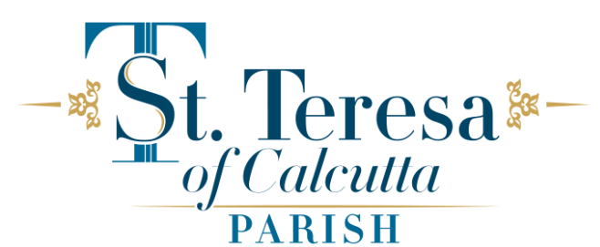
Parish Council Minutes – January 15, 2026
Present on Zoom:
Father Peter, Rob Parkerson, Lisa Murphy-Cipolla, Regina Wiegert, Deacon Bill, Claire Lacourse, Cynthia Niedbala, Cathy Cooke.
Absent:
Annmarie Smith, Cathy Jenkins, Mike Baldi, Robert Healey,
Opening prayer
Father Peter opened the meeting with a prayer
Approval of prior meeting minutes
Upon review of the minutes from the prior meeting the council accepted and approved them.
Parish Council Membership
The council discussed the need for additional members on the council.
CCD
Cynthia Niedbala, DRE, provided an update on the CCD program.
Closing prayer
Father Peter concluded the meeting with the closing prayer at 6:48 pm.
The Next meeting will be Thursday, February 19 at 6:00 pm.
VIA ZOOM
Respectfully submitted,
Robert Parkerson

