

General Price List
Casket Price List
Outer Burial Container Price List
***These prices are effective as of October 1, 2026, and are subject to change without notice***

Lake Martin Funeral Home and Cremation

16797 Highway 280
Dadeville, Alabama 36853
Telephone (256) 750-0381 Joseph Dean 334-750-3751
lakemartinfuneralhome.com
joseph@lakemartinfh.com
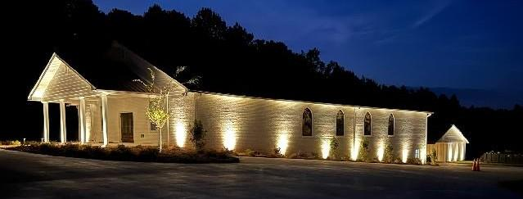

Our Mission
Our Mission is to assist families during their greatest time of need with professionalism, integrity, and dignity. It is our sincere hope that we can and have in some way helped ease the burden that has been yours. If we can be of any other assistance, please do not hesitate to call upon us. Thank you for allowing Lake Martin Funeral Home and Cremation to serve your family.
Beginning October 1, 2026, the State of Alabama has issued a non-declinable, $30 fee for each individual. This will appear on your Statement of Goods and Funeral Services as a $30 “Administrative Fee”. We apologize for any inconvenience.
The goods and services shown below are those we can provide to our customers. You may choose only the items you desire. However, any funeral arrangements you select will include a charge for our basic services and overhead. If legal or other requirements mean you must buy any items you did not specifically ask for, we will explain the reason in writing on the statement we provide describing the funeral goods and services you selected.
Professional Services
- Basic Services of Funeral Director and Staff…………………………………………………………………………………$3,495.00
Our Charge includes consultation with the family or responsible party; staff and facilities to respond to initial requests for service; coordinating service plans with cemetery, crematory, and/or other parties involved in the final disposition of the deceased; securing official documents and necessary registrations and sheltering of the deceased. This fee for our basic services and overhead will be added to the total cost of the funeral arrangements you select. (This fee is already included in our charges for direct cremations, immediate burials, and forwarding or receiving decedent.)

- Additional Services for Arranging, Filing, and Logistics (Technology Fee)……………………………..…..……….1,995.00
This is the charge to each family we serve for the services that our office performs. It includes but is not limited to: ordering of the death certificates from appropriate county, filing insurance claims, creation and submission of obituary notice to newspaper(s), submission of death to Social Security Administration and the State of Alabama, the creation of lobby signage for decedent, and posting to company website and Facebook. Use of TV’s, Sound, video, etc….

- Other Preparation of the Deceased
- Embalming…………………………………….……………………………………………………………………………..….$1,295.00
Embalming is not required by law. Embalming may be necessary, however, if you select certain funeral arrangements, such as a funeral with viewing. If you do not want embalming, you usually have the right to choose an arrangement that does not require you to pay for it, such as direct cremation or immediate burial.
- Dressing, casketing, and cosmetology………………………………………………………………….……...…..….…$ 200.00
- Dressing and casketing Only…………………………………………………………………………….……………..….…$ 150.00
- Special care of autopsied cases or organ/Tissue donation................................................................$ 500.00
- Washing and disinfecting the decedent with no embalming……………………………………………………..…$ 350.00
- Shelter and storage of the decedent (per day commencing on the 4th day).……………………………….……$100.00
- Identification prior to direct disposition required or requested)..........................................................$100.00
- Refrigeration (per day)………………………..……………………………………………………………………………..…..$100.00
(This fee will be charged if unembalmed decedents are held at the Funeral Home beyond the initial 48 hour period after death)

Professional Services for Children
Fees for children are a percentage of the above charges and will be quoted upon request.

Facilities, Equipment & Staff
- Use of facilities and staff for visitation (up to 3 hours) ..…………………………………………………………………..…….$750.00
Each Additional hour per hour………….…………….………………………………………………………………….…………..….$300.00
- Use of Facilities and Staff for funeral service………….……………………………………………………………….…………...$750.00
- Use of Facilities and Staff for Memorial Service……...…………………………………………………………..….……...….…$750.00
(This charge is for on or off our premises).
- Use of equipment and Staff for Church Service…………………………………………………………………………….…....…$750.00
- Use of Equipment and Staff, Tent, Twelve chairs and Cemetery grass for Graveside Service………..……..….....$1,595.00
- Crematory Fee……………………………………….………………………………………………………………………………...….…..$550.00
- Return of Cremated Remains.
- Pick up at Lake Martin Funeral Home (16797 Hwy 280 Dadeville, AL 36853) Within business hours ( Monday-Friday: 8 a.m. – 5 p.m. CT or Saturday: 10 a.m. – 2 p.m. CT. *Please make sure to call at least 24 hours in advance on Saturdays; so, we can make sure to have everything ready for you………………………………....….Free/No charge
- USPS Priority Express Shipping: shipped within the continental U.S. with a tracking number and estimated time of arrival. Once shipped, delivery or parcel receipt left 24-72 hours. SIGNATURE REQUIRED.………….……......$150.00
- Delivery (By funeral home representative) to address within 90 miles of LMFH …………..........………………...$150.00
- Delivery (By funeral home representative) to address 90-200 miles of LMFH……………….....………..….………$250.00

Transportation

Charges based on a 50 mile radius. Beyond this radius we charge $4.00 per mile for the service/utility vehicle, and $5.00 per mile for the funeral coach.
- Removal/Transfer of Remains to Funeral home …………………………………………………………….….………….…...…$595.00
- Funeral Coach (Hearse) …………………………….…...………………………………………………………….………………...… $595.00
- Lead/Clergy Sedan.……………………..….………………………………………………………………………….………......…….. $395.00
- Service/Utility Vehicle………………………..……………………………………………………….……………….…………...…..…$395.00
- Transportation to common carrier – (Atlanta/Birmingham Airport)……………..…………………………..………….……$450.00

Special Services
Forwarding Remains To another Funeral Home……………………………………………………..…...$3,695.00
Included:
- Basic Professional Services of Funeral Director and Staff and Overhead
- Clerical and Administrative Services
- Embalming AND/OR Other Preparation of the Deceased
- Removal/Transfer of Remains to Funeral Home (within 50 miles)
Not Included:
- Casket
- Transportation to the Common Carrier (Atlanta Airport-100 miles)
- Merchandise (Memorial Register, Memorial Folders, Acknowledgement cards, etc.)
- Cash Advance items (Death Certificates, Newspaper Obituaries, Opening/Closing of Grave, Hairdresser, etc.)

Receiving Remains From another Funeral Home…………………………………………………….....$3,150.00

Included:
- Basic Professional Services of Funeral Director and Staff and Overhead
- Clerical and Administrative Services
- Transportation (within 35 miles) from our Funeral Home to Cemetery or Crematory
Not Included:
- Embalming AND/OR Other Preparation of the deceased
- Use of Facilities and staff for viewing/visitation
- Use of Facilities and staff for Funeral Ceremony
- Use of equipment, Staff, Tent, Twelve chairs, and Cemetery Grass
- Casket
- Merchandise (Memorial Register, Memorial Folders, Acknowledgement Cards, etc.)
- Cash Advance Items (Death Certificates, Newspaper Obituaries, Opening/Closing of Grave, Hairdresser, etc.)
- Vault Installation

Burial

NOTE: The following packages include only the items listed. You may select additional service and/or merchandise; however, you may not delete or substitute any items from the packages. Cash advance items are addition
Immediate Burial $4500.00 - $4500.00
A. Immediate Burial (without ceremony with casket provided by purchaser) ................$4500.00
B. Immediate Burial (without ceremony with casket purchased from funeral home. Casket cost is additional)....................................................................................................................$4500.00
Included:
- Basic Professional Services of Funeral Director and Staff and Overhead
- Additional Services for Arranging, Filing and logistics
- Clerical and Administrative Services
- Removal/Transfer of Remains to Funeral Home (within 50 mile radius)
- Transportation (within 35 mile radius) of the Deceased to Cemetery

Not Included:
- Embalming AND/OR Other Preparation of the deceased
- Use of Facilities and staff for viewing/visitation
- Use of Facilities and staff for Funeral Ceremony
- Use of equipment, Staff, Tent, Twelve chairs, and Cemetery Grass for graveside
- Casket
- Outer Burial Container
- Merchandise (Memorial Register, Memorial Folders, Acknowledgement Cards, etc.)
- Cash Advance Items (Death Certificates, Newspaper Obituaries, Opening/Closing of Grave, Hairdresser, etc.)
- Vault Installation

Complete Traditional Service (Church, Chapel, Graveside).................................................$6495.00
Included:
- Basic Professional Services of Funeral Director and Staff and Overhead
- Additional Services for Arranging, Filing and logistics
- Clerical and Administrative Services
- Embalming
- Other Preparation of the Deceased
Dressing, Casketing and Cosmetology (not including Hairdresser)
- Use of Equipment & staff, Tent, Twelve chairs and Cemetery grass for Graveside
- Use of Facilities & staff for Visitation (up to 3 hours)
- Removal/Transfer of Remains to Funeral Home (within 35 mile radius)
- Transportation (within 35 mile radius) of the Deceased to Cemetery
- Use of Equipment and staff for funeral service
- Use of Funeral Fleet – Funeral Coach, Lead Car and Flower Van

Not Included:
- Casket
- Outer Burial Container
- Cash Advance Items (Death Certificates, Newspaper Obituaries, Opening/Closing of Grave, Hairdresser, etc.)
- Merchandise (Memorial Register, Memorial Folders, Acknowledgement Cards, etc.)
- Vault Installation

Cremation Services
Note: The following packages include only the items listed. You may select additional services and/or merchandise; however you may not delete or substitute any items from the packages. Cash advance items are additional.

Direct Cremation $2,995 - $3995.00
- Direct Cremation (without ceremony with container provided by purchaser) ………………………………………...$2,995.00
- Direct Cremation (without ceremony with container purchased from funeral home. Urn cost is additional).................................................................................................................................................$2,995.00
- Direct Cremation (with Embalming and Private Viewing) ..................................................................…………$3,995.00
Included:
- Basic Professional Services of Funeral Director and staff and overhead
- Clerical and Administrative Services
- Removal/Transfer of Remains to Funeral Home (within 35 miles)
- Transportation (to the Crematory)
- Crematory Fee
- Alternative Cremation Container
If you want to arrange a direct cremation, you can use an alternative container. Alternative containers encase the body and can be made of materials like fiberboard or composition materials (with or without an outside covering). The containers we provide are cardboard and meet all requirements of Alabama law. A cremation container and ashes container are required by Alabama State Law.
Not Included:
- Embalming
- Other Preparation of Deceased
- Use of Facilities and Staff for Visitation
- Casket
- Cremation Urn
- Burial Urn Vault
- Merchandise (Memorial Register, Memorial Folders, Acknowledgement Cards, etc.)
- Cash Advance items (Death Certificates, Newspaper Obituaries, O/C of Grave, Hairdresser, etc.)

Your Funeral Director can explain to you the many options available with cremation. Please feel free to ask any questions.

The following packages are in addition to, not in place of, direct cremation option.
Cremation Package A: Cremation with Memorial Service………………………………………………………..…$3,750.00
Included:
- Basic Professional Services of Funeral Director and Staff and Overhead
- Clerical and Administrative Services
- Use of Facility and Staff for Memorial Service
- Removal/Transfer of Remains to Funeral home (within 50 miles)
- Transportation (to the crematory)
- Crematory Fee
- Alternative Cremation Container and temporary Urn
Not Included:
- Embalming
- Other Preparation of the Deceased
- Casket
- Outer burial Container
- Merchandise (Memorial Register, Memorial Folders, Acknowledgement Cards, etc.)
- Cash Advance Items (Death Certificates, Newspaper Obituaries, O/C of Grave, Hairdresser, etc.)

***Memorial Service and Visitation…………………………………………………………………….….....$4,495.00

Cremation Package B: Visitation with Cremation following ……….......................................$5,995.00
Included:
- Basic Professional Services of Funeral Director and Staff and Overhead
- Clerical and Administrative Services
- Embalming
- Other Preparation of the Deceased
- Use of Facilities and staff for visitation (up to 2 hours)
- Removal/transfer of remains to funeral home (within 35 miles)
- Crematory Fee
- Alternative cremation container and temporary urn
- Casket – solid oak rental casket

Not Included:
- Merchandise (Memorial Register, Memorial Folders, Acknowledgement Cards, etc.)
- Cash Advance items (Death Certificates, Newspaper Obituaries, O/C of Grave, Hairdresser, etc.)

Cremation Package C. Complete Funeral Service with cremation following…………………..…..$6,995.00
*Body present at Memorial Service*
Included:
- Basic Professional Services of Funeral Director and Staff and Overhead
- Clerical and Administrative Services
- Embalming
- Other Preparation of the Deceased
- Use of Facilities and staff for visitation (up to 2 hours)
- Removal/transfer of remains to funeral home (within 35 miles)
- Crematory Fee
- Alternative cremation container and temporary urn
- Casket – solid oak rental casket

Not included:
- Merchandise (Memorial Register, Memorial Folders, Acknowledgement Cards, etc.)
- Cash Advance items (Death Certificates, Newspaper Obituaries, O/C of Grave, Hairdresser, etc.)
Brown Service Policy Funeral

With Valid, In-Force Brown-Service Burial Policy Only
Included:
- Basic Professional Services of Funeral Director and Staff and Overhead
- Embalming AND Other Preparation of the deceased
- Use of Facilities and staff for viewing/visitation
- Use of Facilities and staff for Funeral Ceremony
- Removal/Transfer of Remains to Funeral Home (within 35 mile radius)
- Transportation of the Deceased to the Cemetery (within 35 mile radius)
- Casket Specified by Brown Service Policy

Not Included:
- Additional Services for Arranging, Filing and logistics
- Use of Equipment & staff, Tent, Twelve chairs and Cemetery grass for Graveside
- Transportation of the Deceased beyond 35 mile radius
- Service/Utility Vehicle (Flower Van)
- Memorial Package
- Outer Burial Container
- Cash Advance Items (Death Certificates, Newspaper Obituaries, O/C of Grave, Hairdresser, etc.)
- Vault Installation

Services not provided by Brown Service Policy

Included writing and distributing, website obituary, completing memorial info, arranging with service participants (ministers, speakers, musicians, or pallbearers), transportation of flowers, Funeral Director’s lead car, pre-recorded music or piano rental, and website memorial page.
If you have further questions about deviating from the policy or a policy upgrade, please ask your Funeral Director for details.
Casket Price List
Effective as of January 16, 2026
Caskets range from $795.00 - $12995.00

Bronze and Copper
48 oz. Bronze Z64 Classic Gold Velvet $9,995.00
48 oz. Bronze Z64 Venetian Velvet $9,495.00
32 oz. Copper Y33 Jefferson Silver Velvet $6,795.00

Stainless Steel
Stainless Steel OR 6 Renaissance Velvet $5,895.00
Stainless Steel OR 7 Greyson Velvet $5,895.00
Stainless Steel OD1 Platinum Velvet $5,495.00
Stainless Steel Regency Velvet $5,195.00
Stainless Steel Champagne Pearl Velvet $5,095.00
Stainless Steel U86 Silver Pearl Velvet $5,095.00
Stainless Steel UG1 Sapphire Velvet $4,595.00

Carbon Steel
18 Gauge Capstone Velvet $4,290.00
18 Gauge Plainsman Velvet $4,290.00
18 Gauge Carson Velvet $3,740.00
18 Gauge Meadow Merlot Crepe $3,595.00
18 Gauge Stapleton Velvet $3,575.00
18 Gauge O61 Burnished Silver Crepe $3,395.00
18 Gauge O61 Tuscany Silver Crepe $3,395.00
18 Gauge 887 Keystone Basketweave $3,295.00
18 Gauge Springfield Velvet $3,295.00
18 Gauge Sheffield Velvet $3,295.00
18 Gauge J37 Primrose Crepe $3,295.00
18 Gauge J37 Amethyst Crepe $3,295.00
18 Gauge OT9 Platinum Velvet $3,150.00
18 Gauge Patriot Black Twill $2,995.00
18 Gauge Freedom Blue Twill $2,995.00
18 Gauge Horizon Crepe $2,495.00
20 Gauge M39 Velvet $2,495.00

20 Gauge Wingate Crepe $2,395.00
20 Gauge Q88 Revere Crepe $2,295.00
20 Gauge Jessup Crepe $1,995.00
20 Gauge Spectra NG Crepe $1,595.00

Wood
Mahogany Olympus Velvet $9,995.00
Cherry Pembroke Velvet $7,695.00
Poplar Magnolia Velvet $4,595.00
Poplar Provincial Crepe $4,395.00
Oak American Barn Natural Cotton $3,695.00
Poplar Fredrick Basketweave $3,595.00
Pecan Sebring Brocade $3,595.00
Pecan Veneer Woodhaven Velvet $3,595.00
Hardwood Riley Linwood $3,295.00
Maple Country Maple Crepe $3,495.00
Pine Portland Pine Crepe $2,975.00
Hardwood Endicott Crepe $2,695.00
Pine Cloth Covered Satin $895.00

Cremation Caskets
Poplar Dayton Basketweave $3,295.00
Veneer Rosiebrook Crepe $2,495.00
Veneer Lexington Crepe $1,895.00
Veneer Norfolk Crepe $1,595.00
Cloth Fiberboard Dawson Crepe $795.00

Ceremonial Caskets
Cherry Barrett Velvet $1,595.00
Oak Donovan Crepe $1,295.00

Alternative Container
Fiberboard Alternative Unlined $175.00

Vault Price List
Effective as of January 16, 2026
Vaults range from $350.00-$4695.00
State or local law does not require that you buy a container to surround the casket in the grave. However, many cemeteries require that you have such a container so that the grave will not sink in. Either a grave liner or a burial vault will satisfy these requirements.

Concrete Vaults
Concrete Wilbert Copper Triune-Lined $5,595.00
Concrete Wilbert Venetian-Lined $2,095.00
Concrete Wilbert Continental-Lined $1,995.00
Concrete Wilbert Monticello 30” -Lined $1,895.00
Concrete Wilbert Monarch 30” $1,295.00

Steel Vaults
Steel 12 Gauge Galvanized $2,100.00
Steel 12 Gauge Basic $1,645.00

Polypropylene Vaults
Polypropylene Atlas $1,595.00
Polypropylene Air Seal $1,395.00
Polypropylene Graveliner $795.00

Urn Vaults
Concrete Stainless Steel Triune-Lined $975.00
Concrete Monticello- Lined $575.00
Polypropylene 18” Standard Black $435.00
Polypropylene 14” Standard Black $350.00

Cemetery Services – Cash Advance
Open and Closing Grave (during the week, service before 3:00 pm) $995.00
Open and Closing Grave (during the week, service after 3:00 pm) $1,195.00
Open and Closing Grave (weekend/holiday) $1,595.00
Open and Closing Urn Grave (during the week, service before 3:00 pm) $350.00
Vault Installation (Installing burial vault) $550.00
Cutting Date of Death $400.00

Accommodation Caskets
18 Gauge
18 Gauge Steel Ridgefield 32” Crepe $3,995.00
18 Gauge Steel Ridgefield 28” Crepe $3,495.00
18 Gauge Steel Columbia Char 28” Crepe $3,095.00
18 Gauge Steel Ridgefield 27” Crepe $2,895.00

20 Gauge
20 Gauge Steel Whitney 35” Crepe $3,795.00
20 Gauge Steel Whitney 32” Crepe $3,595.00
20 Gauge Steel McKinley 28” Crepe $2,795.00
20 Gauge Steel Majestic NG 28” Crepe $2,095.00

Wood
Poplar Provincial Grande 33” Crepe $4,395.00
Poplar Dakota 27” Basketweave $3,795.00
Poplar Vista 27”` Crepe $3,795.00
Poplar Viscount 29” Crepe $3,395.00

Accommodation Vaults

Steel 12 Gauge Basic Steel 36” $2,395.00
Concrete Wilbert Monticello 34” Lined $2,195.00

Miscellaneous
Shipping Container Combo $250.00
Shipping Container Air Tray $250.00

Clothing
Women’s Dresses and Gowns (includes undergarments) .........................................................................$195.00
Men’s Suits (includes shirt, tie, and undergarments).................................................................................$295.00

Additional Offerings
The following items, which we regularly have available, may be purchased from us as they fit your needs:
.
Guest Register Book…………………………………..…................…....................................................................$125.00
Personalized Memorial Folders ……..………………..……...…………………………………………………………….…..$75.00/100
Service Bulletin ……………………………..….……………….…….................................................................. $150.00/100
Acknowledgement Cards ………(50 cards with envelopes)…………………………………………………………………. $50.00
Personalized Acknowledgement Cards available upon request
Memorial Package (Includes Register book, acknowledgement cards and service records)…………..$225.00
Flag Cases
Wooden Flag Case………………………………..………………………………………………………………...$245.00-$75.00
Plastic Flag Pouch…………………………..………….…………………………………………………………………….... $25.00
Keepsake Video …………..…………………………….…………………………………………………………………………………$150.00
Each additional copy……………………………….........………….……………………………………………………………….….$20.00

Keepsake candles and jewelry prices available upon request
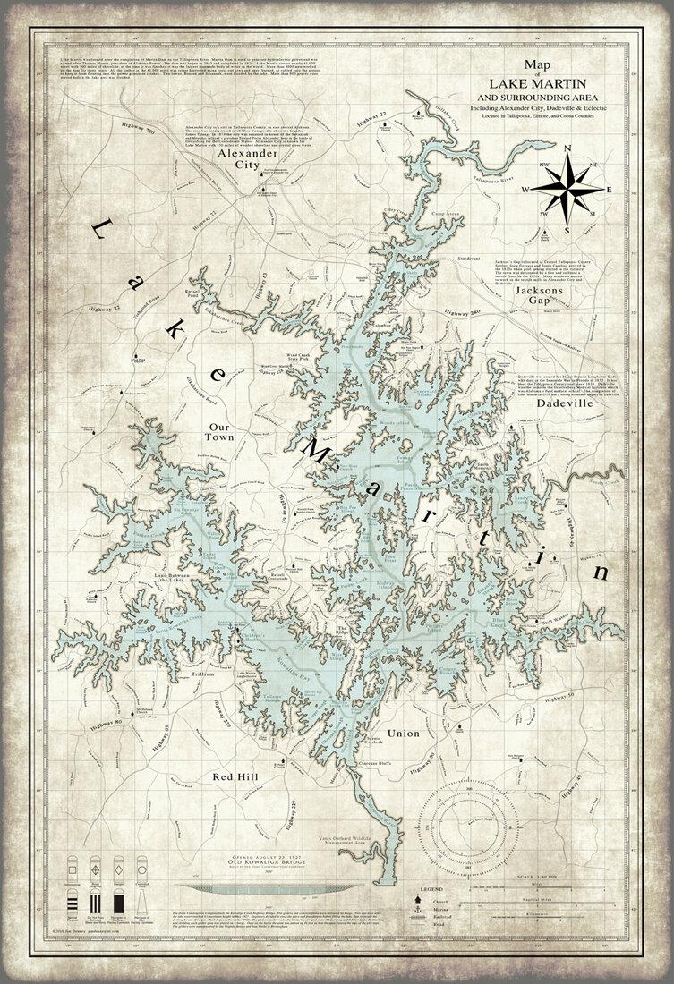

PAYMENT POLICY
To lose someone you love is a devastating human experience. It is frequently traumatic and can seriously impact judgement. We believe in the importance of the recognition and meaningful celebration of a life that has been lived and will assist in arranging an appropriate service to meet individual needs.

It is also important to be realistic with respect to funeral expenditures. We do not want a family to spend more than they should nor less than they would like. We believe that it is important that arrangements be in keeping with a family’s wishes and budget.
We require payments be made at the time of arrangements.
For your convenience we will accept the following methods of payment:
- Cash, Check, or Debit Card
- Visa – Mastercard – Discover – American Express
(A 3.5% convenience fee will be added)
- Insurance Assignment of a verifiable policy
(A 4% convenience fee will be added)
- Advance payment by forwarding or receiving funeral home
- Pre-Arrangement

Due to complexity and time involved, we are unable to accept payments from Estates.

Services will NOT be available on Easter Sunday, Christmas Day, or Thanksgiving.
Warranty Disclaimer
Our funeral home makes no representations or warranties regarding caskets or outer burial containers. The only warranties expressed or implied, provided in connection with goods sold by this funeral home, are the written warranties, if any, extended by the manufacturers thereof. No other warranties and specifically, no implied warranties of merchantability or fitness for a particular purpose, are extended by the funeral home.



