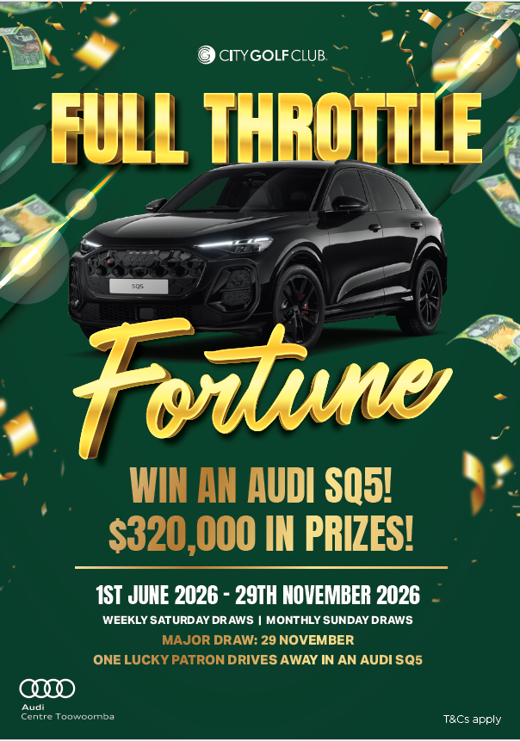

Terms and Conditions

- This promotion is conducted by City Golf Club staff.
- Promotion runs at the above times except for during other conflicting promotions.
- The promotion will be run at the City Golf Club. Entries to the physical barrel & virtual barrel will accumulate at The City Golf Club according to the Draw Schedule.
- Winners for Club wide draws will be announced via the public address system at The City Golf Club.
- Winners must be present at all draws to be eligible to claim prizes.
- Patrons called to claim prizes will have 2 minutes to present themselves to draw staff with identification to claim the prize.
- Once 2 minutes have passed the called patron will no longer be eligible to claim the prize and another patron will be drawn until an eligible winner is found.
- Management decision on all matters is final.
- Club Management reserves the right to finalise, alter or amend the promotion if deemed necessary. Any decision made will be final and no correspondence will be entered into by the Club.
- If an act, omission, event or circumstance occurs that is beyond the reasonable control of The City Golf Club and prevents The City Golf Club from complying with these terms and conditions, The City Golf Club will not be liable for any failure to perform or delay in performing its obligation and The City Golf Club reserves the right (subject to applicable law) to cancel, terminate, modify or suspend any promotion.
- The City Golf Club Board Members, officers and employees will not be liable for any loss, damage or personal injury whatsoever (including but not limited to direct, indirect and consequential loss) suffered or sustained in connection with any promotion, the marketing of a promotion or use of any prize, except for any liability which cannot be excluded by law.
- The City Golf Club reserves the right to re-draw any winning prize in a promotion in the event of the following: (i) a breach of these terms and conditions (ii) the forfeiting of a prize (iii) unclaimed prizes or (iv) inability to contact the winner.
- The City Golf Club cannot be held responsible for any communications that is delayed due to third party providers including short message service (SMS), multimedia message service (MMS), electronic direct mail (EDM) or direct mail.
- Prizes are not transferable or redeemable for cash once won.
- Patrons are capped at 3 Audi entries– meaning if a patron wins more than 3, they forfeit that Entry - their Audi entry will be drawn out of the red barrel after the 9 winners are found on the mayor draw day, 4pm 29th November 2026.
Entry Mechanism (Barrel Draw):
- Entries will be printed from POS terminals, Member Kiosks based on the schedule of Entries below.
- Physical entries are generated with eligible food and/or beverage purchase of $10 at POS with a valid member card (all media types).
- Physical entries are generated with eligible Keno purchases of $10 with valid member card.
- Physical entries are generated by kiosk swipe, one entry per day per person.
- Patrons are responsible to collect entries from purchases, swipes & plays and enter them into the entry barrels. The City Golf Club and staff will not be liable for patrons failing to collect entries or failing to enter them into the barrel prior to draws commencing.
- Entries drawn during draws will not be returned to the barrel.
- No further entries will be allowed to be put into the barrel in between barrel draws on the day of each draw.
- Barrel will be emptied at the end of each monthly draw.
- Patrons must be 18+ to be eligible.
- Patrons must be financial members of the Club to participate in this promotion. Suspended or cancelled memberships are not eligible.
- Staff members and immediate family (living in the same household) are not eligible to claim prizes in this promotion.

City Golf Club-Entry Mechanism (Virtual Gaming Draws):
- Entries will be awarded for each $20 turnover with a membership card correctly inserted in the gaming machine at the City Golf Club.
- Double virtual entries will accumulate 10am to midnight Mondays, Tuesdays & Wednesdays during the promotion period.
- Entries accumulate from 10am 1st June 2026 to the end of the promotion.
- The virtual barrel will be emptied at the end of each weekly draw.
- Patrons must be 18+ to be eligible.
- Patrons must be financial members of the Club to participate in this promotion. Suspended or cancelled memberships are not eligible.
- Patrons must be in the City of Gold Gaming lounge at The City Golf Club to claim their prize.
- Staff members and immediate family are not eligible to claim prizes in this promotion.

