May 6th
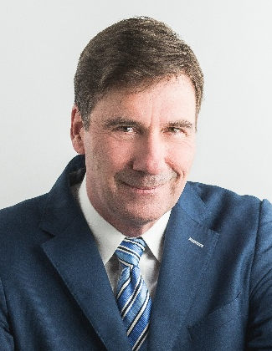
KEYNOTE — BOB KITTELL
Memory & Connection Expert
Bob Kittell is an engaging speaker and trainer who helps people strengthen their memory, recall names and faces, and build meaningful connections through the power of listening. With humor, energy, and practical techniques, Bob makes learning unforgettable.
He has shared the stage with legends such as Zig Ziglar, Brian Tracy, Tom Brady, Les Brown, Terry Bradshaw, and George Bush, inspiring audiences in more than 300 cities worldwide. His proven memory methods are fun, easy to learn, and immediately applicable to business and personal success.
Bob began his career by founding Memory Improvement Systems, teaching tens of thousands of students at over 100 universities how to retain and recall information. Today, his message continues to inspire people to connect deeply, remember more, and succeed with confidence.

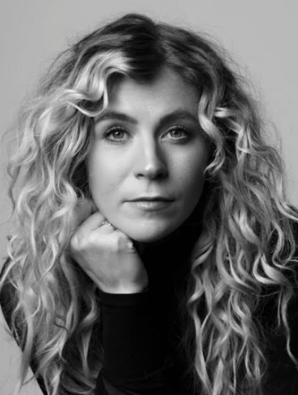
EMMA GRACE HAMILTON
Through Memory, We Heal: My Story of Loss, Addiction and the Power of Remembering
Emma Grace Hamilton is a licensed funeral director, singer-songwriter, and speaker from Salt Lake City, Utah. After losing her brother - the musician who first inspired her - in 2018, Emma stepped away from music and struggled to find her creative voice. In 2020, she returned to songwriting with Illenium, co-writing and performing the track Brave Soul, released in 2021 on Illenium’s Grammy-nominated album Fallen Embers. After a season of deep personal struggle, Emma survived a devastating motorcycle accident in 2023 that reshaped her life and purpose. Today, she uses her platform to help others navigate grief, embrace vulnerability, and rediscover hope in the aftermath of loss.

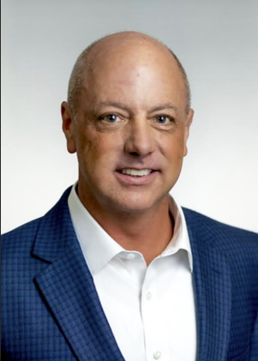
LANCE RAY
Prep Room Safety
Lance has been involved in funeral service since 1990. Lance is the Chief Operating Officer for Pierce Chemical. Lance holds a Funeral Director /Embalmers license in Texas. He is a graduate of the Dallas Institute of Funeral Service where he earned an Associate of Science degree and holds a Bachelor of Science in Human Resources from Friends University, Wichita, KS.

Prior to working on the supply side of funeral service he worked in a 600-call funeral home in Wichita, KS as their prep room manager.

Over the past 30 years Lance has held various positions within the family of Wilbert dealers covering Kansas, Colorado, Arkansas, Oklahoma, Michigan, and Ohio. He accepted the position as Executive Vice President of Sales and Marketing at Pierce in December of 2012 after the purchase of Pierce by Wilbert Funeral Services, Inc. and in 2014 he was promoted to COO of Pierce.

Lance has three grown children and in his spare time enjoys competing in Ironman Triathlons – he has completed 7 Ironman events and has signed up to do his 8th IM event on May 16th, 2026, in Jacksonville, Florida. In addition to his love for triathlons, last year Lance completed the Boston Marathon along with 30,000 other crazy runners on a charity bib. He raised $12,000 dollars.

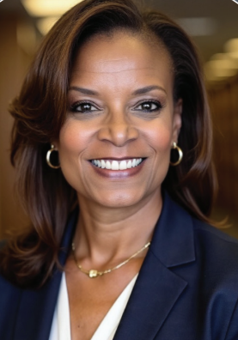
ANGELIQUE SIMPSON-MATTHEWS
Put Your Mask on First Before Assisting Others—Self Care in Funeral Service

Angelique has been a much-sought-after speaker, trainer, and personal development coach for individuals, teams, and corporations for the past 30 years. As the Professional Development Director for Matthews, Angelique leads funeral directors through exciting and innovative seminars designed to inspire and educate. Angelique is well-known for her high energy and dynamic training programs that express learning in an exciting way.
Angelique’s journey as a trainer started in the healthcare industry, but through the years she has supported training for the real estate industry, medical field, funeral service, and legal firms to name a few.
Angelique happily joined the Matthews Aurora™ team in 2016, where she gets to share her positive energy and true passion for the funeral service profession through professional development.
Angelique is a graduate of UCLA, and she, her husband Michael, and their daughter Bethany enjoy a life filled with fun travel as often as they can get away.

May 7th
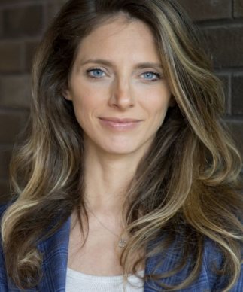
KEYNOTE — JANINE STANGE
Choose to Rise: Decisions that Ignite Momentum
Janine Stange is a motivational speaker, singer, and on-air personality. She is best known for her historic journey to sing the Star-Spangled Banner in all 50 states – a mission she embarked on to honor our brave. Her story is the subject of “National Anthem Girl” a documentary by Kelly’s Filmworks now streaming on Amazon Prime and Apple TV.
Janine has been featured on every major television network and appeared on national news shows including: TODAY Show, Fox & Friends, NBC Nightly News, and Fox News @ Night. She can also be heard every Thursday morning on Sirius XM’s 60’s Gold with Phlash Phelps.
For more information on Janine, please visit: www.janinestange.com and follow on social: Twitter: @TheAnthemGirl, Facebook: NationalAnthemGirl, Instagram: JanineStange. Join "Janine's Team" by texting USA to 33777.

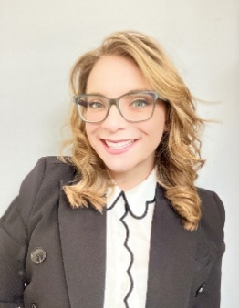
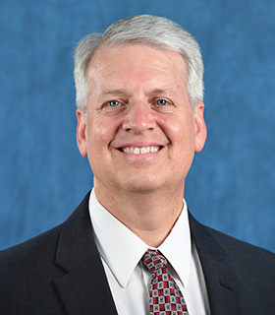
JEFF ZEALLEY & STEPHANIE KELLY
A Conversation with Students
Jeff Zealley has been a licensed funeral director and embalmer since 1991 and has worked in Virginia, Idaho, Wyoming, Montana, and Utah. He has been an active member of DMORT since 2002. He has an MBA and a master’s in bioethics. He has taught full-time at Salt Lake Community College Mortuary Science Program since 2015, where he teaches mortuary science, bioethics, and a class about Louisiana. Jeff loves to travel and has been to all 50 states and 23 countries. A tenacious tombstone tourist has visited hundreds of cemeteries and taken over 10,000 photos. He recently discovered the fun of cleaning headstones and has cleaned hundreds of them, mostly in Louisiana. He loves cooking (and eating), mostly Cajun and Asian foods. Since his teen years, Jeff has been fascinated with most everything related to World War II. His favorite animals are sharks. His greatest joy, however, is spending time with his wife, four children, and six grandchildren.

Stephanie Kelly is an Assistant Professor in the Mortuary Science Program at Salt Lake Community College and a licensed funeral director. A graduate of the same program she now teaches in, she brings both professional experience and a student-centered approach to preparing future funeral service professionals.
She is currently pursuing a master’s degree in education technology and instructional design, focusing on strengthening online learning and enhancing classroom engagement through innovative teaching strategies.
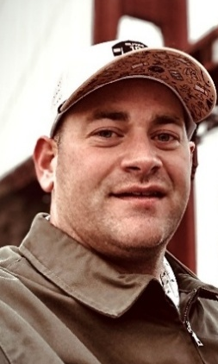
TYLER MORRISON
Small Cases, Big Responsibility: Advancing Infant Embalming Standards
Tyler Morrison, CCO, was born in Nampa, ID in 1990 and was raised in Moses Lake, WA. After serving an LDS mission in Riverside, CA, Tyler decided to follow in his father’s footsteps by beginning his studies in funeral science in 2013. He received his mortuary science degree from the Commonwealth Institute of Funeral Service and became a licensed Funeral Director in 2016. He has always been drawn to the technical aspect of funeral service. Tyler’s passion for serving families has come from embalming, cosmetics, and restorative art. His current position is with Larkin Mortuary as the Care Center Manager.
Tyler and his wife Melissa have three adorable children and are currently residing in Woods Cross, UT. Besides being a dedicated and loving father, Tyler is also a serial hobbyist and enjoys a variety of sports and recreational activities. Among the most consistent are hockey, golf, photography, bargain shopping, and running a small custom laser engraving shop in his spare time.
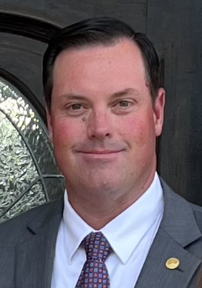
LADD PULLIAM
Global Funeral Trends: What Today’s Families Expect and How you can Deliver.
Ladd Pulliam is a licensed funeral director and embalmer and has been with Jones and Son Funeral Home for almost 20 years. Ladd and his wife Jennifer became owners of Jones and Son Funeral Home in August of 2017 following the purchase from the Jones family. Ladd is a graduate of Greene County High School, Jones County Jr College, and East Mississippi Community College. Ladd and his wife Jennifer are residents of Leakesville and they, along with their daughter Addison Claire, attend Sweet Water Missionary Baptist Church in Leakesville. Ladd is a member of the Mississippi Funeral Directors Association, where he has served two terms as President, and he is also a member of the National Funeral Directors Association. He also serves the citizens of Greene County as Coroner, a position he has held since 2013. Ladd is a member of the Hattiesburg Officials Association as a football official. In his free time, he enjoys traveling, playing golf, and fishing.

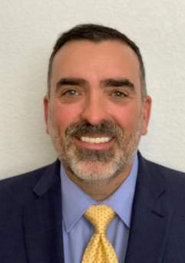
^{JOHN FUDENBERG}
Mass Fatality Preparedness, Lessons Learned from the Las Vegas Mass Shooting
John Fudenberg is the Executive Director for the International Association of Coroners and Medical Examiners (IACME) and conducts private consulting services in the medicolegal profession, disaster preparedness and legislative services.

John retired in 2020 after over thirty years of public service in law enforcement and the medicolegal profession. John served as the Coroner for the Clark County Office of the Coroner/Medical Examiner (CCOCME) in Las Vegas, Nevada. John is a past commissioner of the National Commission on Forensic Science and currently serves as the chair of the American Academy of Forensic Sciences Standards Board (ASB) Medicolegal Death Investigation Consensus Body. John is also a past president of the IACME.

In October 2017, John led the coroner's response team after the mass shooting in Las Vegas, Nevada, bringing to the forefront the need for continuous planning, coordination, and training in the medicolegal death investigation field as well as the need to aggressively address wellness/mental health in Coroner/Medical Examiner Offices.

