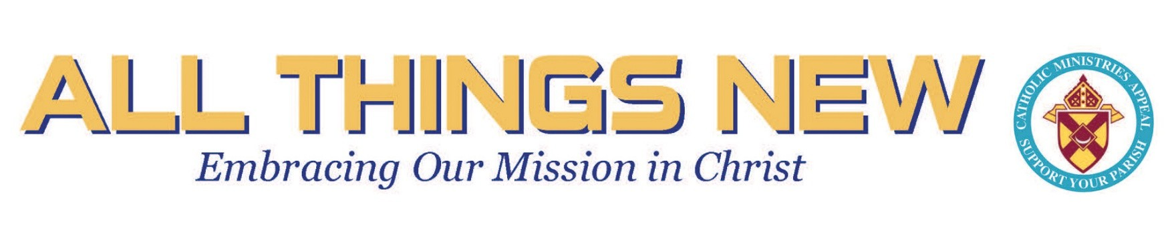
Goal
$107,000
2026-2027 CATHOLIC MINISTRIES APPEAL

Dear parishioners,
Today, we launch our 2026–2027 Catholic Ministries Appeal Campaign here in the parish. As you know, this is a wonderful opportunity for each parish in the Diocese to support our shared mission and the many ministries that serve our Catholic community.
Thanks to the generosity and commitment of our beloved parishioners, St. Martin de Porres has been very successful in reaching the goal each year, and I am confident that this year will be no different.
Therefore, I invite each of you to prayerfully consider making a gift and investing in this important mission. Your generosity strengthens our parishes, faith formation programs, Catholic schools, ministries, seminarians, and charitable outreach throughout all 12 counties.
Through your financial support, we are able to promote Catholic education, nurture vocations, support those preparing for the priesthood, and extend Christ’s love and compassion to those most in need. In a very personal way, the CMA has also helped address the shortage of priestly vocations by making it possible for the Diocese of Rochester to welcome men from Colombia—like me—who have been called to serve as priests here in the diocese.
For this reason, I am personally and deeply grateful for the CMA. Through this program, I have been given the opportunity to come to this country, discern and prepare for the priesthood, and ultimately serve both the American and Hispanic communities. Your generosity makes these opportunities possible and allows the Church to continue responding to the needs of God’s people with faith, hope, and charity.
Thank you for your continued generosity and commitment to our parish and to the mission of the Catholic Church. Together, we can make a lasting impact and ensure that our shared faith continues to grow and flourish.

HOW CAN YOU HELP US REACH THE GOAL?

- Make a pledge by December 1, 2026
This year, our parish goal is $107,000, representing an $8,000 increase over last year’s goal ($99,000). Please, prayerfully consider making a gift this year and pledge support by December 1, 2026. Your consideration is greatly appreciated.

- Make a Gift to the CMA from your IRA
This is a special opportunity for those at least 70 ½ Years Old. You can give any amount directly to the CMA without having to pay taxes on the amount as part of your annual income. This option is called the Charitable IRA Rollover, and you may have seen it also referred to as a Qualified Charitable Distribution (QCD). If you are 73 or older and required to take minimum distributions (RMDs), a QCD can count toward your RMD obligation.
Your disbursement must come directly from the administrator of your IRA to the Diocese (you should not receive the funds first).
The check should be made payable to: Diocese of Rochester/CMA. Please request a notation with the gift to include: Your Name and Your Parish
The Diocese of Rochester/CMA is a qualified charity. The EIN or Tax ID# is 16-0755765.

Please have the check mailed to: CMA/Diocese of Rochester (1150 Buffalo Rd. Rochester, NY 14624)

THANK YOU FOR YOUR SUPPORT & GENEROSITY

God bless you all!
Fr. Carlos

Scan this QR code to donate

