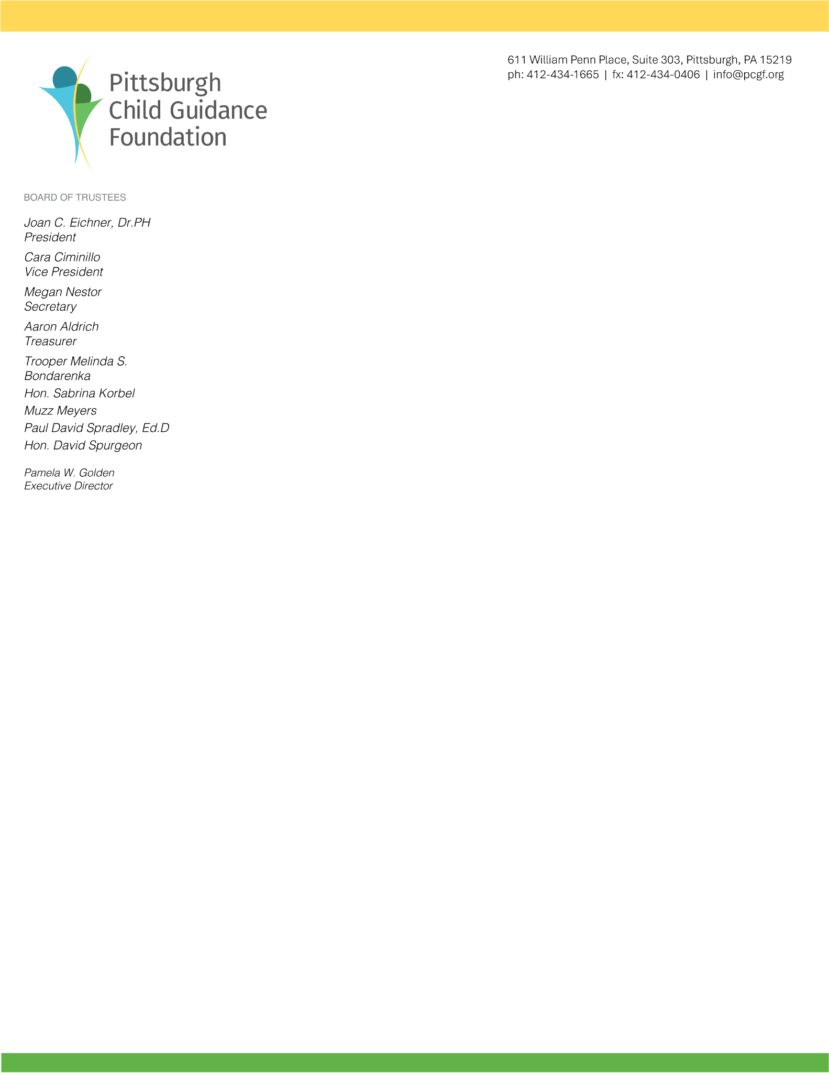

Applying for a Grant from the
Pittsburgh Child Guidance Foundation

The Pittsburgh Child Guidance Foundation (PCGF) is dedicated to improving the health and well-being of children and youth living in Allegheny County by providing grants and collaborating with public and private organizations to implement innovative policies, practices, and programs. PCGF and valued partners collaborative to have a positive impact on the lives of children and youth by changing their behavior, their minds, their experiences, and ultimately, their lives.

Since 2024, the Foundation has been collaborating with service providers to support the work that has a direct and positive impact on the lives of disadvantaged children and youth.

The Foundation focuses on programs that support children and youth by nurturing social and emotional development that will enable them to learn skills throughout their lives.

PCGF supports programs that focus on these goals:
- Encourage completion of high school
- Increase self-confidence
- Foster interest in exploration of career opportunities
- Connect children and youth with role models
- Teach life and work ready skills

The tangible and intangible skills children develop through social and emotional learning (SEL) programs will help them to thrive in the future. Grant applications will be accepted through Wednesday, September 30, 2026.

If there is a connection between what we fund and your organization’s mission, we invite you to submit a proposal that includes the following information:
    - Name, street address, email address, phone number, of the key contact(s)
    - Amount being requested
    - State how it would be used; who are the beneficiaries
    - Identify your geographic service areas
    - State how your work aligns with our mission, an overview of your organization;
    - Who your other partners are for this particular program
    - What are the goals for the program we would support
    - Time frame of program
    - State how will you measure the success of the program
    - Copy of the budget for the program
    - Program for which you are requesting funding as a word document
    - Is the work by this program considered prevention or intervention? In what way(s)?
    - Any previous funding your organization has received from PCGF (a mention – not a detailed report)
    - Copy of your IRS 501(c)3 determination
    - List of current board members
    - Completed Project Overview and Outcomes Planning Form (attached)
    - On a separate page, please include a one-to-two-page summary of the program for which you are seeking funding. Submit this description as a Word document.

Submit your qualifying application to info@pcgf.org or via mail to Executive Director, Pittsburgh Child Guidance Foundation, 611 William Penn Place, Suite 303, Pittsburgh, PA 15219.

Applications will be accepted through Wednesday, September 30, 2026.

Please note: PCGF supports organizations that do not intend to deny services, employment or volunteer involvement based on race, age, ancestry or national origin, sexual orientation, gender identity or gender expression, physical or mental disability or religion. It is not the intent of this policy to deny support for programs that serve specifically defined populations.

For programs that serve a specifically defined population, if your program is unable to fulfill a request for services, your program shall make an appropriate referral and assist the requestor in identifying an appropriate agency.

For programs that serve a specifically defined population and are unable to meet the needs of a request, it will NOT be deemed a denial if a referral is made to an appropriate program.

The Foundation is an active investor. Trustees and staff visit funding agencies and review reports. Groups that welcome partnerships with funders are best able to utilize the Foundation’s assistance.

If your organization is approved to receive funding, we will request a final report at the end of your one-year grant or by October 1, 2027.

This invitation does not guarantee funding from the Pittsburgh Child Guidance Foundation. It presents the opportunity to submit an application.

Visit www.PittsburghChildGuidanceFoundation.org for more information, email info@pcgf.org, or call 412.434.1665.

