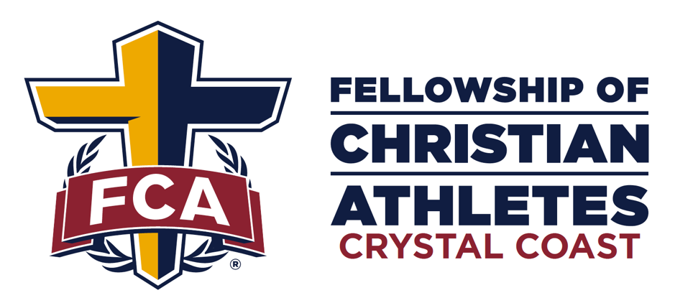
2025 GOLF TOURNAMENT
Thursday, October 23 | Morehead City Country Club
Benefiting the Crystal Coast FCA

Registration
Entry Fee and/or Hole Sponsorships can be paid for with check. Make checks payable to “Fellowship of Christian Athletes” send it with the completed form to:
Crystal Coast FCA
2204 North Road, Morehead City, NC 28557
************************************************************************************************************************
Schedule of Events
➢ 12:00pm – Check-in
Mulligans Packets(includes 1 mulligan & 1 Red Tee) will be available for purchase the day of the event for $20 and Raffle Tickets are $5.
➢ 1:00pm – Shotgun Start
Following Play raffle and tournament winners will be recognized. *********************************************************************************************************************
Sign up!
$150 per player OR $600 per foursome

TEAM NAME:_______________________________
CONTACT #: _______________________________
Player 1 __________________________________
Handicap/Avg Score _____________
Player 2: __________________________________
Handicap/Avg Score _____________
Player 3: __________________________________
Handicap/Avg Score _____________
Player 4:______________________________________________
Handicap/Avg Score ________________

SPONSORSHIP
$2500 Premier/$1000 Hall of Fame/ MVP $750/ $150 HOLE
__________________________________________
Name
__________________________________________
Business Name as Listed on Sponsor Sign
__________________________________________
Phone #
__________________________________________
Website
__________________________________________
Contact Email

For questions please contact (252) 229-8556 or Email shannonwilliams@fca.org

