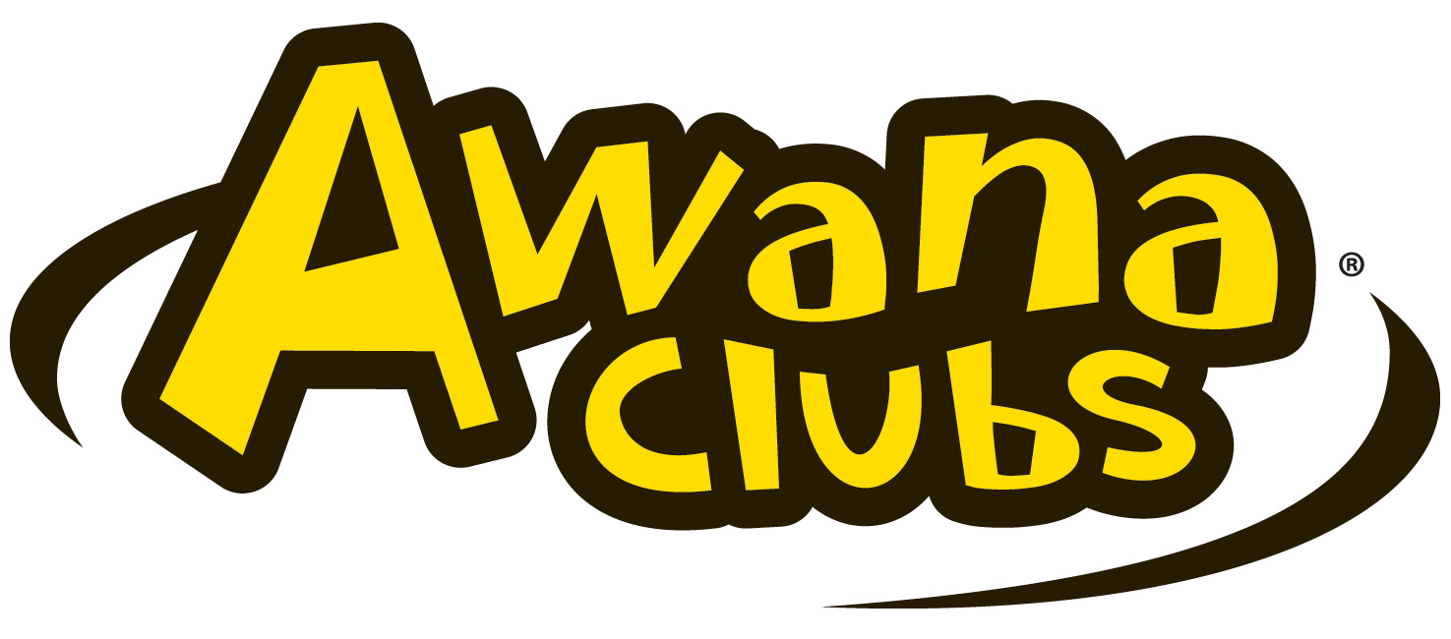
PARENTAL/GUARDIAN CONSENT AND RELEASE OF LIABILITY
Event NAME AwanaGames & Sparks-A-Rama
EVENT DATE/LOCATION February 28, 2026 @calvary baptist Church,
little egg harbor, NJ
THIS DOCUMENT CONTAINS A RELEASE OF LIABILITY. PLEASE REVIEW IT CAREFULLY.
Please Print & Provide All Information Requested - Please return this form to your coach before each Event.

Child’s Name: ___________________________________________________________ Birthdate (mm /dd / year): _________________

Address: _______________________________________________________________________________________________________

Telephone: ________________________ Cell Phone: ________________________ Grade _____ T-shirt SIZE___________

Backup Emergency Contact and Phone Number: _______________________________________________________________________________

Church Team Name: _____________________________________________
I understand and agree that participation in “AwanaGames,” or “Sparks-a-Rama (“Event”) hosted by Calvary Baptist Church (“CBC”) is a privilege. In consideration of that privilege, I am signing this Parental/Guardian Consent and Release of Liability.

Consent to Attend Event & Release of Liability
I hereby give permission for my Child to attend and participate in the Event. Prior to my Child’s involvement in the Event activities, I acknowledge that involvement of my Child in the Event may involve risk of property damage and of personal injury, illness or even death, including but not limited to the risks arising from transportation–related activities, recreational activities, accidents in and around facilities, adverse weather conditions, and injuries and illness as a result of food-borne illnesses and allergic reactions. By signing this Parental/Guardian Consent and Release of Liability, I state that my Child is fully capable of safely participating in all Event activities, and I expressly assume all risks of my Child’s involvement, whether such risks are known or unknown to me at this time. I further generally release CBC, its elders, deacons, pastors, employees and volunteers, and other participants at the Event, from any and all claims that I or my Child may have against any of them, whether on or off Event grounds. This Release of Liability is given on behalf of myself, my Child, and any heirs, family, estate, administrators, and personal representatives of me and my Child (hereinafter “we”). We expressly agree that this Release is intended to be as broad and inclusive as permitted by the State of New Jersey and that this Release shall be governed by and interpreted in accordance with the laws of the State of New Jersey without regard to its choice of law provisions. Further, we irrevocably consent and agree that jurisdiction and venue with respect to any legal action arising with respect to the Activities will be in the Court of Common Pleas of Ocean County, New Jersey.

Consent to Medical Treatment
I hereby give my consent that my Child may receive medical treatment that may be deemed advisable in the event of injury, accident and/or illness during this event. List any medical or food allergies of Participant
(please write “None” if applicable):
______________________________________________________________________________________________________________________
Will Participant be under any medication while at Event? If yes, please provide details:
(please write “No” if applicable):

______________________________________________________________________________________________________________________
Media Release
I understand that at this Event or related activities, my Child may be photographed. I hereby assign all rights to the photographs/video made of my Child by CBC. I hereby authorize and consent to the editing, reproduction, exhibition and use of said photographs/video by CBC for promotional purposes in its publications, on its Web site and in local print media. I acknowledge CBC’s right to crop or treat the photographs/video at its discretion.

Authority to Sign
I represent and warrant that I am a parent or legal guardian of the Child named above, and have the full power and authority to enter into this Parental/Guardian Consent and Release of Liability on behalf of my Child. By signing below, I acknowledge that I have read and understand this document, and also represent that all information provided is accurate.

Signature_____________________________________________ Date: _____________________

Parent/Guardian Print Name_____________________________________________

