

September 10, 2022 Quarterly Board Meeting
Montessori School of Englewood Location: WebEx
Present:

Board Members: Karen Anderson, Joe Motto, Jim Sulzer, Peter Cunningham, Ebonie Townsend, Tiffany White, Marcus Robinson, Peter Talmers [joined following discussion at Item III below]
Board Members not in attendance: Marv Hoffman, Gabrielle Sansonetti, Tanesha Peeples, Tiffany White

School staff: Maggie Mikuzis, Maria Barksdale Guest: Jayla Rufus
Meeting minutes and recording taken by: Joe Motto

- Call to Order

Anderson called the meeting to order at 9:02 AM

White took roll. Board members White, Townsend, Anderson, Sulzer, Cunningham, Robinson, and Motto, Mikuzis, Barksdale, and Rufus announced themselves present.

- Approval of Minutes

Circulated in advance of the meeting were the draft minutes for the July 11, 2022 board meeting. See Ex. A. Opportunity was given for discussion. Sulzer moved to approve the minutes as drafted. Cunningham seconded. All board members present noted above voted to approve. None opposed nor abstained. Motion passed.

- Development

Anderson led discussion as to the state of fundraising and grant and fundraising opportunities. Board members were strongly encouraged to give in any amounts in order to accomplish 100% board giving, which supports our fundraising efforts.

Talmers joined the meeting at this point.

The Montessori Network
6936 South Hermitage Ave., Chicago, Illinois 60636

- Finance

Motto led discussion on finances, including based on the school’s financial statements through July 2022 (see Ex. B), as to which enrollment is strong and we are otherwise slightly ahead of budget. Quatrro is helping us with the ongoing audit. AHS is transitioning in place of Quatrro as our new financial services firm.

- Building Report

Mikuzis delivered the building report and covered a number of items, such as:

- A major priority right now is ensuring safety and security during student arrival and departure, and thus new rules and procedures have been put in place, such as requiring entrance through the three main front entrances and designated staff to supervise the process at key designated areas;

- Boiler repairs have completed;
- New doors are to be delivered shortly;
- Playground design is underway and progressing, see Ex. C;
- We recently passed our health inspection;
- The School has partnered with the Fresh Fruit and Vegetables Program, separate from the National School Lunch Program. Beginning on September 12, students will receive two snacks per week, one fruit and one vegetable.

- Executive Director’s Report

Mikuzis and Barksdale delivered the Executive Director’s report (see Ex. D) in Rita Nolan’s absence. Priorities for the year, which were discussed, include:

- Targeted professional development;
- Ongoing assessment that proactively informs instruction;
- School safety, including through the 7th/8th grade mentorship program, which started in September and aims to help these students develop useful social/personal skills and habits.

The Montessori Network
6936 South Hermitage Ave., Chicago, Illinois 60636



- Head Start

Mikuzis delivered the Head Start report, including an overview and status of current program staffing, budgeting, reporting/compliance, updated procedures, and other items.

Discussion was had concerning proposed new Head Start fiscal policies and procedures.
See Ex. E. Sulzer made a motion that the board adopt the proposed new policies and procedures. Cunningham seconded the motion. All present noted above voted in favor. None opposed or abstained. Motion passed.

- Reports from School Staff

Anderson described that going forward, we intend to provide specific opportunity at board meetings for staff input. Additionally, we intend to propose an amendment to our bylaws that will allow for up to two school staff members to become non-voting members of the board.

Barksdale and Mikuzis described efforts that are underway to break down, explore, and respond to areas of improvement identified from the Five Essentials surveys.

- New Business

None.

- Public Comment

There was no public comment. With no further business, the meeting was adjourned.

Meeting Adjourned: 11:32 AM

The Montessori Network
6936 South Hermitage Ave., Chicago, Illinois 60636

Exhibit A



July 11, 2022
Special Board Meeting Montessori School of Englewood

Location: WebEx Present:
Board Members: Karen Anderson, Joe Motto, Jim Sulzer, Peter Cunningham, Tanesha Peeples, Tiffany White, Marv Hoffman, Ebonie Townsend, Peter Talmers, Marcus Robinson, Gabrielle Sansonetti, Rita Nolan

School staff: Maggie Mikuzis

Meeting minutes and recording taken by: Joe Motto

- Call to Order

Anderson called the meeting to order as acting President of the board. Motto took roll.
Anderson, Sulzer, Cunningham, Peeples, Motto, White, Hoffman, Townsend, Talmers, Robinson, and Nolan announced themselves present. Sansonetti joined the meeting following item II below.

- Report From Board Officer Search Committee

Cunningham and Robinson delivered a report on their executive committee leadership search process. Discussion ensued. Cunningham moved to adopt the following officer slate: Anderson as board president; Townsend as board vice president; Motto as board treasurer; and White as board secretary. Sulzer seconded. All voted in favor, none opposed. Motion passed. Those four officers are elected to a two-year term, to expire July 2024.

- Executive Director Performance Review Framework

Motto circulated in advance of the meeting the Executive Director performance review framework attached as Exhibit A. Anderson led discussion. Sulzer and Townsend will lead the evaluation process in relation to the 2021-2022 year.

The Montessori Network
6936 South Hermitage Ave., Chicago, Illinois 60636

- School Year 2022-2023 Regular Board Meeting Schedule

Anderson described that the Executive Committed adopted the following regular board meeting schedule for the 2022-2023 school year:

- Saturday, September 10, 2022, at 9:00 a.m. at the School
- Saturday, November 12, 2022, at 9:00 a.m., at the School
- Monday, January 23, 2023, at 6:00 p.m., at Winston & Strawn
- Saturday, March 11, 2023, at 9:00 a.m., at the School
- Monday, May 15, 2023, at 6:00 p.m., at Winston & Strawn
- Monday, June 12, 2023, at 6:00 p.m., at Winston & Strawn
We are operating on the assumption that meetings will occur in-person, though that is not guaranteed. Discussion was had. There were no objections to the above schedule, which will serve as the regular board meeting schedule for the coming year.

- Board Member Terms

The current board terms for Anderson, Cunningham, Motto, Hoffman, Sansonetti, Sulzer, and Talmers are at an end. Motto made a motion to renominate each for a new three- year term. Cunningham seconded the motion. All voted in favor. None opposed. Motion passed. Anderson, Cunningham, Motto, Hoffman, Sansonetti, Sulzer, and Talmers are elected to new board terms, to expire July 2025.

- 5 Essentials

Nolan gave a preliminary report on findings from the most recent 5 Essentials survey. The findings, which are not yet public, are promising and show a two-level increase relative to the prior survey results. Discussion ensued.

- Public Comment

There was no public comment.

With no further business, the meeting was adjourned.

The Montessori Network
6936 South Hermitage Ave., Chicago, Illinois 60636

Executive Director Performance Evaluation
Purpose: Both the Executive Director and the Board of Directors seek a framework by which there can be clear expectations, support, and accountability for the Executive Director. This proposed framework seeks to provide that clarity of expectation and serve as a driver for evaluation, support, contract renewal, incentives, etc.
Overview: The framework is built to emphasize the most important aspects of the work of the Executive Director. As the leader of the school, the Executive Director must set the tone and ensure results. Therefore, this framework proposes 7 top line metrics, some process metrics and some outcome metrics, with the goal of most closely capturing the idea of excellence for The Montessori School of Englewood. Further, the proposed weightings are an attempt to demonstrate the importance of that measure to the success of the school and the Executive Director’s ability to influence such.
Next Steps:
- Come to agreement on metrics and weighting.
- Define specific measures and cut points for each metric.
- Determine any consequences (positive/negative) of performance ratings (i.e. support, pay, etc.)
- Create calendar and assign any roles or responsibilities necessary (i.e rubric evaluators).
- Communicate the framework to appropriate stakeholders as necessary.
- The Executive Committee designates Board members as evaluation team to gather necessary data, conduct interviews specified in the plan and submit a report of its results to the Board.
Proposed Metrics:
The metrics proposed below are a balance of generally accepted CPS and school metrics for executive directors and metrics that ensure that MSE stays true to its Montessori roots and mission. They are outlined below along with the proposed weighting.
- Charter. Renewal Metrics
  - Weight: 15%
  - Rationale: In line with all CPS schools (charter and district), this system has been built by experts in and around CPS. It also has the benefit of having been implemented and is regularly adjusted to reflect any evolutions of thought. It also continues to evolve and reflect the current priorities of the district. Inclusion of this metric seeks to ensure baseline student success, sustainability in terms of renewals, and reflect the current priorities of the authorizer.
Renewal Comprehensive Evaluation breakdown
    - Academic Performance
    - II. Financial Performance III. Operational Performance
    - The sub categories under these domains include:
    - • Legal Compliance

    - • Governance
    - • Diverse Learners
    - • English Learners
    - • Students in Temporary Living Situations
    - • Parent Issue Review
    - • Student Admission and Enrollment
    - • Teacher Licensure
    - • Student Transportation
    - • Student Discipline
    - • Student Safety
    - • Agreement Conditions
- Montessori Leadership Practice
  - Weight: 30%
  - Rationale: The Executive Director is responsible for ensuring that the school stays true to its unique mission. This measure seeks to ensure the innovative approach of MSE. The weighting here recognizes that while the existence of these practices does not directly impact the existence of the school it does keep the Montessori principles on which the school was founded front and center. The consortium of Montessori schools in the public sector has developed a rubric to identify the existence of those core Montessori leadership practices.
  - Measure: Adapt and adopt a rubric that has been created and published in a book by Montessori in the public sector. The Board and ED will need to determine who, how, and frequency of ratings on this rubric. Points can be awarded based on scoring in one of multiple ratings.
- 5 Essentials
  - Weight: 15%
  - Rationale: This measure has been a focus of the school for the last year. Incredible research and testing has gone in to the development of this measure. Widely used by schools, this measure indicates whether the practices occurring at the school are likely to lead to successful student outcomes. (https://uchicagoimpact.org/our-offerings/5essentials)

  - Measure: Ratings are in one of 5 categories. Full points can be awarded for highest rating and proportionally less in each category. Measure is annual reported out in June.
- Financial Scorecard
  - Weight: 15%
  - Rationale: The ED has a responsibility to also ensure the fiscal health of the school. As such, CPS annually publishes a financial scorecard on 4 key metricsLiquidity Ratio, Cash on Hand, Net Asset Ratio, and Change in Net Assets. These measures are reliable and used throughout the city for all charters.

  - Measure: 3 tier rating in each of the 4 categories (does not meet, meets, exceeds standard). Full points on the rating can be based on meeting/exceeding standards in all 4 categories and proportionally less if categories do not meet standards. Measure is published annually in the winter following the relevant school year; however, scores are basically known at the end of the fiscal year.
- Enrollment
  - Weight: 10%
  - Rationale: A critical driver of revenue and indicator of the quality of the school is the enrollment. The ED oversees the recruitment efforts and ensures that parents keep their student(s) enrolled because they feel they are being well served at MSE.
  - Measure: An annual goal can be mutually agreed upon by the Board and ED. At the 20th day of school (the annual count day for CPS) that number can be compared to the goal and a rating assign based on the percent deviation (above or below) from the goal. Measure is annual but a second semester count could also be factored in.
- Human Capital (Recruit, Retain, Develop)
  - Weight: 5%
  - Rationale: Building the best team and helping them thrive together is crucial to the success of the school. Acknowledgement of such in the evaluation elevates this responsibility for the ED.
  - Measure: Can simply use a measures like year over year retention measured against a goal or can develop a rubric that incorporates quality of hire/vacancies filled day one, desired retention rates, and response to surveys regarding professional development. In addition, the evaluation team will conduct interviews with members of the school’s leadership team regarding the ED’s performance. The questions used in these interviews will be agreed upon in advance by the evaluation team and the ED.
- Annual Goal (Mutually Agreed Upon Goal)3
  - Weight: 5%
  - Rationale: Schools are constantly evolving; therefore, having a space to put emphasis on different aspects annually addresses that fact. Perhaps there is a specific focus on reading, or achievement, or parental involvement, or early childhood, or anything that the Board and ED believe should be a specific focus for the year. This could also align to the specific strategies outline in the annual school improvement plan.
  - Measure: The measure here could take many forms. It could simply add weight to other metrics, emphasize a specific element of other metrics, or develop a new specific measure altogether. The Annual Goal should be established and evaluated in interviews between the ED and the evaluation team assigned by the Executive Committee of the Board and conducted at intervals assigned by the Board, which, minimally, should take place mid-year and at the end of the year.

Propose Metric Weighting Breakdown Metric Weighting SQRP 45.00% Montessori Leadership Practices 15.00% 5 Essentials 10.00%4 Financial Scorecard 10.00% Enrollment 10.00% Human Capital (Recruit, Retain, Develop) 5.00% Annual Goal (Mutually Agreed Upon Goal) 5.00%

Exhibit B

Montessori Network
Budget to Actual
For the One Month Ending 7/31/2022

Actual (UR) Budget (UR) Budget
Description YTD YTD Variance ($) Variance (%) Annual

Revenue
CPS Funding

CPS SBB & Non-SBB | 244,483 | 232,739 | (11,745) | 105.05% | 2,792,862
CPS Special Education (SPED) | 54,840 | 54,840 | 0 | 100.00% | 658,085
CPS Supplemental Aid | 26,992 | 26,992 | 0 | 100.00% | 323,900
Total CPS Funding | 326,315 | 314,571 | (11,745) | 103.73% | 3,774,847
Government Funding Title I | 0 | 22,877 | 22,877 | 0.00% | 274,524
Title II | 0 | 793 | 793 | 0.00% | 9,517
Title III | 0 | 170 | 170 | 0.00% | 2,040
Other Government Funding | 57,845 | 69,360 | 11,515 | 83.40% | 832,320
Title IV | 0 | 206 | 206 | 0.00% | 2,475
State Bilingual | 0 | 900 | 900 | 0.00% | 10,800
Other CPS Funds | 6,600 | 25,000 | 18,400 | 26.40% | 300,000
Total Government Funding | 64,445 | 119,306 | 54,861 | 54.02% | 1,431,676
Student Fees

Release from Restriction

Release from Restriction | 4,167 | 0 | (4,167) | 0.00% | 0
Total Released from Restriction | 4,167 | 0 | (4,167) | 0.00% | 0
Donations
Individuals Donations | 26 | 33,333 | 33,307 | 0.08% | 400,000
Corporate & Foundation Donations | 25,925 | 0 | (25,925) | 0.00% | 0
Total Donations | 25,952 | 33,333 | 7,382 | 77.85% | 400,000
Other Revenue
Other Revenue | 2,316 | 667 | (1,649) | 347.33% | 8,000
Total Other Revenue | 2,316 | 667 | (1,649) | 347.33% | 8,000
Total Revenue | 423,194 | 467,877 | 44,683 | 90.45% | 5,614,523
Expenses
Personnel Costs
Salaries | 222,325 | 286,101 | 63,776 | 77.71% | 3,433,213
Health/Dental/Life/ADD benefits | 54,452 | 41,472 | (12,980) | 131.30% | 497,662
Pension CTPF | 0 | 16,873 | 16,873 | 0.00% | 202,481
FICA/Medicare | 15,015 | 14,404 | (611) | 104.24% | 172,842
State Unemployment | 1,634 | 7,122 | 5,488 | 22.94% | 85,459
Worker's Comp | 0 | 1,852 | 1,852 | 0.00% | 22,224
Professional Development | 0 | 4,015 | 4,015 | 0.00% | 48,175
Staff Recruitment | 0 | 333 | 333 | 0.00% | 4,000
Total Personnel Costs 293,425 |  | 372,172 | 78,747 | 78.84% | 4,466,056

Direct Student Costs
Classroom Supplies 0 4,167 4,167 0.00% 50,000

Actual (UR)  Description YTD |  | Budget (UR)  YTD | Variance ($) | Variance (%) | Budget  Annual
PPE Expenses | 0 | 208 | 208 | 0.00% | 2,500
Educational Materials | 0 | 5,833 | 5,833 | 0.00% | 70,000
Instructional Equip & Technology | 0 | 605 | 605 | 0.00% | 7,254
Transportation/field trips/student events | 0 | 1,667 | 1,667 | 0.00% | 20,000
Consultants (RSP, Special Ed, direct student related) | 404 | 8,333 | 7,930 | 4.84% | 100,000
Parent Activities | 0 | 917 | 917 | 0.00% | 11,000
Related Service Providers | 0 | 17,500 | 17,500 | 0.00% | 210,000
Other Direct Student Expenses | 0 | 2,083 | 2,083 | 0.00% | 25,000
Total Direct Student Costs | 404 | 41,313 | 40,909 | 0.98% | 495,754
Office & Administration
Office Supplies | 0 | 883 | 883 | 0.00% | 10,600
Accounting & Audit | 14,833 | 17,441 | 2,608 | 85.05% | 209,291
Legal | 0 | 833 | 833 | 0.00% | 10,000
Payroll Fees | 77 | 1,250 | 1,173 | 6.13% | 15,000
Phone & Internet | 0 | 592 | 592 | 0.00% | 7,100
Printing & Copying | 0 | 2,500 | 2,500 | 0.00% | 30,000
Consultants (Admin) | 0 | 1,667 | 1,667 | 0.00% | 20,000
CPS Admin Fee | 9,855 | 9,583 | (272) | 102.84% | 115,000
Total Office & Administration | 24,765 | 34,749 | 9,984 | 71.27% | 416,991
Occupancy
Repairs & Maintenance | 0 | 4,167 | 4,167 | 0.00% | 50,000
Building Supplies | 0 | 2,917 | 2,917 | 0.00% | 35,000
Consultants (Security, Custodial) | 0 | 1,300 | 1,300 | 0.00% | 15,600
Total Occupancy | 0 | 8,383 | 8,383 | 0.00% | 100,600
Other Costs
Corporate Insurance | 522 | 3,750 | 3,228 | 13.93% | 45,000
Student Recruitment | 0 | 625 | 625 | 0.00% | 7,500
Interest Expense | 58 | 250 | 192 | 23.38% | 3,000
Membership Dues & Subscriptions | 0 | 1,250 | 1,250 | 0.00% | 15,000
Tuition Reimbursement | 0 | 1,250 | 1,250 | 0.00% | 15,000
Special Events | 0 | 1,310 | 1,310 | 0.00% | 15,723
Depreciation | 1,403 | 1,283 | (120) | 109.36% | 15,400
Postage and Shipping | 0 | 125 | 125 | 0.00% | 1,500
Travel | 0 | 583 | 583 | 0.00% | 7,000
Other Expenses | 5,224 | 833 | (4,390) | 626.83% | 9,999
Total Other Costs | 7,208 | 11,260 | 4,052 | 64.01% | 135,122
Total Expenses | 325,802 | 467,878 | 142,076 | 69.63% | 5,614,523
NET SURPLUS/(DEFICIT) | 97,393 | (1) | (97,393) | - | (0)

Montessori Network
Statement of Activities Finance Committee For the One Month Ending 7/31/2022

Unrestricted Restricted Budget Budget
Description YTD YTD Total YTD Variance Annual

Revenue
CPS Funding

CPS SBB & Non-SBB | 244,483 | 0 | 244,483 | 232,739 | (11,745) | 2,792,862
CPS Special Education (SPED) | 54,840 | 0 | 54,840 | 54,840 | 0 | 658,085
CPS Supplemental Aid | 26,992 | 0 | 26,992 | 26,992 | 0 | 323,900
Total CPS Funding | 326,315 | 0 | 326,315 | 314,571 | (11,745) | 3,774,847
Government Funding Title I | 0 | 0 | 0 | 22,877 | 22,877 | 274,524
Title II | 0 | 0 | 0 | 793 | 793 | 9,517
Title III | 0 | 0 | 0 | 170 | 170 | 2,040
Other Government Funding | 57,845 | 0 | 57,845 | 69,360 | 11,515 | 832,320
Title IV | 0 | 0 | 0 | 206 | 206 | 2,475
State Bilingual | 0 | 0 | 0 | 900 | 900 | 10,800
Other CPS Funds | 6,600 | 0 | 6,600 | 25,000 | 18,400 | 300,000
Total Government Funding | 64,445 | 0 | 64,445 | 119,306 | 54,861 | 1,431,676
Student Fees

Release from Restriction

Release from Restriction | 4,167 | (4,167) | 0 | 0 | 0 | 0
Total Released from Restriction | 4,167 | (4,167) | 0 | 0 | 0 | 0
Donations
Individuals Donations | 26 | 0 | 26 | 33,333 | 33,307 | 400,000
Corporate & Foundation Donations | 25,925 | 2,967 | 28,892 | 0 | (28,892) | 0
Total Donations | 25,952 | 2,967 | 28,918 | 33,333 | 4,415 | 400,000
Other Revenue
Other Revenue | 2,316 | 0 | 2,316 | 667 | (1,649) | 8,000
Total Other Revenue | 2,316 | 0 | 2,316 | 667 | (1,649) | 8,000
Total Revenue | 423,194 | (1,200) | 421,994 | 467,877 | 45,883 | 5,614,523
Expenses
Personnel Costs
Salaries | 222,325 | 0 | 222,325 | 286,101 | 63,776 | 3,433,213
Health/Dental/Life/ADD benefits | 54,452 | 0 | 54,452 | 41,472 | (12,980) | 497,662
Pension CTPF | 0 | 0 | 0 | 16,873 | 16,873 | 202,481
FICA/Medicare | 15,015 | 0 | 15,015 | 14,404 | (611) | 172,842
State Unemployment | 1,634 | 0 | 1,634 | 7,122 | 5,488 | 85,459
Worker's Comp | 0 | 0 | 0 | 1,852 | 1,852 | 22,224
Professional Development | 0 | 0 | 0 | 4,015 | 4,015 | 48,175
Staff Recruitment | 0 | 0 | 0 | 333 | 333 | 4,000
Total Personnel Costs 293,425 |  | 0 | 293,425 | 372,172 | 78,747 | 4,466,056
Direct Student Costs
Classroom Supplies | 0 | 0 | 0 | 4,167 | 4,167 | 50,000
PPE Expenses | 0 | 0 | 0 | 208 | 208 | 2,500
Educational Materials | 0 | 0 | 0 | 5,833 | 5,833 | 70,000
Instructional Equip & Technology | 0 | 0 | 0 | 605 | 605 | 7,254
Transportation/field trips/student events | 0 | 0 | 0 | 1,667 | 1,667 | 20,000
Consultants (RSP, Special Ed, direct student related) | 404 | 0 | 404 | 8,333 | 7,930 | 100,000
Parent Activities | 0 | 0 | 0 | 917 | 917 | 11,000
Related Service Providers | 0 | 0 | 0 | 17,500 | 17,500 | 210,000
Other Direct Student Expenses | 0 | 0 | 0 | 2,083 | 2,083 | 25,000
Total Direct Student Costs | 404 | 0 | 404 | 41,313 | 40,909 | 495,754
Office & Administration
Office Supplies | 0 | 0 | 0 | 883 | 883 | 10,600
Accounting & Audit | 14,833 | 0 | 14,833 | 17,441 | 2,608 | 209,291
Legal | 0 | 0 | 0 | 833 | 833 | 10,000
Payroll Fees | 77 | 0 | 77 | 1,250 | 1,173 | 15,000
Phone & Internet | 0 | 0 | 0 | 592 | 592 | 7,100

Unrestricted |  | Restricted |  | Budget |  | Budget
Description YTD |  | YTD | Total | YTD | Variance | Annual
Printing & Copying | 0 | 0 | 0 | 2,500 | 2,500 | 30,000
Consultants (Admin) | 0 | 0 | 0 | 1,667 | 1,667 | 20,000
CPS Admin Fee | 9,855 | 0 | 9,855 | 9,583 | (272) | 115,000
Total Office & Administration | 24,765 | 0 | 24,765 | 34,749 | 9,984 | 416,991
Occupancy
Repairs & Maintenance | 0 | 0 | 0 | 4,167 | 4,167 | 50,000
Building Supplies | 0 | 0 | 0 | 2,917 | 2,917 | 35,000
Consultants (Security, Custodial) | 0 | 0 | 0 | 1,300 | 1,300 | 15,600
Total Occupancy | 0 | 0 | 0 | 8,383 | 8,383 | 100,600
Other Costs
Corporate Insurance | 522 | 0 | 522 | 3,750 | 3,228 | 45,000
Student Recruitment | 0 | 0 | 0 | 625 | 625 | 7,500
Interest Expense | 58 | 0 | 58 | 250 | 192 | 3,000
Membership Dues & Subscriptions | 0 | 0 | 0 | 1,250 | 1,250 | 15,000
Tuition Reimbursement | 0 | 0 | 0 | 1,250 | 1,250 | 15,000
Special Events | 0 | 0 | 0 | 1,310 | 1,310 | 15,723
Depreciation | 1,403 | 0 | 1,403 | 1,283 | (120) | 15,400
Postage and Shipping | 0 | 0 | 0 | 125 | 125 | 1,500
Travel | 0 | 0 | 0 | 583 | 583 | 7,000
Other Expenses | 5,224 | 0 | 5,224 | 833 | (4,390) | 9,999
Total Other Costs | 7,208 | 0 | 7,208 | 11,260 | 4,052 | 135,122
Total Expenses | 325,802 | 0 | 325,802 | 467,878 | 142,076 | 5,614,523
NET SURPLUS/(DEFICIT) | 97,393 | (1,200) | 96,193 | (1) | (96,193) | (0)

Exhibit C

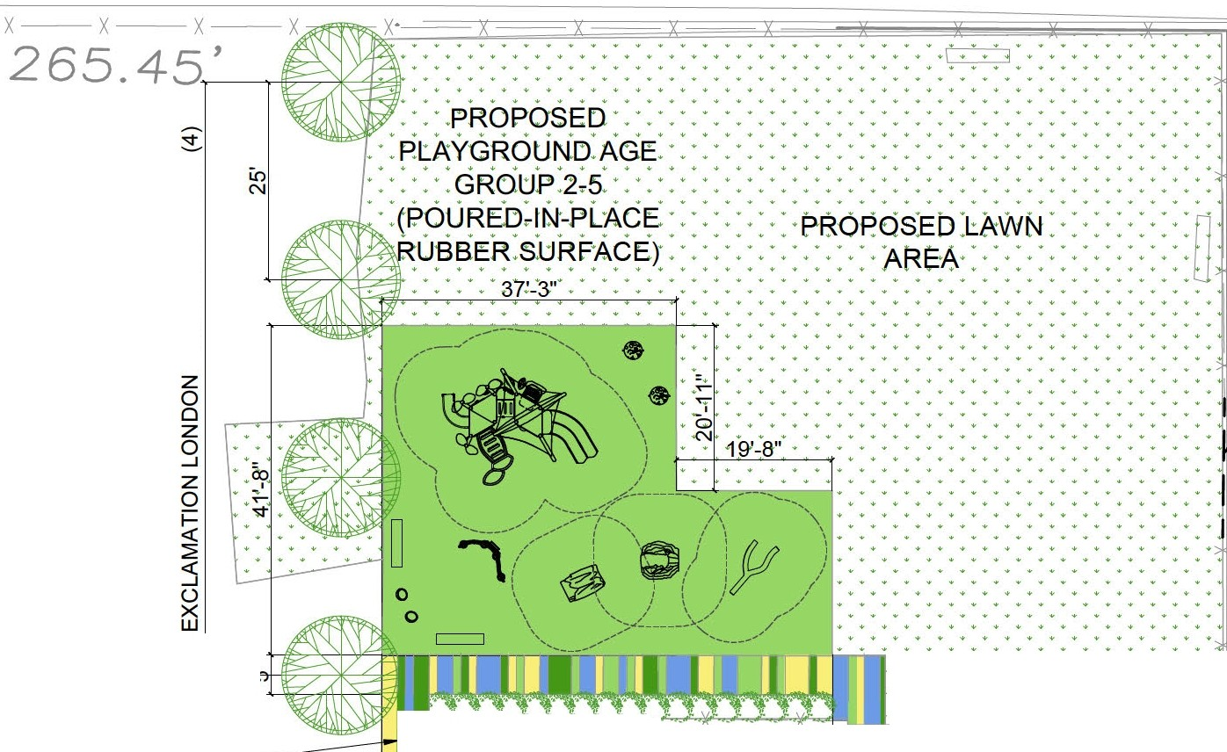

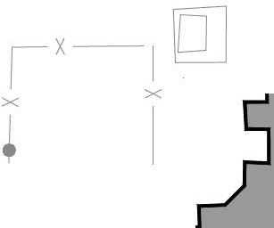



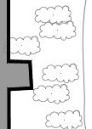




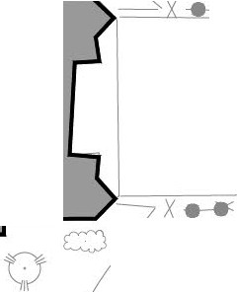
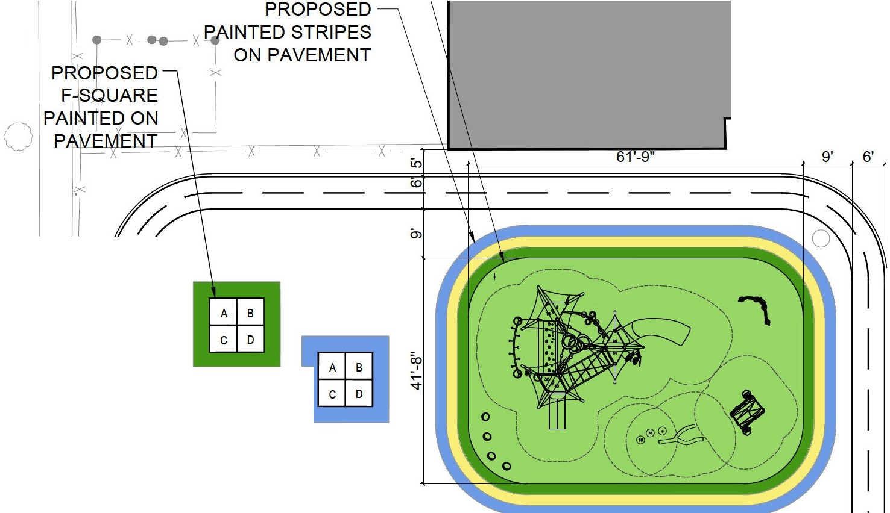
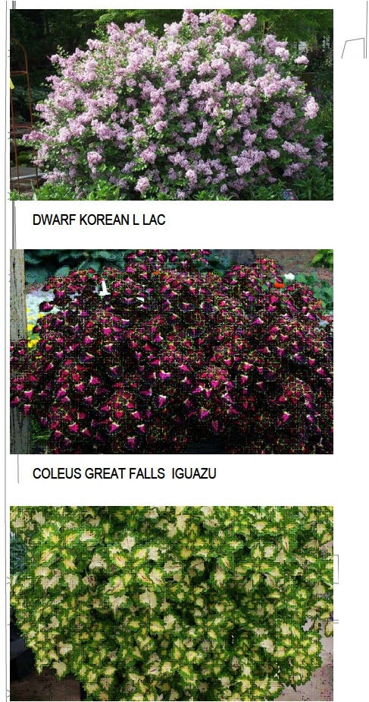






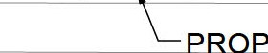
--@---- 0

1 6' PUBLIC
ALLEY

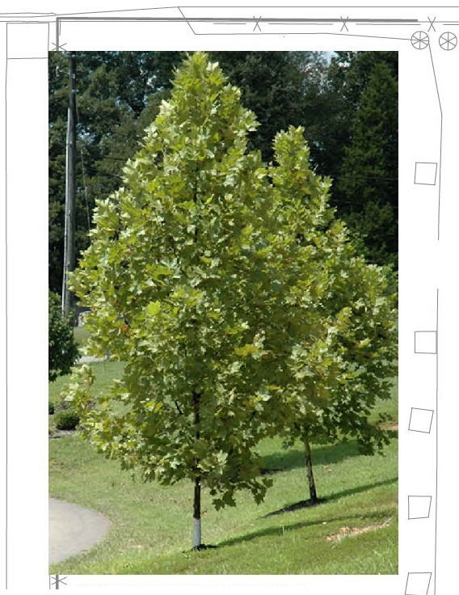
()
□
D□
EXCLAMATIONLONDON PLANETREE
0

0

0

0

0

0
0

0

0

c:::;
oo
DO
<> I:::) <)
0 D
D u D

u
'.)
Cl..
w' w 0::
f­
zw
'.)
Cl..

□
PR" POSED FENCE IN 1LL TO MATCH

TING
D
□

0 D
D
D
0 PROP9SfD PAINTED
LJPAVEMENT
ROPOSED DWARF KOREAN LILAC OR co (GREAT FALLS IGUAZU
0
AN EA( LS YOSEMITE).
PROPOSED DRINKING
ooo% FOUNTAIN WITH HOSE BIB
0o o
ao
(§)
D o ooo

""·""""'""1'· '· . . . . . ...
.......,.. .,_,r .•, • _,.,,. .,_.,. .,.,, .,_,,. .,_,,.
57'
... ..........................
............................................
0
0

a

◊
0
0
B

X
X
X
COLEUSGREAT FALLS YOSEMITE

LO
.I I'<)
•
(D
LO
sq--
0

f­
•
(/)

t§
s

(

PROPOSED PLAYGROUND AGE
GROUP 5-12 0
(POURED-IN-PLACE RUBBER SURFACE)
I

THE MONTESSORI SCHOOL OF ENGLEWOOD 6936 S. HERMITAGE AVE.
CHICAGO, IL

4-STORY BRICK BUILDING

[

0
X
a
I

X

X OJ

X

D

0
>Lu
<:(
Lu
(_)
it

ct Lu I:

•
(/)

PRC7111POSEr
m

ASPHALT PAVEMENT
0

IX -x
X
•
(/)

0

FENCf INFIL TO_IPATC E11ST1Nf
PROlfOSE
lrrRACf PAINJED Oit-J
PA EMEN
0 0
0
X
0 Q
X


X EXISTING PARKING
I LOT TO REMAIN 0

100 BOARD
I

X


X

I


PR(1lPOSicD Sl!IDINCB GATE

b
0 co

0 l
60'

0 PATCH POTHOLE
D
)
X

X a

X x-x X X • X

0
 | 0 | 0 | INFILL @MATC  ..EXISTING |  | 0 | 0 0
 | W. 70th.. ST. |  |  | L>.  VEHICULAR ACCESS |  | 0

xi-_ -x X X


QSED_EEJ\JC.

0

0 0

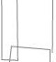 !iwi,

L _ _,IPETREA
CURRENT DESIGN PHASE

l JI COLLABORATIVE

--@---- 0

1 6' PUBLIC
ALLEY

()
□
D□
EXCLAMATIONLONDON PLANETREE
0

0

0

0

0

0
0

0

0

c:::;
oo
DO
<> I:::) <)
0 D
D u D

u
'.)
Cl..
w' w 0::
f­
zw
'.)
Cl..

□
PR" POSED FENCE IN 1LL TO MATCH
TING

0 D
D
D
0 PROP9SfD PAINTED
LJPAVEMENT

""·""""""1· '· . . . . . ...
.......,.. .,_,r .•, • ,,.,,. ,.,, .,_,,. ·•·"
57'
0
... ...................... ....
............................................
D 0

COLEUSGREAT FALLS YOSEMITE
ROPOSED DWARF KOREAN LILAC OR co (GREAT FALLS IGUAZU
AN EA( LS YOSEMITE).
0
□
PROPOSED DRINKING
ooo% FOUNTAIN WITH HOSE BIB
0o o
ao
(§)
D o ooo

a
◊
0 0
B
X
X
X

LO
.I I'<)
•
(D
LO
sq--
0

f­
•
(/)

t§
s

(

PROPOSED PLAYGROUND AGE
GROUP 5-12 0
(POURED-IN-PLACE RUBBER SURFACE)
I

THE MONTESSORI SCHOOL OF ENGLEWOOD 6936 S. HERMITAGE AVE.
CHICAGO, IL

4-STORY BRICK BUILDING

[
a
0
X
I

X

X OJ

X

D

0
>Lu
<:(
Lu
(_)
it

ct Lu I:

•
(/)

PRC7111POSEr
m 0

ASPHALT PAVEMENT
•
(/)

0

FENCf INFIL
TO_IPATC E,1sT1N,

0
TURF FIELD

0
0
X
0 Q
X

X EXISTING PARKING
I LOT TO REMAIN 0
I

X

X
I

PRC1lPOSicD Sl!IDINCB GATE

0

100 BOARD

100 BOARD
0 PATCH POTHOLE
D
0 )
X

X a

X x-x X X • X

0
_{X} xi-_ -x X X
QSED_EEl'JC.
0
 | 0 | 0 | INFILL @MATC  ..EXISTING |  | 0 | 0 0
 | W. 70th.. ST. |  |  | L>,  VEHICULAR ACCESS |  | 0

0 0

!iwii

L _ _,IPETREA
FUTURE PHASE

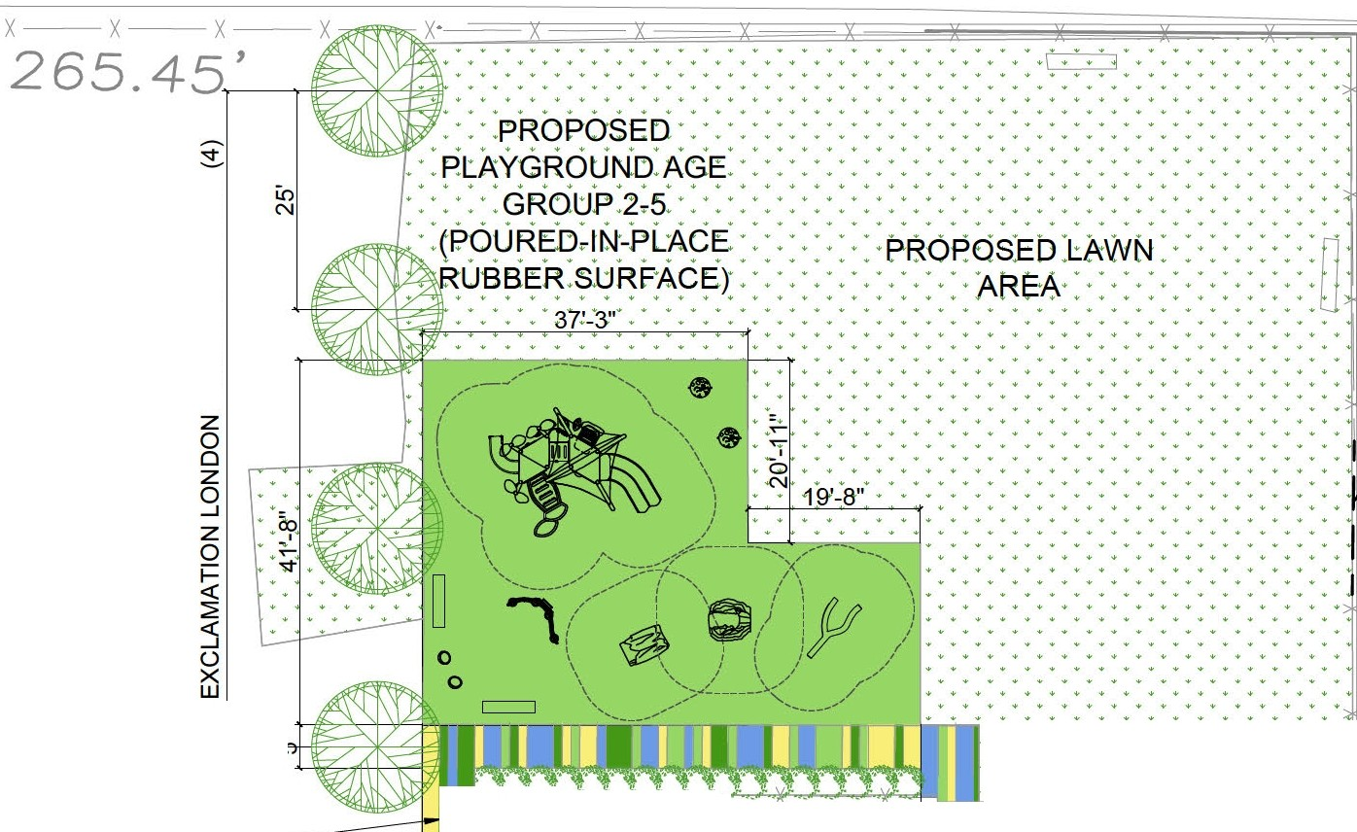
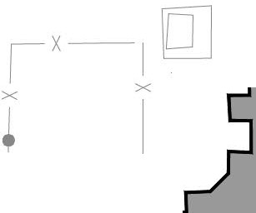

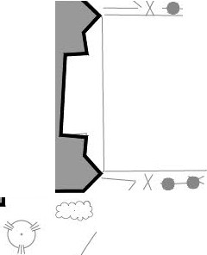

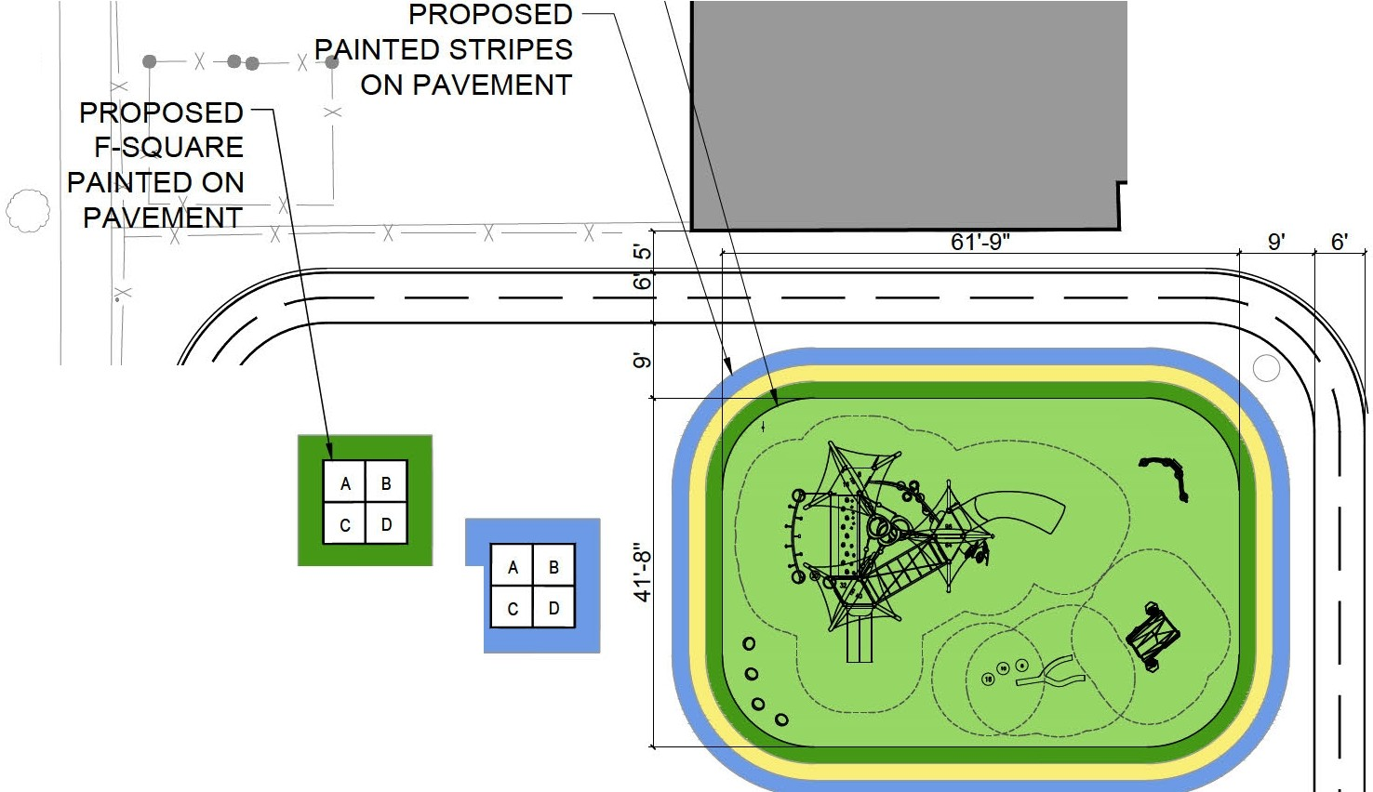








l JI COLLABORATIVE

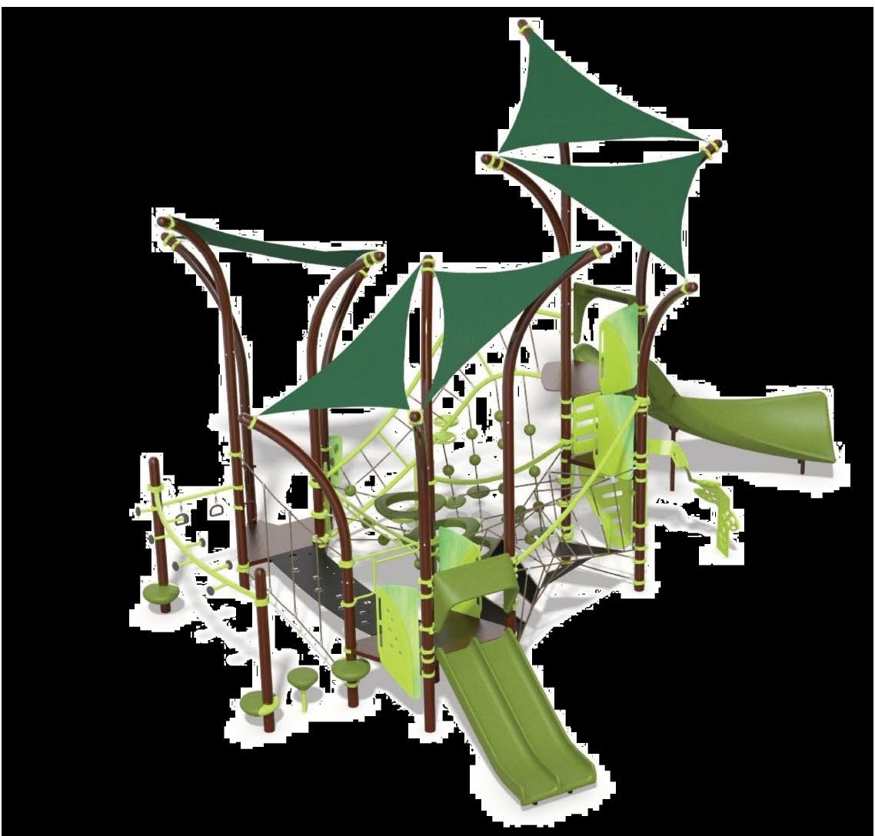






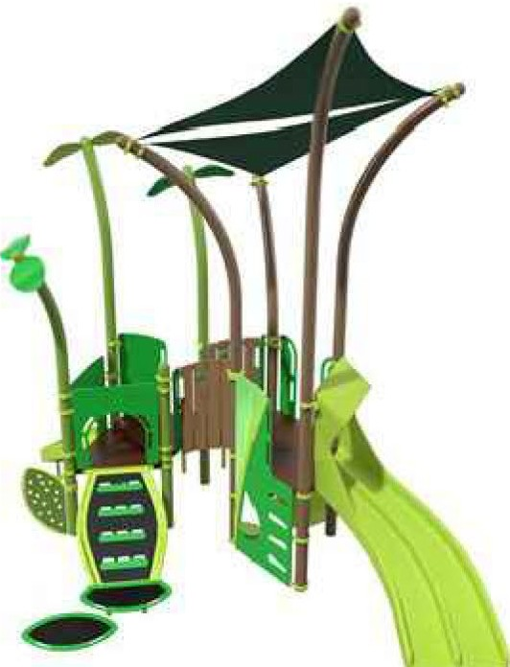







I

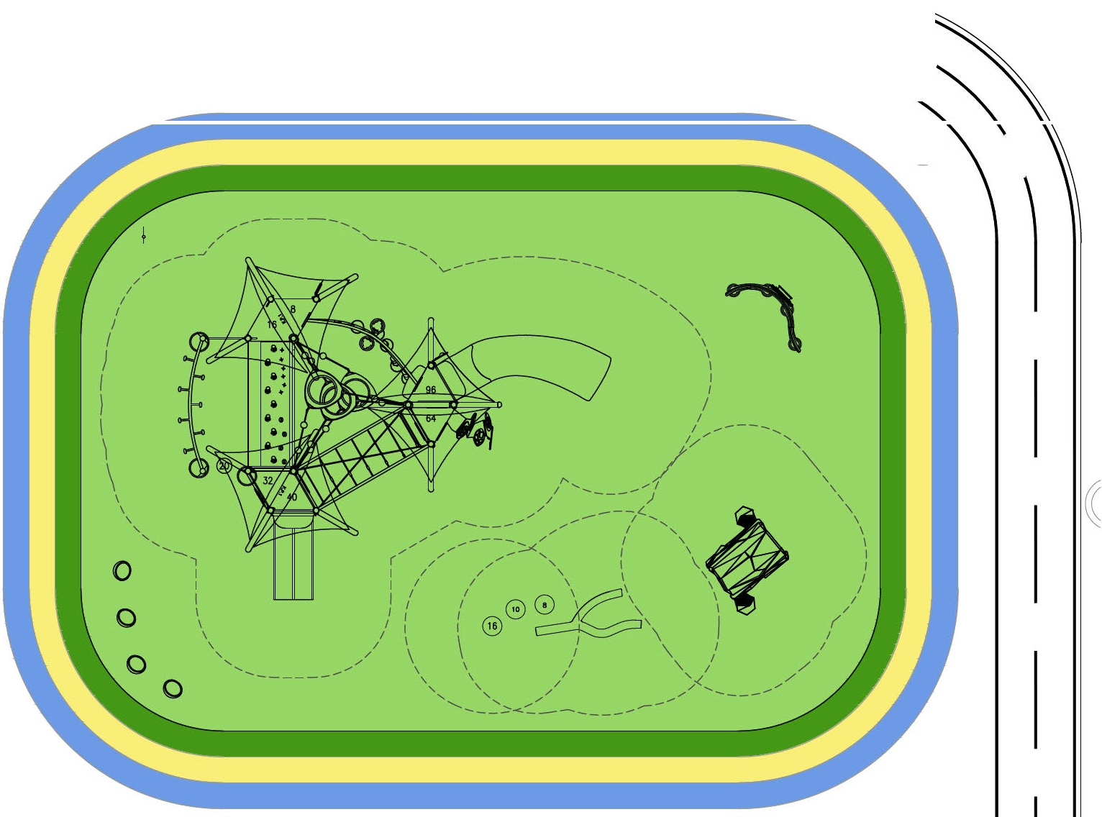


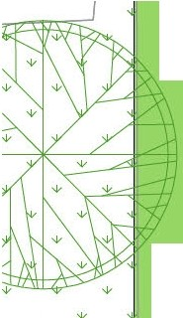
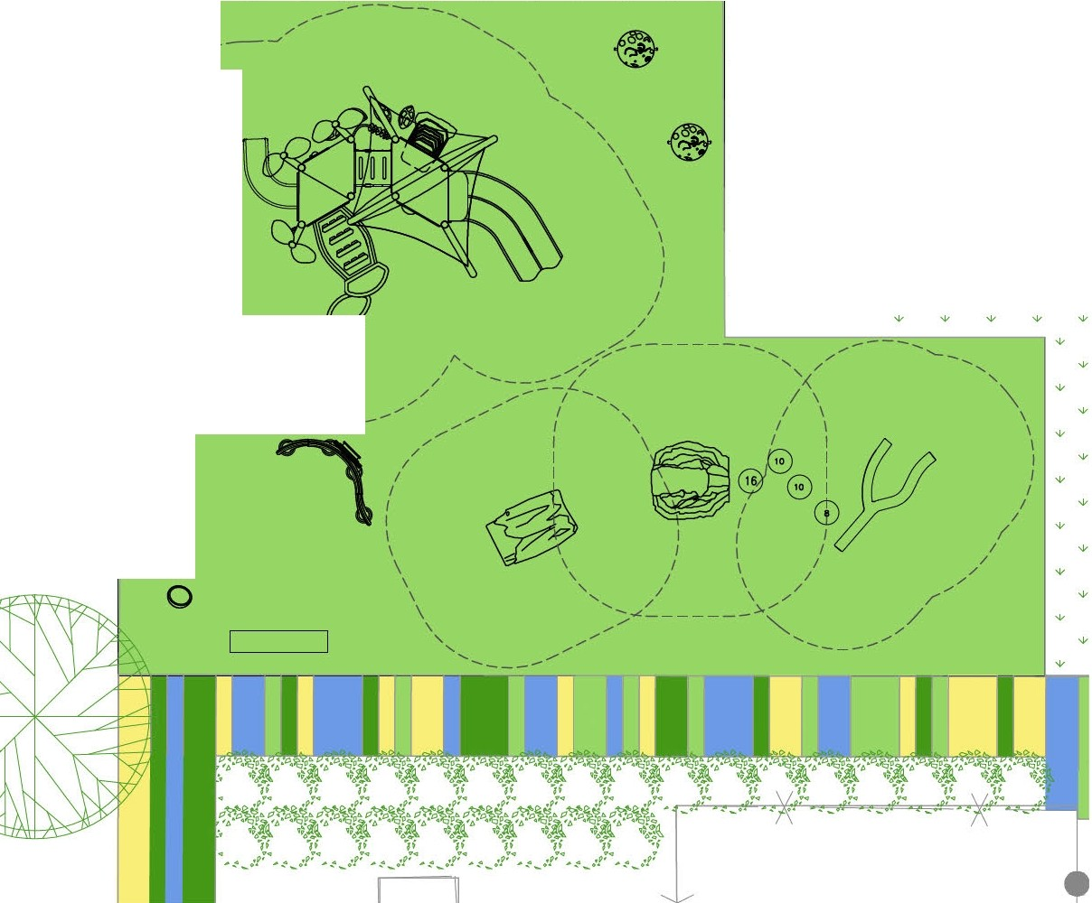



CUSTOM GRAPHIC ON THE FRONT OF RAIN SOUND PANEL
0
' ' ' ' '
'
w
w
'
•
w
• •
•
•
'
w
•
•
•
•
•
•

+
' '
+
w
+
'
+
•
w
+ +
/
/
/
I
•
•
•
•
+
w
w
I
w w + +
+ +
I
I
+ + + w
w w + + + + + +
•
+
+
+
w
w
I
w
I
' '
•
+ +
+
I
\
• • •
• •
+
w
w
\
' ' ',
+
'
•
• • • •
+ +
w w w w +
w
• • • • • •
+
)
+
• •
w w w w w
I
I
w
• •
I
\
\
' ', -----
w
I LJ
0
0






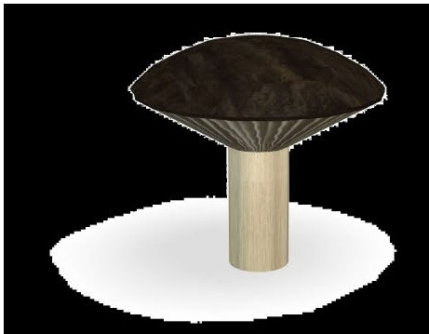
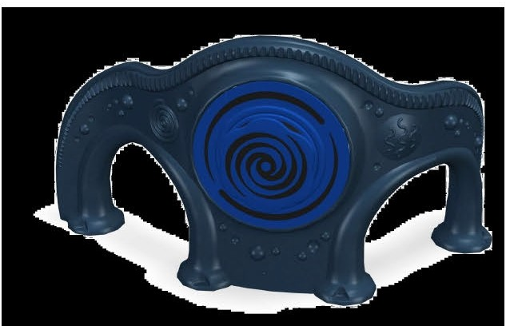

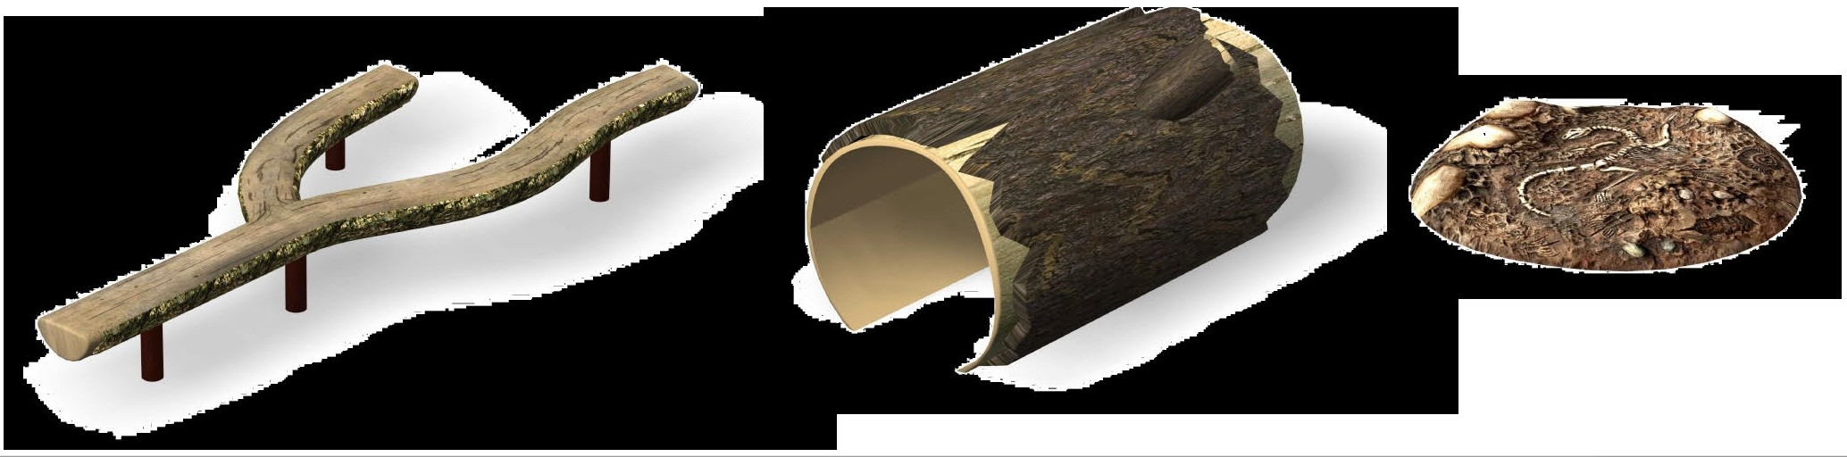

I
I

IPETREA
ICOLLABORATIVE

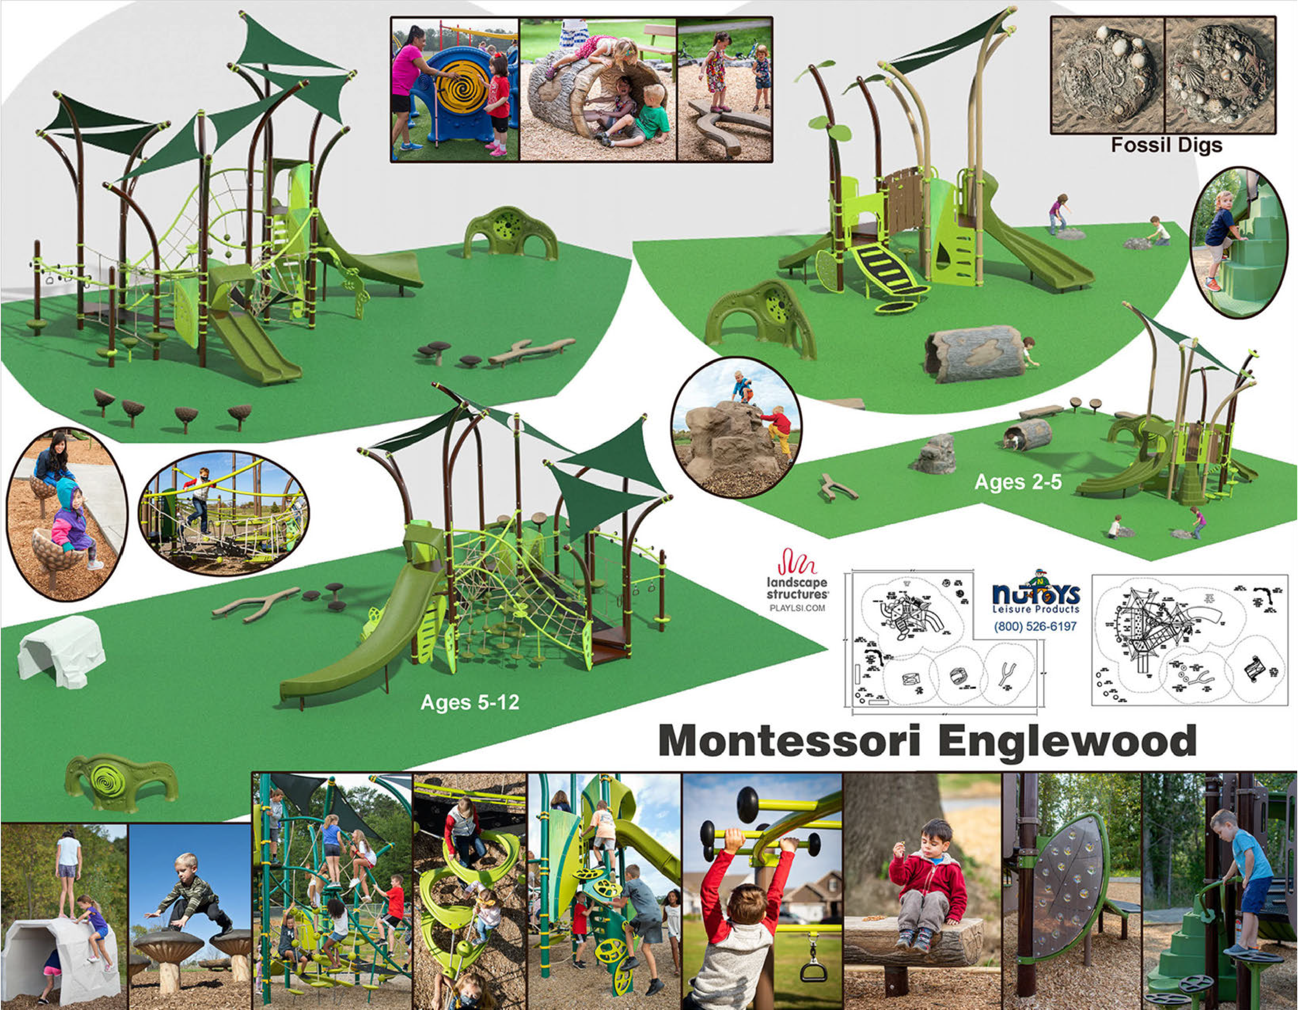



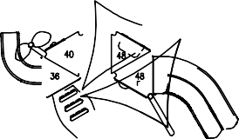


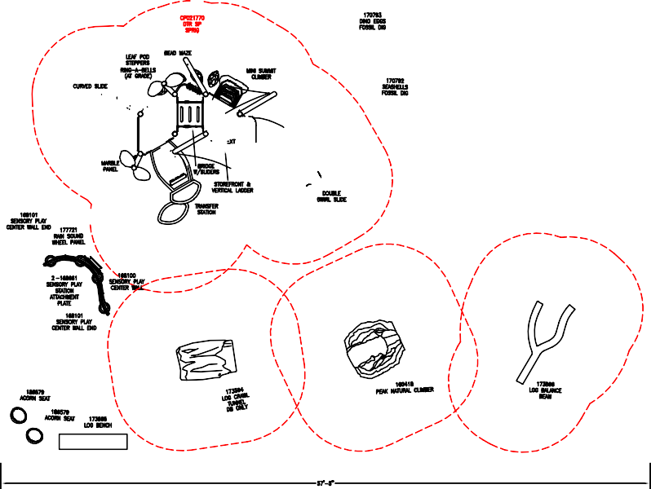
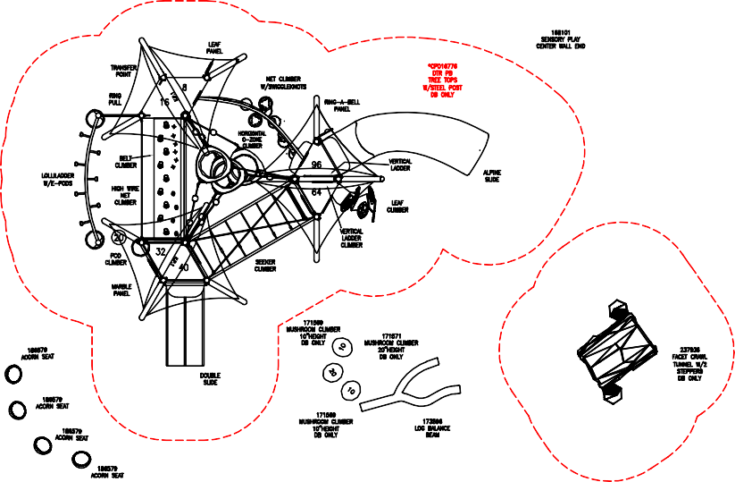
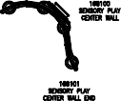
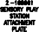


Exhibit D



Executive Director

Overview
Executive Director Report September 10th, 2022

Our overarching goal this school year is to maximize instructor effectiveness in the classroom in order to significantly improve our Montessori practice. In order to ensure that our students make the appropriate developmental and academic growth and foster a culture of professional growth and collaboration by engaging instructors in their own professional development based on individual, curricular, and student needs.

Our major priorities for the 2022-2023 are:

- Targeted professional development
  - One-on-one instructional coaching and action plans
  - Individualized professional development goals
  - Formal and informal feedback (e.g. performance evaluations)
  - Structured planning time and increased collaboration between levels
  - Focus on Montessori Coaching at all levels

- Ongoing assessment that proactively informs instruction
  - Utilizing technology to proactively informs instruction (Multi-Tiered Systems of Support) Fastbridge
  - Data analysis support to help instructors identify instructional priorities and offer individualized coaching to teachers

- Student Safety

  - The 7/8th grade Mentorship Program (Advisory Croup) started in September . The overall goal of this new program is to help upper grade students develop social/personal skills and habits they can use throughout

their lifetimes.

Fundraising
- Board: $27,446
- Corporate: $0
- Grants: $0
- Individual: $1,937
- Anonymous $50,000 Total: $79,383
- In-kind: Trotter Project
United Way Donors Choose
St. Andrew’s Philoptochos Society University of Chicago
Donors Choose
Children’s Research Triangle Chicago Institute for Psychoanalysis

Enrollment and Attendance
- Enrollment: 330-- Budgeted 320
- Attendance: 90.33%
- Head Start 61--Budgeted 70--(5 students need additional paperwork to enroll) Applications are coming in daily.

Head Start
  - We have currently two openings for Head Start Assistants that will need to be filled before October 7, 2022
  - Succeeding year’s FY Head Start Grant- Approved by Board and PPC
  - Submitted Monthly Agency Human Resources Report to DFSS
  - Updated Board Membership List has been updated and submitted to DFSS
  - Our Early Childhood program was accepted into a program that is a collaboration between Ann & Robert H. Lurie Children's Hospital of Chicago, Northwestern Medicine and The University of North Carolina.

The teachers will receive training on trauma informed care at the Early Childhood Level
  - The Board has a copy of our updated Fiscal & Accounting Procedures-- Board must review and approve new procedures. Head Start Fiscal Policies and Procedures Head Start Fiscal Handbook
  - The Board is in the process of finalizing the Annual Evaluation of the Executive Director-once approved by the Executive Committee it will be submitted to DFSS

Operations
Building
  - Doors are in the process of delivery. CPS has informed us that the project will begin in the middle of September.
  - Playground design is at 60% of completion. The pre-bid meeting will be held on November 16th, 2022 and the bids received will be on November 30th, 2022. The construction timeline will be from April-June.
  - TMSOE passed the annual City Health Inspection.
  - Boiler repairs were completed in July and the City Inspection is set for October.
  - In an effort to ensure TMSOE Students are consistently safe and secure during arrival and dismissal periods of the school day, TMSOE’s Leadership Team have added several more important rules and/or procedures to the original plan. This includes all students must enter through the three main front entrances, staff are located at the landing of each staircase to ensure students safely arrive to their classroom, and other individuals are designated to walk through the hallways to direct students to their classrooms.

Compliance
  - 41 compliance requirements have been submitted for CPS compliance.
  - Title I funding and ESSER Programmatic funding have been approved.
  - TMSOE has partnered with the Fresh Fruit and Vegetables Program, separate from the National School Lunch Program. Beginning on Monday September 12th, students will receive two snacks per week, one fruit and one vegetable.

Middle School
- This year Middle School begins the day with a small group advisory. Mentors also plan activities with their students for Friday afternoons.
- MSE will be hosting a high school fair on September 22nd. We have sixteen high schools already committed to coming.

Elementary
- There are two teachers currently in training, one is working with a seasoned teacher and the other is being coached.
- Upper Elementary expanded this year to four classes with the reinclusion of 6th grade. One classroom is headed by a newly certified Montessorian.
- Classes have been utilizing the garden for science, cooking and enjoyment.

Specialized Support
- We are starting off the year fully staffed with related service providers
- Several newly enrolled students came to us from other schools (both within CPS and from other districts) with out-of-compliance IEPs. We are keeping track of these internally, but CPS also tracks this information, and should not be a ding on our compliance numbers.
- Currently, 18% of our students have an IEP. We have 7 students in the evaluation process, and 15 more students at a high level of academic concern. This means we could potentially end the year with 25% of our students having an IEP. Chicago Public Schools and Illinois public schools are each at 15%.
- We are continuing our partnership with the Children’s Research Triangle and the Chicago Psychoanalytic Institute, and are working to assemble a team to form a more cohesive system of support for our students with behavioral health needs.

MTSS
- MTSS academic testing is almost complete!
- Ms. Lori has completed Kindergarten
- 1st-8th has completed their computer based testing
- All that’s left are make ups and necessary one-on-one administration
- This will be the first year we complete SEL benchmark testing and the staff is excited to start collecting behavioral data to better support their students
- As testing is almost complete Tier II academic interventions will definitely be in full swing by the beginning of October
- Data meetings are finally underway as well

Bilingual
- Parent notification letters will be sent home to inform parents of their students’ EL status in the next week
- All EL Screeners are complete
- ESL minutes have begun and Spanish language minutes will begin in October
- The BAC meeting will be on September 28th, 2022

Assessments
Assessment Testing Dates KIDS Observational Window:
8/22/22 - 10/17/22
Score Entry Window:
10/10/22 - 10/28/22

EL Screeners Required within the First 30 days of enrollment or within 14 days of enrollment

High School Assessment (HSA)
October 26th, 2022 Accommodation Window 10/25/2022 -10/27/2022

ACCESS 1/11/23 - 2/28/23

Illinois Assessment of Readiness (IAR)
3/6/23 - 3/31/22
(Paper-based testing)
3/13/23 - 4/21/22 (Computer-based testing)

Illinois Science Assessment (ISA)
3/20/23 - 4/28/23

Exhibit E

I
Annual Fiscal
Head Start
ti
11·
Policies and Procedures Training

rHe Montessori School
of Englewood I ! ,Ile

Revised June, 2022


% !! & ' ( & ' " " ( " " # ( ) $" ( "

Welcome and Our Why- Management

- Learning Objectives:
  - Understand and Implement MSE Policies and Procedures and rationale
  - Be able to correctly complete and approve Personnel Activity Reports
  - Understand the MSE cost allocation approach

now, understand, and identify potential conflicts of interes·
  - Be able to follow the purchasing process for any purchases
  - Understand the payroll process
  - Be able to implement the in-kind match process and documentation
  - Understand the accounting and reporting requirements and procedures

$) % & ' % & ' ! " # * ( # ' '

Training is Critical!
,e.


.................-:-., .

-:.•TRAINING'·
.._.......

- Required Annually for:
  - Staff
  - Executive Director, Director of Operations, and Site Director
  - Parent Policy Committee
  - Finance Committee of the Board
  - Board of Directors
·.·•,, ,,

Management Systems Wheel I ECLKC (hhs.gov}

The Management Wheel- Critical to Quality Outcomes

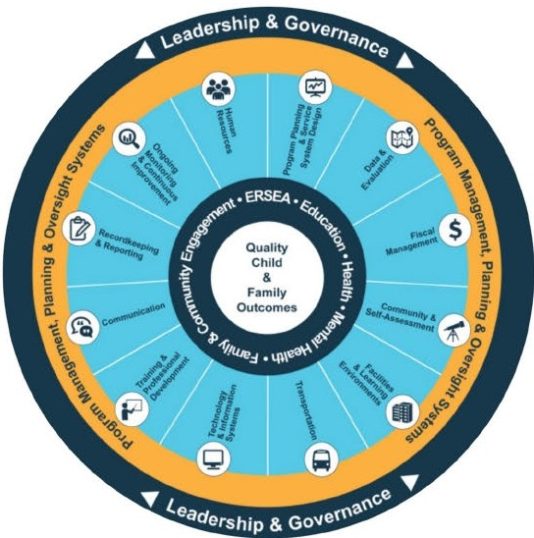


How we get Head Start revenue­
--·-==---·-!
- Budget is developed annually

  - Fiscal year for DFSS is December 1


  - Vouchers submitted monthly with all necessary backup paperwork.
  - Personnel Activity Reports and other documents required.
  - Budget Revisions submitted as needed (usually 2-3 times per year)

Head Start Program Monitoring SUBRECIPIENT II f)NI'l1f)Ill Nf•
- Compliance Monitoring a regular component of Head Start

  - Regular Check Ins with DFSS Program Manager
,i
;/}. CLARIDJ(;M

  - DFSS Audits as required including fiscal administrative focused reviews
  - Federal Visit at least once per grant period (every 5 years)
  - MSE is a sub-recipient under DFSS (the recipient)


Overview

- Audit/Auditor
- Cost Allocation
- Allowable/Unallowable Costs
- In-Kind Policies and Procedures- Non-Federal Match
- Purchasing Procedures
- Conflict of Interest
- Employee Time and Effort Reporting
- Payroll Policies
- Accounting and Reporting Procedures

Annual Audit

Federal Requirement

- Audit Conducted Annually
- Federal Single Audit also conducted annually as MSE spends more than $750k in federal funds annually.
- Independent Auditor selected by the Board via a thorough process
- Director of Finance coordinates the audit with the auditors.
- Findings, recommendations, or other concerns are communicated directly to the Board, specifically the Finance Committee of the Board.

M/G


Cost Allocation - Whtt d o we hare?

Federal Requirement
I I


- Cleaning supplies

How do we make sure that each award only pays its fair share of a cost?
- Utilities
- Bulk Supplies
- Maintenance Service Employees
- Accounting Services
- Insurance

M/G


Cost Allocations

Federal Requirement

- Uniform Guidance, 2 CFR part 200, establishes the principles for determining costs of grants, contracts, and other agreements with the Federal Government.
- Direct vs. Indirect Costs
  - All costs are direct except management and general expenses
- Three types of costs

  - Program Services
  - Fundraising
  - Administration
- HHS has adopted the UG with 45 CFR Part 75

M/G

Cost Allocation (Typical Shared Costs) M/G

Type | Allocation | Note
Employee Compensation | Time Spent/Square Footage/Enrollment | Must be charged and document to the appropriate program.
Consumables | Actual Use in Program/Square Footage/Enrollment
Professional Services | Direct to where occurred/enrollment breakdown
Utilities/Maintenance | Direct/Square footage
Insurance | Direct/Enrollment breakdown
Equipment and Furniture | Direct | Capitalize single item over  $5,000

Cost Allocations - Indirect Costs

- MSE has elected to charge the de minimis rate of 10% of modified total direct costs (MTDC)

De Minimis Indirect Cost Rate
M/G


Unallowable Costs

- Advertising
  - Exceptions: recruitment of staff, procurement posting
- Bad Debts
- Contingency Fund Reserves
- Fundraising Costs
- Entertainment
  - Except where specific costs that might otherwise be considered entertainment have a programmatic purpose and are authorized either in the approved budget for the Federal award
- Fines and Penalties
- Honoraria

A

Unallowable Costs

- Interest Expense
- Meetings and Conferences
  - Except where the primary purpose of the event is dissemination of technical information
- Inter-Fund Borrowing
- Alcoholic Beverages

A

Unallowable Costs

- Where should it be caught before happening?

  - Initial purchase application - Staff
  - Purchase approver - Management
  - Purchase payor - Management
  - Voucher approver - DFSS

A


Non-Federal Match

- Non-Federal Match is a statutory requirement of the Head Start Act
- DFSS also requires an additional non-federal match
- Total non-federal match requirement for DFSS delegate agencies is 33%
- Cost sharing, in-kind donations, contributions, donations may be eligible for Non-Federal Match.
- Not all donations/contributions are eligible- must be needed/beneficial for program objectives
- Appropriate documentation is required

A

Non-Federal Match Criteria
-
NFM
Rules

- Are verifiable from the recipient's records

- Are not included as contributions for any other federally assisted project or program

- Are necessary and reasonable for proper and efficient accomplishments of project or program objectives

- Conform to any limitations or exclusions set forth in these principles or in the Federal award as to types or amount of cost items.

- Are consistent with policies and procedures that apply uniformly to both Federally financed and other activities of the non-Federal entity.

- Are accorded consistent treatment. A cost may not be assigned to a federal award as a direct cost if any other cost incurred for the same purpose in like circumstances has been allocated to the Federal award as an indirect cost

- Are allowable under the applicable cost principles (Uniform Guidance, CFR part 200)

- Are not paidby the Federal Government under another award, except where otherwise authorized by Federal statute per Uniform Guidance, CFR part 200.

- Are included in the latest approved budget

- Are documented uponreceipt using the Non-Federal Match Donation/In-KindContribution Form.

M/G

:^{C}:/:⁾ ,
u ..,..
z .....
UJ

Non-Federal Match - Common Sources

- Donations
- Contributions of Goods/Services
- Volunteer Services
- Board and Parent Policy Council Time
- Parent Volunteer Time
- Donated Supplies
- Donated Building, Land, and Equipment
Qc, 2
0:: :!:: AWARENESS(/) w Cl)
f5SERVICES 5AID
CLU!J HELPING R:E;;STOPGEETCHETRN:Ei!SS:
c !!lr VOLUNTEER!
COMMUNITY li:DONATIONS
CONTRIBUTION o TEAMWORK
!::;ASSISTED §: PERSON
0
5 :=, :%:
< U)

A


Non-Federal Match - Documentation

- All non-federal match eligible sources must be documented using the in-kind form
- Due to the Operations Manager by the end of the month of the occurrence/donation
- In-Kind Form

M/G

Non-Federal Match - Documentation

A


Non-Federal Match - Common Errors
O(Jts·I
\

- Missing Dates
- No Signatures
- Unclear/Incomplete Description
- Inaccurate valuation

M/G

Insurance

- Director of Operations responsible for maintaining the below types of insurance
  - Theft and Vandalism
  - Student Accident
  - General Liability
  - Directors and Officers Liability
  - Group Insurance

M/G

Purchasing Procedures

- Introduction
  - Most purchases are done via purchase order but sometimes a check request can be used.
  - Proper approvals must always be obtained first.
  - The Director of Operations will keep a log of expenditures as they are made to keep an updated budget balance. The Director of Finance will submit monthly financial reports to the Executive Director, Site Director, and Director of Operations to review spending and budget balances.
  - All purchase orders must remain within Board approved budgets. Budgets are developed according to Uniform Guidance, CFR part 200. All extra budgetary items must have Board approval before expenditure is approved.
  - No tax is necessary for most purchases made by The Montessori School of Englewood. A
tax-exempt letter should be provided to any supplier requesting one. If any purchase includes taxes for which The Montessori School of Englewood is exempt, the purchaser will be personally liable for reimbursing The Montessori School of Englewood. A


Purchasing Procedures - The 14 Elements

- Items purchased must be within the approved budget. Check your budget and year to date expenses to make certain there are funds available in the category.
- Avoid purchasing unnecessary items.

- You must have a clear and accurate description of the technical requirements for materials, product, or service to be purchased.
- Compare prices of items in catalogs and negotiate lower prices with vendors.

- Purchases of large equipment/furniture (over $25,000) require three bids before the final order placement.
A

Purchasing Procedures - The 14 Elements

- Where appropriate, an analysis should be made to determine if lease or purchase alternative would be the most economical and practical procurement.
- A clear and accurate description of the technical requirements for the materials, product, or service to be purchased. In competitive procurement, a description shall not contain features, which unjustifiably restrict competition.
- List requirements, which the bidder/offeror must fulfill, and all other factors to be used in evaluating bids or proposals.
- A description, whenever practicable, of technical requirements in terms of
functions to be performed or performance required, including the range of acceptable characteristics or minimum acceptable standards. A

Purchasing Procedures - The 14 Elements
- The specific features of "brand name or equal" descriptions that bidders are required to meet when such items are included in the solicitation.
- The acceptance, to the extent practicable and economically feasible, of products and services dimensioned in the metric system of measurement.
- Preference, to the extent practicable and economically feasible, for products and services that conserve natural resources and protect the environment and are energy efficient.
- Priority should be made to utilize small businesses, minority-owned firms, and women's business enterprises, whenever possible.
A
- If there are funds available, prepare a purchase order.

Purchasing Procedures - Other Considerations
For all procurement actions under $10,000 are considered micro-purchases where cost comparisons are not required. To the extent practicable, the agency will distribute micro-purchases equitably among qualified suppliers with reasonable pricing.
The agency follows the Davis Bacon Act that requires all contractors and subcontractors performing work on federal construction contracts or federally assisted contracts, in excess of $2,000, to pay their laborers and mechanics not less than the prevailing wage rates and fringe benefits for corresponding classes of laborers and mechanics employed on similar projects in the area.
Contractors and Consultants will be vetted through a Contract Approval Process and bids will be kept in the contract files. Contractors will provide completed W-9 forms upon execution of contract.
If an approver is also the requester (i.e., an expense report), that person's supervisor or their delegate shall become the approver.
The approver for expenses of the Executive Director is the Board Treasurer or Board President.

A

) )0 #$ ! * *!+ " +1, , 2 , " " %  *1,2 | ! ". # $& ! % ' ! | 3 $ ! " ! 4 " " "4 & % ! ! % ! ! ! " % ! # 5  %! ! $!# "!4 # ! !$ ! " | 6" / % % % 7! ! " ' ! 0 "8 0 6 "# !  ! " # % 98 | ( ! . ( "
*1,2.*2,9 , | .0'.!# ! &3' :! ' ! !$ | 3 $ ! " % ! ! 4! " " 4$ !# " !4 % ! ! " # %! # ! ! $ ! "5 | 6" % % % 77 ! ! " #80 6 " # % 98 |   (! .

Amount of  Purchase | Required Approvals | Required Solicitation | Required Documentation | Procurement Method
$10,001-  $19,999 | - Site Director  - Director of Operations  - Director of Finance  - Executive Director  - If a fixed asset purchased with federal funds (>$4,999), prior written approval from Funder may be required. | - Attempt three  (3) written bids (catalogue, Internet, written)  - Utilize the appropriate procurement p r o t o CO IS | - All of the above, and Documentation of bids received Contract Routing Protocol.  - Written approval of funding source, if required. | Small Purchase
$20,000-  $149,999 | - Site Director  - Director of Operations  - Director of Finance  - Executive Director  - Board of Directors  - If a fixed asset purchased with federal funds (>$4,999), prior written approval from Funder may be required. | - Attempt three  (3) written bids | - Copy of RFB or RFP Proposal scoring grids including who | Large Purchase  A
 |  | (Request for Bids or  Request for Proposals) | participated in the scoring  - Proposal and contract of | Large Purchase  A
 |  | - Evaluation  factors must be | winning bid  - Written approval of funding | Large Purchase  A
 |  | approved by the  Director of Finance | source if required.  - Board minutes documenting | Large Purchase  A
 |  | and Executive | approval, if required. | Large Purchase  A
 |  | Director documented. |  | Large Purchase  A

Emergency Procurement

In an emergency, the Director of Operations or Site Director may direct the purchase of goods or services to address the needs of the emergency outside of the day-to-day procurement policy up to
$50,000.
An emergency need must be presented and approved by the Board President or Board Treasurer AND Executive Director.
The emergency declaration must have an end date no longer than 6 months from initiation, but it may be renewed by the approval of the full Board of Directors for subsequent 6-month terms.

M/G


Purchase Order Form
!(\1
-
Purchase Order Request Form

REQUBTINC EMPWYEE INFORMATION:

Ndmeof indlvldul complednJ the
«quest:

Date:

PurchHc O.nlc.rN
Ship to(Itemsmust b<, shipped to
iMSOE)
This form must be completed and approved before any Items are purchased.
Vendor (include address or Web  site if Web purchase) Include  FEIN number1,ben aoolicable | Descrlotion/Pu,oose | Expense Type  (select dror•""wn) | Amount
 |  | .
 |  | .
 |  | .
 |  | .

1, this expense fN the budget NOT in the: b1..u.lg,c1
MONTESSO"R' I SCHOOL
E-,,,.,.J

EmplO')·ee Signature: Director's Signature Principal's Signature
M/G

PO Form - Common Errors

- Missing Dates
- No Signatures
- Unclear/Incomplete Description
- Inaccurate pricing
- Improper Authorization
- Not using approved vendors

M/G

Purchase Order Process
- The Director of Finance should receive within 5 days from the purchase date all original back-up with (if any) remaining money or credits given by vendors. Please obtain a receipt for money turned in to fiscal office. This serves as proof that you turned in the money.

- Receipts dated 45 calendar days prior to the day of submission will not be reimbursed.

- All expenditures should come with proper accounting codes or explanations and should be accompanied by check stub or check number.

- Petty Cash should be requested monthly. All petty cash expenditure receipts (itemized if needed) should be accompanied by the Summary Sheet and correct balance should be turned in to the Fiscal Office no later than the 5th working day ofthe following month.

- Receipts submitted for reimbursement should only reflect purchases made for The Montessori School of Englewood.

- Credit Cards are not allowed to be used.

M/G


Conflict of Interest

Purpose: This Conflict-of-Interest policy is designed to help directors, officers, and employees identify situations that present potential conflicts of interest.
- Who is affected- employees and Board Members and their:
  - 1. Spouses or domestic partners
  - 2. Brothers and sisters
  - 3. Parents, children, grandchildren, and great-grandchildren
  - 4. Spouses of individuals listed in 2 and 3
- Violations will result in disciplinary action that may include termination.

A

Conflict of Interest - What is it?
Negotiates or approves a contract, purchase, sale, or lease on behalf of MSE and has direct or indirect interest in, or receives personal benefit from, the entity or individual providing and/or receiving the goods or services.
Approves the employment of, or directly supervises a person who is an immediate family member of the director or employee.
Provides goods or services in competition with MSE
Uses MSE's facilities, other assets, employees, or other resources for personal gain.
Receives a substantial personal gift (greater than a value of $50/year) from a vendor if the director or employee is responsible for initiating or approving purchases from that vendor.

A


Employee Activity Reporting - (PARs)

!/\ -

Federal Guidelines require all employees to complete a bi-weekly Personnel Activity Report (PAR) These are especially important for anyone with shared duties across multiple programs as the time dedicated to each must be tracked accurately.
Purpose: To ensure accurate reflection of employee's time so that compensation is charged appropriately to the proper grant and in the right amount.
Not following the PAR process can result in MSE having disallowed costs and losing the revenue Personnel Activity Reports must contain the following:
Reflect the after-the-fact actual activity
Accurately account for 100% of an employee's activity for which he/she is compensated
Must be signed by employee completing the activity report or an email from the employee can be used as proof of signature
Must be reviewed and signed by employee's supervisor or an email from the supervisor can be used as proof of signature
Must be completed twice per month in a timely manner
A

Employee Activity Reporting - Procedure

!/\ -
The Personnel Activity Report must be completed in the Personnel Activity Report template to ensure accuracy of total hours worked.

- Fill in the employee's name in the space provided at the top of the form.
- Fill in the month and date from and to.
- Specify the actual hours worked for each day and for each program(s).
- Paid time off should be included under the Pay Status section. Make sure to specify whether it is a vacation, sick, personal, or holiday.
- Review the Personnel Activity Report for accuracy.
- On the closing of the pay period, the employee must email the spreadsheet to the Site Director for his/her review.
- The Site Director will send approved PAR to the Director of Operations and the Director of Finance.
- The Director of Finance will review the Personnel Activity Report against payroll registers to ensure
A
accuracy.

Employee Activity Reporting - Procedure


A


Employee Activity Reporting Procedure
Employee
Poslt1-0nl Teacher

Pay Period Startinel
I
1
I
1
I
J
9/25/20211
He&d'Stl'lrt/Presthoo'- |  | 6.08 | 6.06 | 6.06 | 6.06 | 6.06 |  |  | 30.40 |  | 30,40
Charter Schoof |  | 1.92 | l.92 | 1.92 | l.92 | 1.92 |  |  | 9.60 |  | 9.60
Title 1 |  |  |  |  |  |  |  |  | 0.00 |  | 0.00
 |  |  |  |  |  |  |  |  | o.oo |  | o.oo
 |  |  |  |  |  |  |  |  | 0.00 |  | 0.00
 |  |  |  |  |  |  |  |  | 0.00 |  | 0.00
 |  |  |  |  |  |  |  |  | 0.00 |  | 0.00
Hclldoy |  |  |  |  |  |  |  |  | 0.00
Vocotion |  |  |  |  |  |  |  |  | o.oo
Sictt.ea...e |  |  |  |  |  |  |  |  | 0.00
f$0t1t1I L owt |  |  |  |  |  |  |  |  | 0.00
Total Hrs; |  | 8.00 | 8.00 | 8.00 | 8.00 | 8.00 | 0.00 | 0.00 | 40.00 | 0.00 | 40.00
WEEK2 |  | 10/l>l/21 | 10/D4/2l | 1()/IJS/21 | J l | 1()/()1/21
Headstart/Preschool'. |  | 6.08 | 6.08 | 6.06 | 6.06 | 6.06 |  |  | 30.40 |  | 30.40
Charter |  | l.92 | l.92 | l.92 | l.92 | 1.92 |  |  | 9.60 |  | 9.60
litle 1 |  |  |  |  |  |  |  |  | 0.00 |  | 0.00
 |  |  |  |  |  |  |  |  | 0.00 |  | 0.00
 |  |  |  |  |  |  |  |  | 0.00 |  | 0.00
 |  |  |  |  |  |  |  |  | o.oo |  | o.oo
 |  |  |  |  |  |  |  |  | 0.00 |  | 0.00
HONd y |  |  |  |  |  |  |  |  | 0.00
\.bcoti:m |  |  |  |  |  |  |  |  | 0.00
S,ckUaw- |  |  |  |  |  |  |  |  | 0.00
l'trJMO'fUO'lt' |  |  |  |  |  |  |  |  | o.oo
Total Hrs: |  | 8.00 | 8.00 | 8.00 | 8.00 | 8.00 | 0.00 | 0.00 | 40.00 | 0.00 | 40.00
WEEKl |  | lq/Jq/2J
Head'start/Pnmhod |  |  |  |  |  |  |  |  | 0.00 |  | 0.00
0.al'tet School I |  |  |  |  |  |  |  |  | 0.00 |  | 0.00

Endkt-g
I
I
10/10/2021
I I

A

Payroll
Employees are compensated on a bi-monthly basis
15th and last day of the month. If falls on a weekend or holiday, will be closest PRIOR business day.
Pursuant to the current and applicable prior HHS appropriation acts, none of the funds awarded by HHS shall be used to pay the salary of an individual at a rate in excess of the Federal Executive Level II (Effective 2021: $199,400).
All Fiscal & Human Resources policies regarding the personnel compensation will adhere to Head Start/Early Head Start guidelines. The salary schedule shall be reviewed during the grant application process each year. Any changes to the salary schedule shall be approved by the Board of Directors. Payroll is a vital function to the agency and qualified professionally trained staff will be tasked with ensuring payroll is processed with accuracy and in a timely manner.

A


Cost of Living Adjustments

Cost of Living

Employees are compensated on a bi-monthly basis
15th and last day of the month. If falls on a weekend or holiday, will be closest PRIOR business day.
Pursuant to the current and applicable prior HHS appropriation acts, none of the funds awarded by HHS shall be used to pay the salary of an individual at a rate in excess of the Federal Executive Level II.
- All Fiscal & Human Resources policies regarding the personnel compensation will adhere to Head Start guidelines. The salary schedule shall be reviewed during the grant application process each year. Any changes to the salary schedule shall be approved by the Board of Directors.

A

Cost of Living Adjustment Letter

Cost of Living Adjustment Letter for Employees Example

Due to the increase in the Consumer Price Index, there will be a cost of living (COLA) increase of 1.22% for the 2021-2022 school year. COLA is defined as the amount of money an individual needs to maintain their standard of living, housing, food, transportation etc.
This is documented on your offer letter for the 2021-2022 school year. Please note, this increase is for only individuals on the head
start budget. If you have any questions, please contact your direct supervisor.

COLA: Salary amount: $1,459.17 increase of $5.34 New salary amount: $1,464.51 Total Salary increase for the year: $74.77

A

Accounting and Reporting
Internal Controls
The purpose of a system of internal control is to ensure an effective system to monitor compliance with policies and procedures established by management.
Administrative controls deal with the operations of the business, whereas the accounting controls deal with accounting for such operations.
Accounting controls were designed to achieve the following objectives: validation, accuracy, completeness, maintenance, and physical security.

M/G


Accounting and Reporting- Segregation of Duties
-/
Duty | Personnel | Backup
Opens mail | Assistant to the Executive Director | Office Assistant
Prepares Bank Deposits | Director of Operations | Accountant
Reconciles Bank Accounts | Director of Finance | Accountant
Review Bank Reconciliations | Director of Finance | Accountant
Makes Bank Deposits | Accountant | Director of Finance
Initiates Purchases | Site Director/Director of Operations | Executive Director
Primary Signer of Checks | Director of Operations | Executive Director
Receives Goods | Office Manager | Director of Operations
Approves Bank Reconciliations | Executive Director | Board Treasurer

r'(:17 '2;
'<=IJf

M/G

Accounting and Reporting- Safeguarding Assets
Financial records are maintained in a proper filing system and in the cloud.

Financial statements are prepared monthly by the 15th day and compared to the budget and any variances are investigated.
Monthly financial reports include: Consolidated Income Statement Consolidated Balance Sheet Program Specific Income Statement Budget to actual variance report Cash Flow
All cash and checks are deposited to the bank on a regular basis (weekly).
Bank statements are reconciled monthly through the accounting software. The reconciliation is reviewed by the Director of Finance, dated, initialed, and submitted to the Executive Director for approval.
Documents on all securities are kept in a safe locked fireproof box.
Appropriate insurance for all assets will be maintained. M/G
Online financial systems are backed up to the cloud daily and a backup is downloaded monthly.

Accounting and Reporting-
Cash and Cash Receipts Receipts by Mail
Receipts by Direct Payment

- Void Checks
- Automatic Bank Deposits and Withdrawals
- Assets Liabilities Revenues Expenses
Financial System Back-Up
MSE does not use a Petty Cash system.

MIG

Accounting and Reporting- Fixed Assets
CAPITALIZATION POLICY
All purchases of fixed assets that exceed $5,000 per item should be capitalized. Fixed assets include leasehold improvements, office equipment, and office furniture and fixtures.
Requires approval from grantee (DFSS)
FIXED ASSETS ADDITIONS
Asset addition records should include date of purchase, description of items purchased, the amount paid, estimated useful life, and the funding source.
DETAILED PROPERTY RECORDS
Disposal records should include the date of purchase, amount paid, date of disposal and reason of disposition. Once an asset is disposed of, the asset is removed from the balance sheet.

M/G

Accounting and Reporting- Fixed Assets
DEPRECIATION AND AMORTIZATION
Depreciation and amortization expenses for the fixed assets and other asset accounts will be recorded monthly. The entry to record depreciation and amortization into the accounting software is entered through the general ledger/general journal module.
The straight-line depreciation method will be used to reduce the value of the fixed asset and other assets over the estimated useful lives as follows:
5-7 years for furniture and equipment 10 years for leasehold improvements 15 years for building improvements
PHYSICAL INVENTORY
Equipment - Every two years all equipment valued over $5,000 per item shall be inventoried and kept in the record as required by the award requirements.
Supplies- Supplies will be inventoried annually as part of the budget development process.

M/G

Records Retention
All financial records, supporting documents, statistical records, and all other records pertinent to an award, except payroll related, shall be retained for a period of five years from the submission date of the final expenditure report or as required by the grantor/contract.
If there is any litigation, claim, financial management review, or audit is started before the expiration of the 5-year period, the records shall be retained until all litigation, claims or audit findings involving the records have been resolved and final action taken.
Auditor's reports, financial reports, tax returns, pension records, the corporation articles of incorporation, bylaws, and the board minutes shall be retained permanently.

A

Reporting
Q Executive Director/Director of Operations/Site Director - WEEKLY
Q - Weekly reports on status of budget
Q - Present financial ledger
Q - Review any personnel changes
Q - Determine the need for any budget revisions
Q - Review and Reconcile Personnel Activity Reports
Q Finance Committee of the Board - MONTHLY
Q - Review financials
Q - Discuss and determine and trend changes or burn rate concerns
Q - Approve any needed budget revisions
Q - DFSS Monthly HR Report
Q - Discuss any conflicts of interest Q Parent Policy Committee - QUARTERLY Q - Review financials (Monthly}
Q - Enrollment Report

Q Discuss any personnel changes
Q DFSS HR Report
Q Discuss/Ai:>_prove any needed budget revisions

M/G

Confidentiality
Those with Fiscal and Human Resource responsibilities have access to confidential Protected Personally Identifiable Information including bid proposals, individual salary information, wage garnishments, social security numbers and bank account information.
This information must be kept private, to be shared only with appropriate individuals. Violation of this policy will result in a formal reprimand and/or other forms of disciplinary action up to and including termination.
The PPC and Board must maintain confidentiality with regard to discussion of any sensitive matters, including employee performance and compensation. They may not discuss any of this information with non-members or anyone who is not management.

A

COVID-19
- Fiscal
  - Procurement- Policies and procedures should still be followed.
  - The Director of Finance will work with the Site Director and Director of Operations to develop budgets for any additional revenue provided, such as CARES funds.
  - Additional monthly reports will be developed by the Director of Finance for CARES funding ledger/reporting.
- Costs
  - Any additional funds shall go only toward allowable expenses such as PPE, staff and student wellness, technology, etc.
  - MSE will prioritize health and safety in the spending of any CARES dollars. See Emergency Procurement Procedures for more information

A

What have we learned?

A

" # $ % # $' ' % % & ! % '

# $ % & ( $ %( ( ( ) * & ( & + ' & ( ! "

& ! " # ' ! " # $ ' ( % # #

Post Training Survey?

A

