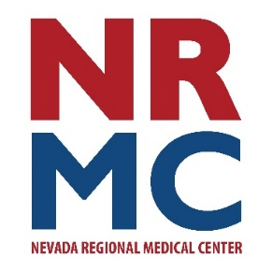
Spring Health Insert

Jennifer Eaton
Community Relations & Foundation Director
417.448.3710
FOR IMMEDIATE RELEASE
April 15, 2026
BE FAST When Recognizing Stroke Symptoms
Every 40 seconds, someone in the U.S. has a stroke. Do you know the warning signs?

It can happen anywhere - your workplace, the grocery store, or even at home. Knowing how to recognize the warning signs and acting quickly can save a life and help prevent long-term disability.

Calling 911 is the fastest way to get stroke care. EMS can start care immediately and alert the hospital team before arrival. The faster a stroke is treated, the more likely the patient is to recover. It’s a matter of getting the right treatment, right away.

Stroke warning signs: B.E. F.A.S.T.
- Balance loss or coordination
- Eye (vision) loss or changes
- Facial weakness or drooping on one side
- Arm weakness or numbness
- Slurred speech or trouble speaking
- Time – call 911 immediately

Nevada Regional Medical Center (NRMC) is working to obtain a Stroke Ready Hospital designation this summer. Acute Stroke Ready Hospitals can provide the specialized treatment for patients experiencing stroke symptoms. Stroke program coordinator, Melissa Gould notes, “NRMC has been providing this level of care for some time, however, achieving this special designation at the state level will allow our local EMS crews to deliver patients here rather than traveling to the next closest facility to provide this time critical intervention. When it comes to stroke care, time is brain. Our goal is to provide our patients with rapid evaluation and administration of clot busting therapies to ensure the best possible recovery outcomes.”

###
About Nevada Regional Medical Center
Serving a six-county area since 1937, Nevada Regional Medical Center is a 71-bed acute, intensive and skilled care hospital. Nevada Regional Medical Center staff represent more than a dozen medical specialties including ear, nose & throat, family practice, general surgery, internal medicine, pediatrics, psychiatry, orthopedics and wound care services. Additionally, consultation clinics are held regularly by specialists in cardiology, dermatology, neurology, podiatry, pulmonology, rheumatology and urology.

