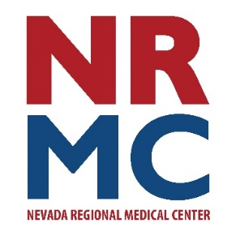
Spring Health Insert

Jennifer Eaton
Community Relations & Foundation Director
417.448.3710
FOR IMMEDIATE RELEASE
April 15, 2026
Pelvic Floor Dysfunction – What is it?
The pelvic floor is composed of a group of muscles in the pelvic area. Similar to a sling, our pelvic muscles support the bladder, uterus in women, prostate in men, and the rectum. Bowel and bladder movements are controlled when we contract and relax the pelvic muscles.
When the muscles, ligaments and connective tissue that support the pelvic organs don’t work as they should, it may lead to symptoms such as:
Urinary or bowel incontinence (frequent or urgent need as well as leakage)
Pelvic pain or pressure
Pregnancy & postpartum recovery
Pain with intimacy
Core weakness or low back pain (including tailbone and hip pain)
Post-surgical recovery

Pelvic floor disorders are common, but treatment options can help. Pelvic floor therapy is a non-surgical solution that could include:

  - Exercises to identify and strengthen the pelvic floor
  - Core strengthening exercises
  - Manual therapy techniques such as soft tissue/joint mobilization & myofascial release to address muscle imbalance
  - Bladder and bowel training
  - Self-care education including diet and lifestyle changes that can help improve symptoms

Nevada Regional Medical Center (NRMC) is pleased to begin providing this therapy service in June. Ami Schwarten, MPT and NRMC team member, is a physical therapist specially trained in pelvic floor disorders. Ami notes her passion to provide this service is to “help patients regain confidence, comfort and control through customized treatment plans based on individual needs. We will help you gain control of your bladder, decrease pain, reduce medication use or incontinence and pain, and may even prevent the need for surgical intervention.” This service will be available for women only for now, with additional services for men and children, as the program grows. While your insurance may allow you to see a therapist without a referral, it is recommended that you have a provider managing your overall health care. For further questions or more information, please call 417-448-3790.

###
About Nevada Regional Medical Center
Serving a six-county area since 1937, Nevada Regional Medical Center is a 71-bed acute, intensive and skilled care hospital. Nevada Regional Medical Center staff represent more than a dozen medical specialties including ear, nose & throat, family practice, general surgery, internal medicine, pediatrics, psychiatry, orthopedics and wound care services. Additionally, consultation clinics are held regularly by specialists in cardiology, dermatology, neurology, podiatry, pulmonology, rheumatology and urology.

