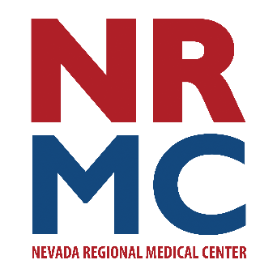
Press Release

Jennifer Eaton
Community Relations & Foundation Director
417.448.3710
FOR IMMEDIATE RELEASE
May 28, 2026

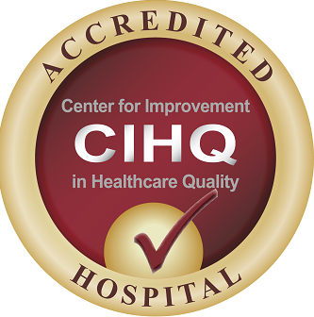
Center for Improvement in Healthcare Quality seal
NRMC obtains Hospital Accreditation for Stroke Readiness
Nevada Regional Medical Center (NRMC) was recently surveyed by the Center for Improvement in Healthcare Quality (CIHQ) and has successfully met the requirements for Hospital Accreditation by demonstrating compliance with CIHQ Standards and the Conditions of Participation by the Centers for Medicare and Medicaid Services.
NRMC was subjected to a rigorous onsite assessment May 19, 2026. The CIHQ team toured the hospital, reviewed medical records, observed care practices, and interviewed staff and patients. The purpose of the survey, to obtain a Stroke Ready Hospital designation, has been in process since early 2026. The Emergency Department team of physicians and nurses have been preparing for several months to ensure a successful outcome. Acute Stroke Ready Hospitals can provide the specialized treatment for patients experiencing stroke symptoms. Stroke program coordinator Melissa Gould, BSN, RN notes, “NRMC has been providing this level of care for some time, however, achieving this special designation at the state level will allow our local EMS crews to deliver patients here rather than traveling to the next closest facility to provide this time critical intervention. When it comes to stroke care - time is brain. Our goal is to provide our patients with rapid evaluation and administration of clot busting therapies to ensure the best possible recovery outcomes.”
“CIHQ’ goal is to partner with hospitals to improve the care provided in our communities,” states Richard Curtis, Chief Executive Officer of CIHQ. “CIHQ is proud to recognize Nevada Regional Medical Center for achieving accreditation and reflects NRMC’s commitment to safety and quality patient care.”
NRMC will submit this accreditation to the Missouri Department of Health and Senior Services’ Time Critical Diagnosis System to apply for designation as a Level III Stroke Center.
###

