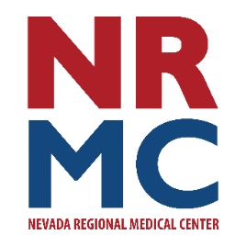
Jennifer Eaton
Community Relations & Foundation Director
417.448.3710
FOR IMMEDIATE RELEASE
June 5, 2026

Press Release

NRMC Foundation Receives Donation for Breast Cancer Awareness
Nevada Regional Medical Center Foundation recently received a $5,000 donation from the HOPE 4 You Breast Cancer Foundation, located in Joplin, MO. HOPE is an acronym for Help, Outreach, Prevent and Educate. The purpose of the HOPE 4 You Breast Cancer Foundation is to raise awareness, provide support, offer education and instill hope for those affected by breast cancer in the local area. Between 2007-2025, HOPE 4 You has raised more than $730,000 to assist women in the Four States, where their impact and support has had a tremendous effect locally.
“We are truly honored to be included in the list of recipients,” said Jennifer Eaton, Foundation Director. “This gift will help us make sure we can offer mammogram screenings to every woman who needs one. And our involvement and support of HOPE will help them carry out their mission.”
For more information on the HOPE 4 You Foundation visit www.hope4youbcf.org. For more information about the NRMC Foundation visit www.nrmchealth.com or find us both on Facebook.

# # #

