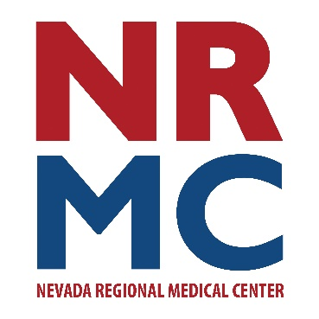
Jennifer Eaton
Community Relations & Foundation Manager
417.448.3710
FOR IMMEDIATE RELEASE
June 5, 2026
Press Release

Finis Moss Trust Awards Grant to NRMC Foundation
The Finis M. Moss Charitable Trust recently approved a grant proposal for $11,772 from Nevada Regional Medical Center (NRMC) Foundation to fund the purchase of (3) handheld ultrasound devices for use across key clinical areas at Nevada Regional Medical Center. This investment will directly benefit patients by expanding access to essential diagnostic tools, improving outcomes, and strengthening NRMC’s ability to deliver efficient, patient-centered care.
The addition of the handheld ultrasound devices will allow providers in the emergency department, obstetrical unit, and outpatient clinic settings to perform real-time imaging at the bedside, improving diagnostic speed, enhance clinical decision-making and reduce unnecessary transfers to distant facilities.
“These devices will enhance our ability to provide timely, high-quality care to patients,” notes Christi Keating, Chief Nursing Officer. “We are very grateful to the Finis Moss Trust for this investment. These devices will help us to take the best care possible for our patients quickly and in real-time.”
###

