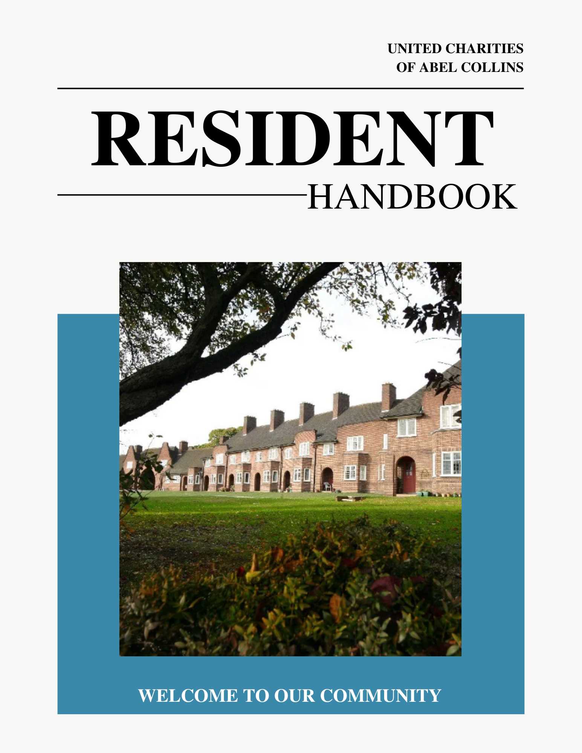

Contents

Topic Page

Section One: Staff on site 2

Section Two: Moving In 4

Section Three: The Site 5

Section Four: Your Home 8

Section Five: Conditions of Occupancy 16

Section Six: Health and Safety 25

Section Seven: Our Policies 30

General Information and Advice 32

Your Privacy 35

History of the Charity, Governance and Policies 38

Section One

Staff on site

Abel Collin’s Homes provide housing for up to one hundred people with a mix of houses and bungalows on one site. There are two staff based on site during office hours.

The Independent Living Co-ordinator (ILC)
The Independent Living Co-ordinator’s role is to provide the support, advice and guidance residents need to help them live independent lives.

The Co-ordinator usually works Monday to Friday and is based in the office or the hall.

The Co-ordinator will speak to you regularly to check that you are ok, either in person or by calling you using the alarm unit in your home. If you need help, the Co-ordinator will contact your relatives or call a doctor or other professional for you.

The Co-ordinator cannot provide medical assistance (except in an emergency) or assist you with personal care, such as dressing, cooking or helping with medications. However, during working hours the Co-ordinator can contact your relatives or your next of kin. It is very important that you keep the Co-ordinator updated with contact details of your next of kin and your GP.

Please note that the Co-ordinator is not on duty 24 hours a day in the week, nor at weekends, and cannot be contacted out of normal working hours.

When the Co-ordinator is not at work, for example during a weekend or during their annual leave, residents can contact Nottingham On Call by pressing the unit in their home or using their pendant.

The Administrator
The Administrator works closely with the Trustees, and is responsible for the administration, maintenance and smooth running of the Homes.

The Administrator works Monday to Friday and is based in the office.

The Administrator can help you if you have any questions or concerns relating to the Homes, including;
- Queries about your Weekly Maintenance Charges and utility bill payments;
- Other queries about finances;
- Repairs in your home;
- Maintenance issues related to the site, grounds or hall;
- Refurbishment works in properties;
- New residents moving into the homes;
- Moving out of your home;
- Any other issues that you would like raise with the Trustees.

Section Two

Moving In

When you come to live at Collin’s Homes the Co-ordinator will require information from you to send to Nottingham On Call. The Co-ordinator will also complete a ‘support plan’ with you. The support plan is a document that sets out the support you think you need to live independently at the Homes. Your support plan also gives our staff the information we need about who to contact on your behalf in an emergency.

When you move in you will be given guidance on the operation of equipment in your property including the emergency alarm, central heating and shower systems. Our staff will also advise you of the action you should take in the event of a fire or other emergency.

A few weeks after you move in one of the Trustees will arrange to visit you to see how you are settling in and to ask whether you have further questions. If you have any problems in the meantime, you should contact the Administrator.


Section Three

The site

The Hall

The hall is a welcoming shared space which is for the use of residents for social and recreational activities. We encourage residents to use the hall regularly, and to feel free to organise meet ups and events with neighbours.

Although our staff do organise some events throughout the year, you are actively encouraged to arrange additional events yourself. Our community is a sociable and friendly one, and the hall is the ideal meeting space for social events, exercise or just a coffee and chat with your neighbours.

The hall is equipped with a large television, hard and soft seating, an outside terrace and a well-equipped kitchen. Tea and coffee are always available in the kitchen for you to make a drink for a small donation to cover costs. Residents all have the code for the door and may come and go from the hall whenever they please (assuming it is not already in use for an activity). We just ask that anyone who uses the hall leaves it clean and tidy, with any dirty cups or dishes stacked inside the dishwasher.

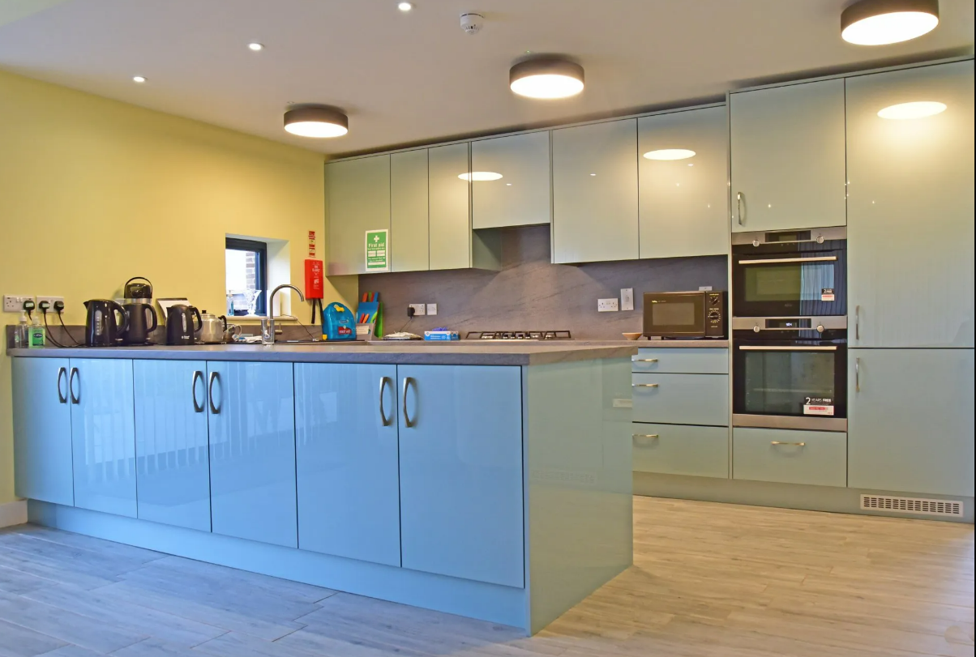

If you would like to organise an event, the Co-ordinator can give you advice and guidance, although we will encourage you to organise the event yourself as far as you are able.

The events that we organise during the year are funded by donations or through buying tickets.

Speak to the Co-ordinator if you wish to arrange a small celebration such as a birthday or anniversary party, to check there is no clash with other planned activities. If you do wish to use the hall for a private event you will need to complete a short, simple ‘Use of Hall’ form, obtainable from any staff member. It will be your responsibility to make sure the hall is clean and tidy for the next event or user and the premises is secure. A donation towards the residents’ fund is expected in this instance.

The grounds

The communal grounds are for the use and enjoyment of all residents.

Maintaining our grounds is a major piece of work, and the charity appoints contractors to carry out grass cutting, planting and tree pruning. Please do not put your own plants or trees in the communal beds and grassed areas. Please also do not ask our gardeners to do work for you when they are on site. They have been employed to care for specific areas of the site.

There are apple trees in the grounds that are there for all residents to enjoy. You are free to pick apples when they are ready, but we ask that you are mindful of other residents and ensure that enough are left so that everyone can enjoy them. If you are not able to pick apples yourself you are welcome to ask a friend, relative or neighbour to pick some for you.

Parking

Please park vehicles, and ask your visitors to park theirs, so that there is a clear route through the site for the emergency services and refuse collectors. We ask all residents and visitors to the site to ensure they never park on a grassed area or across a dropped kerb.

Residents and visitors to the houses should park on the opposite side of the slip road at the rear of their properties, alongside the grassed area.

Residents and visitors in the single bungalows and at the top of the site should park on the side of the road alongside properties 51-59 to allow clear access in an emergency.

The Collin’s site is private property, and non-residents are not allowed to use the site as a free car park. There is a maximum speed restriction of 15mph on the site and for the benefit of those residents who are registered blind, have acquired deafness or limited mobility we ask all drivers to take care as you enter the site and on corners in case of pedestrians.

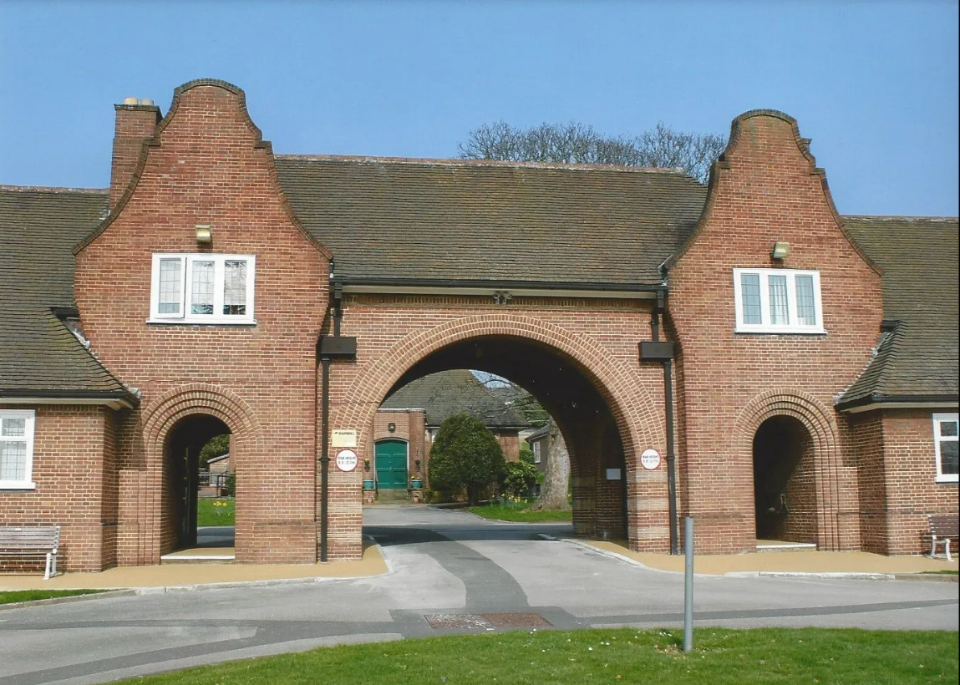
Section Four

Your home

Cleaning
You are responsible for keeping your own property, and the outside area immediately around it, clean and free of rubbish or other items. You should keep your drains free of leaves and ensure that the paths immediately around your property are clear of obstruction.

If you have a problem with cleaning inside your property, the Co-ordinator can guide you to an appropriate agency who can help you. Please take note that a property that is cluttered with belongings can be a risk factor for both falls and in extreme cases could be deemed a fire risk. If this occurs staff may ask you and your emergency contact to address it urgently.

Window cleaning
A window cleaner is employed to clean the outside of all windows, and there is no charge to you for this.

You should keep the inside of your windows clean (apart from the high windows in the Drury Bungalows which are cleaned twice a year).
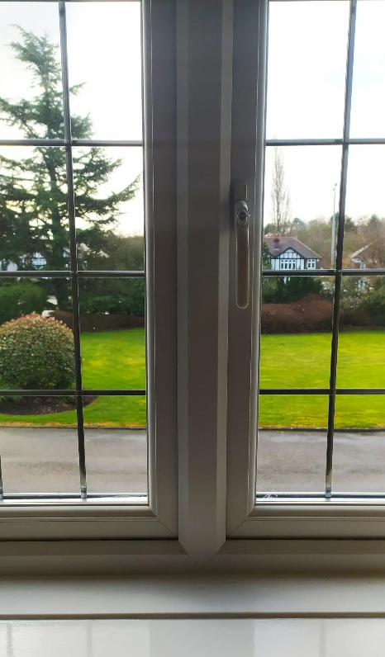

Gas, Electricity and Hot Water charges

The weekly charges you pay for living at the homes includes your gas, electricity and water costs.

Using gas and electricity sensibly will help you, and everyone else at the homes, to keep heating and lighting costs affordable.

Heating your home
All our homes have full central heating which is maintained, repaired and serviced annually by the charity.

Some properties already have gas fires installed. However, due to more recent health and safety guidelines, the trustees no longer allow the installation of gas fires or any gas appliances.

Gas and electrical safety
For the safety of residents, we do not allow the use of any gas appliances other than those installed and maintained by the Homes. This includes electric radiant heaters (i.e., with fire bars), paraffin heaters and LPG (Calor gas, etc.) heaters.

All boilers are checked annually by our contractors and a certificate issued, which we keep in the office. The cost of this annual check is included in the WMC.

The Co-ordinator will show you the location of the consumer unit (main electricity switches) in your property. Safety of your own electrical appliances is your responsibility. Multi-outlet adapters should be used as little as possible (never in the kitchen), and it is obviously sensible to avoid trailing leads on fires, irons and other appliances.

The bathroom showers are thermostatically controlled to avoid the risk of scalding.

Please ensure that you keep your boiler cupboard unlocked and clear from clutter. Locks and padlocks are not permitted on boiler cupboards so that our staff and contractors can quickly and easily access the cupboards when needed in an emergency.

Installing your own appliances
If you wish to buy an electric cooker or other appliance, installation must be carried out by our own qualified contractors, and there will be a charge for this. You should discuss this with the Administrator before purchasing. Our contractors are qualified engineers and will provide you with a certificate for any work done, which you must keep safely. All appliances must be of an approved safety standard.

If an electric cooker or other appliance that you have paid for needs repairs, maintenance or servicing in the future, you will be responsible for arranging and paying for these repairs. Disconnection of appliances must be arranged with our contractors, via the Co-ordinator.

Solar Panels

In spring 2015, the charity invested in solar panels, which have been fitted to our 24 south-facing bungalows. These panels generate an income that benefits all residents and helps to keep overall energy costs lower for everyone.
Water and Sewerage
The Co-ordinator will show you the location of the ‘sure stop’ (blue switch) in your property which should be switched off if you discover a water leak. This will cut off the water supply to the property. If you have to use the blue switch, please contact our staff immediately so that we can get the leak promptly repaired.

Water and sewerage charges are paid on your behalf by the charity; you do not pay for them.


Plumbing
Wet wipes, paper towels and other non-degradable material, and shredded paper must never be put down the toilet. This will block up the drains, and clearing them is time-consuming and expensive. Although wet wipes may be described as degradable or flushable, they are not – and should be put in your refuse bin (black bin).

Gardens and Grounds
Most properties have a garden area for residents to use. The gardens are designed to be open-plan so please do not put a fence or boundary around your garden.

You are responsible for keeping your garden and the area around your property clean and tidy. If you are unable to do so, speak to the Administrator who can suggest a suitable agency to approach. We ask residents not to plant trees in the gardens as these need to be carefully located away from drains and building foundations. You may however plant anything else that you choose in your garden area.

Please do not obstruct paths or place objects in a way that could be a hazard to you or to others. This is especially important in the event of fire or other emergency. Please keep access points and pathways clear at all times.

Our site is a well maintained and attractive place, and we ask residents to help keep it this way by making sure outdoor spaces are kept in good order and not accumulating or storing items that might affect the view for other residents.
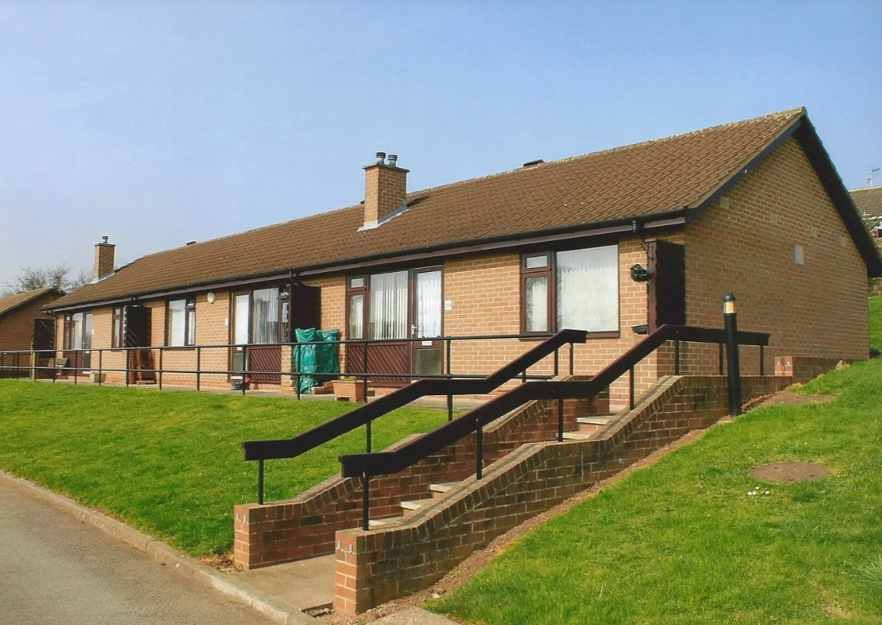
Refuse and unwanted items

Recyclable and non-recyclable waste is collected by Broxtowe Borough Council on alternate Fridays.

Please ensure that you use the correct bins:
Black bins: for all non-recyclable waste – wrap kitchen refuse well beforehand.
Brown bins: for rubbish from your own garden.
Red bins: for glass bottles and jars.
Green bins: for recyclable items (paper and some plastics – check with the Administrator or Co-ordinator if unsure).

If you have a large item for disposal (e.g., furniture or an electrical appliance), you should contact Broxtowe Borough Council and pay for removal. If the item is in good condition, you could contact a local charity.

Do not leave furniture and household items outside your property, except for a short time before any pre-arranged collection.
Use the brown garden bins around the site for your garden waste.

Skips on site are for the use of our contractors only. Please do not use the contractor’s bay at the top of the site to dispose of unwanted items.

Repairs and Decoration
The trustees are responsible for external and internal repairs to your home, including painting and decorating the outside of the building.

If you notice any repairs that need to be carried out, please report these to the office using a repair slip, or tell the Administrator. Repair slips are available in the hall. Completed repair slips can be posted through the door at the office or handed to a member of staff.

If a repair is an emergency, such as a water leak or heating breakdown during the winter, please contact a the Administrator immediately by phone or by pressing your alarm if this happens out of hours.

When you a report a repair our staff will give you a likely date when the work will be done, and you should ensure you are at home at this time. Callout charges are costly and have to be paid for, even if access to your property cannot be gained. Only in an emergency would the staff let a workman into your property. Do be patient while waiting for repairs; routine work might not be done immediately as it may be more economical for several jobs to be done at the same time.

Do not ask other workmen, friends or relatives to carry out alterations or repairs. If the work did not meet the required standards, our own contractors would need to make good the work and you could be charged for this. We are required to comply with strict health and safety regulations.

Any proposed alterations must be discussed with the Administrator, who will then raise the matter with the Board of Trustees. Minor work such as putting up pictures can, however, be carried out by the Helpful Bureau or an approved handyman/woman. Check with the Administrator first before contacting them.

Decorating your home
All the Homes are decorated internally before each resident moves in. If you want to decorate inside your home, please speak to a member of staff before planning work or purchasing any supplies.

Borders and permanent transfers must not be put on units, tiles or walls.

Improvements and Alterations to your Home
If you would like any improvements or alterations to your home (for example, installing a shelf, ceiling light or fire surround) please first discuss this with the Administrator. In some cases, where the work you are suggesting is significant, the Administrator will ask you to write to the trustees seeking their permission. If the trustees agree to this, the work must be carried out by our contractors, for which there could be a charge. Permission to make changes to your property could be refused if the trustees consider it would make it less pleasant for future residents or for your neighbours.

The floors in the kitchens, bathrooms and toilets are a special non-slip surface. These must not be covered with carpet, vinyl, or other permanent material.

Any fixtures must be left in place when you leave. If any work is carried out without first gaining the trustees’ consent, you could face a charge on vacating the property.

The Helpful Bureau
The Bureau aims to help people to remain independent and will carry out small jobs such as erecting shelves and pictures. You must NOT ask them to deal with any electrical, gas or plumbing work. They also organise social activities and excursions. Assessments are carried out free of charge. For more information telephone (0115) 949 1175.



Telephones

You are responsible for the cost of changing supplier. If the last occupant used a different supplier to one you wish to use (that is, if you want a BT line and the property has Virgin Media installed, or vice versa), you will need to organise this yourself. Telephone wires must not be removed when vacating your property. Any contract you have taken out must be cancelled on your vacating and any due charges settled in full.

Television

People over 75 do not pay for a television licence. By special concession, residents under 75 pay a small sum for an annual licence, which is included in your weekly charges. This is at no additional cost to residents. The Administrator will arrange this when you move in.

All properties can receive digital TV through your devices or with the additional cost of broadband from your chose supplier. You will be responsible for the charges for any subscription to a digital service.

Some properties have been fitted with an external aerial by our contractors, but no additional ones may be fitted. TV aerials and wiring must not be removed when you vacate your property.

Please be considerate to your neighbours in the use of television, radio, musical instruments, and playing music especially outside your property or with the windows open.



Low level baths and wet rooms / shower rooms
Most baths are of a fairly low level. If you are finding difficulties getting in and out of the bath, in the first instance please speak to the Co-ordinator or the Administrator. It may be possible to apply to the council for a wet-room grant.

Insurance

An insurance policy is held by the charity to cover the buildings. Residents are however responsible for the contents of their own home (personal belongings, furniture, electrical equipment, etc), and are advised to take out a policy to cover these. In the sad event of a burglary or fire our insurance would not cover your own personal possessions.

Section Five

Section Five

Conditions of Occupancy

Letter of Appointment / Licence to Occupy

The Homes are owned and managed by a charity. Living in homes owned by a charity is slightly different to living in homes rented from, for example, the council, a housing association or a private landlord.

When you moved into the homes you will have received a ‘Letter of Appointment’ called a ‘Licence to Occupy’ which you would have signed. This means that you are a ‘beneficiary of an almshouse charity’ rather than a tenant in the legal sense. This means that neither you nor any relative or guest of yours has any legal interest (a comprehensive term to describe any right, claim or privilege towards real or personal property) in the accommodation allocated to you. As a resident you have been given permission to reside at the Collin’s Homes by being formally appointed by the Board of Trustees, in accordance with the charity’s trust deed. It also means that the weekly charges for living at the homes are not ‘rent’ but are instead called Weekly Maintenance Contribution (WMC).

It is possible for you to be asked to leave in specific circumstances, e.g. breaking the conditions of the Licence to Occupy, or refusing to meet with Trustees to discuss a chronic decline in health or a diagnosis that is chronic raising safeguarding concerns. You can be asked to leave if you are no longer eligible for residence. The most common case would be if you are unable to continue to live independently, or if you failed to keep within the charity’s rules – then you could be required to leave.

On a day to day basis living at the homes is no different to living in conventional rented accommodation. However, it is important that you understand the distinction, and that you are living in the homes as a ‘beneficiary’ rather than a ‘tenant’.

If you would like this explained in any further detail please speak to the Administrator.
Independent Living
It is a condition of residence at the Collin's Homes that you are able to live independently. By this we mean;
- not needing regular or frequent help with everyday household tasks such as preparing food, cleaning and laundry;
- not needing regular or frequent help with managing personal affairs, such as dealing with day-to-day money and making and keeping appointments;
- not needing regular or frequent help with personal care: washing (and getting in or out of the bath or shower), dressing, eating, getting to and using the toilet, or communicating needs;
- not needing regular supervision to avoid putting yourself or others in danger; for example, needing someone to keep an eye on your medical condition or diet, or because you cannot control the way you behave.

The Co-ordinator will alert outside agencies and your family only in an emergency and is able to provide only time limited emergency care until the appropriate services arrive.

The trustees do realise that circumstances can change over time and it is possible that you could require short-term [less than 6 months] domiciliary care, perhaps after a stay in hospital. In this event you and your family would need to discuss your changing needs with the Co-ordinator, who could advise on help available from various outside agencies. It must be understood, however, that the Co-ordinator is not able to provide any kind of personal after-care.

You must be aware that in the event of prolonged ill-health [over 12 months] or mental or physical disability the trustees could, in consultation with you, your relatives, doctor and / or other professionals, require you to find accommodation more suitable for your needs. This will usually be because you can no longer live independently and have significant supervision, or support, or personal care needs.

Combined Weekly Maintenance Contribution (WMC, heating and lighting)
You have agreed to pay a combined weekly maintenance contribution, which is your contribution towards the cost of the services we provide.
The amount you pay covers part of the cost of running the Homes and includes:
- repairs and maintenance
- internal and external decorating of properties
- a proportion of staff salaries
- insurance of the buildings (but not the contents of your property)
- maintenance of the shared grounds
- cleaning of communal areas
- the concessionary television licence (for those under 75)

The housing benefit or other benefits that you claim from the council will be paid by the council direct into your bank or building society account. You are required to then pay the combined WMC charges to the charity every four weeks from the date you move into your accommodation. Standing Order is the safest and most convenient way to pay this, the charity do not accept payments in cash. The Administrator will discuss this further with you and help you make sure your payments are correctly set up.



When you move to the Homes it could take several weeks for Broxtowe Borough Council to begin paying your Benefit. During this time, you must however pay the charity your combined WMC, which, as stated above, is due from the date you move in. Please ensure you have sufficient funds to cover this until benefit is paid.

The charges are reviewed each year by the trustees, and you will be given at least four weeks’ notice of any increase. The trustees are required by law to ‘balance the books’. For most residents any WMC increase will be covered by benefits.

Paying for your home

It is a condition of entry to the Homes that new residents are already receiving, or are eligible to receive, Housing Benefit or the Housing Cost element of Universal Credit or income related Council Tax support.

The local authority paying your Housing Benefit, or Universal Credit or Council Tax support, when you move to the Homes is Broxtowe Borough Council. If your previous address was in the Broxtowe Borough Council area, you will need to be re-assessed when you move here. The Administrator can help you in completing the necessary forms.

It is important that you inform the Council if your financial circumstances alter, as this could affect your entitlement. Withholding this type of information could constitute benefit fraud, which is a criminal offence.

Ceasing to receive Housing Benefit/Universal Credit would not necessarily affect your status as an established resident. However, the trustees reserve the right to take action against any resident who is found to have intentionally provided misleading information about their eligibility for the Homes. (See Re-housing/Repossession).

Other Costs
Currently residents do not pay for the following: new building projects; water and sewerage charges; some support costs, such as the alarm system; the Christmas meal and Christmas gift. These are paid by the charity.

Absence from Home
You should not be away from the Homes for more than 28 continuous days in any one year, except of course for any medical reason such as a hospital stay or convalescence. If you expect your holidays and visits to family and friends to add up to more than 28 continuous days you must seek written permission from the trustees beforehand.

If you are planning to be away for a few days on holiday or for any other reason it is helpful if you let the Co-ordinator know in advance so that we know your property will not be occupied overnight.

Antisocial behaviour
Providing an environment that is safe, secure, comfortable and peaceful for all residents, visitors, staff and contractors is of the utmost importance to the trustees. Any incidents of anti-social behaviour should be reported promptly to staff and will be thoroughly and swiftly investigated.

If you witness or are the victim of anti-social behaviour our staff will support you and maintain your anonymity if you require it. Your complaint will be investigated in accordance with our anti-social behaviour policy.

If you are the perpetrator of anti-social behaviour you should be aware that your conduct could ultimately result in you being asked to leave the homes, in accordance with our policy.

You are responsible for the conduct of any of your visitors to the site, and could be held responsible if your visitors cause anti-social behaviour.

Abuse of staff and contractors
The trustees take a zero-tolerance approach to abuse of our staff and contractors. Staff and contractors have the right to do their jobs without fear of aggressive or abusive behaviour. You must not shout or swear at our staff or contractors or behave in any way that could be judged to be aggressive or intimidating. This also applies to your visitors, and you are responsible for the conduct of your visitors when they are on site.

Any acts of assault on our staff or contractors will be reported to the Police.



Re-housing / Repossession
In certain circumstances, and depending upon your particular situation, the trustees could require you to find alternative accommodation, for example:
- if the trustees found that you had intentionally provided misleading information about your eligibility when accepting accommodation at the Homes;
- if you do not comply with the rules set out in your Letter of Appointment / Licence to Occupy or in this Handbook;
- the trustees will regard as serious any form of abuse – whether physical, verbal or psychological – towards members of staff, contractors, other residents or visitors;
- if you are consistently in arrears with your combined WMC payments;
- if you are no longer able to look after yourself. There may come a time when other residents and/or you yourself could be at risk by remaining at the Homes;
- if you inherit or win a substantial amount of money.

The rules are designed for the benefit of all residents. Please observe them. The trustees will set aside your appointment at the Homes (and ask you to find other accommodation) only as a last resort, to remain in keeping with our charitable objectives and after a fair process of investigation and warning. They will give you as much time and help as possible to find alternative accommodation.

Businesses and Working
Residents, their relatives and friends are not permitted to carry out any form of business from their property or anywhere else on the Collin’s site, nor may the Homes be used as a registered business address. If you wish to take on any paid work, you will need to discuss this with the trustees beforehand. Your Housing Benefit entitlement could also be affected, and therefore your living at the Homes.

Moving Elsewhere in the Homes
Residents will be considered for transfer from one property to another for reasons of health – for instance, if you live in a house and are having difficulty in managing the stairs, you might wish to apply to be considered for a bungalow – and in other exceptional circumstances. Written application must be made to the trustees; the Administrator can help you with this if you wish. Each request will be considered carefully by the trustees, taking into account your particular circumstances.



Moving Out
If you vacate your property, you must give four weeks’ notice in writing to the Administrator. Your combined WMC / heating and lighting charges must be paid until your property is cleared to the trustees’ satisfaction, and all keys returned to the Administrator. All furniture, household and other items including personal possessions must be removed from the site before you leave at your cost, and the property left in a clean state.

If you intend to take your gas appliances with you, you must ask the Co-ordinator to arrange to have them disconnected by our contractors. There will be a small charge for this. We cannot arrange for any unwanted electrical appliances, furniture or other items to be removed from the site, and you will need to organise this yourself. Do not remove television aerials/wires or telephone wires.

Before you move out you must arrange for your mail to be redirected to your new address. Any mail received at the Homes when you have left will be returned to the sender after one month.

Relatives and Visitors
While you are welcome to have friends or relatives to stay for short periods, they are not allowed to stay for extended periods of time, or to live in your home. They cannot stay overnight for more than a total of 28 days in any year; and – except in the case of your illness – no stay can be for more than two weeks at a time without the trustees’ permission. Please let the Co-ordinator know when you have visitors to stay, so that we are aware of new faces on site. Visitors’ cars should be parked with consideration to your neighbours and to the emergency services, and should not be parked on the grass.

Electric Mobility Scooters
If you wish to buy or use a mobility scooter, please discuss this with the Administrator beforehand. This is so that we can agree a safe and suitable place for the storage of your scooter. Scooters must be stored appropriately in a place that does not block access or paths for other residents, contractors and the emergency services. If a storage shed or similar storage unit is required for your scooter this will be at your own expense, and may only be installed in a location agreed with staff and trustees.

We strongly recommend that you organise the relevant insurance cover for your scooter.

There will be a small charge for installing an external socket at your property.



Barbecues
Barbecues are permitted on the site, but users must comply with the following:

- they must be controlled at all times by a responsible adult;

- they must be used outside the property and not taken inside;

- consideration must be given to neighbours, in regard to smoke and noise from any party being held;

- barbecues are a potential fire hazard. All appropriate precautions must be taken to ensure that the surrounding area is protected;

- the site of the barbecue must be cleared completely after the event and returned to its previous state.

Pets
You may keep a caged bird or fish in an aquarium, but you are not allowed to keep any other animal at your property or within the grounds. The exception to this rule is if you own or need a guide dog or assistance dog.

Your visitors are welcome to bring their dog when they visit you. However please note that dogs must be on a lead in the grounds and under strict control at all times. Any mess on the site must be cleaned up and disposed of appropriately. Your visitors must take their pets with them when they leave, and not leave them with you to look after – this applies to the daytime as well as to overnight.

Working Together
The trustees and staff endeavour to ensure that the Collin’s Homes provide a happy and comfortable environment in which to live. Please be considerate towards your neighbours, staff and contractors, and play your part in contributing to the pleasant atmosphere and community spirit of the Homes.

Section Six
Health and Safety

Emergency Call System

The Co-ordinator will demonstrate the alarm call system in your property. The Co-ordinator is not on duty 24 hours a day, but will deal with emergencies during working hours. When off duty the emergency call system will be switched over to Nottingham On Call. The Nottingham On Call service is provided by Nottingham City Council and is staffed 24 hours a day, 365 days a year.

When the Co-ordinator is not available Nottingham On Call staff will handle emergency calls for ambulance, police and fire, and contact your next of kin to get help to you quickly. In an emergency situation in the Co-ordinator’s absence, Nottingham On Call are able to provide mobile Co-ordinator cover.

Do use the alarm to summon help in an emergency – for example:
- a sudden illness, medical emergency or accident
- a gas smell
- a serious water leak
- if an intruder enters, or attempts to enter, your property
Do not use the alarm:
- to make normal contact with the Co-ordinator
- to request routine repairs – such as a lack of hot water. Use a repair request form, and post it through the office letter box

Do not tie up the pull cords, which could put them out of reach in an emergency. Do not remove the cords under any circumstances – they could be your lifeline in an emergency situation.
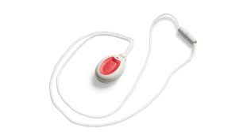

Contractors on site and repairs
For your own safety you must never enter properties that are undergoing refurbishment. Do not ask our contractors to do work or repairs for you, report the need for repairs to staff. Requests for repairs can be applied for using the repair slips, available in the hall, which you should post through the office letter box or via a telephone call to the member of staff. The Administrator needs to keep a clear record of the repairs that are required and the cost of those repairs, so that we can manage the charity’s money carefully.

Sickness and Emergencies

If you are ill or in difficulties, the Co-ordinator will make every effort to get in touch with relatives, friends, your doctor, emergency or support services on your behalf if you are unable to do so. To make it possible to act quickly the Co-ordinator and Nottingham On Call need some personal details, including names and addresses of your nearest relatives / friends and of your doctor. It is important for them to know of any long-term illness / condition you might have and any medication you take. This means that prompt action can be taken should an emergency situation arise. Details are recorded on your personal information form and the Co-ordinator will ask you to update this twice yearly. You will be asked to check and sign that the information is correct.

It is important that you let the Co-ordinator know of any change of address or telephone number of your contacts and doctor. Your personal information will be treated in a confidential manner, kept securely, and given to a third party without your prior agreement only in exceptional circumstances (See page 35 – Your Privacy with The United Charities of Abel Collin). Let the Co-ordinator know if you are ill. It is particularly important for the Co-ordinator to know if you are going into hospital, and to be notified when you are returning home.

If you have an existing disability or become disabled while living at the Collin’s Homes, it may be possible to obtain equipment or to make alterations to your home to help you to continue to live an independent life. Discuss this with the Co-ordinator.

Health Services
If you have your own doctor locally there is no need to change. If you have moved to the Homes from another area, the Co-ordinator can supply names of local doctors.

Fire Precautions
Please do:
- dispose of smoking materials safely

- read the fire safety leaflets on the hall noticeboard

- keep your property clear from fire hazards

Please do not:
- leave pans (especially chip pans, air fryers, frying pans) electric toasters and irons unattended
- smoke in bed
- leave naked flames unattended
- use candles

If there is a fire in your property, do not try to fight it. Raise the alarm, leave your home immediately, and do not stop to collect personal items or valuables. Close the door behind you, and call the Fire Brigade from elsewhere.

If there is a fire whilst you are in the hall raise the alarm and leave the building immediately and go to the fire assembly point under the central archway (left-hand side facing Derby Road).

Your home is fitted with a smoke alarm which is ‘hard wired’ into the electrics in your home. The alarm has a battery backup, meaning that it should work even in the event of a power cut. We will test the smoke alarms in your home annually, and replace the back up batteries if necessary.

The Notts Fire & Rescue Service recommend that you check the smoke detector in your property on a weekly basis.

Abuse and Safeguarding Adults
Abuse can take many forms – physical, verbal, psychological, financial – and it could come from, or be directed against, all kinds of people: spouse, partner, other family member, staff, a trustee, a visitor to the site, a contractor, or another resident.

If you have any concerns for yourself or about the situation of another resident you should contact the Co-ordinator, Administrator, or a trustee, who will inform the Chairperson of the board of trustees and the trustee with specific responsibility for dealing with such problems. You should be aware that if you do contact a member of staff or a trustee, the information you give might have to be passed on to another authority, such as the police.

However, if the person you believe is abusing you (or someone else) is a trustee or member of staff, you or your family can report it directly to Nottinghamshire County Council’s Adult Social Care, Health & Public Protection Department (formerly Social Services) – telephone 0300 500 8080. Please see the poster in the hall and read the leaflet provided to you by the Co-ordinator when you move in.

We have a clear policy on safeguarding and how we handle safeguarding concerns. Please ask a staff member if you would like a copy.

Keys
So that our staff can help to keep you safe in an emergency we retain a key for the back door of your home. This key will only be used to access to your property in an emergency or with your permission. All keys are held securely and your privacy will always be respected. Access is given to a 3rd party only with your permission.

You must not fit extra locks as this could delay any necessary access. You are welcome to give a spare key to a friend or relative so that they can help you in an emergency. If you do this, please let the Co-ordinator know so that they can make a note on their records.

Snow and icy conditions
Extra care should be taken on the site during snowy or icy conditions. When poor weather occurs staff will aim to arrange for snow clearance/gritting on major routes around the site. Salted grit is stored around the site in the designated yellow bins, and this may be used by residents as necessary.

Although we will always aim to grit hard surfaces in poor weather this may not always be possible, especially in times of sudden or unexpected bad weather. Please do not take any unnecessary risks in poor conditions. You should not attempt to walk on any untreated roads or paths and should be aware that, even when treated, there may still be a slip hazard.



Water safety and Legionella
Residents who do not regularly use their showers should run these once a month for ten minutes to avoid the risk of legionella. If you have an outside tap, run it on a monthly basis for ten minutes.
Section Seven
Our policies

The charity has a range of policies and procedures in place that set out how the charity is run, how decisions are made and what residents living in the Homes can expect.

Our policies are available to residents, relatives or carers or anyone else who is supporting a resident at any time. If you would like to have a copy of a specific policy please speak to a member of staff.

Your feedback
The trustees and staff welcome views from residents on matters affecting the quality of life at the Homes. The trustees will ask for your comments on any important change in the running of the Homes. If you would like to speak to a trustee, please arrange this through the Administrator.

If you need to complain
People are often reluctant to complain, but the trustees and staff cannot solve problems and improve life at the Homes if you do not speak up when things go wrong. Routine or minor problems, e.g. repairs and maintenance issues, should be referred to the Administrator. WMC or Housing Benefit issues should also be referred to the Administrator.

If your complaint is about the staff, trustees, residents or contractors, or you have other concerns, you can write to the Chair of the Board of Trustees. Anything you put in writing will, of course, be treated as confidential. The Chair will first try to deal with the matter informally. If this does not solve the problem, or the matter is very serious, your complaint will be discussed at a meeting of the Board of Trustees. If you wish, you can attend the discussion and bring a friend, relative or professional advisor with you. The trustees will write to give you their decision in response to your complaint.

If you are still not satisfied that the issue has been addressed you should write again to the Chairperson, who will consider whether independent advice is needed. Records of complaints are held on file for five years.

‘Whistle-blowing’
‘Whistle-blowing’ means reporting a general issue affecting the whole charity and its residents which ought to be investigated in ‘the public interest’.

If you suspect that something is seriously wrong with the way the trustees or staff are running the charity, or that contractors are not behaving as they should, the charity has a Whistle-blowing Policy. You can consult this and the charity’s other policies as they are on file in the Administrator’s office. Even if it turns out that there is no problem, your information will be treated as confidential. Please note that there is a separate procedure for personal complaints (see above).

Gifts & Legacies

It is the trustees’ policy that no person involved in the running of the charity should accept a gift or legacy from a resident. If you wish to make a donation to the charity, please discuss this with the Administrator.

General Information and Advice

Council Tax
This is a personal tax. Many people are entitled to reduced charges, and some do not pay any. You should contact Broxtowe Borough Council if you have concerns about the council tax charge, and if you consider that you should be reassessed.

Newsletters and Noticeboards
The hall noticeboards contain useful information, details of the members of the Board of Trustees and details of forthcoming events. Do check the noticeboards regularly. Copies of the charity’s policies are in a folder in the office and are available via the Administrator. You will also receive a newsletter several times during the year.

Personal Problems
If you have financial or personal problems and you have no family member or friend whom you feel able to consult, the Administrator can point you towards agencies such as the Citizens’ Advice Bureau for advice. Staff and trustees are not allowed to provide financial advice or to carry out financial transactions on your behalf.

Death and Wills / Power of Attorney
It is advisable to have an up-to-date will, and essential if you wish to leave personal property to a particular relative or friend. Please discuss this with your family. The same applies to a power of attorney, so that in the event of incapacity trusted family or friends can deal with your savings, property and any healthcare issues.

The status of beneficiary of the charity ceases on death.

If you die and you have left a will:
- your estate will be responsible for payment of the combined WMC until the property is cleared to the trustees’ satisfaction, and all keys returned to the Administrator;
- your executors should arrange for all furniture, household items including personal possessions to be removed from the site, and the property must be left in a clean state;
- your executors should arrange for all mail to be redirected to their address. Any mail received here at the Homes after a period of three months will be returned to sender and marked “deceased”;
- your executors should contact the Administrator if there are any problems or concerns.

If you die without having made a will and you have no family to deal with the property:
- the charity will try to contact any concerned party but, meanwhile, reserves the right to clear the property;
- all your possessions (except perishable items) will be stored securely for a period no more than three months, and will then be disposed of;
- any items of value will be sold. The proceeds will be used to offset any outstanding combined WMC due. Any excess will be held by the charity for a period of one year, after which time the whole sum will be donated to a charity deemed, by the trustees, to be appropriate.

Respect Form

Personal Cash
You are advised not to keep more cash in your home than you need for day-to-day spending. It is always safer to keep money in a bank/building society account. Please do not ask the staff to take care of your money, or ask them for financial advice, since they are not allowed to give it.

Security
Everyone living in the Homes should be aware of security issues. Our recommendations are;

Do:
- keep your doors locked at all times, whether you are in or not.
- If your door has a chain, use it, and do not release it until you have identified the caller.
Do not:
- allow a stranger to enter your home without proof of identity or good reason
- leave keys in your doors. If you were in difficulties and could not open the door it might have to be broken down to obtain access
- obstruct your front and back doors, porches and paths with furniture and garden items – swift access would be required in an emergency
- buy items from door-to-door sellers (‘cold callers’) – these people are discouraged from coming onto the site and the staff will ask them to leave if someone is selling door-to-door.

If you are in any doubt about a stranger wanting to enter your house or you see someone acting suspiciously on the site, ensure your door is locked and contact a member of staff or the police, or pull the alarm cord.

The police and fire service visit us from time to time to give advice on personal safety. These meetings are very informative and interesting, and residents are recommended to attend.

Your Privacy with The United Charities of Abel Collin

In order to provide an effective service for you, we have to obtain, process and store personal information about you.

What is personal information?
Personal information – This includes information relating to you, for example your name, address, date of birth and national insurance number. It can be held on a computer or organised filing system.

Sensitive personal information – Personal information may also include sensitive information such as your racial or ethnic origin, political opinions, religious or other beliefs, membership of a trade union, physical or mental health and criminal allegations/proceedings/convictions.

Abel Collin processes this personal information, meaning we hold, disclose and, where applicable, delete this information.

What personal information does Abel Collin hold about you?
Abel Collin will only hold personal information that you provide or that has been provided to us by third parties with whom we have a professional relationship such as social workers and health visitors.

What does Abel Collin do with your personal information?
The law and our commitment to good practice in response of your personal information, means that it must be:
- Obtained and processed fairly and lawfully
- Obtained only for a specified and lawful purpose and must not be processed in a manner which is incompatible with that purpose
- Adequate and kept up to date
- Kept for no longer than is necessary for the purpose for which is it processed
- Processed in line with your rights
- Be subject to appropriate technical and organisational measures to protect it against unauthorised or unlawful processing and against accidental loss, destruction or damage

We will ensure that your personal information is stored safely and securely.

Why does Abel Collin hold and process your personal information?
Your personal information is stored in order to enable Abel Collin to provide a service to you of the highest standard and in particular to:
- Meet your support and health needs
- Meet regulatory requirements laid down by other organisations with whom we work
- Conduct research and monitor equal opportunities
- Prevent and / or reduce crime

Who can see your personal information?
In general, only Abel Collin staff and the trustees will see your personal information, including sensitive information. However, there are some circumstances where we will disclose your information to other individuals and organisations such as our legal advisers, local authorities, contractors, Nottingham On Call, government departments and the police. Usually this is done with your knowledge and consent.

We may disclose sensitive information without your consent when we have a legal obligation to do so.

How can you find out about the information we hold about you?
You can request to see what personal information we hold about you but there are some exceptions to this. In particular, we may not be required to give you access to your personal information if this information involves another resident.

If you would like to find out what personal information we hold about you please write to the Administrator.
We reserve the right to decline the request should it be considered inappropriate to disclose the information requested for reasons compliant with the General Data Protection Regulations.

You will receive a response within 30 days of your request being received by the Administrator.

If you find any information to be incorrect then please inform the Administrator and we will amend as necessary.

The History of the Charity, Governance and Policies

History

The United Charities of Abel Collin date back to 1708 when Thomas Smith, acting as executor for his late uncle Abel Collin, bought land in what is now Friar Lane for the erection of twenty-four almshouses. These were completed the following year. Although his father, brother-in-law and nephews were public figures, Abel Collin (1653-1705) seems to have been a very private man. Nevertheless, he was extremely aware of the needs of others and his lengthy Will of 1704 also included provision for buying coal for the poor and for payments to debtors in the Town and County Gaol.

Thomas Smith was the son of Abel Collin's sister Fortune and her husband Thomas Smith, a mercer whose family had originally been small landowners in Cropwell Bishop. His founding of Smith's Bank in 1688 is commemorated by a plaque on the wall of the National Westminster Bank at the corner of Exchange Walk. Another son of Thomas (the elder), Abel, was the forebear of the Abel Smith family, who had links with the charity until recently.

Thomas Smith the younger bought a further plot of land in the Broad Marsh area to provide income for the charity, and in 1829 another twenty almshouses were built on part of the site. In 1936 this property was sold. The proceeds enabled the trustees to build twenty-six houses on the Derby Road site, where the charity is now based. The Friar Lane almshouses continued as a well-known Nottingham landmark until 1958, when they were demolished as part of the Maid Marian Way development. The compensating transaction with the City Council consisted of cash to build twenty-four single bungalows on Derby Road, and the transfer of commercial property in Chapel Bar. In 2000 the charity sold the Chapel Bar land and buildings for development. Its investment income now comes from a mixture of commercial property in Nottingham, and financial investments in the money markets.

In 1982 and 1986 the Trustees were able to build two groups of three bungalows using a generous legacy from Mrs Marion Kitching and a grant from the Skerritt Trust. In 1990 a further group of three bungalows was built using the charity's accumulated funds from the Chapel Bar commercial property that it then owned.

Starting in the late 1990s, the charity embarked on a long-term programme of modernization, beginning with major refurbishment of the houses, as funds allowed.
In 2008 the sale of one of the charity’s investment properties and of the Drury Homes in Chilwell (for which modernization was not practical) enabled work to start on four new bungalows. These, called the Drury Bungalows (numbered 53a,b,c,d Collin’s Homes), have been designed to high environmental standards and their completion at the end of 2009 celebrated the charity’s 300 years since its foundation.

Governance and Policies
The Collin’s Homes is a charity, and is not run along the same lines as a housing association or the local council. It is answerable to the Charity Commission, is guided by the National Association of Almshouses, and governed by the laws applicable to charities. Its policies are reviewed regularly and copies are held in a folder in the office.
The charity is administered by a minimum of seven trustees. A list of the current members of the Board of Trustees is posted on the Hall noticeboard. The trustees meet regularly, normally 8 times a year, at the Collin’s Homes. They come from various walks of life – some are retired, some are still working. They receive no payment for giving their time to the running of the charity, but all have a common interest – in continuing the work that Abel Collin laid down and left provision for in his Will over three hundred years ago.

Further information
If there is anything you are unsure about, or you would like further information on
any aspect of the charity, please discuss this with the Administrator.

