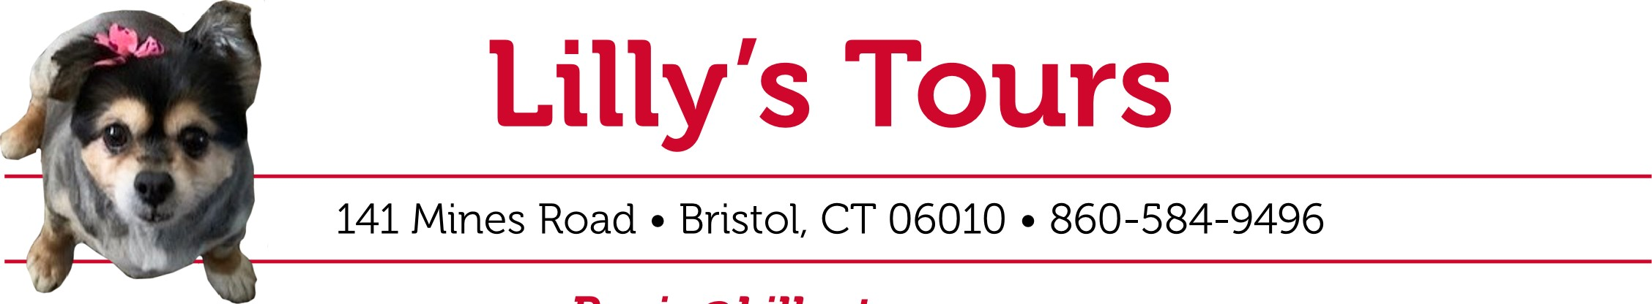

Rosie@Lillystours.com

Christmas in July

Looking forward to the rest of 2025 & 2026

Any **new bookings** from July 7 to July 31,2025

Will get 10% off for deposit on any trip, all deposits must reach my office by July 31, 2025, to the address above and to email above to get 10% off. After this date WILL NOT BE HONORED

Will fine updated trips on website or call for listing

Rosie Lagasse

NOTE: have a new computer and have lost all emails so if you want a list of specials, you must call in or email your information