Confirmation Candidate
Christ the king/st. stephen catholic church Confirmation Eligibility Form
(Due Sun. Nov. 16, 2025)
Full Name of Candidate ____________________________________________________________
Parish Name ____________________________________________________________________
Parish Mailing Address ______________________________________________________________
City, State, Zip __________________________________________________
Phone (_____) _______________
Confirmation Date: ___________________________________________
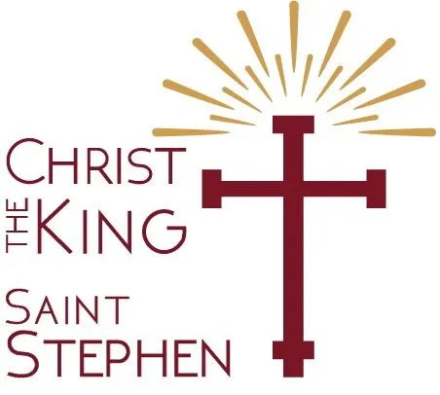
From the Code of Canon Law: Sponsors for the Sacrament of Confirmation must be Catholics who have been confirmed and have received the Sacrament of Eucharist. They must be free from canonical penalty and must lead a life in harmony with the faith in keeping with the function to be undertaken. (Canons #874 & 893)
Sponsor’s Parish
Sponsor Information
Full Name of Sponsor___________________________________________________
Mailing Address _______________________________________________________
City, State, Zip ________________________________________________________
Phone (_____)____________________________________
Please read and check the following affirmations if they are true:
- I am at least 16 years of age.
- I have celebrated the sacraments of Baptism, Confirmation, and Eucharist.
- (If married) My marriage was celebrated according to the norms of the Catholic Church.
- I am not married.
- I understand the responsibility I am undertaking and have both the desire and intention to fulfill it faithfully.
- I affirm that I meet all the necessary requirements to act as a sponsor.
- I am a parishioner of _______________________________________ since date ___________
- I am not the parent of the person receiving the sacrament
__________________________________ _______________________
Signature of Sponsor Date
Parish Name ____________________________________________________________________
Parish Mailing Address ______________________________________________________________
City, State, Zip ___________________________________________Phone (_____)_____________
To the best of my knowledge, this person can fulfill the responsibilities involved in sponsoring the Catholic initiation of another. Yes No Other (comment on reverse side)
At this parish, I serve as (circle one): Pastor, Priest, Deacon, Lay Ecclesial Minister. I am authorized to make this statement about our parishioner.
Printed Name ___________________________________
Signature _______________________________________ Date _____________________

