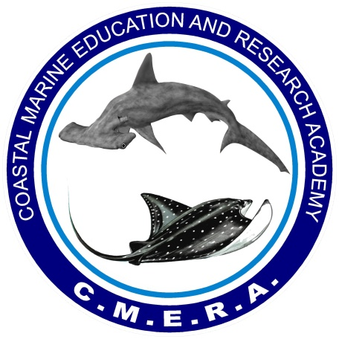

Welcome to the Coastal Marine Education and Research Academy

Shark Scientist Discovery Program – 2026
Thank you for registering for CMERA's Shark Scientist for a Day Program. We are excited to have you join our research team for a unique hands-on marine science experience in beautiful Tarpon Springs, Florida.
This packet contains important information to help you prepare for your upcoming research trip. Please read it carefully and contact us if you have any questions before your scheduled date.

Arrival Information
Location:
Anclote Village Marina
1029 Baillies Bluff Road
Holiday, FL 34691
Arrival Time: 9:45 AM
Departure Time: 10:00 AM Sharp
Return Time: Approximately 2:00 PM
Please arrive at least 15 minutes early to complete check-in and prepare for departure. Late arrivals may miss the vessel departure.

What to Expect
This is a real marine field research experience—not a sightseeing cruise or fishing charter.
Participants will join marine biologists aboard one of our research vessels and assist with ongoing shark and ray research projects. Throughout the day, you will learn how scientists collect data, monitor populations, and study marine ecosystems in the waters of Florida's Gulf Coast.
Because this is real field research, every trip is unique. Some days may involve multiple shark captures, while other days may focus more heavily on research techniques, data collection, species identification, and marine ecology. Wildlife encounters can never be guaranteed.

What You Will Learn
Participants may have opportunities to assist with:
- Species identification of local sharks and rays
- Scientific data collection techniques
- Measuring and processing captured animals
- Shark and ray tagging procedures
- Recording field data
- Marine conservation and research methods
- Understanding local marine ecosystems and food webs
You will also learn about seagrass beds, sandy bottom habitats, reef systems, and mangrove ecosystems and the important role these habitats play in supporting marine life.

Boat Amenities
Our vessels provide:
- Shade-covered seating areas
- Drinking water
- Cooler w/ice for your snacks
Please bring a refillable water bottle to stay hydrated throughout the day.

Food and Drinks
Participants should:
- Eat breakfast before arrival
- Bring their own lunch
- Bring a refillable water bottle
- Bring any additional snacks, sports drinks, or beverages desired
Florida summer conditions can be extremely hot. Staying hydrated is important for your comfort and safety.

What to Bring
- Clothes that can get wet, dirty, or stained
- Closed-toe shoes (required)
- Sunscreen
- Sunglasses
- Hat
- Refillable water bottle
- Camera
- Swimsuit (optional)
- Small towel (optional)
We also recommend bringing a waterproof phone case or dry bag for electronics.

Footwear Requirements
For your safety, closed-toe shoes are mandatory.
Acceptable footwear includes:
- Sneakers
- Hard-soled water shoes
- Closed-toe deck shoes
The following are NOT permitted:
- Crocs
- Flip-flops
- Sandals
- Thin-soled water shoes
Footwear should protect both the bottoms and tops of your feet and remain securely attached while working onboard.

Weather and Sea Conditions
Trips operate rain or shine. However, trips may be delayed, shortened, or rescheduled due to lightning, high winds, rough seas, or other unsafe boating conditions.
If weather conditions require rescheduling, participants will be contacted as soon as possible.

Motion Sickness
If you are prone to motion sickness, we strongly recommend taking preventative medication before arrival. Please consult your physician regarding any medications you plan to use.

Safety
Participant safety is our highest priority. All participants must follow crew instructions at all times. Certain research activities may be modified or restricted based on weather conditions, animal size, animal behavior, or other safety considerations.

Research Impact
The data collected during these trips contributes to a long-term shark and ray monitoring project that has been conducted in this area for more than 15 years.
Research focuses include:
- Species distribution
- Population monitoring
- Growth and age structure
- Sex ratios
- Site fidelity and movement patterns
- Long-term population trends
Data collected through these efforts is shared with organizations including the Florida Fish and Wildlife Conservation Commission (FWC), NOAA, and the Florida Division of Parks and Recreation.

Required Waiver
All participants must complete the required liability waiver before boarding.
Waiver Link:
https://form.jotform.com/252585027722155
Photo Release:
https://form.jotform.com/252585327972165
Payment Link:
If you have not already paid, here is a link to make your payment.
https://app.fluidpay.com/spp/sharkscientist
We look forward to having you join our research team and spending an exciting day on the water studying Florida's incredible sharks.

