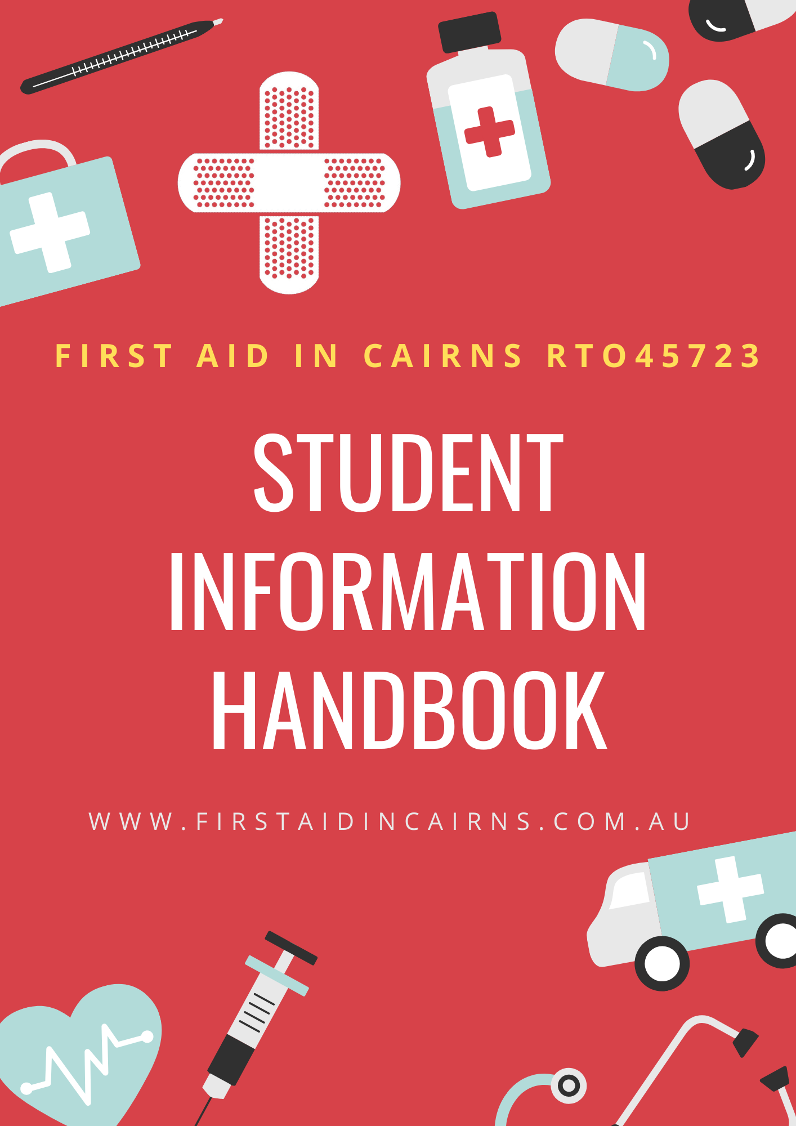

Welcome
Thank you for choosing the First Aid in Cairns experience for your training and educational needs.

On behalf of all the staff, I would personally like to welcome you to First Aid in Cairns.

We trust that your time with First Aid in Cairns and our training partners is an enjoyable one and that the skills you learn here prove valuable in your chosen career. You may even have the opportunity to use your skills in your home or in public place.

All staff are here to assist you to learn as quickly, efficiently and effectively as possible. We encourage you to talk to us at any time to discuss any problems you may have.

This Student Information Handbook has been designed to contain everything you need to know to prepare for and participate in your learning experience at First Aid in Cairns. We hope this handbook will answer many of the questions you have about training with us.

Please take the time to read this handbook. You will be required to sign an acknowledgement declaration prior to starting your course. This acknowledgment form will be filed in your student file.

If, after reading this handbook you have any questions, please ask your trainer or another staff member to explain.

Remember, “Safety through Education.”

I look forward to welcoming you to First Aid in Cairns and the beautiful tropics of Far North Queensland! See you soon!

Wayne Christiansen
Director of Education
First Aid in Cairns

Conditions of Use

This Student Information Handbook is subject to copyright.

© First Aid in Cairns Pty Ltd 2021

All rights reserved: no part of this Student Information Handbook may be used, reproduced, stored in a retrieval system or transmitted in any forms or by any other means, electronic, mechanical, photocopy, computer scanning, facsimile or otherwise without written consent First Aid in Cairns.

www.firstaidtrainingcairns.com.au
Version Date: March 2026
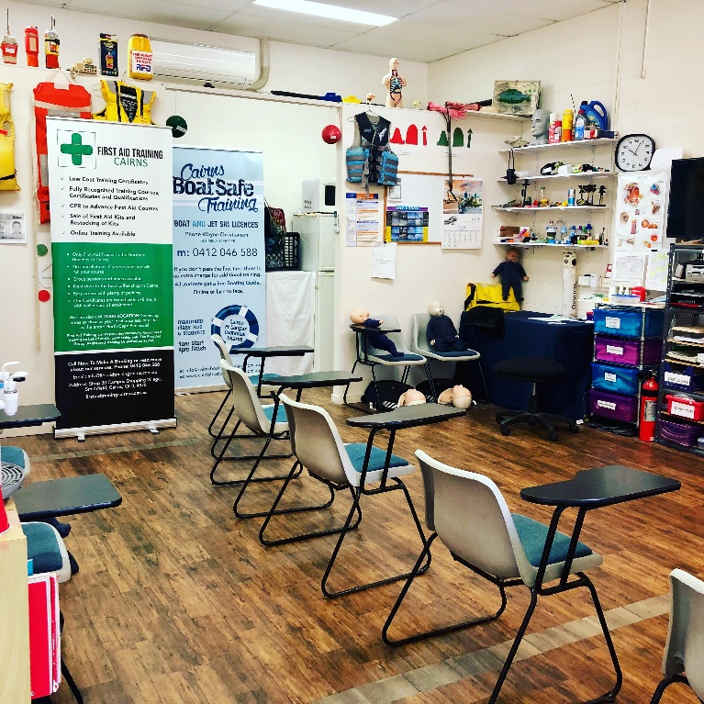
Contents
A Brief History in Time 1
Who is First Aid in Cairns? 1
Company Objectives 1
Our Mission Statement 1
Our Vision 1
Our Values 1
Our Purpose 1
Our Training Commitment 1
Our Service Commitment 1
Calls and Emails 1
Statements of Attainment 1
Wallet Cards of Attainment 1
Contact Details & Location of Training 1
Courses, Duration and Breaks 2
Access and Equity 2
VET Quality Framework (VQF) 2
What Is a Registered Training Organisation (RTO)? 2
Unique Student Identifier 2
Admission and Entry Requirements 3
Student Induction 3
Expectations of Students 3
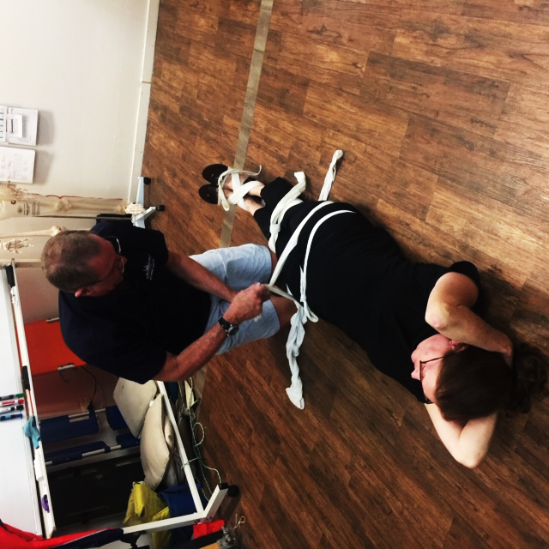
Student Support 3
Training Materials and Equipment 3
Refund Policy 4
Waiver 4
Accidents 4
Competency Based Training 4
Student Assessment Processes 5
Language, Literacy & Numeracy (LLN) 5
Literacy 5
Language 5
Numeracy 6
Recognition of Prior Learning 6
Assessment Methods 6
Candidates with Special Needs 6
Complaints and Appeals 7
Complaints 7
Appeals 7
Access to Participant Records 8
Release of Contact Details and Information 8
Privacy Policy 8
Results 8
What if I need my Statement of Attainment to be re-issued? 8
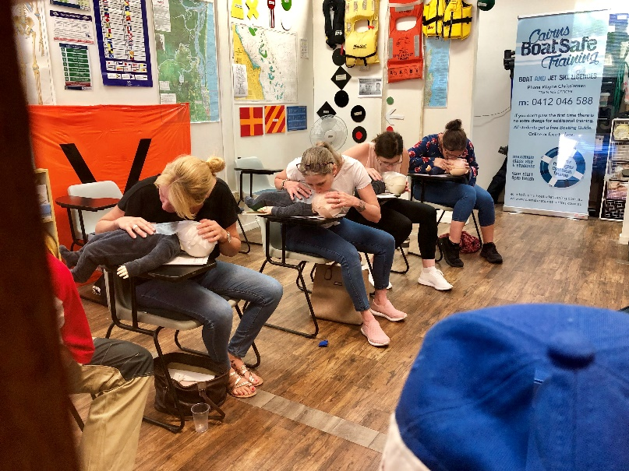
Who will be training you? 8
Training Staff 8
How to Enrol? 8
How to Pay? 9
What to Bring? 9
What to Wear? 9
Evaluation 9
Disability 9
Other Relevant Legislation 10

A Brief History in Time

The land upon which First Aid in Cairns currently stands is part of the country traditionally owned by the Djabugay (pronounced japurkai), Yirrijandji (pronounced irrikandji) and Gimuy Yidinji (pronounced goom eyeyidinji). The current owners and staff of First Aid in Cairns would like to recognise the traditional owners of the site and acknowledge the elders past and present and emerging. We recognise these people’s deep and continuing cultural and spiritual connection to the area.

The suburb of Smithfield was originally a township of its own on the banks of the Barron River. It was named after William Smith (a gold prospector) in 1876. However, the township was unknowingly built in a floodplain and after a number of floods, the entire town was relocated to the current location and the previous site was deserted by 1881. Smithfield is now a suburb of Cairns, and the urban development around First Aid in Cairns continues, with growing parts of the Smithfield Village and North Point estates. In 1987 James Cook University opened the Cairns Campus in Smithfield and Campus Shopping Village was opened shortly after.

Who is First Aid in Cairns?

First Aid in Cairns commenced their training facilities in 2014 with the Director of Education, Wayne Christiansen bringing with him, 18 years of medical and training experience.

First Aid in Cairns specialises in high quality training in preparation and support for a career in many occupations. Our training courses meet many different regulatory licensing requirements and work place Health & Safety guidelines.

First Aid in Cairns boasts a small team of highly qualified and experienced Trainers and Assessors who are committed to providing dynamic high quality learning experiences and networking opportunities. As part of our special assistance to our clients in all of the above options, we provide personalised support to ensure that you achieve your expected outcomes.

Company Objectives

Our Mission Statement

“Safety through Education.” It is our objective to offer the best training and education programs possible. It is our intent to develop an organisation of quality and integrity that offers our clients nationally recognised qualifications in a flexible learning environment. Our goal is to develop an organisation with a level of excellence where safety comes through education. We want to develop new and innovative ways to market and implement our programs.

Our Vision

To be a reputable business giving people the opportunity to learn in a comfortable safe environment. To empower our students with the confidence to help others in their time of need though engaging learning and passionate teaching.

Our Values

Our Clients, Our People, Our Reputation

Our Purpose

Dedication to provide the highest level of training so that our students may:
- Protect Others
- Preserve Life
- Prevent Further Injury
- Promote Recovery

Our Training Commitment

To ensure that we provide training and assessment services that meet the needs of clients and industry, we employ suitably qualified and experienced Trainers, secure suitable facilities, ensure sufficient opportunities for learning in appropriate environments, with suitable resources and assessment that is fair and flexible.

Our Service Commitment

Calls and Emails
Your questions are important to us. Please be aware that our Trainers and administration team are working with other students as well as yourself.

We are committed to returning your calls and emails but we ask that you allow us one (1) working day to respond, just in case we are unable to return your call or email the same day.

Assessment results and feedback will be given at the completion of training and assessment.

Statements of Attainment
Statements of Attainment are issued on the same day, by hand, after successful completion of training.

Statements of Attainments are only issued once payment has been finalised and the student has provided a valid Unique Student Identifier (USI).
To ensure your skills remain current and in line with industry standards, it is recommended that your First Aid (HLTAID011) qualification be updated every 3 years and your CPR (HLTAID009) component be updated every 12 months.

Wallet Cards of Attainment
Wallet Cards of Attainment are included in the course cost. These cards will be presented to you upon successful completion of your course.

Contact Details & Location of Training

First Aid in Cairns can be contacted by:

Phone: 0412 046 588 / +61 412 046 588

Email: training@firstaidincairns.com.au

Website: www.firstaidincairns.com.au

In Person: Shop 31B
Campus Shopping Village
5-21 Faculty Close
Smithfield QLD 4878

Operating Hours 8.00am to 5.00pm daily or
By appointment

First Aid Courses are either held at our shop at Smithfield, Cairns or for group training sessions, at a venue of your choice.

Perform Basic Water Rescues SISCAAQU002, Supervise Clients in Aquatic Locations SISCAQU006 and Perform advanced water rescues SISCAQU007 are usually held at Marlin Coast Swimming and Fitness Centre, Smithfield or at other suitable locations, with a swimming pool of not less than 25 metres in length.

Courses, Duration and Breaks

As a Registered Training Organisation (RTO), First Aid in Cairns is accredited provide the following courses:

Course / Cost | Code | Duration | Breaks  L (lunch)
Provide cardiopulmonary resuscitation $70 | HLTAID009 | 3 hrs | 10 min
Provide basic emergency life support $125 | HLTAID009  HLTAID010 | 6 hrs | 15 min  30min (L)  15 min
Provide First Aid $155 | HLTAID009  HLTAID010  HLTAID011 | 8 hrs | 15 min  30min (L)  15 min
Provide First Aid in an education and care setting $185 | HLTAID009  HLTAID010  HLTAID011  HLTAID012 | 8 hrs | 15 min  30min (L)  15 min
Provide First Aid in remote or isolated site $390 | HLTAID009  HLTAID010  HLTAID011  HLTAID013 | 14 hrs | 15 min  30min (L)  15 min  15 min  30min (L)
Provide Advanced First Aid $390 | HLTAID009  HLTAID010  HLTAID011  HLTAID014 | 14 hrs | 15 min  30min (L)  15 min  15 min  30min (L)
Provide advanced resuscitation and oxygen therapy $160 | HLTAID009  HLTAID015 | 6 hrs | 15 min  30min (L)  15 min
Perform rescue from live LV panel and Provide cardiopulmonary resuscitation $110 | UETSS00047  UETDRMP018  HLTAID009 | 4 hrs | 15 min  30min (L)
Perform rescue from live LV panel and Provide First Aid $250 | UETDRMP018  HLTAID009  HLTAID010  HLTAID011 | 9 hrs | 15 min  30 min (L)
Perform Rescue from Live LV $90 | UETDRMP018 | 1 hr | 10 min
Perform basic water rescues $85 | SISCAQU002 | 8 hrs | 15 min  30min (L)  15 min
Supervise clients in aquatic locations $275 | SISCAQU006 | 5 hrs | 15 min  30min (L)  15 min
Perform advanced water rescues $250 | SISCAQU007 | 8 hrs | 15 min  30min (L)  15 min
Education courses do not incur GST.

Access and Equity

Based on the Access and Equity Policy for the Vocational Education and Training System First Aid in Cairns will deliver training that is:
- Equitable for all people through the fair allocation of resources and involvement in Vocational Education and Training
- Provides an equal opportunity for all participants
- Promotes fairness and equal access, for all First Aid in Cairns staff, students and potential students, regardless of characteristics such as their age, ethnic background, gender, marital status, nationality, pregnancy, race, religion, disability or impairment, or sexuality.
- Provides an access for all to appropriate quality Vocational Education and Training programs and services
- Provides support services which enhances achievement of positive outcomes
- Implements reasonable adjustments as necessary to ensure delivery and assessment of all courses meets individual student’s needs
- Ensures all participants are aware of equal opportunity guidelines and dispute resolution processes and procedures
- Interacts with prospective and current students in a courteous, professional and non-discriminatory way

VET Quality Framework (VQF)

The Australian Skills Quality Authority (ASQA) audits Registered Training Organisations (RTOs) like First Aid in Cairns to ensure compliance against the VQF.

Compliance includes meeting the Standards for Registered Training Organisations (RTOs) 2025, which set out four Quality Areas:
• Training and Assessment
• Student Support
• VET Workforce
• Governance and Accountability.

What Is a Registered Training Organisation (RTO)?

An RTO is an accredited training provider that has been approved by the relevant State or National Regulating Authority. An RTO is regularly assessed by this regulatory authority to ensure that all training and education courses offered are delivered in accordance with the VET Quality Framework.

As an RTO, First Aid in Cairns offers nationally recognised training that eventually leads to nationally recognised qualifications.

Unique Student Identifier

In accordance with Compliance Requirement 12, First Aid in Cairns verifies all USIs before use and prior to or on the day of training with the Registrar and ensures that no individual’s student identifier (USI) will appear on any VET qualification or statement of attainment issued to you.

The purpose of the USI is to enable the collection and storage of your records of participation in vocational education and training on a central database, allowing you easy access to your records.

In the event that you are unable or unwilling to get a USI please visit the following website for further information on what to do to be able to participate in training. For more information and to apply for your USI or an exemption go to http://usi.gov.au

Admission and Entry Requirements

First Aid in Cairns requires that the participant can:
- Obtain a USI or evidence of an exemption
- Read and interpret workplace documentation
- Speak clearly and unambiguously in English
- Writing is required to the level of completing workplace forms
- Be able to participate in the physical and activities

Inherent Requirements: To be deemed competent in First Aid units (such as HLTAID009 or HLTAID011), the national training package requires that students must be physically capable of performing at least 2 minutes of uninterrupted CPR on an adult resuscitation manikin placed on the floor.
If you have a physical limitation, injury, or pregnancy that may prevent you from kneeling on the floor, please contact us prior to enrolment to discuss suitability and support options.
If you are unsure whether you can meet these inherent requirements, please contact us before enrolment so we can discuss reasonable adjustments or alternative training options.
Suitability Advice: In accordance with Outcome Standard 2.2, First Aid in Cairns reviews your skills, competencies, and digital literacy prior to enrolment. Based on this review, we will provide you with individual advice regarding whether this training product is suitable for your needs and existing skill level to ensure you have the best chance of success.
First Aid in Cairns adopts a support-needs model of disability. The Director of Education (Wayne Christiansen) is the designated Wellbeing and Inclusion Champion. We use the Notice–Ask–Respond model to identify when a student may be struggling and connect you with appropriate supports.
We are not a crisis service. If you or someone else is in immediate danger, call 000.

First Aid in Cairns upholds the principle that all applicants seeking to enrol are treated fairly and equitably and ensure that throughout the process of selection and admission, applicants are treated courteously and expeditiously.

First Aid in Cairns reserves the right to suspend from their training courses, participants who are:
- Unable to actively participate in the course activities as a result of injury or illness
- Disruptive
- Affected by drugs or alcohol

Should this situation arise, immediate and discreet contact will be made with the participant to discuss future training options for the individual(s) concerned.

During the course, students will be required to:
- Listen Attentively
- Watch Videos and Demonstrations
- Participate in all forms of Practical Activities
- Complete Accident Report Forms
- Successfully complete all Multiple-Choice Questions
- Speak up and ask questions at the end of each topic, if further explanation or clarification is required regarding content
- Speak up, if you feel uncomfortable about anything related to the course delivery or environment
- And for students completing the course Provide cardiopulmonary resuscitation (HLTAID009) are required to perform CPR, on a mannequin, located on the floor for two minutes non-stop.

Student Induction

Your trainer will provide you with all the guidelines for your course. Your trainer is responsible for the delivery of training and undertaking assessments. Your trainer will also inform you of the following ‘housekeeping’ requirements whilst you are undertaking training:
- Emergency evacuation procedures
- Exit(s) and exit routes
- Student amenities including tea and coffee facilities
- Designated training areas
- Requirements for leaving the site
- All signs and warnings including designated smoking areas

Expectations of Students

To avoid any confusion in the future, the following expectations of behaviour are provided. Compliance with these expectations is required by all Participants. Failure to do so may result in cancellation of your enrolment:
- Abide by Copyright and Plagiarism laws and legislation (Please refer to Plagiarism Policy for further information)
- Comply with workplace health and safety regulations at all times
- Comply with anti-discrimination legislation at all times. This includes but is not limited to equal opportunity, racial vilification and disability discrimination
- Comply with workplace harassment, victimisation and bullying regulations at all times
- Ensure that behaviour is of a level acceptable to the workplace at all times
- Complete training and assessment activities within agreed timeframes
- Communicate any difficulties with completion of activities or assessment with your Trainer
- Inform your Trainer immediately should you be unable to attend due to illness or other reasons
- Inform your Trainer if you have a medical condition that may affect your participation or affect those with whom you may be training

Student Support and Wellbeing

Please refer to Our Commitment Service on page 1 for times responding to calls and emails.

First Aid in Cairns is committed to your success and adopts a whole-of-RTO approach to student wellbeing. Our Director of Education, Wayne Christiansen, is the designated Wellbeing and Inclusion Champion responsible for overseeing student support strategies.

Our Support-Needs Model We follow a support-needs model of disability, focusing on the functional impact a condition has on your learning rather than a medical diagnosis. We encourage safe disclosure of any learning, physical, or mental health needs during enrolment so we can assist you early. Services we can assist with include:
- Language, Literacy, Numeracy and Digital (LLND) support.
- Reasonable adjustments for assessments (e.g., extra time, oral instead of written answers).
- Wellbeing referrals to external professional services if you are experiencing distress or personal challenges.

Useful Contacts for Students While we provide internal support, we are not a crisis service. For professional mental health support, please refer to the Useful Contacts Directory on the back page of this handbook, which includes services such as Lifeline (13 11 14) and Beyond Blue (1300 22 4636).
Note: External support services may attract a fee from the provider which is the responsibility of the student.

Individual Support/Learning Plans If you identify a need for support, we will collaborate with you to develop a confidential Student Support/Learning Plan. This plan documents agreed adjustments to ensure you can participate in training and assessment on the same basis as your peers. These plans are monitored regularly by your trainer to ensure they remain effective.
Post-Course Revision To ensure you maintain high-quality skills, students may revise any component or part of a completed course within 6 months of the date of completion, free of charge.
completion, free of charge. No questions asked.

Training Materials and Equipment

During training, First Aid in Cairns participants will be given access to safety equipment and other required material and equipment. This equipment and material is to be used in accordance with the instructions given by the Trainer / Assessor. If a piece of equipment is purposely damaged or treated in a manner not in accordance with the instructions given by the Trainer, a fee may be charged.

The copyright and ownership of all training material provided during the training belongs to First Aid in Cairns and cannot be copied or claimed without written consent. All training materials are quality assured and are continuously updated.

Refund Policy

In summary:
• No refunds are issued after the course has commenced.
• If you cancel less than 2 working days before the course, a $50 administration fee applies.
• Course transfers are allowed with at least 24 hours’ notice.

If a student provides notice (by email, phone or in person) of withdrawal less than 2 working days prior to commencement of the course, a $50.00 administration fee will be charged.

A student is unable to attend due to extended hospitalization / illness, and / or pregnancy / childbirth.

Note: any training materials are to be returned in initial condition otherwise this amount will be deducted from the refund.

Refunds will not be issued when:
- Withdrawal from course is less than 1 day prior to course commencement
- Changes occur in student work hours
- Students change their mind and they have commenced the course
- It becomes inconvenient for a student to travel to class
- A student moves interstate
- A student changes jobs or become retrenched
- A student leaves before finishing course/unit of competency
- A student is expelled from the training centre for a serious breach of discipline

No refunds will be paid after the commencement of the course.

Course transfer is allowable if advised 24 hours prior to start of the course. Transfer is not available to students who fail to show for the class or who do not give the required notice.

Students who arrive after the scheduled course start time will be denied access to training and be required to pay an additional 25% of original course fees to re book an alternative date. Fees must be paid at the time of booking.

Requests for refunds must be made in writing stating all details of the claim. The request is to be made to the Director of Education / Administration Officer.

Waiver

First Aid in Cairns takes full responsibility for students while training and engaging with our Trainers / Assessors.

However, we do not take responsibility for any injuries or disputes which occur while undertaking any on the job training in your chosen field.

First Aid in Cairns takes no responsibility for personal belongings or vehicles parked at training centres while undertaking training with us on-site or at our training centres.

Accidents

All accidents must be reported immediately to your Trainer or to Administration staff and be recorded on an Incident Report Form. This must be signed by the Trainer / Assessor / Director of Education / Administration staff and signed by any witness to the incident. Any action taken must be recorded in the incident register. Follow up will be completed the following day to ensure the student’s well-being.

Competency Based Training

A Statement of Attainment will be issued if you demonstrate competency in your course and our training is based on the principles of Competency Based Training.

Delivery and assessment will involve students accomplishing tasks required to demonstrate competency in any one unit. As a result, evidence will be gathered to confirm that students can perform required skills and knowledge.

Students will be provided with every opportunity to demonstrate that they can carry out required tasks. You will be given feedback on all assessment activities and given feedback on areas that might need further work.

Competency based assessment does not use a marking scale rather you are deemed:
- Satisfactory (S) or Not Yet Satisfactory (NYS)
- Competent (C) or Not Competent (NC)

Retraining may be required to bring you to a level of competency, and an assessment re-sit may be required. The process is as follows:

Stage 1: Student undertakes in-class assessment
Students will be notified immediately pursuant to undertaking an assessment of their performance

Stage 2: Student deemed not yet competent in FIRST assessment.
Students who are deemed to be NYC are to be provided with information identifying the areas in which they failed to achieve competency. Students will then have the opportunity to repeat the assessment task on the same day.

Stage 3: Student deemed not yet competent in FIRST Re-sit
If the student is again deemed NYC they will be provided with information identifying the areas in which they failed to achieve competency. The student must then participate in a new assessment on the same day;

Stage 4: Student deemed not yet competent in SECOND re-sit
If the student is still unable to demonstrate competency, then the student will be required to repeat the unit of competency. First Aid in Cairns will determine the time at which the unit will be available. The student will be liable to pay a re-enrolment fee to be determined by the training centre to cover the costs of extra tuition and assessment.
Our assessment principles support our compliance with the Outcome Standards for Training and Assessment under the Standards for RTOs 2025.

Student Assessment Processes

Assessments should provide opportunity for students to be informed of the context and purpose of the assessment and the assessment process.

This will include but will not be limited to information regarding assessment methods and alternative assessment methods if required to accommodate special needs or circumstances.

Information sessions will be included with the introduction of each subject to advise students of the assessment processes, requirements for the assessment process, number of assessments and types of assessments.

Education staff are available to discuss and provide limited professional advice as to the outcomes of the assessment process and guidance on future options. Re-assessment is available on appeal; see further details in the Complaints and Appeal Process Section.

Units of competency delivered by mode face-to-face will be assessed on the same day (for a one-day course) or on the last day (of a two day course).

First Aid in Cairns will ensure that assessment tools meet the Rules Evidence.

The Trainer / Assessor is assured that:

Validity – the learner has the skills, knowledge and attributes as described in the unit of competency and associated assessments requirements.

Sufficiency – the quality, quantity and relevance of the assessment evidence enables a judgement to be made of the learner’s competency.

Authenticity – the evidence presented for assessment is the learner’s own work

Currency – the assessment evidence demonstrates current competency. This requires the assessment evidence to be from the present or the very recent past

Assessment approaches will be in line with the Principles of Assessment, namely:

Fairness – the individual learner’s needs are considered in the assessment process. Where appropriate, reasonable adjustments are applied by the RTO to take into account the individual learner’s needs. The RTO informs the learner about the assessment process and provides the learner with the opportunity to challenge the result of the assessment and be reassessed if necessary

Flexibility – the assessment is flexible to the individual learner by: reflecting on the learner’s needs, assessing competencies held by the learner (no matter how or where they have been acquired), drawing from a range of assessment methods and using those that are appropriate to context, the unit of competency and associated assessment requirements and the individual

Validity – any assessment decision made by the RTO is justified, based on the evidence of performance of the individual learner. Validity requires assessment against the unit of competency and associated assessment requirements covers a broad range of skills and knowledge that are essential to competent performance, assessment of knowledge and skills is integrated with their practical application, assessment is to be based on evidence that demonstrates that a learner could demonstrate these skills and knowledge in other similar situations and judgement of competence is based on evidence of learner performance that is aligned to the unit of competency and associated assessment requirements

Reliability – evidence presented for assessment is consistently interpreted and assessment results are comparable irrespective of the Trainer / Assessor conducting the assessment

Language, Literacy & Numeracy (LLN)

First Aid in Cairns aims at all times to provide a positive and rewarding learning experience for all of its students.

In the event of language, literacy and numeracy becoming an issue, the administration staff at the training centre will contact the student to discuss their requirements.

Students must ensure that they have discussed any concerns they may have about their capacity to participate because of any Language, Literacy or Numeracy difficulties. The training centre will offer to any student at enrolment a reading and comprehension exercise to ascertain suitability for enrolment into a course. You will require a minimum level of English to Complete the course

Where LLN competency is essential for students, the training centre will make every effort to ensure that each participant is adequately supported to enable them to complete their training. Some examples of the type of support that First Aid in Cairns can offer include:

Literacy
- Providing students only essential writing tasks
- Consider the use of group exercises so that the responsibility for writing rests with more than one person
- Provide examples and models of completed tasks
- Ensure that documents and forms are written and formatted in plain English
- Use clear heading, highlight certain key words or phrases and provide explanations of all technical terms used
- Assessments can be conducted using the interview technique where required

Language
- Present key information in small chunks
- Speak clearly, concisely and not too quickly
- Give clear instructions in a logical sequence
- Give lots of practical examples
- Encourage students to ask questions
- Ask all questions to ensure students understand

Numeracy
- Ask student to identify in words, what the exact problem is and how they might solve it
- Show students how to do the calculations through step by step instructions and through examples of completed calculations
- Help students to work out what maths / calculations / measurements are required to complete the task
- Encourage the use of calculators (if applicable) and demonstrate how to use them.
- We are an equal opportunity training centre and are open to everyone. If you require any assistance with the language, reading or numerical sections of your course, please contact our administration office. We will endeavour to provide you with appropriate learning tools, resources and help

Training centre assessments are designed to the level of workplace and all assessments are set according to the Training Package requirements and level of the AQTF the course relates.

Recognition of Prior Learning

First Aid in Cairns recognises that students might acquire vocational skills from a variety of different sources, other than formal training. These skills are valid, irrespective of how they were acquired.

If you believe you have skills and knowledge that would be covered in the training courses offered by us, you are advised to apply at time of enrolment to have your skills and knowledge assessed and where appropriate have the training course reduced. You can make an application for Recognition of Prior Learning (RPL) at any time. The RPL Application Form is available from the Administration Officer.
First Aid in Cairns will recognise nationally accredited training delivered by other training organisations. These qualifications will be recognised and where appropriate could be used to reduce any training course being offered by us.
You will be required to produce a certified copy or the original certificate to the Administration Officer or in some cases the Trainer, who will make note of the qualification in our record system.
This is typically applicable where students produce a pre-requisite qualification for a course they are currently wishing to undertake.

Assessment Methods

First Aid in Cairns uses a combination of assessment methods. Some of the methods include:

- OBSERVATION – where the student will be observed performing a series of tasks, a number of times, to determine competency
- VERBAL QUESTIONING AND ANSWERS – when the student will be questioned to determine the depth of their understanding of the process to ensure that they are competent
- WRITTEN ASSESSMENT – in this instance the student will be given the opportunity to demonstrate their competency through multiple choice questions, short answers questions, written reports, third party forms etc
- OTHER METHODS as appropriate may include case studies, projects, essays, role plays etc

All assessment tasks must consider any language and literacy issues, cultural issues or other individual needs related to the assessment related to the task.

First Aid in Cairns will ensure that we focus on the application of the skill and knowledge as required in the workplace and/or community setting including task skills (actually doing the task), task management (managing the task including its interaction with others around you) and contingency management skills (what happens if something goes wrong).

Once satisfactory performance is achieved for performance criteria for a unit, the candidate will be marked S for Satisfactory or NYS for Not Yet Satisfactory until re-assessment takes place.

Once a satisfactory performance is achieved in all of the performance criteria for a unit, the candidate will be marked C for Competent. If a student is not able to demonstrate competency after re-assessment, they will receive a NC for Not Competent for the overall assessment outcome.

Do refer to the specific course information on our website for information on each course assessment methods.
First Aid in Cairns do not provide job or work placements as part of any course.

Candidates with Special Needs

One fundamental principle of an assessment system is that each candidate must have access to fair and open assessment. Candidates with special needs should be offered the same opportunities as any other candidate.

As special needs extend to more than identifying physical or learning difficulties, an Assessor will also need to consider the best approach when dealing with candidates with needs such as low literacy, lack of confidence or non-English speaking background.

Learners who would benefit from a full language, literacy and numeracy assessment with ongoing support will be directed to a Trainer / Assessor specialised in this area.

Following this assessment, integrated support mechanisms are put in place between the service provider, the learner and First Aid in Cairns with the aim of achieving vocational competency.

An Assessor must take special needs into consideration from the planning stage onwards and adopt particular assessment methods as appropriate.
Depending on any specification given in the standards, the Assessor may be able to accept alternative evidence from a candidate with special needs.

If there is uncertainty, the Assessor should call on other Assessors or a verifier for assistance and guidance, as required. In such a case, the situation must be fully documented, with appropriate feedback being provided to the candidate at all stages.

In the event, that your needs exceed our skill to assist you with enhancing your LLN skills, we will refer you to an external support provider such as an appropriate LLN professional to further assist you. If
so, these costs will be covered by you.

Complaints and Appeals

Our processes meet Outcome Standards 2.7 and 2.8. We provide a fair, transparent process at no cost to the student. If a dispute cannot be resolved internally, First Aid in Cairns provides access to an independent third party for review. You have the right to be accompanied by a support person at any stage of the process.
First Aid in Cairns is dedicated to providing a high standard of service. Should you have a complaint or wish to appeal an assessment result, you are encouraged to do so by using the following processes:

Complaints

Complaints are the expression of the dissatisfaction with the quality or any aspect of the business operations and service, including nuisances, discrimination or similar against another person, inclusive of Participants, Staff and Contractors. The following are examples of issues for which you may lodge a complaint:
- Enrolment
- Training delivery
- Training and / or Assessment
- Any other activities associated with the delivery of training and assessment services
- Issues such as discrimination, sexual harassment, participant amenities, theft etc.

If you have a complaint:
- Raise it informally with your trainer.
- If unresolved, lodge a formal complaint in writing to training@firstaidincairns.com.au.
- We will acknowledge your complaint within 5 business days and aim to resolve it within 20 business days.
- If not satisfied, you may seek an independent review. For Appeals: If you disagree with an assessment decision, your assessment will be reviewed by another qualified assessor who was not involved in the original decision

1st instance: You are encouraged to speak immediately with your Trainer. If you are not comfortable addressing the issue with the Trainer you are encouraged to contact the administration staff on the day of training, at the next available break.

2nd instance: If the issue is not resolved you are encouraged to either speak to or contact in writing the Director of Education by emailing training@firstaidincairns.com.au.

3rd instance: If the matter is still not resolved an independent third party will be requested to assist with resolution. Third parties may include relevant training representative(s), legal representative(s) e.g. Anti-discrimination Board or The Police or other relevant personnel or legal representatives.

Outcomes of complaints will be provided to you in writing within fifteen (15) working days of the decision.

In the event that a complaint has been lodged, an Incident and Complaint Form will be completed and forwarded to the Director of Education, even if the situation has been resolved to the satisfaction of all parties. Supporting information will be attached by the Compliance Officer eg notes of discussions, notes of phone calls, copies of emails etc. This documentation will then be logged in the Complaint and Appeal Register and used for the continuous improvement of processes and procedures of First Aid in Cairns.

4th instance: If you are not satisfied with the outcome of this procedure you should be advised of your right to contact the Australian Skills Quality Authority (ASQA) by completing the complaints form at: https://www.asqa.gov.au/ complaints/getting-started-making-complaint-about-training-provider.

Additional independent commercial mediators may also be considered, if mutually agreed by the student and First Aid in Cairns. Eg Resolution Institute or InterMEDIATE

Appeals

Appeals are the expression of the dissatisfaction of an assessment result. This would occur when a student has been deemed not yet competent and does not agree with this decision.

There are various grounds for lodging an assessment appeal. These include, but are not limited to:
- not being fully informed of the assessment process
- the assessment process is different to that outlined by the Trainer / Assessor assessment process not based on Training Package / Unit of Competence requirements
- an inappropriate method used to assess the Training Package / Unit of Competence
- alleged bias of the Trainer / Assessor
- alleged incompetence of the Trainer / Assessor
- faulty or inappropriate equipment or facilities

Step 1 You must discuss appealing an assessment outcome and/or the assessment process with your Trainer/Assessor involved. This step must commence within five (5) working days of the assessment outcome being advised.

Step 2 If still not satisfied, you must appeal in writing to the Director of Education or complete the Assessment Appeal Form and email training@firstaidincairns.com.au. This should occur within five (5) working days of Step 1.

Step 3 The assessment is to be reviewed by a different Assessor and the results of the review will be summarised on the Assessment Appeals Form. You are to be advised of the appeals outcome within ten (10) working days of Step 2.
Step 4 If still not satisfied with the outcome of the appeal, your appeal is to be reviewed by the Director of Education. The Director of Education will send an acknowledgement letter to you, record the receipt of the Assessment Appeals Form, then review. The Director of Education if necessary, will convene a review panel to thoroughly examine the appeal. You are to be advised of the outcome within ten (10) working days of Step 3.

Step 5 If you are not satisfied with the outcome of this procedure they should be advised of your right to contact the Australian Skills Quality Authority (ASQA) by completing the complaints form at https://www.asqa.gov.au/ complaints/getting-started-making-complaint-about-training-provider.

Access to Participant Records

First Aid in Cairns manages student records in accordance with Compliance Requirement 10. We implement the following mandatory retention schedule:
- AQF Certification Records (Results): Retained for a period of 30 years.
- Completed Student Assessment Evidence: Retained for a period of 2 years after you have completed the training product.

You may wish to access your records to check on work completed, progress or for other reasons. Please organise with your Trainer a time suitable to view your training records. Other parties will not be permitted to access your files without written consent from you. We comply with the Data Provision Requirements 2025 and securely store your records in accordance with national VET data policies.”

Release of Contact Details and Information

To ensure that Registered Training Organisations meet the national standards and offer quality training to participants, ASQA produce regulated audits. The audit process involves a delivery of a training organisations policies, procedures, record keeping and practices.

On occasions ASQA may contact past and present training students to conduct an interview to confirm that the organisation is complying with its obligations and providing a service which meets the needs of participants and industry.

Upon request First Aid in Cairns is required to supply the following information to ASQA:

- Contact details including address, telephone numbers and email address
- For audit purposes and in the event of a complaint or appeal, ASQA may request to view your files. The purpose of this is to ensure compliance with regulations and standards.

Privacy Policy

First Aid in Cairns will collect information, manage, use it and disclose it in a way that complies with and in accordance with the Privacy Act 1988, including the 2022 amendments, and the Australian Privacy Principles. Sensitive health data is used only to provide agreed support and is kept strictly confidential. First Aid in Cairns will:

- Where information is provided by another person, ensure that collection has been authorised by the individual concerned, or by someone who is legally authorised to act on their behalf
- Only collect information by lawful and fair means and not in an unreasonably intrusive way
- Protect archived personal information from loss or unauthorised access, use, disclosure, or misuse and from inappropriate modification

We comply with the Data Provision Requirements 2025 and securely store your records in accordance with national VET data policies and the Privacy Act 1988 (including 2022 amendments)

Results

On the day of training or for training that occurs over two days (on the last day of training), you will receive your result and an Assessment Feedback Form.

On completion of your Unit of Competence,
a Statement of Attainment and a Wallet Card of Attainment will be issued to you by hand.

Soft copies, issued by email, are available by request at a cost of $5 per course.

What if I need my Statement of Attainment to be re-issued?

In the event of a lost or damaged Statement of Attainment, please contact our office to request reissuance of a Statement of Attainment and return with payment of $50.

Who will be training you?

All Trainers and Assessors at First Aid in Cairns are well qualified and have a minimum of five years of experience in their particular field. All Trainers and Assessors hold qualifications either at the level or higher than those that they are training as well as the Certificate IV in Training and Assessment or Certificate IV in Workplace training. You will find all staff to be very knowledgeable in their respective fields and very approachable.

Training Staff

The training centre will abide by the VET Quality Framework regarding Trainer and Assessor qualifications in relation to all training and assessment activities. We will ensure that all of our Trainers / Assessors will have as a minimum, the following combination of:
- Certificate IV in Training and Assessment (TAE40110)
- A minimum of five (5) years recent industry experience in your vocational area
- Familiarity with the principles and practices of Competency-Based training and The Australian Qualification Framework (AQF)
- Familiarity with Equal Employment Opportunity and Occupational Health and Safety principles.
- Yellow and blue card, working with children check or equivalent

How to Enrol?

Bookings can be made by contacting us:

By Phone 0412 046 588
+61 412 046 588

By Email training@firstaidincairns.com.au

Online www.firstaidincairns.com.au

Once your booking has been received by us, you will receive a formal online registration form by email. This form will confirm the day of the course and the course you have nominated. Information to be entered online includes full name, date of birth, USI, address, telephone number, education details etc.

If you are unable to register online, you will be asked to manually complete an Enrolment Application Form on the day of training.

How to Pay?

Payment for the course may be made by:
- Credit card over the phone
- Direct credit / electronic funds transfer using internet banking
- In person with cash, debit card or credit card payment

Do note that your Statements of Attainment will not be released until payment has been received.

What to Bring?

- Your Unique Student Identifier (USI)
- A form of identification
- Student ID card, senior’s card or copy of current certificate if you have received a discount on training.

Pens, notepaper and all other equipment is supplied. Tea, coffee and chilled water is available during your course free of charge.

You are encouraged to bring your own lunch. We have a fridge and microwave available for your use.

There are food outlets nearby at Campus Shopping Village, however lunch breaks are short.

What to Wear?
- If you wear glasses for reading, please bring these with you
- If you feel the cold, please bring a light jacket as our training facilities are air-conditioned

We request that appropriate attire be worn (ie a short sleeve polo shirt or round neck t-shirt with long shorts or long trousers). Appropriate attire is required as:

- you will be performing some of the assessments on the floor. Padding is supplied for kneeling, when performing cardiopulmonary resuscitation (CPR) demonstrations and practical skills on the floor
- you will be touching and making contact other participants in the course when practicing and demonstrating skills. Other participants will be required to touch and make contact with you too. This will occur in activities such as practicing and demonstrating the recovery position, CPR and bandaging
- so the Trainer, staff and other participants of the course feel comfortable and at ease

If you attend wearing inappropriate attire, you may be asked to reschedule your course

Inappropriate clothing may be defined as skimpy, tight fitting activewear, tops with plunging necklines, revealing or transparent tank tops, singlets, short shorts and short skirts. We would like to ensure that course is conducted in a professional manner and this includes the participants being professional in their behaviour and appearance as well.

Please note that first aid competency standards do require a level of physical ability to meet the evidence requirements for assessment. These standards relate to the level of performance required to provide resuscitation and respond to an emergency situation where there may be risk to life.

For students completing Provide cardiopulmonary resuscitation HLTAID009 you will be required to undertake activities on the floor. This includes performing two minutes of uninterrupted CPR on an adult and baby CPR manikin.

Due to the potential risk to health and safety where a nominated first aider, or worker with duty of care, does not have the ability to perform resuscitation and / or first aid to the performance standard it is not appropriate to issue a statement of attainment to students who are physically unable to meet the assessment requirements.

In cases where a student has attended a resuscitation or first aid course but is unable to meet the full requirements of the competency, First Aid in Cairns may wish to provide that student with a certificate of attendance, or similar, as an indication of their participation in the course.

If you feel that you have any current health issues which would prevent you from undertaking such activities, you must contact us prior to your course to discuss the options available to you.

Evaluation

Your feedback is particularly important to our commitment to ongoing improvement. Throughout your training you will be asked to provide your thoughts and comments on the training received.

First Aid in Cairns encourages all students to make contact should they wish to provide feedback or comments on any aspect of the service received. After the completion of your training you will receive an email with a link to an Online Learner Engagement Survey. The results of this survey are provided to ASQA annually.

Disability

The purpose of this Disability section is to provide additional information to assist with answering the disability question in the student enrolment form.

If you indicated the presence of a disability, impairment or long-term condition, please select the area(s) in the following list:

Disability in this context does not include short-term disabling health conditions such as a fractured leg, influenza, or corrected physical conditions such as impaired vision managed by wearing glasses or lenses.

Hearing/deaf - Hearing impairment is used to refer to a person who has an acquired mild, moderate, severe or profound hearing loss after learning to speak, communicates orally and maximises residual hearing with the assistance of amplification. A person who is deaf has a severe or profound hearing loss from, at, or near birth and mainly relies upon vision to communicate, whether through lip reading, gestures, cued speech, finger spelling and/or sign language.

Physical - A physical disability affects the mobility or dexterity of a person and may include a total or partial loss of a part of the body. A physical disability may have existed since birth or may be the result of an accident, illness, or injury suffered later in life; for example, amputation, arthritis, cerebral palsy, multiple sclerosis, muscular dystrophy, paraplegia, quadriplegia or post-polio syndrome.

Intellectual - In general, the term ‘intellectual disability’ is used to refer to low general intellectual functioning and difficulties in adaptive behaviour, both of which conditions were manifested before the person reached the age of 18. It may result from infection before or after birth, trauma during birth, or illness.

Learning - A general term that refers to a heterogeneous group of disorders manifested by significant difficulties in the acquisition and use of listening, speaking, reading, writing, reasoning, or mathematical abilities. These disorders are intrinsic to the individual, presumed to be due to central nervous system dysfunction, and may occur across the life span. Problems in self-regulatory behaviours, social perception, and social interaction may exist with learning disabilities but do not by themselves constitute a learning disability.

Mental illness - Mental illness refers to a cluster of psychological and physiological symptoms that cause a person suffering or distress and which represent a departure from a person’s usual pattern and level of functioning.

Acquired brain impairment - Acquired brain impairment is injury to the brain that results in deterioration in cognitive, physical, emotional or independent functioning. Acquired brain impairment can occur as a result of trauma, hypoxia, infection, tumour, accidents, violence, substance abuse, degenerative neurological diseases or stroke. These impairments may be either temporary or permanent and cause partial or total disability or psychosocial maladjustment.

Vision - This covers a partial loss of sight causing difficulties in seeing, up to and including blindness. This may be present from birth or acquired as a result of disease, illness or injury.

Medical condition - Medical condition is a temporary or permanent condition that may be hereditary, genetically acquired or of unknown origin. The condition may not be obvious or readily identifiable, yet may be mildly or severely debilitating and result in
fluctuating levels of wellness and sickness, and/or periods of hospitalisation; for example, HIV/AIDS, cancer, chronic fatigue syndrome, Crohn’s disease, cystic fibrosis, asthma or diabetes.

Other - A disability, impairment or long-term condition which is not suitably described by one or several disability types in combination. Autism spectrum disorders are reported under this category.

Other Relevant Legislation

The following legislation applies to your training and participation with First Aid in Cairns. These laws protect your rights, safety, privacy, and access to quality training. We comply with all relevant Commonwealth and Queensland legislation, including:

Standards for Registered Training Organisations (RTOs) 2025 These standards ensure nationally consistent, high-quality training and assessment across the VET sector. They are comprised of the Outcome Standards, the Compliance Requirements, and the Credential Policy
.
The Work Health and Safety Act 2011 provides a framework for managing health and safety risks in Australian workplaces. The objective of the Act is to prevent fatalities, injuries and illness caused by a workplace, by workplace activities or by a specified high risk plant - this is achieved by preventing or minimising exposure to risk. All organisations must comply with this Act, regardless of the types of services they offer https://www.legislation.gov.au/ Details/C2017C00305

The Privacy Act 1988 makes provisions to protect the privacy of individuals, and for related purposes.
It should be noted, however, that the Federal Privacy Act does not regulate state or territory agencies (except for the ACT). For information on privacy regulations in other states and territories, visit https://www.oaic.gov.au/

The Copyright Act 1968 is an Act relating to Copyright and the protection of certain performances, and for other purposes. For more information go to https://www.legislation.gov.au/Series/C1968A00063

The National Vocational Education and Training Regulator Act 2011 was introduced in 2011 to establish a consistent registration and accreditation framework for Vocational Education and Training, by applying nationally agreed standards. For more information visit: http://www.comlaw.gov.au/Details/C2014C00623

Disability Discrimination Act 1992 (DDA) & Disability Standards for Education 2005 (DSE) The DDA makes it unlawful to discriminate against a person on the basis of disability in education. The DSE sets out the legal obligations of providers to ensure students with disability can access and participate in training on the same basis as students without disability, including through the provision of reasonable adjustments.

Work Health and Safety Act 2011 (Qld) This Act provides a framework to manage health and safety risks. First Aid in Cairns complies with this Act and the Work Health and Safety Regulation 2017 to prevent injuries and illness during training activities.

Anti-Discrimination Act 1991 (Qld) As a Queensland-based RTO, we comply with state legislation prohibiting discrimination, sexual harassment, and victimization in education and delivery of services
.
Australian Consumer Law (ACL) The ACL (Schedule 2 of the Competition and Consumer Act 2010) protects your rights as a consumer, ensuring training providers are honest in their dealings, can prove their claims, and provide an equitable and safe marketplace.

Equal Opportunity
New South Wales Anti-Discrimination Act 1977
Queensland Anti-Discrimination Act 1991
South Australia Equal Opportunity Act 1984
Victoria Equal Opportunity Act 2010
Western Australia Equal Opportunity Act 1984
Disability Discrimination Act 1992
Age Discrimination Act 2004
Sex Discrimination Act 1984
Racial Discrimination Act 1975

Useful Contacts for Students

- Lifeline: 13 11 14 (24/7 crisis support and suicide prevention).
- Beyond Blue: 1300 22 4636 (24/7 phone and online mental health support).
- 1800RESPECT: 1800 737 732 (Support for sexual assault and domestic violence).
- MensLine Australia: 1300 789 978 (Counselling for men).
- Headspace (Cairns): (07) 4041 3780 (Support for young people aged 12–25).
- 13YARN: 13 92 76 (Crisis support for Aboriginal and Torres Strait Islander people - Note: This is from general knowledge as it fits your Cairns cohort perfectly).
- Reading and Writing Hotline: 1300 655 506 (For advice and referral to adult literacy and numeracy providers).
- Safe Steps: 1800 015 188 (24/7 support for those experiencing family violence or abuse).

End of Student Information Handbook

