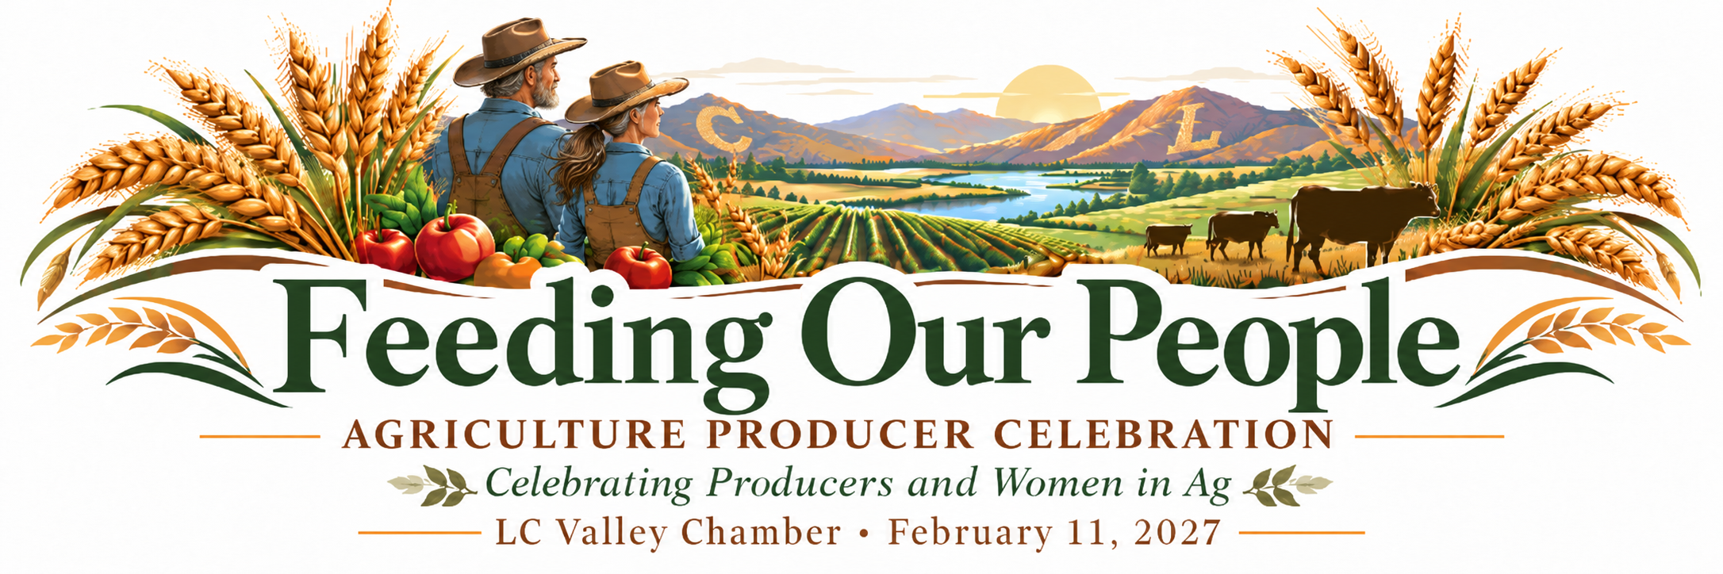
SPONSORED BY 
2027 AGRICULTURE & PRODUCER CELEBRATION
Celebrating Women in Agriculture
THURSDAY, FEBRUARY 11, 2027 | 4:30–8:00 PM | CLEARWATER CASINO, LEWISTON
Join the LC Valley Chamber of Commerce at NO COST, for an evening honoring you, the people who feed our communities and power our regional agricultural economy. Feeding Our People is a special invitation to farmers, ranchers, producers, and agricultural families throughout our region.
From cattle and grains to fruits, vegetables, and other food production, we invite agricultural producers to gather for an evening of appreciation, connection, and recognition. This year, we are also proud to celebrate the leadership and dedication of women in agriculture.
AN EVENING TO CONNECT, CELEBRATE & SUPPORT THE NEXT GENERATION
🌾 Business Expo: Meet agriculture producers and connect local businesses with the farmers and ranchers serving our region.
🌾 Steak Dinner: Enjoy a shared meal while celebrating agriculture and the people behind it.
🌾 Women in Agriculture: Hear personal stories from women who live and lead in agriculture every day.
🌾 FFA Chapter Highlights: Celebrate wins, achievements, and the future of agriculture through our area FFA chapters.
🌾 Producer of the Year: Recognize an exceptional regional producer for their contributions.
🌾 Student Scholarships: Celebrate three student scholarship awards: 1st place $2,500, 2nd place $1,500, and 3rd place $1,000.
🌾 Silent Auction: Help raise $5,000 for scholarships benefiting agriculture students graduating in 2028.
A REGION-WIDE INVITATION
We welcome producers and businesses throughout the LC Valley, Pullman, Moscow, and surrounding agricultural communities. Agricultural producers are invited to attend at no cost. Businesses are encouraged to participate, sponsor tables, and connect with the producers who help sustain our region.
Businesses sponsor tables with four seats for their own guests and four seats for producers. Sponsors may invite producers they know, or the Chamber will help match registered producers with a table. Producers may register online or by completing the return form on page 2.
Registration deadline: February 6, 2027 | Presented by the LC Valley Chamber of Commerce

2027 AGRICULTURE & PRODUCER CELEBRATION
Producer RSVP & Producer of the Year Nomination
THURSDAY, FEBRUARY 11, 2027 | CLEARWATER CASINO | 4:30–8:00 PM
Sponsored By

[ QR CODE PLACEHOLDER — ADD FINAL CODE HERE ]
Please complete and return this form by February 6, 2027. Admission for agricultural producers is free.
PRODUCER RSVP
Farm / Ranch / Business Name: _________________________________________________
Primary Contact: ____________________________________________________________
Phone: ______________________________ Email: ______________________________
Please list the full names of everyone attending, including yourself:
1. _______________________________________________________________________
2. _______________________________________________________________________
3. _______________________________________________________________________
4. _______________________________________________________________________
Additional attendees (attach a list if needed): _________________________________________

PRODUCER OF THE YEAR
Nomination Ballot
Nominate a farmer, rancher, or food producer whose dedication, leadership, or service has made a difference in our region.
Nominee Name: ______________________________________________________________
Farm / Ranch / Business: ________________________________________________________
Why does this producer deserve recognition?
____________________________________________________________________________
____________________________________________________________________________
Nominated by: _________________________________________________________________
Your Phone / Email: _____________________________________________________________

RETURN TO THE LC VALLEY CHAMBER BY FEBRUARY 6, 2027
Email: marklosh@lcvalleychamber.org | Mailing / drop-off address: [add address]
Questions? marklosh@lcvalleychamber.org • One nomination per completed ballot.

