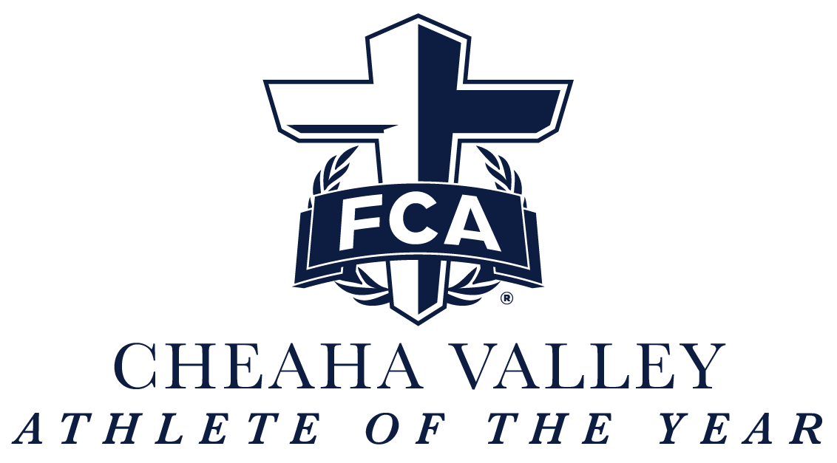

Guidelines: Cheaha Valley FCA announces the 2026 Cheaha Valley FCA Athlete of the Year Award. This college scholarship, a minimum of $250.00, is awarded to one male and one female athlete graduating from a high school within the Cheaha Valley who exemplifies FCA’s core values of integrity, serving, teamwork, and excellence.
Award Description: Applicants will be nominated by their FCA campus sponsor or FCA Staff and selected after careful examination by the Cheaha Valley FCA staff and board. Recipients will be awarded at the Cheaha Valley FCA Athlete of the Year Banquet on April 19, 2026.
Program Requirements:
-Must be nominated by FCA campus sponsor or FCA staff
-Must provide a written recommendation from one coach and one pastor
-Must be a graduating senior
-Minimum 3.0 GPA
-Resume (including FCA experience)
-School Transcript with sign off by school counselor

Mail one copy of a completed typed or printed application package to:
Cheaha Valley FCA Athlete of the Year
c/ o Cheaha Valley FCA
P.O. Box 3345
Oxford, AL 36203
(This includes the application, written recommendations, resume, and school transcript with signature by school counselor)

Applications may be downloaded from our website:
https://www.coosavalleyfca.org/AOY-application

Please type or print your answers.
1. | Last Name: | First Name:
2. | Mailing Address  Street:  City: | State:  Zip:
3. | Cell Number: | Email:
4. | Date of Birth (00/00/0000): | Gender:
5. | Cumulative Grade Point Average (GPA): __________ (On a 4.0 scale)  Attach proof of GPA. Your most recent school transcript is required.
7. | Name and location of High School Attending:
9. | A. If you have decided on what college you will attend, please list school name:  B. If not, list your top 3 college choices:
10. | Name & address of parent(s) or legal guardian(s):  (Include address if different than your own listed in Question 2.)  Name(s):  Street:  City: State: Zip:  Home phone of parents or legal guardians:  Work phone:

STATEMENT OF ACCURACY FOR STUDENTS

I hereby affirm that all the above stated information provided by me is true and correct to the best of my knowledge. I also consent that if chosen as a scholarship winner my picture may be taken and used to promote the 2026 Cheaha Valley FCA Athlete of the Year. (Winner may waive photo due to unusual or compelling circumstances.) I hereby understand that if chosen as a scholarship winner, according to the Cheaha Valley FCA Athlete of the Year policy, I must be present at any potential awards ceremony, surprise, or reception to receive my scholarship award. I hereby understand that if chosen as a scholarship winner, according to the Cheaha Valley FCA Athlete of the Year policy, it is my responsibility to remit to Cheaha Valley FCA the appropriate information for my scholarship to be paid directly to my educational institution for my first semester by July 31, 2026. I hereby understand I will not submit this application without all required attachments and supporting information. Incomplete applications or applications that do not meet eligibility criteria will not be considered for this scholarship.

Signature of scholarship applicant: ______________________________Date: __________

STATEMENT OF SUPPORT BY GUIDANCE COUNSELOR and COACH

I hereby affirm that this application meets the criteria set forth by this scholarship program and that I support this application to the 2026 Cheaha Valley FCA Athlete of the Year.

Name of Guidance Counselor submitting the application: _______________________________
High School: _________________________________________________________________
Contact information (email and phone): _____________________________________________
Signature of Guidance Counselor: _____________________________ Date: ____________

I hereby affirm that this application meets the criteria set forth by this scholarship program and that I support this application for the 2026 Cheaha Valley FCA Athlete of the Year Scholarship. I have also included a letter of recommendation on a separate sheet.

Name of Coach submitting the application: __________________________________________
High School: _________________________________________________________________
Contact information (email and phone): _____________________________________________
Signature of High School Coach: _______________________________ Date: ___________

Checklist
___ Application
___ Resume (with FCA Experience)
___ Written recommendation from one coach and one pastor
___ School Transcript including sign off by school counselor

MAIL COMPLETE APPLICATION PACKAGE TO:
Cheaha Valley FCA Athlete of the Year
c/o Cheaha Valley FCA
P.O. Box 3345
Oxford, AL 36203

REMINDER:
The deadline for this application to be received by the Cheaha Valley FCA Office is:
MARCH 31, 2026, 4:00 p.m. NO EXCEPTIONS!

