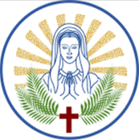
Mary Mother Of Martyrs Parish
Registration
Churches of St. Mary & St. Stephen Protomartyr
1880 Ash St Des Plaines, IL 60018
(847) 824-2026

Family Last Name: Email:
Home Address:
Street City State Zip Code
Phone: Cell phone:

Name: Spouse:
Date of Birth: Date of Birth:
Occupation: Language:

CHECK ONE | Other Family Member in the Household  (First, Middle Initial, Last) | RELATIONSHIP | DOB  mm/dd/yyyy | OCCUPATION
□ Female

□ Male
□ Female

□ Male
□ Female

□ Male
□ Female

□ Male
□ Female
□ Male

Former Parish, City, and State:
Would you like to receive Offering Envelopes: YES NO
Which Church you attend: St. Mary’s St. Stephen’s 
Would you like to sign up for Email Notification from the Parish : YES NO
Please share your comments and suggestions here. We want to know what is important to you:

FOR OFFICE USE ONLY:
DATE RECEVIED: DATE ENTERED: INTIALS:

