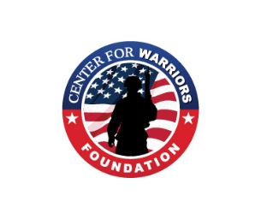
CENTER FOR WARRIORS ELK CAMP 2026
ELK CAMP GEAR LIST

Essentials for each hunter
- Multi-tool
- 2 hunting knives
- Hygiene kit
- Lantern and flashlights
- Binoculars & range finder
- Communication device – cellphone
- Sleeping bag & Pillow
- Medication
- Fire starting kit
- Hunting clothes, camo gloves (light and heavy) camo & camo hat with green light
- Face mask or face paint.
- Coat: raincoat, light coat, heavy coat
- Boots and/or hiking boots
- Thermal underwear (this is Montana)
- Phone charger & charging pack
- Bows & Arrows (extra arrows & broadheads)
- Recommend 1 arrow with rubber blunt or judo tip for grouse
- Release
- Side arm for bears (recommend 44 mag with bear load ammo)
- Bug Repellent
- No scent spray
- Licenses Including Archery License
- Backpack or fanny pack
- Water bladder or canteen
- Emergency blanket
- Toilet paper
- Parachute cord 25’+
- Marking tape
- Matches or Firestarter – wind resistant
- Hunter’s orange, rifle and ammo if bear hunting
- Air mattress if camping in tent.
- Bear Spray
- Camp Chair
- Scent-free soap and shampoo.

DON’T FORGET TO WASH ALL HUNTING CLOTHS, SOX, UNDERWARE AND ANYTHING ELSE THAT YOU WILL BE WEARING IN THE FIELD WHILE HUNTING WITH SCENT FREE DETERGENT.

PRACTICE, PRACTICE, PRACTICE. I WILL BE VERIFYING ACCURACY AT CAMP.

DON’T FORGET, THIS IS A 100% ALCOHOL FREE CAMP (INCLUDING WEED)

