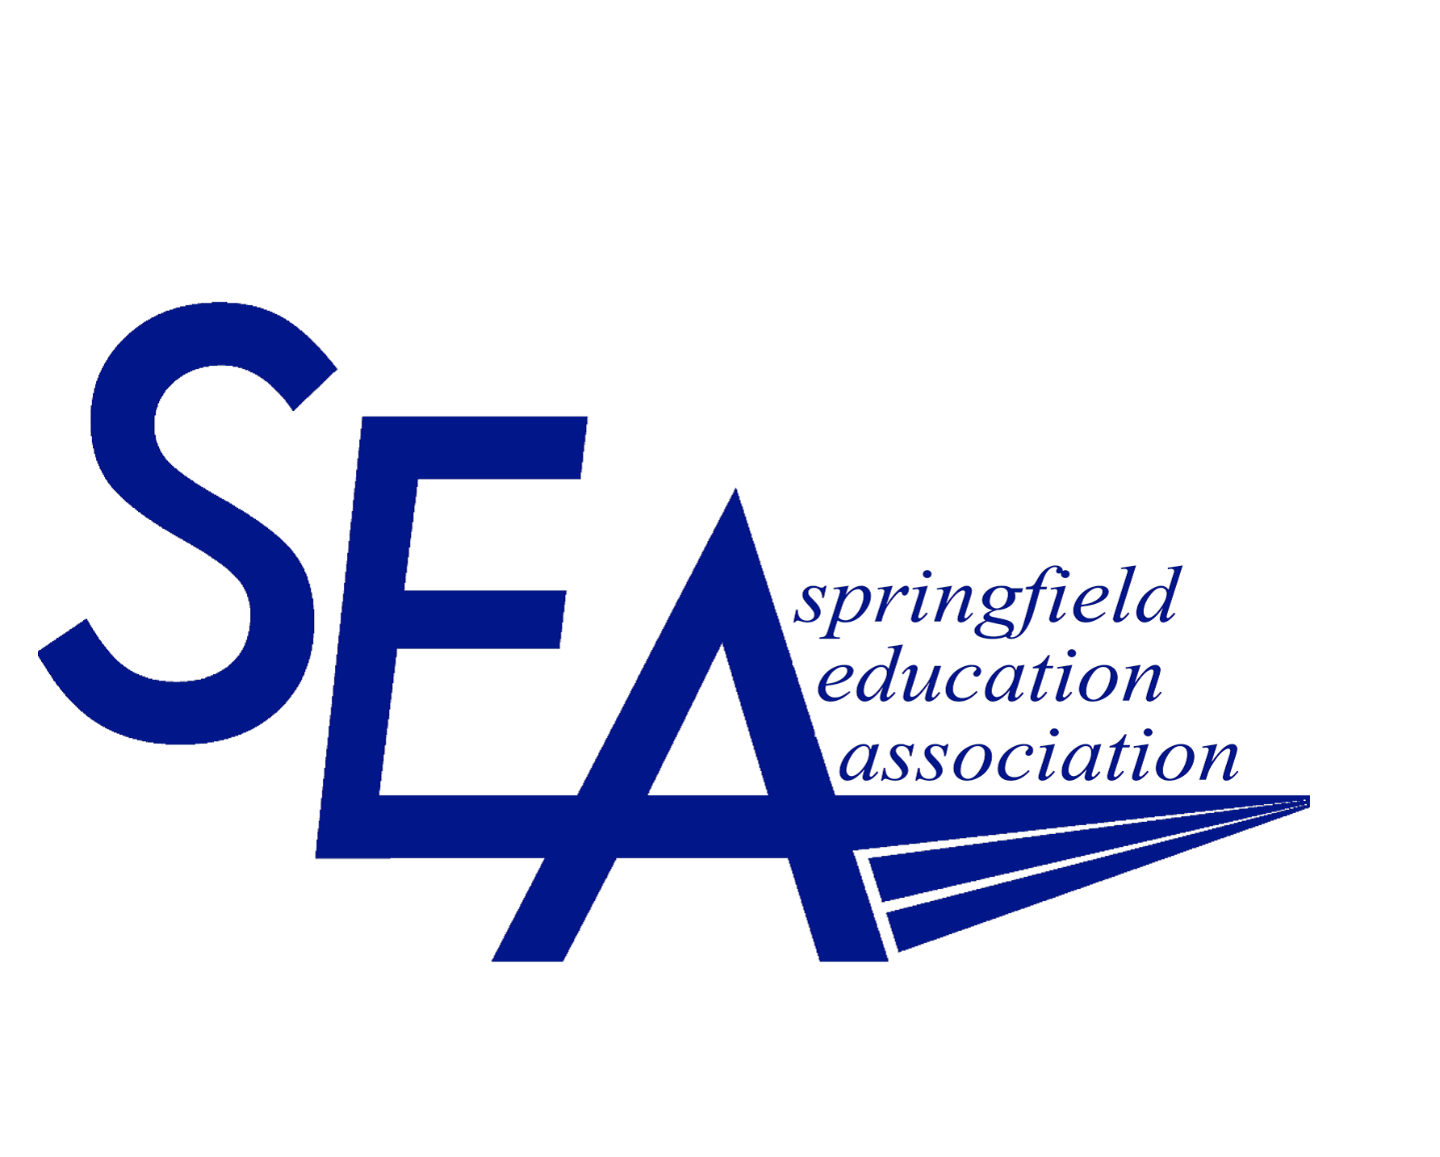



January 2026

Dear Applicant:

Enclosed you will find the application forms for the Springfield Education Association Peter Dupuis Alternative High School Scholarship. The scholarship is in memory of Peter Dupuis, a former SEA member and SEA Professional Relations Associate.

Peter’s last teaching position was at Springfield High School, an alternative school for high school students. Peter’s love for education was reflected in his teaching style and his dedication to his students. Therefore, as SEA’s tribute to Peter, this scholarship is available to graduating seniors at a Springfield Public Alternative High School* who will be continuing their education or training. One $1,000 scholarship will be awarded.

Please follow the instructions as outlined and return all components in the checklist to the:

Springfield Education Association
Peter Dupuis Alternative High School Scholarship
450 Cottage Street, Suite 5
Springfield, Massachusetts 01104

ALL APPLICATIONS MUST BE RECEIVED BY MARCH 9, 2026. PLEASE MAIL TO THE ABOVE ADDRESS OR EMAIL TO CONTACT@SEATEACHERS.COM APPLICATIONS RECEIVED AFTER 4:00 P.M. ON MARCH 9, 2026 WILL BE CONSIDERED LATE.

The recipient will be notified in April. The scholarship funds will be disbursed upon proof of tuition payment. Thank you for applying to our scholarship program.

Sincerely,
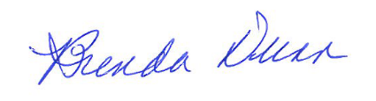
Brenda Dunn
Scholarship Chairperson

*charter schools do not fall under a Springfield Alternative School

Enclosures (4)

SEA PETER DUPUIS ALTERNATIVE HIGH SCHOOL SCHOLARSHIP:
STUDENT APPLICATION FORM

NAME__________________________________DATE____________PHONE #__________

ADDRESS___________________________CITY_________________STATE___ ZIP_____

DATE OF BIRTH________ CURRENT SCHOOL_________________

GUIDANCE COUNSLOR’S NAME (Please print) __________________________________

GUIDANCE COUNSLOR’S SIGNATURE: ________________________________________

SCHOOL HONORS/ACHIEVEMENTS: | COMMUNITY SERVICE/EXTRA CURRICULAR  ACTIVITIES:

WORK EXPERIENCE: LENGTH OF EMPLOYMENT:

COLLEGES/TECHNICAL/TRAINING INSTITUTES APPLIED TO: PROJECTED MAJOR:

ON A SEPARATE PAPER, WRITE AN ESSAY SUPPORTING YOUR INTENT FOR FURTHER EDUCATION. INCLUDE YOUR GOALS AND FUTURE ASPIRATIONS IN YOUR ESSAY.
ATTACH YOUR TYPED ESSAY AND TRANSCRIPT TO THIS FORM.

SEA PETER DUPUIS ALTERNATIVE HIGH SCHOOL SCHOLARSHIP:
TEACHER/COUNSELOR/COMMUNITY RESOURCE PERSON
REFERENCE FORM

Reference Guidelines: Please submit two reference forms.
- One reference form must be submitted from a teacher or counselor who works at the school you attend.
- The second reference may be from a community resource person (ex: YMCA, YWCA, Boy’s Club, Big Sisters, etc.), an employer, or another teacher or counselor who works at the school you attend.

DIRECTIONS FOR THE PERSON WHO IS COMPLETING THE REFERENCE FORM:
Please complete this form and mail it to our office (Springfield Education Association, 450 Cottage Street, Suite 5, Springfield, MA 01104) before March 9, 2026 or email it to contact@seateachers.com

APPLICANT'S NAME_________________________________________________

HOW LONG HAVE YOU KNOWN THE APPLICANT? _________________________

IN WHAT CAPACITY DO YOU KNOW THE APPLICANT? _____________________

_________________________________________________________________

PLEASE SUBMIT A TYPED RESPONSE THAT DESCRIBES QUALITIES WHICH MAKE THE APPLICANT A WORTHY CANDIDATE FOR THIS SCHOLARSHIP. PLEASE ATTACH THE TYPED RESPONSE TO THIS SHEET.

NAME (Please print): ________________________________________________

SIGNATURE ___________________

Check List

BEFORE SIGNING BELOW PLEASE CHECK TO MAKE SURE YOU HAVE RETURNED THE FOLLOWING:

- STUDENT APPLICATION FORM

- YOUR ESSAY (typed on a separate piece of paper) TO SUPPORT YOUR APPLICATION FOR THIS SCHOLARSHIP

- YOUR OFFICIAL TRANSCRIPT

- Two (2) TEACHER/COUNSELOR/COMMUNITY RESOURCE PERSON, EMPLOYER REFERENCE FORMS

You may want to provide your reference with a stamped envelope addressed to: Springfield Education Association, 450 Cottage Street, Suite 5, Springfield, MA 01104.

Applicant’s signature: Date:

REMINDER—INCOMPLETE AND LATE APPLICATIONS
WILL NOT BE CONSIDERED.

DEADLINE – MARCH 9, 2026

